Principles of Macroeconomics, 11e - TB1 (Case/Fair/Oster)
Chapter 1 The Scope and Method of Economics

1.1 Why Study Economics?

1) Which of the following is NOT listed in the book as a reason to study economics?
A) to learn a way of thinking
B) to understand society
C) to be an informed citizen
D) to learn how to make lots of money
Answer: D
Diff: 1
Topic: Why Study Economics?
Skill: Fact
Learning Outcome: Micro-1

2) Among the fundamental concepts in economics are
A) opportunity cost.
B) marginalism.
C) efficient markets.
D) all of the above
Answer: D
Diff: 1
Topic: Why Study Economics?
Skill: Conceptual
AACSB: Reflective Thinking
Learning Outcome: Micro-1

3) Which of the following is the best definition of economics?
A) the study of how individuals and societies choose to use the scarce resources that nature and previous generations have provided
B) the study of how consumers spend their income
C) the study of how business firms decide what inputs to hire and what outputs to produce
D) the study of how the federal government allocates tax dollars
Answer: A
Diff: 1
Topic: Why Study Economics?
Skill: Definition
Learning Outcome: Micro-1

4) The rise of the modern factory system in England during the late eighteenth and early nineteenth centuries is known as the
A) Great Migration.
B) Industrial Revolution.
C) Wealth of Nations.
D) Dark Ages.
Answer: B
Diff: 1
Topic: Why Study Economics?
Skill: Fact
Learning Outcome: Micro-1
5) Which of the following statements is NOT correct?
A) Economics is a behavioral science.
B) In large measure, economics is the study of how people make choices.
C) If poverty were eliminated, there would be no reason to study economics.
D) Economic analysis can be used to explain how both individuals and societies make decisions.
Answer: C
Diff: 1
Topic: Why Study Economics?
Skill: Conceptual
AACSB: Reflective Thinking
Learning Outcome: Micro-1

6) The study of economics
A) is a very narrow endeavor.
B) is a way of analyzing decision-making processes caused by scarcity.
C) is concerned with proving that capitalism is better than socialism.
D) focuses on how a business should function.
Answer: B
Diff: 1
Topic: Why Study Economics?
Skill: Definition
Learning Outcome: Micro-1

7) Which of the following is NOT one of the three fundamental concepts of economics?
A) profit maximization
B) marginalism
C) opportunity cost
D) the working of efficient markets
Answer: A
Diff: 1
Topic: Why Study Economics?
Skill: Conceptual
Learning Outcome: Micro-1

8) Suppose that you purchased a ticket to a jazz festival for $100 from an online ticket broker. Once you arrived at the festival, you discovered that parking costs you an additional $15. In this situation, the additional $15 you pay for parking is an example of
A) an economic loss.
B) opportunity cost.
C) marginal cost.
D) an inefficient cost.
Answer: C
Diff: 2
Topic: Why Study Economics?
Skill: Conceptual
AACSB: Reflective Thinking
Learning Outcome: Micro-1
9) You have decided that you want to attend a costume party as Iron Man. You estimate that it will cost $40 to assemble your costume. After spending $40 on the costume, you realize that the additional pieces you need will cost you $25 more. The marginal cost of completing the costume is
A) $15.
B) $25.
C) $40.
D) $65.
Answer: B
Diff: 2
Topic: Why Study Economics?
Skill: Analytical
AACSB: Analytic Skills
Learning Outcome: Micro-1

10) The concept of opportunity cost
A) is relevant only to economics.
B) can be applied to the analysis of any decision-making process.
C) applies to consumers but not to firms.
D) refers only to actual payments and incomes.
Answer: B
Diff: 1
Topic: Why Study Economics?
Skill: Conceptual
AACSB: Reflective Thinking
Learning Outcome: Micro-1

11) Opportunity cost is
A) that which we forgo, or give up, when we make a choice or a decision.
B) a cost that cannot be avoided, regardless of what is done in the future.
C) the additional cost of producing an additional unit of output.
D) the additional cost of buying an additional unit of a product.
Answer: A
Diff: 1
Topic: Why Study Economics?
Skill: Definition
Learning Outcome: Micro-1

12) The reason that opportunity costs arise is that
A) an economy relies on money to facilitate exchange of goods and services.
B) resources are scarce.
C) there are no alternative decisions that could be made.
D) people have limited wants.
Answer: B
Diff: 1
Topic: Why Study Economics?
Skill: Fact
Learning Outcome: Micro-1
13) Which of the following is NOT an opportunity cost of attending college?
A) the tuition you pay
B) the income you could have earned if you didn't attend college
C) the alternative uses of the time you spend studying
D) the cost of the food that you consume while you are attending college
Answer: D
Diff: 2
Topic: Why Study Economics?
Skill: Conceptual
AACSB: Reflective Thinking
Learning Outcome: Micro-1

14) If your tuition is $5,000 this semester, your books cost $600, you can only work 20 rather than 40 hours per week during the 15 weeks you are taking classes and you make $15 per hour, and your room and board is $3000 this semester (same as if not attending college), then your opportunity cost of attending college this semester is
A) $5,600.
B) $5,900.
C) $10,100.
D) $11,600.
Answer: C
Diff: 3
Topic: Why Study Economics?
Skill: Analytical
AACSB: Analytic Skills
Learning Outcome: Micro-1

15) If your tuition is $25,000 this semester, your books cost $1,500, you can only work 20 rather than 40 hours per week during the 15 weeks you are taking classes and you make $15 per hour, and your room and board is $7,500 this semester (same as if not attending college), then your opportunity cost of attending college this semester is
A) $26,500.
B) $26,800.
C) $31,000.
D) $38,500.
Answer: C
Diff: 3
Topic: Why Study Economics?
Skill: Analytical
AACSB: Analytic Skills
Learning Outcome: Micro-1
16) If you own a building and you decide to use that building to open a book store,
A) there is no opportunity cost of using this building for a book store because you own it.
B) there is an opportunity cost of using this building for a book store because it could have been used in other ways.
C) the opportunity costs equal the cost of inventory.
D) the only cost relevant to this decision is the price you paid for the building.
Answer: B
Diff: 2
Topic: Why Study Economics?
Skill: Conceptual
AACSB: Reflective Thinking
Learning Outcome: Micro-1

17) You own the Star Wars six DVD set. The opportunity cost of watching these DVDs for the second time
A) is zero.
B) is one-half the cost of the DVDs, as this is the second time you have watched it.
C) is the value of the alternative use of the time you spend watching the DVDs.
D) cannot be calculated.
Answer: C
Diff: 2
Topic: Why Study Economics?
Skill: Conceptual
AACSB: Reflective Thinking
Learning Outcome: Micro-1

18) That which we forgo, or give up, when we make a choice or decision is called
A) out-of-pocket cost.
B) marginal cost.
C) real cost.
D) opportunity cost.
Answer: D
Diff: 1
Topic: Why Study Economics?
Skill: Definition
Learning Outcome: Micro-1

19) Economists often refer to risk-free ventures as
A) efficient market outcomes.
B) profit opportunities.
C) those with no opportunity costs.
D) break-even propositions.
Answer: B
Diff: 1
Topic: Why Study Economics?
Skill: Conceptual
AACSB: Reflective Thinking
Learning Outcome: Micro-1
20) If you can buy 9 DVDs for $126 or you could buy 10 DVDs for $130, then the marginal cost of the tenth DVD is:
A) $4.
B) $13.
C) $14.
D) $130.
Answer: A
Diff: 2
Topic: Why Study Economics?
Skill: Analytical
Learning Outcome: Micro-1

21) If you eat at a sushi restaurant that charges $20 for its all you can eat sushi special, then the marginal cost of your 10th piece of sushi is
A) zero.
B) $2.
C) $200.
D) $2,000.
Answer: A
Diff: 2
Topic: Why Study Economics?
Skill: Analytical
AACSB: Analytic Skills
Learning Outcome: Micro-1

22) A market in which profit opportunities are eliminated almost instantaneously is
A) a laissez-faire market.
B) a capitalist market.
C) a socialist market.
D) an efficient market.
Answer: D
Diff: 1
Topic: Why Study Economics?
Skill: Definition
Learning Outcome: Micro-1

23) If information is less costly and more easily available, then usually this
A) makes markets more efficient.
B) makes markets less efficient.
C) increases profit opportunities.
D) increases the opportunity cost of acquiring more information.
Answer: A
Diff: 2
Topic: Why Study Economics?
Skill: Conceptual
AACSB: Reflective Thinking
Learning Outcome: Micro-1
24) An efficient market is a market
A) in which everyone always gets what they want.
B) in which profit opportunities are eliminated almost instantaneously.
C) in which profits are always very high and persistent.
D) in which opportunity costs are zero.
Answer: B
Diff: 2
Topic: Why Study Economics?
Skill: Definition
Learning Outcome: Micro-1

25) Related to the Economics in Practice on p. 5: According to the Economics in Practice, a majority of the $10 retail value of the Barbie doll
A) is needed to pay for the cost of the Taiwanese plastic used to make the dolls.
B) pays for the Chinese labor used to assemble the doll.
C) is captured in the United States.
D) goes to the Japanese manufacturer of the hair which is used for the dolls.
Answer: C
Diff: 2
Topic: Why Study Economics?: Economics in Practice
Skill: Fact
Learning Outcome: Micro-1

26) Related to the Economics in Practice on p. 5: The opportunity cost to Mattel of having its Barbie doll assembled in China is
A) the low wages paid to Chinese workers.
B) the $2 export value the doll carries when it leaves Hong Kong.
C) the $8 of its $10 retail value which is captured in the United States.
D) having the Barbie doll assembled in the next best available location.
Answer: D
Diff: 2
Topic: Why Study Economics?: Economics in Practice
Skill: Conceptual
AACSB: Reflective Thinking
Learning Outcome: Micro-1

27) Resources are unlimited in a wealthy society.
Answer: FALSE
Diff: 1
Topic: Why Study Economics?
Skill: Conceptual
AACSB: Reflective Thinking
Learning Outcome: Micro-1

28) The value of the best alternative foregone is the opportunity cost of making a decision.
Answer: TRUE
Diff: 1
Topic: Why Study Economics?
Skill: Definition
Learning Outcome: Micro-1
29) Opportunity costs arise due to scarce resources.
Answer: TRUE
Diff: 1
Topic: Why Study Economics?
Skill: Conceptual
AACSB: Reflective Thinking
Learning Outcome: Micro-1

30) Marginal cost refers to the incremental cost arising from a decision.
Answer: TRUE
Diff: 1
Topic: Why Study Economics?
Skill: Definition
Learning Outcome: Micro-1

31) A market is considered efficient if profit opportunities remain continually available.
Answer: FALSE
Diff: 1
Topic: Why Study Economics?
Skill: Definition
Learning Outcome: Micro-1

1.2 The Scope of Economics

1) The branch of economics that examines the functioning of individual industries and the behavior of individual decision-making units is
A) positive economics.
B) normative economics.
C) macroeconomics.
D) microeconomics.
Answer: D
Diff: 1
Topic: The Scope of Economics
Skill: Definition
Learning Outcome: Micro-1

2) Studying how the management of Hewlett Packard decides how many computers to produce and the price to charge for its computers would be considered
A) descriptive economics.
B) empirical economics.
C) microeconomics.
D) macroeconomics.
Answer: C
Diff: 1
Topic: The Scope of Economics
Skill: Conceptual
AACSB: Reflective Thinking
Learning Outcome: Micro-1
3) Studying how Joshua allocates his time between school and video games is an example of
A) macroeconomics.
B) microeconomics.
C) industrial organization.
D) descriptive economics.
Answer: B
Diff: 1
Topic: The Scope of Economics
Skill: Conceptual
AACSB: Reflective Thinking
Learning Outcome: Micro-1

4) The study of how benefits are determined for city employees would be considered
A) microeconomics.
B) macroeconomics.
C) descriptive economics.
D) institutional economics.
Answer: A
Diff: 1
Topic: The Scope of Economics
Skill: Conceptual
AACSB: Reflective Thinking
Learning Outcome: Micro-1

5) Inflation and unemployment
A) are the focus of normative economics.
B) are a focus of microeconomics.
C) are a focus of positive economics.
D) are a focus of macroeconomics.
Answer: D
Diff: 1
Topic: The Scope of Economics
Skill: Conceptual
AACSB: Reflective Thinking
Learning Outcome: Micro-1

6) The rate of economic growth is a topic of microeconomics.
Answer: FALSE
Diff: 1
Topic: The Scope of Economics
Skill: Conceptual
AACSB: Reflective Thinking
Learning Outcome: Micro-1

7) The aggregate price level is a topic of macroeconomics.
Answer: TRUE
Diff: 1
Topic: The Scope of Economics
Skill: Conceptual
AACSB: Reflective Thinking
Learning Outcome: Micro-1
1.3 The Method of Economics

1) Better insurance benefits increase the incentive of some individuals to work. This statement is best described as
A) a positive statement.
B) an example of the ceteris paribus assumption.
C) a normative statement.
D) a comparative economics statement.
Answer: A
Diff: 2
Topic: The Method of Economics
Skill: Conceptual
AACSB: Reflective Thinking
Learning Outcome: Micro-1

2) The government should extend the duration of unemployment benefits to those workers who lost their jobs due to outsourcing. This statement is best described as
A) an example of marginalism.
B) an example of the fallacy of composition.
C) a normative statement.
D) a positive statement.
Answer: C
Diff: 2
Topic: The Method of Economics
Skill: Conceptual
AACSB: Reflective Thinking
Learning Outcome: Micro-1

3) The amount of education that one has is an important factor in the determination of his or her wage rate. This is best described as
A) a positive statement.
B) an example of the fallacy of composition.
C) a normative statement.
D) an example of marginalism.
Answer: A
Diff: 2
Topic: The Method of Economics
Skill: Conceptual
AACSB: Reflective Thinking
Learning Outcome: Micro-1

4) The cost involved when choosing between alternatives is known as the
A) marginal cost.
B) sunk cost.
C) opportunity cost.
D) normative cost.
Answer: C
Diff: 1
Topic: The Method of Economics
Skill: Definition
Learning Outcome: Micro-1
5) Positive economics is an approach to economics that
A) seeks to understand behavior and the operation of systems while making judgments about their usefulness to society.
B) analyzes outcomes of economic behavior, evaluates them as good or bad, and may prescribe preferred courses of action.
C) seeks to understand behavior and the operation of systems without making judgments.
D) examines the role of government in the economy.
Answer: C
Diff: 1
Topic: The Method of Economics
Skill: Conceptual
AACSB: Reflective Thinking
Learning Outcome: Micro-1

6) Normative economics is an approach to economics that
A) seeks to understand behavior and the operation of systems without making judgments.
B) analyzes outcomes of economic behavior, evaluates them as good or bad, and may prescribe preferred courses of action.
C) applies statistical techniques and data to economic problems.
D) examines the role of government in the economy.
Answer: B
Diff: 1
Topic: The Method of Economics
Skill: Conceptual
AACSB: Reflective Thinking
Learning Outcome: Micro-1

7) Which of the following is a normative question?
A) Why do gasoline prices increase between Memorial Day and Labor Day?
B) What will happen to gasoline consumption if the federal tax on gasoline is eliminated?
C) To reduce the regressive nature of the gasoline excise tax, should the portion of the gasoline excise tax paid by high-income individuals be increased?
D) How will oil exploration be affected if the government subsidizes oil producers?
Answer: C
Diff: 2
Topic: The Method of Economics
Skill: Conceptual
AACSB: Reflective Thinking
Learning Outcome: Micro-1
8) Which of the following is a positive question?
A) Will the level of teenage unemployment increase if the minimum wage is increased?
B) Should the minimum wage be set at one-half the average manufacturing wage to guarantee individuals a decent standard of living?
C) Wouldn't it be more equitable if the minimum wage increased automatically with the cost of living?
D) Wouldn't it be better to try to increase people's wages through job-training programs rather than by requiring employers to pay minimum wages?
Answer: A
Diff: 2
Topic: The Method of Economics
Skill: Conceptual
AACSB: Reflective Thinking
Learning Outcome: Micro-1

9) Health insurance should be provided to every citizen in a wealthy nation such as the United States. This statement is best described as
A) a positive statement.
B) a normative statement.
C) a marginal statement.
D) an implication of an efficient market.
Answer: B
Diff: 2
Topic: The Method of Economics
Skill: Conceptual
AACSB: Reflective Thinking
Learning Outcome: Micro-1

10) There is great concern over the fact that millions of Americans do not have health insurance. A study of the costs and benefits of implementing a national health-insurance program is an example of
A) laissez-faire economics.
B) positive economics.
C) labor economics.
D) normative economics.
Answer: B
Diff: 2
Topic: The Method of Economics
Skill: Conceptual
AACSB: Reflective Thinking
Learning Outcome: Micro-1

11) A measure that can change from observation to observation is known as a(n)
A) empirical measure.
B) model.
C) causality.
D) variable.
Answer: D
Diff: 1
Topic: The Method of Economics
Skill: Definition
Learning Outcome: Micro-1
12) A formal statement of a theory is known as a(n)
A) model.
B) positive statement.
C) empirical measure.
D) causal statement.
Answer: A
Diff: 1
Topic: The Method of Economics
Skill: Definition
Learning Outcome: Micro-1

Refer to Scenario 1.1 below to answer the questions that follow.

SCENARIO 1.1: An economist wants to understand the relationship between minimum wages and the level of teenage unemployment. The economist collects data on the values of the minimum wage and the levels of teenage unemployment over time. The economist concludes that a 1% increase in minimum wage causes a 0.2% increase in teenage unemployment. From this information he concludes that the minimum wage is harmful to teenagers and should be reduced or eliminated to increase employment among teenagers.

13) Refer to Scenario 1.1. The statement that a 1% increase in the minimum wage causes a 0.2% increase in teenage unemployment is an example of
A) the fallacy of composition.
B) normative economics.
C) positive economics.
D) Ockham's razor.
Answer: C
Diff: 2
Topic: The Method of Economics
Skill: Conceptual
AACSB: Reflective Thinking
Learning Outcome: Micro-1

14) Refer to Scenario 1.1. The statement, "the minimum wage is harmful to teenagers and should be reduced or eliminated to increase employment among teenagers," is an example of
A) marginal economics.
B) normative economics.
C) positive economics.
D) the fallacy of composition.
Answer: B
Diff: 2
Topic: The Method of Economics
Skill: Conceptual
AACSB: Reflective Thinking
Learning Outcome: Micro-1
15) Refer to Scenario 1.1. The collection and use of the data on minimum wage and teenage unemployment over time is an example of
A) law and economics.
B) economic history.
C) econometrics.
D) empirical economics.
Answer: D
Diff: 2
Topic: The Method of Economics
Skill: Conceptual
AACSB: Reflective Thinking
Learning Outcome: Micro-1

16) Refer to Scenario 1.1. The statement that an increase in the minimum wage causes an increase in teenage unemployment is an example of
A) a fallacy.
B) an economic theory.
C) normative economics.
D) deductive reasoning.
Answer: B
Diff: 2
Topic: The Method of Economics
Skill: Conceptual
AACSB: Reflective Thinking
Learning Outcome: Micro-1

17) Refer to Scenario 1.1. A graph of the value of the minimum wage on one axis and the level of teenage unemployment on the other axis is an example of
A) an economic theory.
B) an economic model.
C) inductive reasoning.
D) a variable theory.
Answer: B
Diff: 2
Topic: The Method of Economics
Skill: Conceptual
AACSB: Reflective Thinking
Learning Outcome: Micro-1

18) To isolate the impact of one single factor, economists invoke the assumption of
A) inductive reasoning.
B) Ockham's razor.
C) ceteris paribus.
D) post hoc, ergo propter hoc.
Answer: C
Diff: 1
Topic: The Method of Economics
Skill: Definition
Learning Outcome: Micro-1
19) The principle that irrelevant detail should not be included in a model is known as
A) a fallacy.
B) ceteris paribus.
C) Ockham's razor.
D) normative economics.
Answer: C
Diff: 1
Topic: The Method of Economics
Skill: Definition
Learning Outcome: Micro-1

20) Economists use the phrase ceteris paribus to express the assumption
A) "all else equal."
B) "everything affects everything else."
C) "scarcity is a fact of life."
D) "there is no such thing as a free lunch."
Answer: A
Diff: 1
Topic: The Method of Economics
Skill: Definition
Learning Outcome: Micro-1

21) The Latin phrase economists use that means all else equal is
A) ceteris paribus.
B) cogito ergo sum.
C) carpe diem.
D) caveat emptor.
Answer: A
Diff: 1
Topic: The Method of Economics
Skill: Definition
Learning Outcome: Micro-1

22) Stanley Jevons, an economist in the nineteenth century, noted a high correlation between economic prosperity and sunspots. Based on this observation he developed a "sunspot theory" of how the economy operated. We now know that Jevons
A) committed the fallacy of composition.
B) committed the ceteris paribus error.
C) was confusing causality.
D) showed good reasoning for the nineteenth but not the twentieth century.
Answer: C
Diff: 2
Topic: The Method of Economics
Skill: Conceptual
AACSB: Reflective Thinking
Learning Outcome: Micro-1
23) Whenever the Democrats gain control of the Congress, spending on social programs increases; whenever Republicans gain control of the Congress, spending on defense increases. Hence, we know what the next party in control will do. This statement is an example of
A) fallacy of inductive reasoning.
B) post hoc, ergo propter hoc fallacy.
C) fallacy of composition.
D) ceteris paribus fallacy.
Answer: B
Diff: 2
Topic: The Method of Economics
Skill: Conceptual
AACSB: Reflective Thinking
Learning Outcome: Micro-1

24) I have lived in a house on the Mississippi River for many years and have never seen a flood. Therefore, there is no reason for anyone to buy flood insurance. This statement is an example of
A) fallacy of composition.
B) post hoc, ergo propter hoc fallacy.
C) fallacy of inductive reasoning.
D) ceteris paribus fallacy.
Answer: A
Diff: 2
Topic: The Method of Economics
Skill: Conceptual
AACSB: Reflective Thinking
Learning Outcome: Micro-1

25) The economy was expanding during all of the years that I was a student, but as soon as I graduated, the economy contracted. Therefore, the labor market was waiting until I started looking for a job to contract. This statement is an example of
A) ceteris paribus fallacy.
B) post hoc, ergo propter hoc fallacy.
C) fallacy of composition.
D) fallacy of inductive reasoning.
Answer: B
Diff: 2
Topic: The Method of Economics
Skill: Conceptual
AACSB: Reflective Thinking
Learning Outcome: Micro-1
26) Experimental research in small cities suggests that mandating work for welfare recipients increases their income. Therefore, we should mandate work requirements for all welfare recipients. This statement is an example of
A) fallacy of inductive reasoning.
B) ceteris paribus fallacy.
C) fallacy of composition.
D) post hoc, ergo propter hoc fallacy.
Answer: C
Diff: 2
Topic: The Method of Economics
Skill: Conceptual
AACSB: Reflective Thinking
Learning Outcome: Micro-1

27) Rent control laws are imposed when city officials believe landlords have been exploiting tenants. Which of the following criteria are they using to guide their actions?
A) efficiency
B) equity
C) growth
D) stability
Answer: B
Diff: 2
Topic: The Method of Economics
Skill: Conceptual
AACSB: Reflective Thinking
Learning Outcome: Micro-1

28) A government policy that tries to minimize inflation and unemployment can best be described as trying to achieve economic
A) efficiency.
B) equity.
C) profitability.
D) stability.
Answer: D
Diff: 2
Topic: The Method of Economics
Skill: Conceptual
AACSB: Reflective Thinking
Learning Outcome: Micro-1

29) Redistribution of income from the rich to the poor is achieved from a tax system that requires taxes to rise with income. Which of the following criteria best explains the goal of this tax system?
A) efficiency
B) equity
C) growth
D) stability
Answer: B
Diff: 2
Topic: The Method of Economics
Skill: Conceptual
AACSB: Reflective Thinking
Learning Outcome: Micro-1
30) You know that the computer lab at school gets very crowded at about 3:00 p.m. To avoid the crowds, you start going to the computer lab one hour earlier every day. However many students make the same decision, and now the computer lab becomes very crowded at 2:00 p.m. This is an example of the
A) post hoc, ergo propter hoc fallacy.
B) ceteris paribus fallacy.
C) fallacy of division.
D) fallacy of composition.
Answer: D
Diff: 2
Topic: The Method of Economics
Skill: Conceptual
AACSB: Reflective Thinking
Learning Outcome: Micro-1

31) It always rains about an hour after you finish washing your car. Concluding that washing your car caused it to rain is an example of the
A) fallacy of composition.
B) post hoc, ergo propter hoc fallacy.
C) fallacy of inductive reasoning.
D) ceteris paribus conditions.
Answer: B
Diff: 2
Topic: The Method of Economics
Skill: Conceptual
AACSB: Reflective Thinking
Learning Outcome: Micro-1

32) At a political rally, you stand up to see better. Everyone else stands up, as well. This is an example of
A) ceteris paribus.
B) the post hoc, ergo propter hoc fallacy.
C) the fallacy of composition.
D) Ockham's razor.
Answer: C
Diff: 2
Topic: The Method of Economics
Skill: Conceptual
AACSB: Reflective Thinking
Learning Outcome: Micro-1
33) You have observed that every time you do 30 minutes of cardio exercise before taking an exam you get an A. You therefore conclude that to get an A on an exam, all you have to do is 30 minutes of cardio exercise before you take an exam. You have committed the
A) fallacy of composition.
B) fallacy of inductive reasoning.
C) post hoc, ergo propter hoc fallacy.
D) fallacy of division.
Answer: C
Diff: 2
Topic: The Method of Economics
Skill: Conceptual
AACSB: Reflective Thinking
Learning Outcome: Micro-1

34) If you observe that Event A happens before Event B happens, and you conclude that Event A caused Event B, you would be guilty of an error called the
A) fallacy of composition.
B) fallacy of inductive reasoning.
C) fallacy of ceteris paribus.
D) post hoc, ergo propter hoc fallacy.
Answer: D
Diff: 2
Topic: The Method of Economics
Skill: Definition
Learning Outcome: Micro-1

35) The mistake of inferring causality from two events happening one after the other is called
A) the post hoc, ergo propter hoc fallacy.
B) the fallacy of composition.
C) Ockham's razor.
D) the fallacy of co-dependence.
Answer: A
Diff: 2
Topic: The Method of Economics
Skill: Definition
Learning Outcome: Micro-1

36) The fallacy of composition is
A) the belief that if Event A happens before Event B happens, then Event A causes Event B to occur.
B) the belief that what is true for the whole is necessarily true of the parts.
C) the belief that what is true for a part is necessarily true for the whole.
D) the belief that it is impossible to draw generalizations about cause and effect.
Answer: C
Diff: 2
Topic: The Method of Economics
Skill: Definition
Learning Outcome: Micro-1
37) The collection and use of data to test economic theories is
A) empirical economics.
B) descriptive economics.
C) normative economics.
D) positive economics.
Answer: A
Diff: 2
Topic: The Method of Economics
Skill: Definition
Learning Outcome: Micro-1

38) A change in economic output is potentially efficient
A) if the value of the resulting gains exceeds the value of the resulting losses.
B) if the value of the resulting gains exactly equals the value of the resulting losses.
C) only if no one is made worse off.
D) if the value of the resulting gains is less than the value of the resulting losses.
Answer: A
Diff: 2
Topic: The Method of Economics
Skill: Conceptual
AACSB: Reflective Thinking
Learning Outcome: Micro-1

39) An efficient economy is an economy
A) in which output is steady or growing and there is low inflation.
B) that produces what consumers demand and does so at the least possible cost.
C) that distributes output equally among all consumers.
D) in which there is a fair distribution of wealth.
Answer: B
Diff: 2
Topic: The Method of Economics
Skill: Definition
Learning Outcome: Micro-1

40) An efficient market is characterized by the fact that
A) output is steady or growing and there is low inflation.
B) profit opportunities are eliminated almost instantaneously.
C) there are no opportunity costs.
D) wealth is distributed fairly.
Answer: B
Diff: 1
Topic: The Method of Economics
Skill: Conceptual
AACSB: Reflective Thinking
Learning Outcome: Micro-1
41) The four criteria that are frequently used in judging the outcome of economic policy are
A) efficiency, equity, stability, and economic growth.
B) efficiency, equality, stability, and economic growth.
C) efficiency, equality, profitability, and stability.
D) efficiency, equity, profitability, and stability.
Answer: A
Diff: 1
Topic: The Method of Economics
Skill: Conceptual
AACSB: Reflective Thinking
Learning Outcome: Micro-1

42) You have noticed that there is an increase in the number of homeless people in your city. At the same time you observe that there are also a number of vacant apartments. You believe that the government could reduce the number of homeless people if landlords were required to rent their apartments for less than they are currently charging. This policy recommendation would be motivated by concerns over
A) efficiency.
B) equity.
C) economic growth.
D) stability.
Answer: B
Diff: 2
Topic: The Method of Economics
Skill: Conceptual
AACSB: Reflective Thinking
Learning Outcome: Micro-1

43) There is a possibility that a national sales tax will be implemented. Many economists argue that items such as food and clothing should be exempt from such a tax because low-income people spend a greater percentage of their income on these goods than do high-income individuals. This argument is motivated by concerns over
A) economic growth.
B) economic stability.
C) efficiency.
D) equity.
Answer: D
Diff: 2
Topic: The Method of Economics
Skill: Conceptual
AACSB: Reflective Thinking
Learning Outcome: Micro-1
44) Which of the following is an example of a normative statement?
A) The unemployment rate is six percent.
B) There should be no unemployment in an advanced industrial society.
C) Higher prices cause consumers to buy less.
D) Equilibrium price implies that quantity demanded equals quantity supplied.
Answer: B
Diff: 2
Topic: The Method of Economics
Skill: Conceptual
AACSB: Reflective Thinking
Learning Outcome: Micro-1

45) Which of the following is an example of a positive statement?
A) There should be no unemployment in an advanced industrial society.
B) Higher prices cause consumers to purchase less.
C) Consumption should be distributed fairly in society.
D) People should pollute as little as possible.
Answer: B
Diff: 2
Topic: The Method of Economics
Skill: Conceptual
AACSB: Reflective Thinking
Learning Outcome: Micro-1

46) Related to the Economics in Practice on p. 10: Prior to joining a fraternity, James spent most of his evenings and weekends studying for his classes. Once he joined the fraternity, James spent a majority of his evenings and weekends going to parties. This change in behavior is best described by
A) the fallacy of composition.
B) the post hoc ergo propter hoc fallacy.
C) the problem of causality.
D) the ceteris paribus error.
Answer: C
Diff: 2
Topic: The Method of Economics: Economics in Practice
Skill: Conceptual
AACSB: Reflective Thinking
Learning Outcome: Micro-1
47) Related to the Economics in Practice on p. 10: A study on the effect of roommates on college grades found that there were strong roommate effects on grade point average, effort in school, and fraternity membership. Which of the following is an example of a normative statement concerning this study?
A) The effects of roommates on grade point average are strong.
B) The effects of roommates on effort in school are strong.
C) The effects of roommates on fraternity membership are strong.
D) In order to maintain a high grade point average, students should only choose roommates who have a high grade point average.
Answer: D
Diff: 1
Topic: The Method of Economics: Economics in Practice
Skill: Conceptual
AACSB: Reflective Thinking
Learning Outcome: Micro-1

48) Normative economics looks at outcomes of economic behavior and evaluates them as good or bad.
Answer: TRUE
Diff: 2
Topic: The Method of Economics
Skill: Conceptual
AACSB: Reflective Thinking
Learning Outcome: Micro-1

49) Positive economics looks at outcomes of economic behavior and evaluates them as good or bad.
Answer: FALSE
Diff: 2
Topic: The Method of Economics
Skill: Conceptual
AACSB: Reflective Thinking
Learning Outcome: Micro-1

50) An efficient economy is one that produces what consumers demand and does so at the least possible cost.
Answer: TRUE
Diff: 1
Topic: The Method of Economics
Skill: Definition
Learning Outcome: Micro-1

51) Ceteris paribus literally translated means, "buyer beware."
Answer: FALSE
Diff: 1
Topic: The Method of Economics
Skill: Definition
Learning Outcome: Micro-1
52) Positive economics seeks to understand behavior, but not make judgments.
Answer: TRUE
Diff: 2
Topic: The Method of Economics
Skill: Conceptual
AACSB: Reflective Thinking
Learning Outcome: Micro-1

53) Stability implies a steady rate of economic growth and low inflation.
Answer: TRUE
Diff: 2
Topic: The Method of Economics
Skill: Conceptual
AACSB: Reflective Thinking
Learning Outcome: Micro-1

54) The collection and use of data to test economic theories is called empirical economics.
Answer: TRUE
Diff: 1
Topic: The Method of Economics
Skill: Definition
Learning Outcome: Micro-1

1.4 Appendix: How to Read and Understand Graphs

Refer to the information provided in Figure 1.1 below to answer the questions that follow.

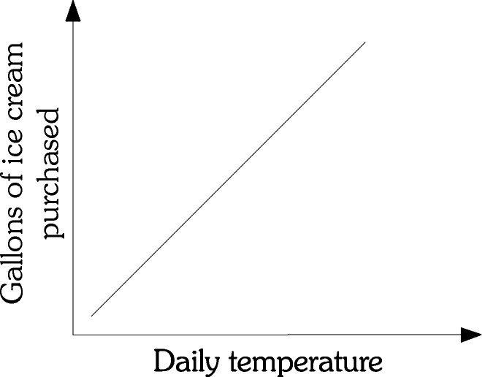

Figure 1.1

1) Refer to Figure 1.1. There is ________ relationship between the daily temperature and the number of gallons of ice cream purchased.
A) a negative
B) a positive
C) both a negative and a positive
D) an inverse
Answer: B
Diff: 2
Topic: Appendix: How to Read and Understand Graphs
Skill: Analytical
AACSB: Analytic Skills
Learning Outcome: Micro-2
Refer to the information provided in Figure 1.2 below to answer the questions that follow.

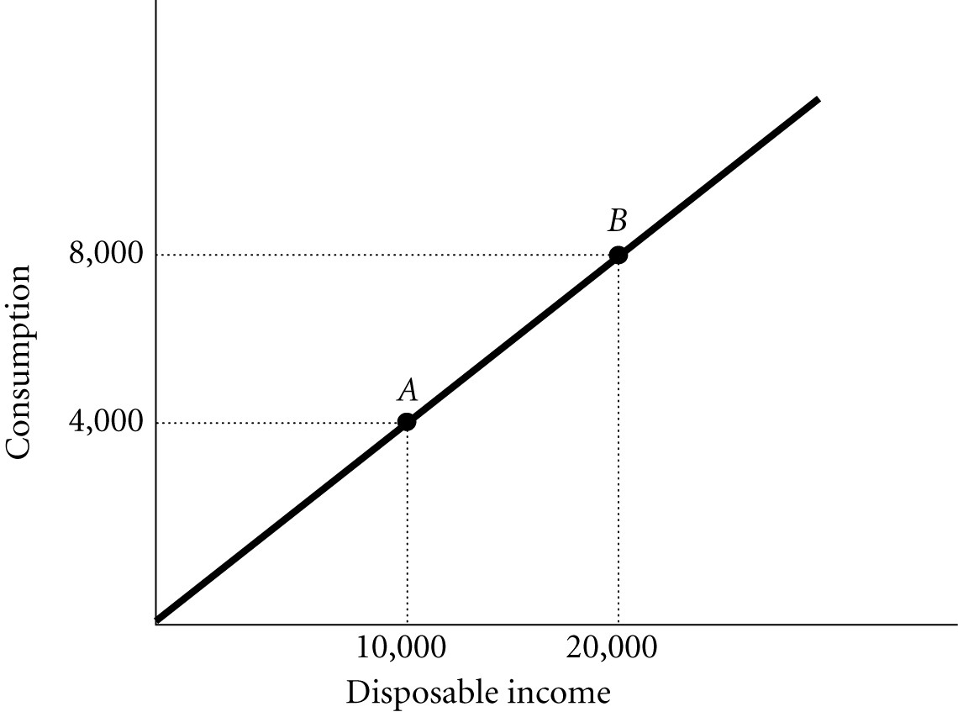

Figure 1.2

2) Refer to Figure 1.2. The slope of the line between Points A and B is
A) 0.4.
B) 1.2.
C) 2.5.
D) indeterminate from this information.
Answer: A
Diff: 2
Topic: Appendix: How to Read and Understand Graphs
Skill: Analytical
AACSB: Analytic Skills
Learning Outcome: Micro-2

3) If the slope of a straight line is -3. and if Y (the variable on the vertical axis) decreases by 6, then X (the variable on the horizontal axis) will
A) increase by 2.
B) decrease by 2.
C) increase by 18.
D) decrease by 18.
Answer: A
Diff: 2
Topic: Appendix: How to Read and Understand Graphs
Skill: Analytical
AACSB: Analytic Skills
Learning Outcome: Micro-2
Refer to the information provided in Figure 1.3 below to answer the questions that follow.

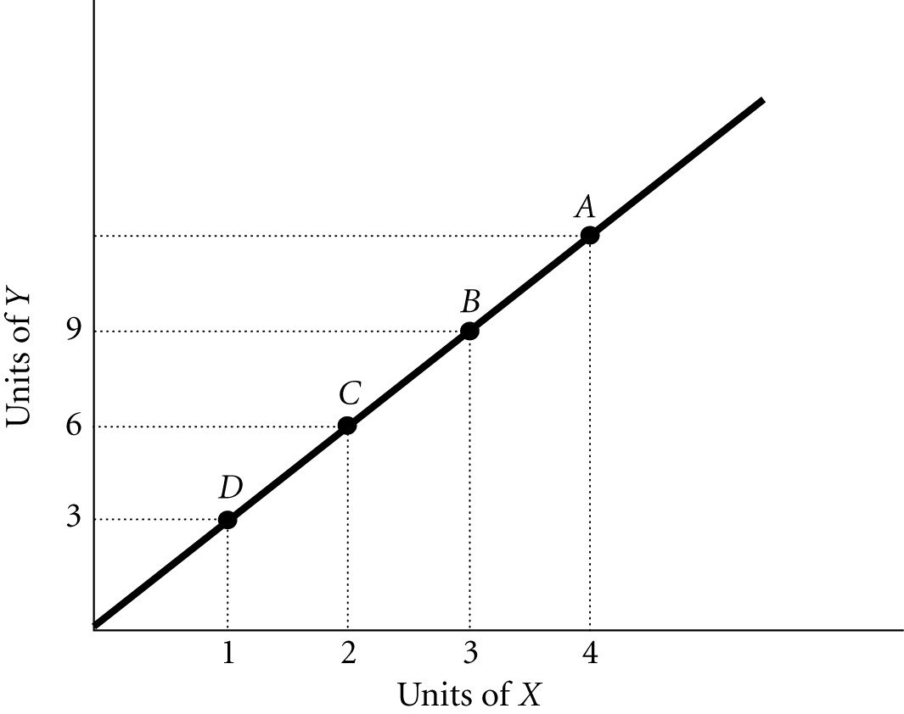

Figure 1.3

4) Refer to Figure 1.3. The slope of the line is
A) positive.
B) negative.
C) increasing at an increasing rate.
D) decreasing at an increasing rate.
Answer: A
Diff: 2
Topic: Appendix: How to Read and Understand Graphs
Skill: Analytical
AACSB: Analytic Skills
Learning Outcome: Micro-2

5) Refer to Figure 1.3. The slope of the line between Points B and D is
A) -3.
B) -0.33.
C) 0.33.
D) 3.
Answer: D
Diff: 2
Topic: Appendix: How to Read and Understand Graphs
Skill: Analytical
AACSB: Analytic Skills
Learning Outcome: Micro-2

6) Refer to Figure 1.3. The slope of the line between Points D and C is
A) -3.
B) -0.33.
C) 0.33.
D) 3.
Answer: D
Diff: 2
Topic: Appendix: How to Read and Understand Graphs
Skill: Analytical
AACSB: Analytic Skills
Learning Outcome: Micro-2
7) Refer to Figure 1.3. If a 45 degree line were also graphed, the existing line shown on the graph would ________ it.
A) lie above
B) lie below
C) cross
D) indeterminate from this information
Answer: A
Diff: 3
Topic: Appendix: How to Read and Understand Graphs
Skill: Analytical
AACSB: Analytic Skills
Learning Outcome: Micro-2

8) Refer to Figure 1.3. At Point A, what is the value of Y?
A) 10
B) 12
C) 15
D) indeterminate from this information
Answer: B
Diff: 2
Topic: Appendix: How to Read and Understand Graphs
Skill: Analytical
AACSB: Analytic Skills
Learning Outcome: Micro-2

9) Refer to Figure 1.3. At Point A the slope of the line is 3, so at Point D the slope would be
A) greater than 3.
B) less than 3.
C) equal to 3.
D) indeterminate from this information.
Answer: C
Diff: 2
Topic: Appendix: How to Read and Understand Graphs
Skill: Analytical
AACSB: Analytic Skills
Learning Outcome: Micro-2
Refer to the information provided in Figure 1.4 below to answer the questions that follow.

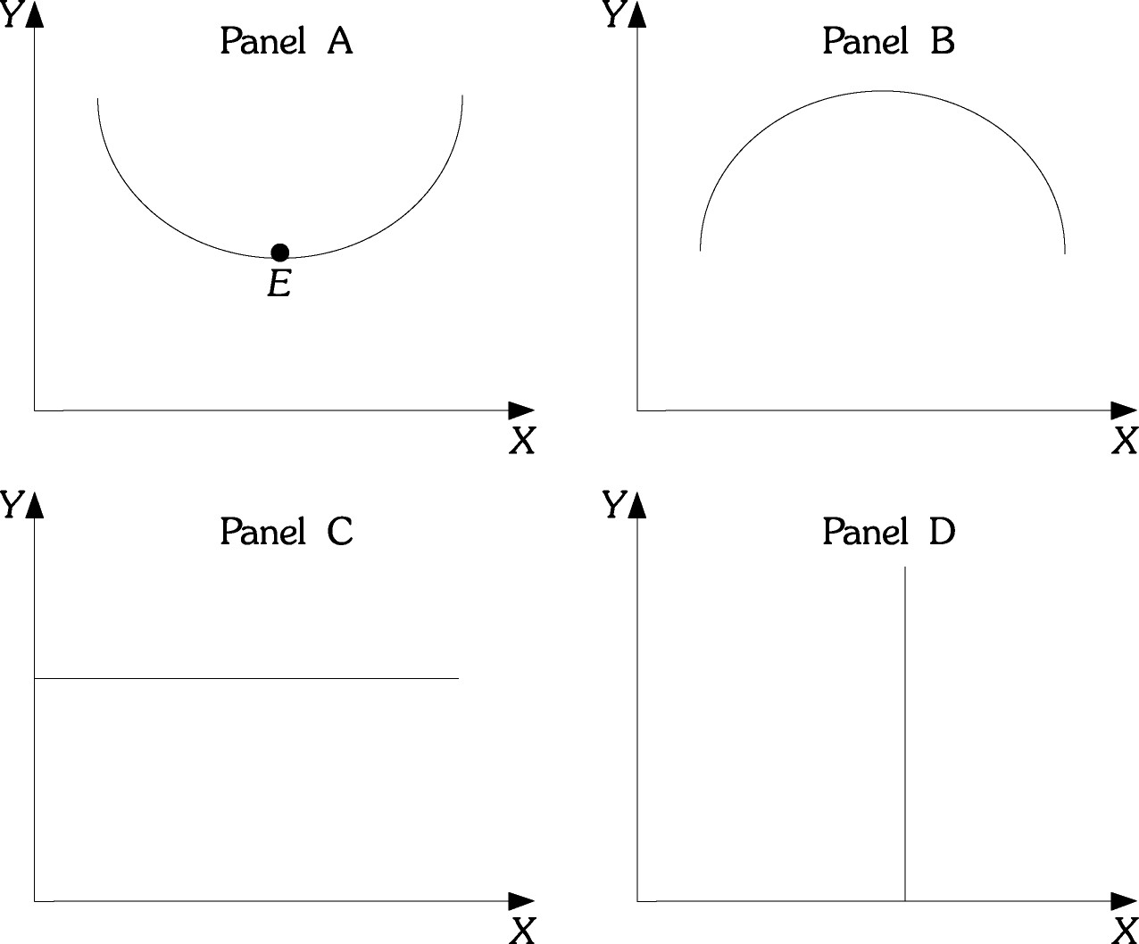

Figure 1.4

10) Refer to Figure 1.4. Which of the curves or lines has a slope that is first positive and then negative?
A) A
B) B
C) C
D) D
Answer: B
Diff: 2
Topic: Appendix: How to Read and Understand Graphs
Skill: Analytical
AACSB: Analytic Skills
Learning Outcome: Micro-2

11) Refer to Figure 1.4. Which of the curves or lines has a slope that is negative and then positive?
A) A
B) B
C) C
D) D
Answer: A
Diff: 2
Topic: Appendix: How to Read and Understand Graphs
Skill: Analytical
AACSB: Analytic Skills
Learning Outcome: Micro-2
12) Refer to Figure 1.4. Which of the following curves or lines has a zero slope throughout?
A) A
B) B
C) C
D) D
Answer: C
Diff: 2
Topic: Appendix: How to Read and Understand Graphs
Skill: Analytical
AACSB: Analytic Skills
Learning Outcome: Micro-2

13) Refer to Figure 1.4. Which of the curves or lines has an infinite slope throughout?
A) A
B) B
C) C
D) D
Answer: D
Diff: 2
Topic: Appendix: How to Read and Understand Graphs
Skill: Analytical
AACSB: Analytic Skills
Learning Outcome: Micro-2

14) Refer to Figure 1.4. At Point E in panel A, the slope is
A) zero.
B) infinite.
C) negative.
D) indeterminate from this information.
Answer: A
Diff: 2
Topic: Appendix: How to Read and Understand Graphs
Skill: Analytical
AACSB: Analytic Skills
Learning Outcome: Micro-2

15) The slope of a non-linear curve
A) is always positive.
B) must first increase then decrease.
C) is not constant.
D) is constant.
Answer: C
Diff: 1
Topic: Appendix: How to Read and Understand Graphs
Skill: Fact
Learning Outcome: Micro-2
16) The slope of a horizontal line is
A) negative.
B) zero.
C) continually changing.
D) infinite.
Answer: B
Diff: 1
Topic: Appendix: How to Read and Understand Graphs
Skill: Fact
Learning Outcome: Micro-2

17) If the slope of a straight line is 4 and if X (the variable on the horizontal axis) increases by 12, then Y (the variable on the vertical axis) will
A) decrease by 3.
B) decrease by 0.33.
C) increase by 3.
D) increase by 48.
Answer: D
Diff: 2
Topic: Appendix: How to Read and Understand Graphs
Skill: Analytical
AACSB: Analytic Skills
Learning Outcome: Micro-2

18) If the slope of a straight line is 4 and if Y (the variable on the vertical axis) decreases by 20, then X (the variable on the horizontal axis)
A) increases by 5.
B) decreases by 5.
C) increases by 80.
D) decreases by 80.
Answer: B
Diff: 2
Topic: Appendix: How to Read and Understand Graphs
Skill: Analytical
AACSB: Analytic Skills
Learning Outcome: Micro-2

19) The slope of a vertical line is
A) zero.
B) infinite.
C) continually changing.
D) negative.
Answer: B
Diff: 1
Topic: Appendix: How to Read and Understand Graphs
Skill: Fact
Learning Outcome: Micro-2
Refer to the information provided in Figure 1.5 below to answer the questions that follow.

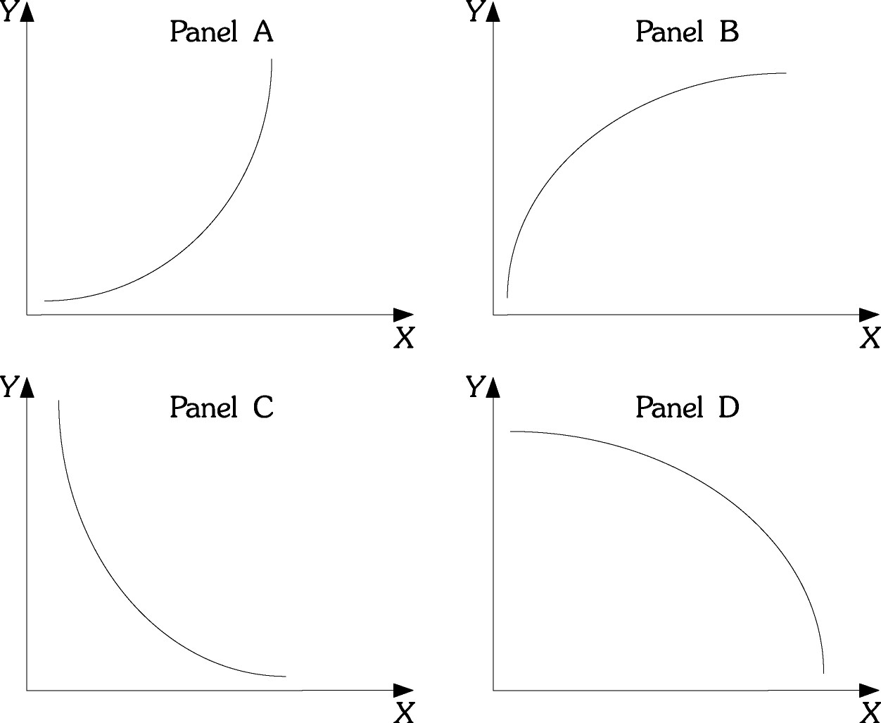

Figure 1.5

20) Refer to Figure 1.5. Which of the curves has a slope that is positive and decreasing?
A) A
B) B
C) C
D) D
Answer: B
Diff: 2
Topic: Appendix: How to Read and Understand Graphs
Skill: Analytical
AACSB: Analytic Skills
Learning Outcome: Micro-2

21) Refer to Figure 1.5. Which of the curves has a slope that is positive and increasing?
A) A
B) B
C) C
D) D
Answer: A
Diff: 2
Topic: Appendix: How to Read and Understand Graphs
Skill: Analytical
AACSB: Analytic Skills
Learning Outcome: Micro-2
22) Refer to Figure 1.5. As income increases, consumption increases, but for each additional increase in income, consumption increases by a larger and larger amount. If consumption is graphed on the vertical axis and income is graphed on the horizontal axis, the relationship between consumption and income would look like which of the following panels?
A) A
B) B
C) C
D) D
Answer: A
Diff: 2
Topic: Appendix: How to Read and Understand Graphs
Skill: Analytical
AACSB: Analytic Skills
Learning Outcome: Micro-2

23) Refer to Figure 1.5. In many industries, as firms produce additional units, average costs of production decline as the firm produces an additional unit, but average costs declines by a smaller and smaller amount as production continues to increase. If output is graphed on the horizontal axis and average costs are graphed on the vertical axis, the relationship between average costs and output would be like which of the following panels?
A) A
B) B
C) C
D) D
Answer: C
Diff: 2
Topic: Appendix: How to Read and Understand Graphs
Skill: Analytical
AACSB: Analytic Skills
Learning Outcome: Micro-2

24) Dividing the change in quantity on the Y axis by the change in quantity on the X axis calculates the slope of a line.
Answer: TRUE
Diff: 1
Topic: Appendix: How to Read and Understand Graphs
Skill: Definition
Learning Outcome: Micro-2

25) A graph illustrating how one variable changes over time is a Cartesian coordinate system.
Answer: FALSE
Diff: 2
Topic: Appendix: How to Read and Understand Graphs
Skill: Definition
Learning Outcome: Micro-2

26) If as the variable on the Y-axis rises the variable on the X-axis rises, the relationship between X and Y is said to be a positive relationship.
Answer: TRUE
Diff: 1
Topic: Appendix: How to Read and Understand Graphs
Skill: Definition
Learning Outcome: Micro-2
27) If as the variable on the Y-axis falls the variable on the X-axis rises, the relationship between X and Y is said to be a negative relationship.
Answer: TRUE
Diff: 1
Topic: Appendix: How to Read and Understand Graphs
Skill: Definition
Learning Outcome: Micro-2

28) The slope of a straight line is not constant unless the line is vertical or horizontal.
Answer: FALSE
Diff: 1
Topic: Appendix: How to Read and Understand Graphs
Skill: Definition
Learning Outcome: Micro-2

