Physics for Scientists and Engineers, 4e (Knight)
Chapter 1 Concepts of Motion

1.1 Conceptual Questions

1) The current definition of the standard meter of length is based on
A) the distance between the earth's equator and north pole.
B) the distance between the earth and the sun.
C) the distance traveled by light in a vacuum.
D) the length of a particular object kept in France.
Answer: C
Var: 1

2) The current definition of the standard second of time is based on
A) the frequency of radiation emitted by cesium atoms.
B) the earth's rotation rate.
C) the duration of one year.
D) the oscillation of a particular pendulum kept in France.
Answer: A
Var: 1

3) The current definition of the standard kilogram of mass is based on
A) the mass of the earth.
B) the mass of the sun.
C) the mass a particular object kept in France.
D) the mass of a cesium-133 atom.
Answer: C
Var: 1

4) If a woman weighs 125 lb, her mass expressed in kilograms is x kg, where x is
A) less than 125.
B) greater than 125.
Answer: A
Var: 1

5) If a tree is 15 m tall, its height expressed in feet is x ft, where x is
A) less than 15.
B) greater than 15.
Answer: B
Var: 1
6) If a flower is 6.5 cm wide, its width expressed in millimeters is x mm, where x is
A) less than 6.5.
B) greater than 6.5.
Answer: B
Var: 1

7) If an operatic aria lasts for 5.75 min, its length expressed in seconds is x s, where x is
A) less than 5.75.
B) greater than 5.75.
Answer: B
Var: 1

8) Scientists use the metric system chiefly because it is more accurate than the English system.
A) True
B) False
Answer: B
Var: 1

9) When adding two numbers, the number of significant figures in the sum is equal to the number of significant figures in the least accurate of the numbers being added.
A) True
B) False
Answer: B
Var: 1

10) When determining the number of significant figures in a number, zeroes to the left of the decimal point are never counted.
A) True
B) False
Answer: B
Var: 1

1.2 Problems

1) Convert 1.2 × 10-3 to decimal notation.
A) 1.200
B) 0.1200
C) 0.0120
D) 0.0012
E) 0.00012
Answer: D
Var: 5
2) Write out the number 7.35 × 10-5 in full with a decimal point and correct number of zeros.
A) 0.00000735
B) 0.0000735
C) 0.000735
D) 0.00735
E) 0.0735
Answer: B
Var: 5

3) 0.0001776 can also be expressed as
A) 1.776 × 10-3.
B) 1.776 × 10-4.
C) 17.72 × 104.
D) 1772 × 105.
E) 177.2 × 107.
Answer: B
Var: 5

4) 0.00325 × 10-8 cm can also be expressed in mm as
A) 3.25 × 10-12 mm.
B) 3.25 × 10-11 mm.
C) 3.25 × 10-10 mm.
D) 3.25 × 10-9 mm.
E) 3.25 × 10-8 mm.
Answer: C
Var: 1

5) If, in a parallel universe, π has the value 3.14149, express π in that universe to four significant figures.
A) 3.141
B) 3.142
C) 3.1415
D) 3.1414
Answer: A
Var: 1
6) The number 0.003010 has
A) 7 significant figures.
B) 6 significant figures.
C) 4 significant figures.
D) 2 significant figures.
Answer: C
Var: 1

7) What is 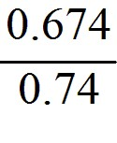 to the proper number of significant figures?
A) 0.91
B) 0.911
C) 0.9108
D) 0.9
Answer: A
Var: 50+

8) What is the value of π(8.104)2, written with the correct number of significant figures?
A) 206.324
B) 206.323
C) 206.3
D) 206
E) 200
Answer: C
Var: 1

9) What is the sum of 1123 and 10.3 written with the correct number of significant figures?
A) 1.13 × 103
B) 1133.3000
C) 1.1 × 103
D) 1133.3
E) 1133
Answer: E
Var: 1
10) What is the sum of 1.53 + 2.786 + 3.3 written with the correct number of significant figures?
A) 8
B) 7.6
C) 7.62
D) 7.616
E) 7.6160
Answer: B
Var: 3

11) What is the difference between 103.5 and 102.24 written with the correct number of significant figures?
A) 1
B) 1.3
C) 1.26
D) 1.260
E) 1.2600
Answer: B
Var: 3

12) What is the product of 11.24 and 1.95 written with the correct number of significant figures?
A) 22
B) 21.9
C) 21.92
D) 21.918
E) 21.9180
Answer: B
Var: 3

13) What is the result of 1.58 ÷ 3.793 written with the correct number of significant figures?
A) 4.1656 × 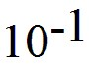
B) 4.166 ×
C) 4.17 ×
D) 4.2 ×
E) 4 ×
Answer: C
Var: 3
14) What is 34 + (3) × (1.2465) written with the correct number of significant figures?
A) 37.7
B) 37.74
C) 4 × 101
D) 38
E) 37.7395
Answer: D
Var: 5

15) What is 56 + (32.00)/(1.2465 + 3.45) written with the correct number of significant figures?
A) 62.8
B) 62.812
C) 62.81
D) 63
E) 62.8123846
Answer: D
Var: 1

16) Add 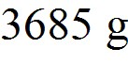 and 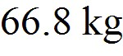 and express your answer in milligrams (mg).
A) 7.05 × 107 mg
B) 7.05 × 104 mg
C) 7.05 × 105 mg
D) 7.05 × 106 mg
Answer: A
Var: 50+

17) Express (4.3 × 106)-1/2 in scientific notation.
A) 4.8 × 10-4
B) 2.1 × 103
C) 2.1 × 10-5
D) 2.1 × 104
Answer: A
Var: 40
18) What is 0.2052/3, expressed to the proper number of significant figures?
A) 0.348
B) 0.35
C) 0.3
D) 0.3477
Answer: A
Var: 50+

19) The length and width of a rectangle are 1.125 m and 0.606 m, respectively. Multiplying, your calculator gives the product as 0.68175. Rounding properly to the correct number of significant figures, the area should be written as
A) 0.7 m2.
B) 0.68 m2.
C) 0.682 m2.
D) 0.6818 m2.
E) 0.68175 m2.
Answer: C
Var: 1

20) The following exact conversion equivalents are given: 1 m = 100 cm , 1 in = 2.54 cm, and 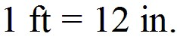 If a computer screen has an area of 1.27 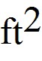, this area is closest to
A) 0.00284 m2.
B) 0.0465 m2.
C) 0.118 m2.
D) 0.284 m2.
E) 4.65 m2.
Answer: C
Var: 1

21) In addition to 1 m = 39.37 in., the following exact conversion equivalents are given: 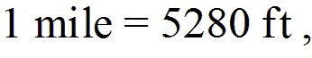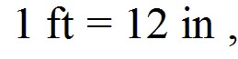 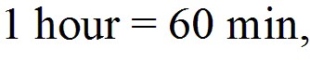 and 1 min = 60 s. If a particle has a velocity of 8.4 miles per hour, its velocity, in m/s, is closest to
A) 3.8 m/s.
B) 3.0 m/s.
C) 3.4 m/s.
D) 4.1 m/s.
E) 4.5 m/s.
Answer: A
Var: 50+
22) A weight lifter can bench press 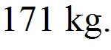 How many milligrams (mg) is this?
A) 1.71 × 108 mg
B) 1.71 × 109 mg
C) 1.71 × 107 mg
D) 1.71 × 106 mg
Answer: A
Var: 50+

23) How many nanoseconds does it take for a computer to perform one calculation if it performs 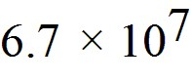 calculations per second?
A) 15 ns
B) 67 ns
C) 11 ns
D) 65 ns
Answer: A
Var: 50+

24) The shortest wavelength of visible light is approximately 400 nm. Express this wavelength in centimeters.
A) 4 × 10-5 cm
B) 4 × 10-7 cm
C) 4 × 10-9 cm
D) 4 × 10-11 cm
E) 400 × 10-11 cm
Answer: A
Var: 1

25) The wavelength of a certain laser is 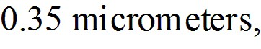 where 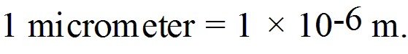 Express this wavelength in nanometers.
A) 3.5 × 102 nm
B) 3.5 × 103 nm
C) 3.5 × 101 nm
D) 3.5 × 104 nm
Answer: A
Var: 50+
26) A certain CD-ROM disk can store approximately 6.0 × 102 megabytes of information, where 106 bytes = 1 megabyte. If an average word requires 9.0 bytes of storage, how many words can be stored on one disk?
A) 6.7 × 107 words
B) 5.4 × 109 words
C) 2.1 × 107 words
D) 2.0 × 109 words
Answer: A
Var: 9

27) A plot of land contains 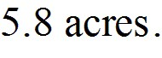 How many square meters does it contain? 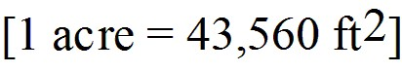
A) 2.3 × 104 m2
B) 7.1 × 103 m2
C) 7.0 × 104 m2
D) 5.0 × 104 m2
Answer: A
Var: 50+

28) A person on a diet loses 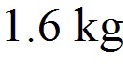 in a week. How many 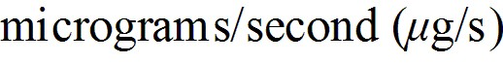 are lost?
A) 2.6 × 103 μg/s
B) 1.6 × 105 μg/s
C) 44 μg/s
D) 6.4 × 104 μg/s
Answer: A
Var: 11

29) Albert uses as his unit of length (for walking to visit his neighbors or plowing his fields) the albert (A), the distance Albert can throw a small rock. One albert is 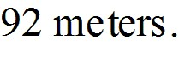 How many square alberts is equal to one acre? (1 acre = 43,560 ft2 = 4050 m2)
Answer: 1.29 A2
Var: 50+
30) Convert a speed of 4.50 km/h to units of ft/min. (1.00 m = 3.28 ft)
A) 0.246 ft/min
B) 82.3 ft/min
C) 165 ft/min
D) 246 ft/min
E) 886 ft/min
Answer: D
Var: 1

31) The exhaust fan on a typical kitchen stove pulls 600 CFM (cubic feet per minute) through the filter. Given that 1.00 in. = 2.54 cm, how many cubic meters per second does this fan pull?
A) 0.283 m3/sec
B) 0.328 m3/sec
C) 3.05 m3/sec
D) 32.8 m3/sec
Answer: A
Var: 1

32) The mass of a typical adult woman is closest to
A) 20 kg.
B) 35 kg.
C) 75 kg.
D) 150 kg.
Answer: C
Var: 1

33) The height of the ceiling in a typical home, apartment, or dorm room is closest to
A) 100 cm.
B) 200 cm.
C) 400 cm.
D) 500 cm.
Answer: B
Var: 1
34) Approximately how many times does an average human heart beat in a year?
A) 4 × 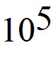
B) 4 × 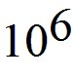
C) 4 × 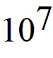
D) 4 × 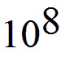
E) 4 × 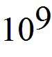
Answer: C
Var: 1

35) Approximately how many times does an average human heart beat in a lifetime?
A) 3 × 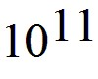
B) 3 × 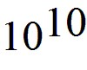
C) 3 ×
D) 3 ×
E) 3 ×
Answer: C
Var: 1

36) Approximately how many pennies would you have to stack to reach an average 8-foot ceiling?
A) 2 × 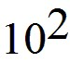
B) 2 × 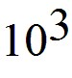
C) 2 × 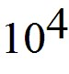
D) 2 ×
E) 2 ×
Answer: B
Var: 1

37) Estimate the number of times the earth will rotate on its axis during a human's lifetime.
A) 3 ×
B) 3 ×
C) 3 ×
D) 3 ×
E) 3 ×
Answer: A
Var: 1
38) Estimate the number of pennies that would fit in a box one foot long by one foot wide by one foot tall.
A) 5 ×
B) 5 ×
C) 5 ×
D) 5 ×
E) 5 ×
Answer: C
Var: 1

39) A marathon is 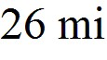 and 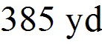 long. Estimate how many strides would be required to run a marathon. Assume a reasonable value for the average number of 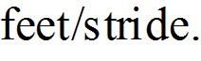
A) 4.5 × 104 strides
B) 4.5 × 103 strides
C) 4.5 × 105 strides
D) 4.5 × 106 strides
Answer: A
Var: 1

40) The period of a pendulum is the time it takes the pendulum to swing back and forth once. If the only dimensional quantities that the period depends on are the acceleration of gravity, g, and the length of the pendulum, ℓ, what combination of g and ℓ must the period be proportional to? (Acceleration has SI units of m ∙ s-2.).
A) g/ℓ
B) gℓ2
C) gℓ
D) 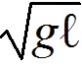
E) 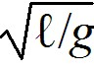
Answer: E
Var: 1
41) The speed of a wave pulse on a string depends on the tension, F, in the string and the mass per unit length, μ, of the string. Tension has SI units of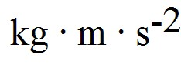 and the mass per unit length has SI units of 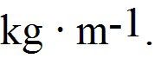 What combination of F and μ must the speed of the wave be proportional to?
A) F / μ
B) μ / F
C) 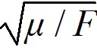
D) 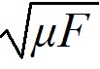
E) 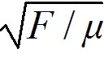
Answer: A
Var: 1

42) The position x, in meters, of an object is given by the equation x = A + Bt + Ct2, where t represents time in seconds. What are the SI units of A, B, and C?
A) m, m, m
B) m, s, s
C) m, s, s2
D) m, m/s, m/s2
E) m/s, m/s2, m/s3
Answer: A
Var: 1

