Organic Chemistry, 9e (Wade)
Chapter 1 Structure and Bonding

1) While you were up late one night studying organic chemistry, you happened to see the last 5 minutes of an infomercial on TV. The spokesperson claimed that their brand of automobile tires were superior to all other brands on the market because they were made by using only natural rubber, isolated from the resin of rubber trees. How could a chemist test her claims that no petroleum products went into the manufacture of her brand of tires?
Answer: Compounds synthesized from petroleum products have a lower content of 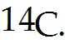 Plant-derived compounds are recently synthesized from CO2 in the air and have a higher 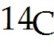 content.
Diff: 2
Section: 1.1
GO: G5

2) The atomic number of boron is 5. The correct electronic configuration of boron is:
A) 1s22s3
B) 1s22p3
C) 1s22s22p1
D) 2s22p3
E) 1s22s23s1
Answer: C
Diff: 1
Section: 1.2
LO: 1.1

3) How many distinct p orbitals exist in the second electron shell, where n = 2?
A) 2
B) 3
C) 4
D) 5
E) 6
Answer: B
Diff: 1
Section: 1.2

4) The ________ tells us that each orbital can hold a maximum of 2 electrons.
A) aufbau principle
B) Pauli exclusion principle
C) Hund's rule principle
D) LeChatelier principle
E) uncertainty principle
Answer: B
Diff: 1
Section: 1.2

5) A node is a region of high electron density between the two atoms in a covalent bond.
Answer: FALSE
Diff: 1
Section: 1.2
6) When filling two or more orbitals of the same energy with electrons, the electrons will go into different orbitals rather than pair up in the same orbital.
Answer: TRUE
Diff: 1
Section: 1.2

7) Atoms with the same number of protons but different numbers of neutrons are called ________.
Answer: isotopes
Diff: 1
Section: 1.2
GO: G2

8) The electron density of ________ orbitals has spherical symmetry.
Answer: s
Diff: 1
Section: 1.2

9) The formal charge on the nitrogen on the structure shown below is:
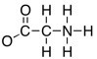
Answer: N = +1
Diff: 1
Section: 1.7
LO: 1.3
GO: G2
MCAT LO: MCAT1.2

10) An oxygen atom has ________ valence electrons.
Answer: 6
Diff: 1
Section: 1.2
LO: 1.1

11) Which element in the second row of the periodic table has six valence electrons and a valence of two?
Answer: oxygen
Diff: 1
Section: 1.2
LO: 1.1

12) Orbitals which are equal in energy are referred to as ________.
A) degenerate
B) polar
C) nodes
D) filled
E) nonpolar
Answer: A
Diff: 2
Section: 1.2
13) In a carbon atom, the 2s and 2p orbitals are the same energy.
Answer: FALSE
Diff: 2
Section: 1.2
LO: 1.1

14) The element with the electronic configuration 1s22s22p63s1 is ________.
Answer: sodium
Diff: 2
Section: 1.2
LO: 1.1

15) Provide the electron configuration of phosphorus.
Answer: 1s22s22p63s23p3
Diff: 2
Section: 1.2
LO: 1.1

16) Draw the shape of a 2p orbital, including shading to indicate phase.
Answer:

Diff: 2
Section: 1.2

17) Draw a correct Lewis structure for chloromethane, CH3Cl, including all non-bonding lone pairs.
Answer:
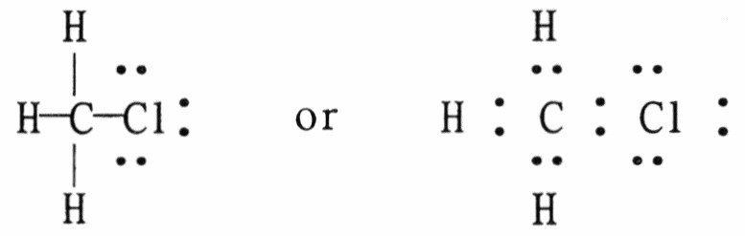
Diff: 1
Section: 1.4
LO: 1.3
MCAT LO: MCAT1.2

18) Provide a Lewis structure for a molecule with molecular formula CH2O2.
Answer:
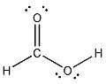
Diff: 2
Section: 1.4
LO: 1.2
GO: G2
MCAT LO: MCAT11.2
19) Draw the Lewis structure for 2-propanol, CH3CH(OH)CH3, including all non-bonding lone pairs.
Answer:
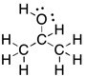
Diff: 2
Section: 1.4
LO: 1.3
MCAT LO: MCAT1.2

20) Draw the Lewis structure of acetic acid, CH3CO2H, including all non-bonding lone pairs.
Answer:
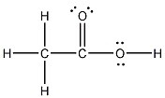
Diff: 2
Section: 1.4
LO: 1.3
MCAT LO: MCAT1.2

21) Draw the Lewis structure for boric acid, B(OH)3, including all non-bonding lone pairs.
Answer:
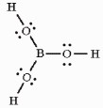 or 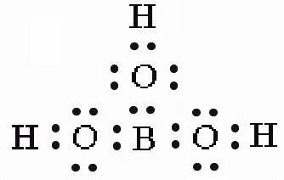
Diff: 2
Section: 1.4
LO: 1.3
MCAT LO: MCAT1.3
22) Draw a correct Lewis structure for tert-butyl alcohol, (CH3)3COH, including all non-bonding lone pairs.
Answer:
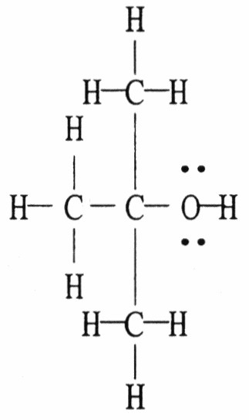
Diff: 2
Section: 1.4
LO: 1.3
MCAT LO: MCAT1.3

23) Draw a correct Lewis structure for acetonitrile, CH3CN, including all non-bonding lone pairs.
Answer:
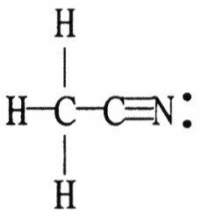
Diff: 2
Section: 1.5
LO: 1.3
MCAT LO: MCAT1.3

24) Draw 2 possible Lewis structures for the compound with molecular formula C3H6.
Answer:
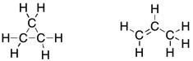
Diff: 2
Section: 1.10
LO: 1.2
GO: G2
MCAT LO: MCAT1.1

25) Write a Lewis structure for a compound with the molecular formula H2N2.
Answer:
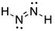
Diff: 2
Section: 1.5
LO: 1.3
MCAT LO: MCAT1.2
26) A carbon-hydrogen bond in ethane (CH3CH3) is best described a ________.
A) highly polar
B) essentially nonpolar
C) ionic
D) a multiple bond
E) resonance stabilized
Answer: B
Diff: 1
Section: 1.6
LO: 1.4
MCAT LO: MCAT1.3

27) The electronegativity of elements on the periodic table increases going ________ a column and to the ________ in each row.
A) up; right
B) up; left
C) down; right
D) down; left
Answer: A
Diff: 1
Section: 1.6
LO: 1.1
MCAT LO: MCAT1.5

28) Within a given row of the periodic table, electronegativity typically increases left to right across the row.
Answer: TRUE
Diff: 1
Section: 1.6
LO: 1.1
MCAT LO: MCAT1.5

29) Which of the following molecules contains a polar covalent bond?
A) H2
B) F2
C) CH3Cl
D) NaCl
E) He
Answer: C
Diff: 1
Section: 1.6
LO: 1.4
GO: G2
MCAT LO: MCAT1.3

30) Covalent bonds may be polar or nonpolar. What property of the atoms forming a given bond determines this?
Answer: Electronegativity
Diff: 2
Section: 1.6
LO: 1.4
31) The compound methylamine, CH3NH2, contains a C-N bond. In this bond, which of the following best describes the charge on the carbon atom?
A) +1
B) slightly positive
C) neutral
D) slightly negative
E) -1
Answer: B
Diff: 3
Section: 1.6
LO: 1.3
MCAT LO: MCAT1.5

32) The formal charge on oxygen in dimethyl ether, CH3OCH3, is ________.
A) +2
B) +1
C) 0
D) -1
E) -2
Answer: C
Diff: 1
Section: 1.7
LO: 1.3
MCAT LO: MCAT1.2

33) For most compounds in which a nitrogen atom bears no formal charge, the valence of this nitrogen atom is ________.
Answer: 3
Diff: 1
Section: 1.7
LO: 1.1
34) The formal charge on the oxygens in the compound below are ________.

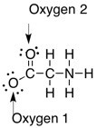

A) Oxygen 1: 0, Oxygen 2: 0
B) Oxygen 1: -1, Oxygen 2: 0
C) Oxygen 1: 0, Oxygen 2: -1
D) Oxygen 1: +1, Oxygen 2: 0
E) Oxygen 1: -1, Oxygen 2: -1
Answer: B
Diff: 2
Section: 1.7
LO: 1.3
MCAT LO: MCAT1.2

35) Assign the correct formal charge to each nitrogen atom in the following Lewis structure. (All non-bonding electrons are included.)

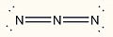
Answer:
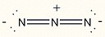
Diff: 2
Section: 1.7
LO: 1.3
MCAT LO: MCAT1.2
36) Add the appropriate formal charge to each atom in the molecule below. It is not necessary to indicate formal charges when zero. (All non-bonding electrons are included.)

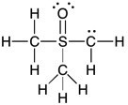
Answer:
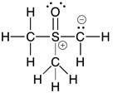
Diff: 2
Section: 1.7
LO: 1.3
MCAT LO: MCAT1.2

37) Add the appropriate formal charge to each atom in the molecule below. It is not necessary to indicate formal charges when zero. (All non-bonding electrons are included.)

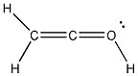
Answer:
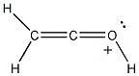
Diff: 2
Section: 1.7
LO: 1.3
MCAT LO: MCAT1.2
38) One or more of the atoms in the structure shown should have nonzero formal charges. Redraw the structure and the atoms with non-zero formal charges.

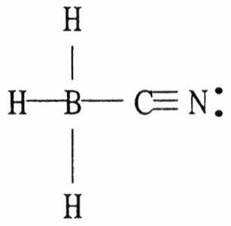
Answer:
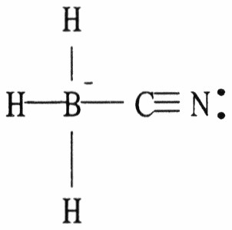
Diff: 2
Section: 1.7
LO: 1.2
MCAT LO: MCAT1.3

39) Which of the following are acceptable Lewis structures, including formal charges, for nitric acid, HNO3?

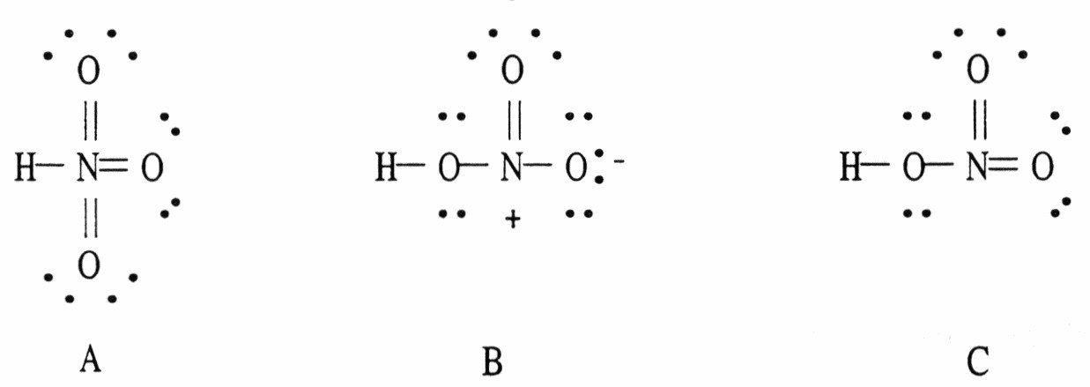

A) A only
B) B only
C) C only
D) both B and C
E) A, B, and C
Answer: B
Diff: 3
Section: 1.7
LO: 1.2
MCAT LO: MCAT1.3
40) One or more of the atoms in the structure shown should have nonzero formal charges. Add the correct formal charge/s. (All non-bonding electrons have been included.)

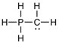
Answer:
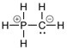
Diff: 3
Section: 1.7
LO: 1.3
MCAT LO: MCAT1.2

41) In the compound sodium methoxide (NaOCH3), there is ________ bonding.
A) ionic
B) polar covalent
C) nonpolar covalent
D) a mixture of ionic and covalent
E) resonance stabilized
Answer: D
Diff: 1
Section: 1.8
LO: 1.1
MCAT LO: MCAT1.3

42) Which of the following compounds are covalent compounds?
A) KCl
B) CF4
C) NH3
D) both A and B
E) both B and C
Answer: E
Diff: 2
Section: 1.8
LO: 1.1
GO: G2
MCAT LO: MCAT1.3
43) Which of the following bonding patterns of carbon is not allowed in the formation of an organic compound?
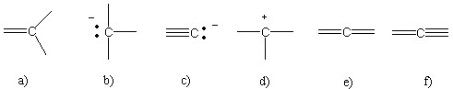
Answer: f
Diff: 2
Section: 1.7
LO: 1.4
MCAT LO: MCAT1.2

44) When a negatively charged species is most appropriately depicted as a hybrid of several resonance forms, the negative charge present is considered to be rapidly moving between the resonance forms bearing the formal negative charge.
Answer: FALSE
Diff: 1
Section: 1.9
LO: 1.4
GO: G2
MCAT LO: MCAT1.3

45) When a molecule can best be represented as a series of resonance forms, each of these forms always contributes to the same degree in the hybrid.
Answer: FALSE
Diff: 1
Section: 1.9
LO: 1.4
MCAT LO: MCAT1.3
46) Which of the following structures (a-d) is another resonance structure of the following organic molecule?
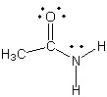

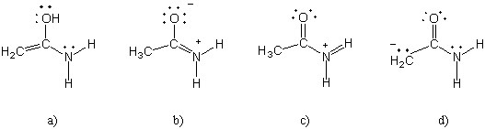
Answer: b
Diff: 2
Section: 1.9
LO: 1.4
GO: G2
MCAT LO: MCAT1.3

47) One resonance structure of a cation is shown. Provide the other reasonable resonance structures.

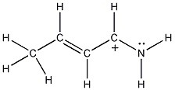
Answer:
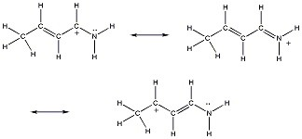
Diff: 2
Section: 1.9
GO: G2
MCAT LO: MCAT2.3
48) Draw additional resonance contributors for:

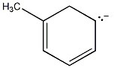
Answer:
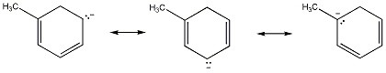
Diff: 2
Section: 1.9
MCAT LO: MCAT2.3

49) Which of the following choices represent(s) a pair of resonance forms?
A)
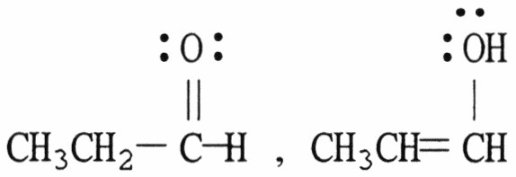

B)
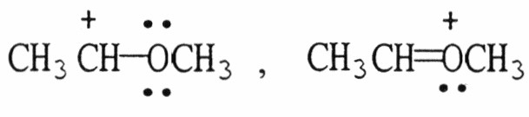

C)
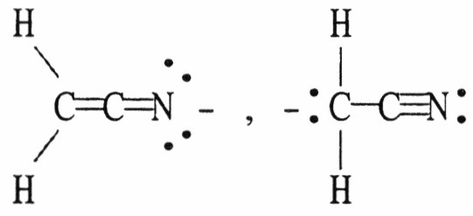

D) both A and C
E) both B and C
Answer: E
Diff: 3
Section: 1.9
LO: 1.4
GO: G2
MCAT LO: MCAT1.3
50) Structures ________, shown below, are resonance structures, and structure ________ is the major contributor to the overall resonance hybrid.

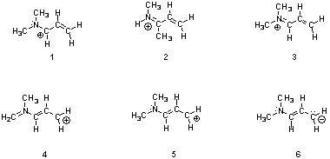

A) 2 & 4; 2
B) 1, 3 & 5; 3
C) 4 & 6; 6
D) 1, 3 & 5; 1
E) 1, 3, 4 & 5; 3
Answer: B
Diff: 3
Section: 1.9
LO: 1.4
GO: G2
MCAT LO: MCAT1.3

51) Nitroamines are common functional groups found in energetic materials, such as RDX and HMX. For the structure below, draw two other significant resonance structures, include any formal charges, and indicate the hybridization on each nitrogen and oxygen.

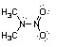
Answer: All nitrogen and oxygen atoms are sp2 hybridized.

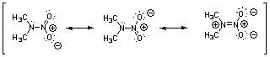
Diff: 3
Section: 1.9
GO: G5
MCAT LO: MCAT2.3
52) Draw the other important resonance form of:

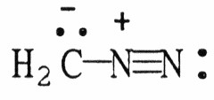
Answer:
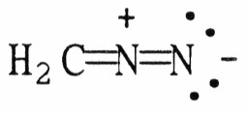
Diff: 3
Section: 1.9
MCAT LO: MCAT2.3

53) Draw the important resonance forms for the structure shown below.

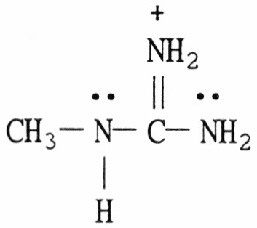
Answer:
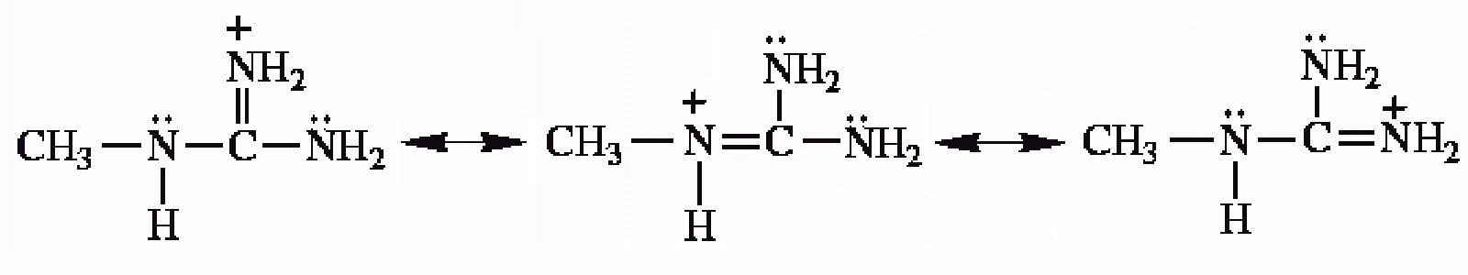
Diff: 3
Section: 1.9
MCAT LO: MCAT2.3

54) Draw the important resonance forms for the structure shown below.

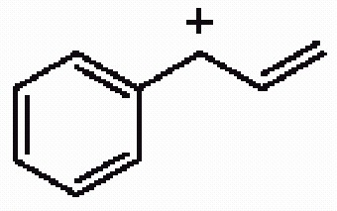
Answer:
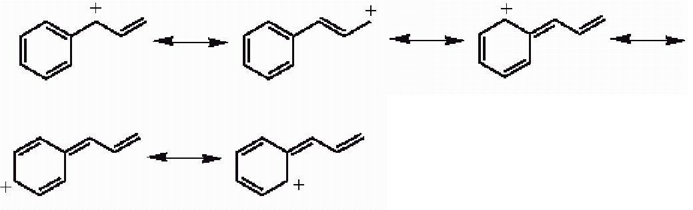
Diff: 3
Section: 1.9
MCAT LO: MCAT2.3
55) Draw the important resonance forms of the structure below to indicate the delocalization of charge. Indicate which is the major contributor to the overall structure.

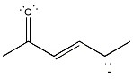
Answer:
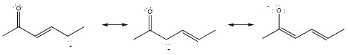
The last structure is the major contributor (negative charge on the more electronegative element).
Diff: 3
Section: 1.9
LO: 1.4
GO: G7
MCAT LO: MCAT2.3

56) Draw 3 significant resonance structures for the compound shown below. Place a box around the major contributor. Fill in any missing formal charges.

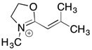

Answer:
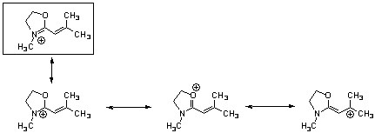
Diff: 3
Section: 1.9
LO: 1.4
GO: G2, G7
MCAT LO: MCAT2.3
57) Draw a line-angle formula for (CH3)2CHCH2CH2NH2.
Answer:
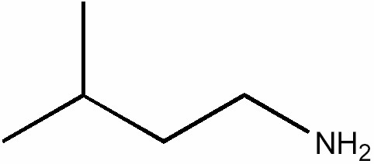
Diff: 1
Section: 1.10
LO: 1.3
MCAT LO: MCAT1.2

58) The Lewis structure of trimethylamine is shown below. Draw the condensed structural formula which corresponds to this Lewis structure.

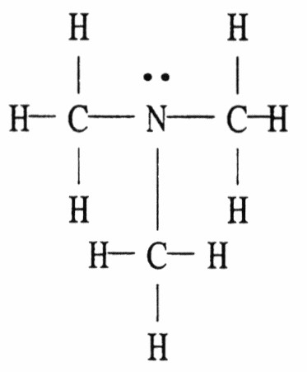
Answer: (CH3)3N
Diff: 1
Section: 1.10
LO: 1.3

59) The Lewis structure of pentane is shown below. Draw the condensed structural formula which corresponds to this Lewis structure.

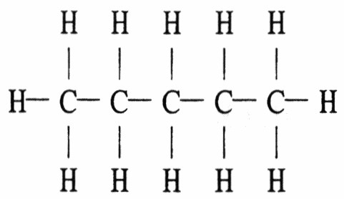
Answer: CH3(CH2)3CH3
Diff: 1
Section: 1.10
LO: 1.3
MCAT LO: MCAT1.2
60) Draw the complete Lewis structure for the compound whose condensed formula is (CH3)2CHCHO.
Answer:
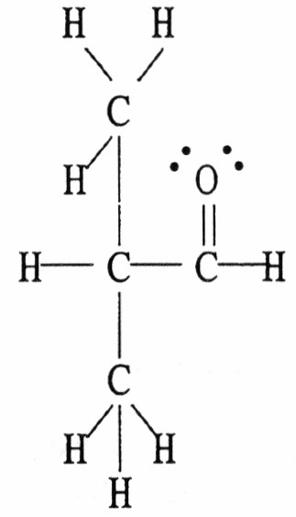
Diff: 1
Section: 1.10
LO: 1.3
MCAT LO: MCAT1.2

61) How many carbon atoms are present in the molecule shown?

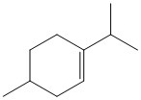

A) 6
B) 8
C) 10
D) 11
E) 12
Answer: C
Diff: 1
Section: 1.10
LO: 1.3
MCAT LO: MCAT1.2
62) Draw a complete Lewis structure, including lone pairs, for (CH3)2CHCO2H.
Answer:
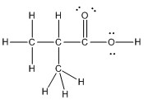
Diff: 2
Section: 1.10
LO: 1.3
MCAT LO: MCAT1.2

63) Which of the following condensed formulas represents the same compound as the line-angle structure shown?

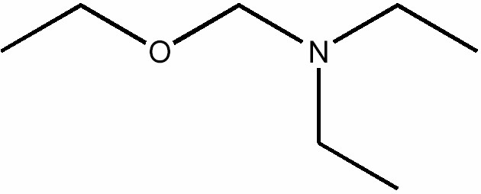

A) CH3CH2CH2OCH2CH2CH2N(CH2CH2CH3)2
B) CH3CH2CH2OCH2N(CH2CH3)2
C) CH3CH2OCH2N(CH2CH3)2
D) CH3CH2OCH2N(CH2CH2CH3)2
E) CH3ON(CH3)2
Answer: C
Diff: 2
Section: 1.10
LO: 1.3
GO: G2
MCAT LO: MCAT1.2
64) Indicate the line-angle structure that corresponds to the condensed structure, HOCH2C(O)CH(CH3)2.

A)
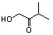

B)
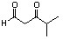

C)

D)

Answer: A
Diff: 2
Section: 1.10
LO: 1.3
GO: G2
MCAT LO: MCAT1.2

65) A condensed structure for acetone is CH3COCH3. Provide the structural formula for acetone.
Answer:
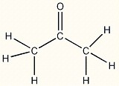
Diff: 2
Section: 1.10
LO: 1.3
GO: G2
MCAT LO: MCAT1.2
66) Provide the line-angle formula for the alcohol CH3CH2CH(OH)CH2CH2CH(CH3)2.
Answer:
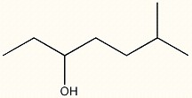
Diff: 2
Section: 1.10
LO: 1.3
MCAT LO: MCAT1.2

67) What is the molecular formula for the following line-angle structure?
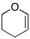
Answer: C5H8O
Diff: 2
Section: 1.10
LO: 1.3
MCAT LO: MCAT1.2

68) What is the molecular formula for the following line-angle structure?

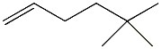
Answer: C8H16
Diff: 2
Section: 1.10
LO: 1.3
MCAT LO: MCAT1.2

69) Provide the line-angle formula (skeletal structure) for (CH3CH2)2C=O.
Answer:
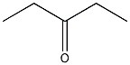
Diff: 2
Section: 1.10
LO: 1.3
MCAT LO: MCAT1.2
70) Provide the line-angle formula (skeletal structure) for (CH3)2CHCH2CHO.
Answer:
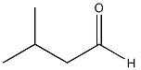
Diff: 2
Section: 1.10
LO: 1.3
MCAT LO: MCAT1.2

71) Draw an acceptable line-angle formula for cyclobutanol (shown below).

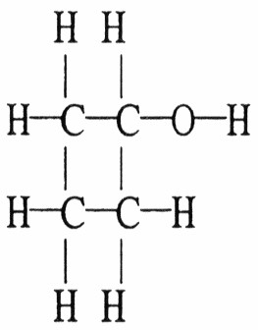
Answer:
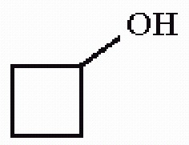
Diff: 2
Section: 1.10
LO: 1.3
MCAT LO: MCAT1.2

72) Draw an acceptable line-angle formula for the compound shown below.

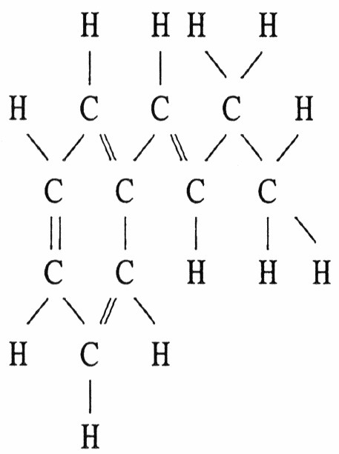
Answer:
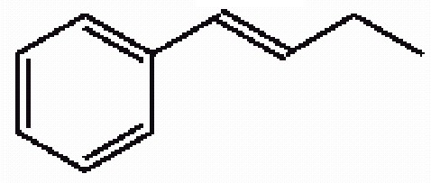
Diff: 2
Section: 1.10
LO: 1.3
MCAT LO: MCAT1.2
73) Draw a correct Lewis structure for acetaldehyde, CH3CHO.
Answer:
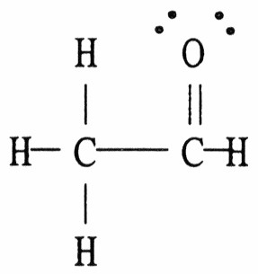
Diff: 2
Section: 1.10
LO: 1.3
MCAT LO: MCAT1.2

74) Draw a correct Lewis structure for CH3CHCHCOOH.
Answer:
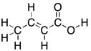
Diff: 2
Section: 1.10
LO: 1.3
MCAT LO: MCAT1.2

75) Which of the following condensed formulas correctly represents the line-angle structure shown below?

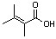

A) CH(CH3)2CH(CH3)CO2H
B) C2(CH3)3CO2H
C) (CH3)2CC(CH3)CO2H
D) C(CH3)2C(CH3)CH2CO2H
Answer: C
Diff: 2
Section: 1.10
LO: 1.3
GO: G2
MCAT LO: MCAT1.2
76) Draw the line-angle formula for three compounds with molecular formula C3H8O.
Answer:
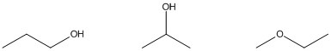
Diff: 2
Section: 1.10
LO: 1.2
GO: G2
MCAT LO: MCAT1.1

77) Provide the line-angle formula for CH3CH2C(CH3)2CH2CHO
Answer:
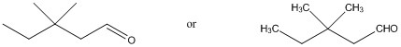
Diff: 2
Section: 1.10
LO: 1.3
MCAT LO: MCAT1.2

78) How many hydrogen atoms are present in the molecule shown?

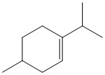
Answer: 18
Diff: 2
Section: 1.10
LO: 1.3
MCAT LO: MCAT1.2

79) Draw condensed structures for the four compounds with formula C3H9N.
Answer: CH3CH2CH2NH2

CH3CH2NHCH3

(CH3)2CHNH2

(CH3)3N
Diff: 3
Section: 1.10
LO: 1.2
GO: G2
MCAT LO: MCAT1.1
80) Compute the empirical and molecular formulas for the compound of molecular weight 180 g/mol which is shown to contain 40.0% C and 6.7% H by elemental analysis.
Answer: The empirical formula is CH2O and the molecular formula is C6H12O6.
Diff: 2
Section: 1.11
LO: 1.5
GO: G4

81) Compute the empirical and molecular formulas for the compound of molecular weight 86 g/mol which is shown to contain 55.8% C and 7.0% H by elemental analysis.
Answer: The empirical formula is C2H3O and the molecular formula is C4H6O2.
Diff: 2
Section: 1.11
LO: 1.5
GO: G4

82) What is the molecular formula for the molecule shown?

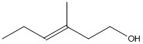
Answer: C7H14O
Diff: 2
Section: 1.11
LO: 1.3
MCAT LO: MCAT1.2

83) A sample of compound X is subjected to elemental analysis and the following percentages by weight are found: 39.97% C, 6.73% H, and 53.30% O. The molecular weight of X is 90. What is the empirical formula of X?
A) C6HO8
B) C2H4O2
C) C4H10O2
D) C3H6O3
E) CH2O
Answer: E
Diff: 3
Section: 1.11
LO: 1.5
GO: G4

84) Calculate the empirical and molecular formulas of the compound with molecular weight 122 and an elemental analysis of 59.01% C, 4.97% H, 13.12% O, and 22.90% N.
Answer: Empirical and molecular formulas are the same: C6H6N2O.
Diff: 3
Section: 1.11
LO: 1.5
GO: G4
85) Calculate the molecular formula for the organic compound whose quantitative elemental analysis showed 48.6% caron and 8.1% hydrogen by weight.
A) CH2O
B) C2H4O2
C) C2H6
D) C3H6O
E) C3H6O2
Answer: E
Diff: 3
Section: 1.11
LO: 1.5
GO: G4

86) The pH of a 150 mL aqueous solution of 2.13 x 10-3 M HCl is ________.
A) -3.000
B) 3.000
C) 2.672
D) 2.130
E) none of the above
Answer: C
Diff: 2
Section: 2.4
LO: 1.7
GO: G4

87) Provide the products of the following acid-base reaction.

(CH3)3NH+ + HO-→
Answer: (CH3)3N + H2O
Diff: 2
Section: 2.5

88) In the following acid/base reaction, label the acid, base, conjugate acid and conjugate base.

HCl + H2O → H3O+ + Cl-
Answer: HCl + H2O → H3O+ + Cl-
acid base conj. acid conj. base
Diff: 2
Section: 2.5
GO: G2

89) In the following acid/base reaction, label the acid, base, conjugate acid and conjugate base.

NH3 + H- → NH2- + H2
Answer: NH3 + H- → NH2- + H2
acid base conj. base conj. acid
Diff: 3
Section: 2.5
GO: G2
90) In the following acid/base reaction, label the acid, base, conjugate acid and conjugate base.

HO- + (CH3)3NH+ → H2O + (CH3)3N
Answer: HO- + (CH3)3NH+ → H2O + (CH3)3N
base acid conj. acid conj. base
Diff: 3
Section: 2.5
GO: G2

91) What is the pKa and general acid strength of formic acid if its conjugate base form has a pKb of 10.23?
A) 3.77 - fairly strong weak acid
B) 5.99 - moderately strong weak acid
C) 14.00 - not an acid but rather a strong base
D) 3.23 - fairly strong weak acid
E) cannot be determined from the information given
Answer: A
Diff: 1
Section: 2.6
LO: 1.7
GO: G4

92) Provide the structure of the conjugate acid of ethanamine (CH3CH2NH2)
Answer:
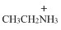
Diff: 1
Section: 2.5

93) The conjugate acid of ammonia, NH3, is ________.
A) NH2-
B) NH2OH
C) NH4+
D) none of the above
Answer: C
Diff: 2
Section: 2.5

94) The Ka of formic acid is 1.7 x 10-4. The pKa of formic acid is ________.
A) 1.70
B) 4.00
C) -2.36
D) 3.77
E) 10.38
Answer: D
Diff: 2
Section: 2.5
LO: 1.7
GO: G4
95) When methanol (CH3OH) acts as a base, its conjugate acid is ________.
A) -CH2OH
B) CH3O-
C) CH4OH
D) CH3OH2+
E) CH4O+
Answer: D
Diff: 2
Section: 2.5

96) Which of the following pairs of bases lists the stronger base first?
A) I- > Cl-
B) H2O > HO-
C) HO- > H2N-
D) CH3COO- > HO-
E) H2N- > CH3COO-
Answer: E
Diff: 3
Section: 2.6
LO: 1.6
GO: G2

97) According to the following pKa values listed for a set of acids, which would lead to the strongest conjugate base?
A) -2
B) 1
C) 7
D) 25
E) 50
Answer: E
Diff: 2
Section: 2.6
LO: 1.7

98) Strong bases usually contain positively charged atoms of high electronegativity and no resonance stabilization.
Answer: FALSE
Diff: 2
Section: 2.12
LO: 1.6
GO: G2

99) Rank the following compounds in order of increasing acidity: CH3OH, HCl, NH3, and CH4.
Answer: CH4 < NH3 < CH3OH < HCl
Diff: 2
Section: 2.9
LO: 1.6
100) Rank the following compounds in order of increasing basicity: CH3O-, H2N-, H2O, and NH3.
Answer: H2O < NH3 < CH3O- < H2N-
Diff: 2
Section: 2.9
LO: 1.6

101) Draw the structure of the conjugate acid of acetone 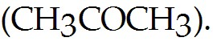
Answer:
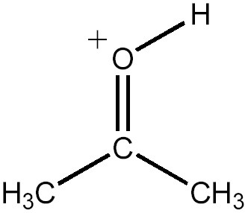
Diff: 2
Section: 2.5

102) Methanol has a pKa of 15.5. Calculate its Ka.
Answer: 3.2 × 10-16
Diff: 2
Section: 2.6
LO: 1.7
GO: G4

103) Write a completed equation for the acid-base pair shown below.

HCN + NaOH →
Answer: HCN + NaOH → NaCN + H2O
Diff: 2
Section: 2.5

104) Write a completed equation for the acid-base pair shown below.

HCO2H + -NH2 →
Answer: HCO2H + -NH2 → HCO2- + NH3
Diff: 2
Section: 2.5
105) The compound phenol is shown below. Provide the structure of the conjugate base of phenol.

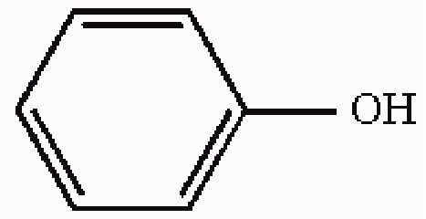
Answer:
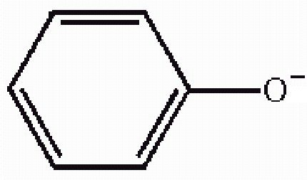
Diff: 2
Section: 2.5
GO: G2

106) Which of the following acids has the most stable conjugate base?
A) CH3CO2H
B) CH3CHO
C) CH3CH2OH
D) CH3CH2SH
E) CH3SO3H
Answer: E
Diff: 2
Section: 2.9
LO: 1.6
GO: G7

107) Which proton is the most acidic in the compound below?

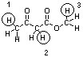

A) 1
B) 2
C) 3
D) They are all the same acidity.
Answer: B
Diff: 3
Section: 2.12
LO: 1.6
GO: G2
108) Which sequence correctly ranks the following protons in order of increasing acidity?

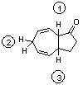

A) 1 < 2 < 3
B) 2 < 3 < 1
C) 3 < 1 < 2
D) 3 < 2 < 1
E) 2 < 1 < 3
Answer: D
Diff: 3
Section: 2.12
LO: 1.6
GO: G2

109) Complete the following acid/base reaction and use pKa or pKb values to predict whether the equilibrium will favor the reactants or products:

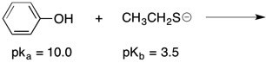
Answer:
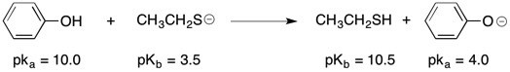

The stronger acid and the stronger base are both on the left side of the reaction (reactants); therefore, the equilibrium concentration should favor the products or right side of this equation.
Diff: 3
Section: 2.7
LO: 1.7
GO: G2, G7

110) Which is more acidic, HF or HI? Explain.
Answer: HI is more acidic. As a conjugate base I- is more stable than F-. The large size of the I- ion allows the extra negative charge to be spread out in a large volume of space.
Diff: 3
Section: 2.9
LO: 1.6
111) Which is more acidic, methanesulfonic acid (CH3SO3H) or propanoic acid (CH3CH2CO2H)? Explain.
Answer: Methansulfonic acid is considerably more acidic. The methanesulfonate ion is much more stable than the propanoate ion. Both of these conjugate bases are stabilized by resonance delocalization of the negative charge, but this delocalization is more extensive in the sulfonate.
Diff: 3
Section: 2.12
LO: 1.6

112) Provide the Lewis structure of the conjugate acid of ethanol (CH3CH2OH).
Answer:
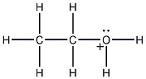
Diff: 3
Section: 2.5

113) Consider the set of compounds, NH3, HF, and H2O. Rank these compounds in order of increasing acidity and discuss your rationale.
Answer: NH3 < H2O < HF

When determining relative acidity, it is often useful to look at the relative basicity of the conjugate bases. The stronger the acid, the weaker (more stable, less reactive) the conjugate base. In this case, one would look at the relative basicity of F-, OH-, and NH2-. The relative strengths of these species can be gauged based on the electronegativity of the charged atom in each. Since fluorine is the most electronegative, F- is the most stable, least reactive base in the group. This means that its conjugate acid, HF, is the strongest.
Diff: 3
Section: 2.9
LO: 1.6
GO: G2, G8

114) Methanesulfonic acid, CH3SO3H, has a pKa of -7 while ethanol, CH3CH2OH, has a pKa of 15.9. Which is the stronger acid and what accounts for this large difference in relative acidity?
Answer: Methanesulfonic acid is the stronger acid. The lower the pKa, the stronger the acid. A lower pKa is associated with a larger Ka which signifies greater dissociation. The large relative difference in acidity in this case can be most easily seen by gauging the relative basicities of the conjugate bases. The weaker the base, the stronger the corresponding conjugate acid. Methanesulfonate, CH3SO3-, is considerably stabilized by resonance delocalization which is not found in ethoxide, CH3CH2O-. This effect greatly reduces the basicity of methanesulfonate relative to ethoxide.
Diff: 3
Section: 20.12
LO: 1.6
GO: G2, G8
115) Would you predict trifluoromethanesulfonic acid, CF3SO3H, to be a stronger or weaker acid than methanesulfonic acid, CH3SO3H? Explain your reasoning.
Answer: Trifluoromethanesulfonic acid is a stronger acid. Compare the strengths of the conjugate bases and remember that the weaker the base, the stronger the conjugate acid. Both bases are stabilized by resonance, but in the case of the trifluoro derivative, the presence of the highly electronegative fluorine atoms serves to delocalize the negative charge to an even greater extent due to the inductive effect. This additional delocalization makes trifluoromethanesulfonate a weaker base.
Diff: 3
Section: 2.12
LO: 1.6
GO: G2, G8

116) Consider the species CH3O-, NH2-, and CH3COO-. Rank these ions in order of increasing basicity, and explain your rationale.
Answer: CH3COO- < CH3O- < NH2-

The first factor to consider is the nature of the atom which bears the negative charge. The more electronegative the atom that bears the negative charge, the more stable the anion. Stable anions are less reactive and are hence weaker bases. Since O is more electronegative than N, the NH2- is the strongest base in the set. In the remaining two species, the negative charge is on the O, but in the case of CH3COO-, the negative charge is also delocalized by resonance.
Diff: 3
Section: 2.9
LO: 1.6
GO: G2, G7

117) Stabilization of a charged species usually results when this species can be more accurately depicted as a hybrid of several resonance forms. Why is this the case?
Answer: Stabilization results from delocalization of charge.
Diff: 3
Section: 2.12
LO: 1.4
GO: G2
MCAT LO: MCAT1.3
118) Which sequence ranks the indicated protons in order of increasing acidity?

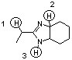

A) 1<2<3
B) 2<1<3
C) 1<3<2
D) 3<2<1
Answer: B
Diff: 3
Section: 2.12
LO: 1.6
GO: G2
MCAT LO: MCAT2.5

119) Which sequence correctly ranks the following protons in order of increasing pKa value?

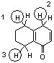

A) 3<1<2
B) 2<1<3
C) 3<2<1
D) 1<3<2
Answer: B
Diff: 3
Section: 2.12
LO: 1.6
GO: G2
MCAT LO: MCAT2.5
120) Peramivir, shown below, has shown to be effective against the influenza B virus (J. Med. Chem. 2010, 6421). Which sequence ranks the following nitrogen atoms in order of increasing basicity?

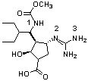

A) 2<3<1
B) 3<1<2
C) 1<3<2
D) 1<2<3
Answer: C
Diff: 3
Section: 2.12
LO: 1.6
GO: G2, G5
MCAT LO: MCAT2.5

121) The hydroxide ion (HO-) cannot function well as which of the following?
A) a Bronsted-Lowry base
B) a Lewis base
C) a nucleophile
D) an electron-pair acceptor
E) a proton acceptor
Answer: D
Diff: 1
Section: 2.13
LO: 1.6
GO: G7

122) Which of the following terms comes closest to describing an electrophile?
A) anion
B) Lewis base
C) Lewis acid
D) nucleophile
E) nonpolar
Answer: C
Diff: 2
Section: 2.13
LO: 1.8
MCAT LO: MCAT1.4
123) According to the Lewis definition, which of the following may act as acids?
A) NH3
B) HCl
C) AlCl3
D) A & B
E) A, B, & C
Answer: E
Diff: 2
Section: 2.13
LO: 1.8
GO: G2
MCAT LO: MCAT1.4

124) Use the curved arrow formalism to show the movement of electron pairs in the following reaction.

Answer:
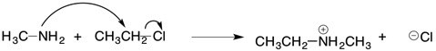
Diff: 2
Section: 2.14
LO: 1.8
GO: G2
MCAT LO: MCAT1.4

125) In the reaction below, label each reactant as a nucleophile or an electrophile.

Answer: CH3NH2, nucleophile
CH3CH2Cl, electrophile
Diff: 2
Section: 2.13
LO: 1.8
GO: G2
MCAT LO: MCAT1.4
126) Use the curved arrow formalism to indicate the movement of electron pairs in the following reaction.

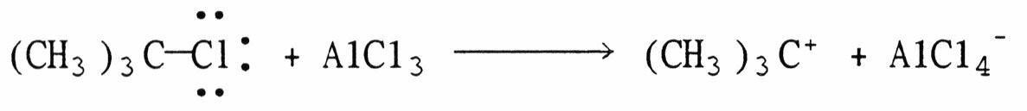
Answer:
Diff: 2
Section: 2.14
LO: 1.8
GO: G2
MCAT LO: MCAT1.4

127) In the reaction below, label each reactant as a nucleophile or an electrophile.

CH3COO- + O2S(OCH3)2 → CH3COOCH3 + CH3OSO3-
Answer: CH3COO-, nucleophile
O2S(OCH3)2, electrophile
Diff: 3
Section: 2.13
LO: 1.8
GO: G2
MCAT LO: MCAT1.4

