Macroeconomics, Second Canadian Edition (Hubbard)
Chapter 1 Economics: Foundations and Models

1.1 Explain these three key economic ideas: People are rational, people respond to incentives, and optimal decisions are made at the margin

1) Changes in global weather patterns can lead to
A) more Canadians drinking coffee.
B) Canadians having to pay more for coffee.
C) wage increases for coffee shop employees.
D) the destruction of the Canadian coffee harvest.
Answer: B
Diff: 1 Page Ref: 3
Topic: Scarcity
Learning Outcome: 1.1 Explain these three key economic ideas: People are rational, people respond to incentives, and optimal decisions are made at the margin
AACSB: Reflective Thinking
Special Feature: Chapter Opener: You versus Caffeine?

2) In economics, choices must be made because we live in a world of
A) unemployment.
B) scarcity.
C) greed.
D) unlimited resources.
Answer: B
Diff: 1 Page Ref: 4
Topic: Scarcity
Learning Outcome: 1.1 Explain these three key economic ideas: People are rational, people respond to incentives, and optimal decisions are made at the margin
AACSB: Reflective Thinking

3) Which of the following statements is true about scarcity?
A) Scarcity refers to the situation in which unlimited wants exceed limited resources.
B) Scarcity is not a problem for the wealthy.
C) Scarcity is only a problem when a country has too large a population.
D) Scarcity arises when there is a wide disparity in income distribution.
Answer: A
Diff: 1 Page Ref: 4
Topic: Scarcity
Learning Outcome: 1.1 Explain these three key economic ideas: People are rational, people respond to incentives, and optimal decisions are made at the margin
AACSB: Reflective Thinking
4) The basic economic problem of ________ has always existed and will continue to exist.
A) scarcity
B) efficiency
C) inflation
D) recession
Answer: A
Diff: 1 Page Ref: 4
Topic: Scarcity
Learning Outcome: 1.1 Explain these three key economic ideas: People are rational, people respond to incentives, and optimal decisions are made at the margin
AACSB: Reflective Thinking

5) By definition, economics is the study of
A) how to make money in the stock market.
B) how to make money in a market economy.
C) the choices people make to attain their goals, given their scarce resources.
D) supply and demand.
Answer: C
Diff: 1 Page Ref: 4
Topic: Scarcity
Learning Outcome: 1.1 Explain these three key economic ideas: People are rational, people respond to incentives, and optimal decisions are made at the margin
AACSB: Reflective Thinking, Communication

6) An economic ________ is a simplified version of some aspect of economic life used to analyze an economic issue.
A) market
B) trade-off
C) variable
D) model
Answer: D
Diff: 1 Page Ref: 4
Topic: Economic Models
Learning Outcome: 1.1 Explain these three key economic ideas: People are rational, people respond to incentives, and optimal decisions are made at the margin
AACSB: Reflective Thinking

7) Where do economic agents such as individuals, firms and nations, interact with each other?
A) in public locations monitored by the government
B) in any arena that brings together buyers and sellers
C) in any physical location people where people can physically get together for selling goods, such as shopping malls
D) in any location where transactions can be monitored by consumer groups and taxed by the government
Answer: B
Diff: 1 Page Ref: 4
Topic: Markets
Learning Outcome: 1.1 Explain these three key economic ideas: People are rational, people respond to incentives, and optimal decisions are made at the margin
AACSB: Reflective Thinking
8) The term ________ in economics refers to a group of buyers and sellers of a product and the arrangement by which they come together to trade.
A) collective
B) cooperative
C) market
D) trade-off
Answer: C
Diff: 1 Page Ref: 4
Topic: Markets
Learning Outcome: 1.1 Explain these three key economic ideas: People are rational, people respond to incentives, and optimal decisions are made at the margin
AACSB: Reflective Thinking

9) Economists assume that individuals
A) behave in unpredictable ways.
B) will never take actions to help others.
C) prefer to live in a society that values fairness above all else.
D) are rational and respond to incentives.
Answer: D
Diff: 1 Page Ref: 4
Topic: People Are Rational
Learning Outcome: 1.1 Explain these three key economic ideas: People are rational, people respond to incentives, and optimal decisions are made at the margin
AACSB: Reflective Thinking

10) Economists assume that rational behavior is useful in explaining choices people make
A) because irrational people do not make economic choices.
B) even though people may not behave rationally all the time.
C) because individuals act rationally all the time in all circumstances.
D) even though people rarely, if ever, behave in a rational manner.
Answer: B
Diff: 2 Page Ref: 4-5
Topic: People Are Rational
Learning Outcome: 1.1 Explain these three key economic ideas: People are rational, people respond to incentives, and optimal decisions are made at the margin
AACSB: Reflective Thinking

11) Economists assume that rational people do all of the following except
A) use all available information as they act to achieve their goals.
B) undertake activities that benefit others and hurt themselves.
C) weigh the benefits and costs of all possible alternative actions.
D) respond to economic incentives.
Answer: B
Diff: 2 Page Ref: 4-5
Topic: People Are Rational
Learning Outcome: 1.1 Explain these three key economic ideas: People are rational, people respond to incentives, and optimal decisions are made at the margin
AACSB: Reflective Thinking
12) Economics does not study correct or incorrect behaviors but rather it assumes that economic agents behave ________, meaning they make the best decisions given their knowledge of the costs and benefits.
A) equitably
B) rationally
C) emotionally
D) selfishly
Answer: B
Diff: 2 Page Ref: 4-5
Topic: People Are Rational
Learning Outcome: 1.1 Explain these three key economic ideas: People are rational, people respond to incentives, and optimal decisions are made at the margin
AACSB: Reflective Thinking

13) Consider the following statements:
a. Car owners purchase more gasoline from a gas station that sells gasoline at a lower price than other rival gas stations in the area.
b. Banks do not take steps to increase security since they believe it is less costly to allow some bank robberies than to install expensive security monitoring equipment.
c. Firms produce more of a particular DVD when its selling price rises.

Which of the above statements demonstrates that economic agents respond to incentives?
A) a only.
B) b only.
C) c only.
D) a and b.
E) a, b, and c.
Answer: E
Diff: 3 Page Ref: 5
Topic: People Respond to Economic Incentives
Learning Outcome: 1.1 Explain these three key economic ideas: People are rational, people respond to incentives, and optimal decisions are made at the margin
AACSB: Analytic Skills

14) As professors and teachers get closer to retirement age they typically spend more time reading and thinking about the financial planning as well as the stock market. By gathering and using all available information as they act to achieve their goals, these teachers are exemplifying the economic idea that
A) people are rational.
B) people respond to economic incentives.
C) optimal decisions are made at the margin.
D) equity is more important than efficiency.
Answer: A
Diff: 2 Page Ref: 4-5
Topic: People Are Rational
2CE: New to 2CE
Learning Outcome: 1.1 Explain these three key economic ideas: People are rational, people respond to incentives, and optimal decisions are made at the margin
AACSB: Reflective Thinking
15) Suppose your provincial government encouraged new medical school graduates to take over rural and small town practices from doctors wishing to retire by paying both the new and retiring doctors $100,000. These doctors would be exemplifying the economic idea that
A) people are rational.
B) people respond to economic incentives.
C) optimal decisions are made at the margin.
D) equity is more important than efficiency.
Answer: B
Diff: 2 Page Ref: 5
Topic: People Respond to Economic Incentives
Learning Outcome: 1.1 Explain these three key economic ideas: People are rational, people respond to incentives, and optimal decisions are made at the margin
AACSB: Reflective Thinking

16) Obesity is one of the biggest health challenges facing Canadians, with few Canadians getting the recommended amount of daily physical activity. Economists would expect
A) people who value physical appearance to exercise less than others.
B) people will exercise more when the cost of skipping exercise increases.
C) people who agree to pay a fine for skipping exercise sessions will be less healthy than those who do not.
D) there is no correlation between fines for skipping exercise and how often people will go to the gym.
Answer: B
Diff: 2 Page Ref: 5
Topic: People Respond to Economic Incentives
2CE: New to 2CE
Learning Outcome: 1.1 Explain these three key economic ideas: People are rational, people respond to incentives, and optimal decisions are made at the margin
AACSB: Reflective Thinking
Special Feature: Making the Connection: Get Fit or Get Fined

17) By charging users that skip workouts, the designers of GymPact are
A) increasing the marginal cost of exercise
B) increasing the marginal benefit of exercise
C) increasing the marginal cost and the marginal benefit of exercise by the same amount.
D) decreasing the marginal cost and the marginal benefit of exercise.
Answer: B
Diff: 1 Page Ref: 5
Topic: People Respond to Economic Incentives
2CE: New to 2CE
Learning Outcome: 1.1 Explain these three key economic ideas: People are rational, people respond to incentives, and optimal decisions are made at the margin
AACSB: Reflective Thinking
Special Feature: Making the Connection: Get Fit or Get Fined
18) In economics, the term ________ means "additional" or "extra."
A) allocative
B) marginal
C) equity
D) optimal
Answer: B
Diff: 1 Page Ref: 6
Topic: Optimal Decisions Are Made at the Margin
Learning Outcome: 1.1 Explain these three key economic ideas: People are rational, people respond to incentives, and optimal decisions are made at the margin
AACSB: Reflective Thinking

19) A grocery store sells a bag of potatoes at a fixed price of $5.50. Which of the following is a term used by economists to describe the money received from the sale of an additional bag of potatoes?
A) marginal revenue
B) gross earnings
C) pure profit
D) marginal costs
E) net benefit
Answer: A
Diff: 1 Page Ref: 6
Topic: Optimal Decisions Are Made at the Margin
Learning Outcome: 1.1 Explain these three key economic ideas: People are rational, people respond to incentives, and optimal decisions are made at the margin
AACSB: Reflective Thinking

20) Economists reason that the optimal decision is to continue any activity up to the point where the
A) marginal benefit is zero.
B) marginal benefit is greater than the marginal cost.
C) marginal cost is zero.
D) marginal benefit equals the marginal cost.
Answer: D
Diff: 2 Page Ref: 6
Topic: Optimal Decisions Are Made at the Margin
Learning Outcome: 1.1 Explain these three key economic ideas: People are rational, people respond to incentives, and optimal decisions are made at the margin
AACSB: Reflective Thinking

21) Marginal analysis involves undertaking an activity
A) until its marginal costs start declining.
B) only when its marginal benefits are positive.
C) until its marginal benefits equal marginal costs.
D) only if its marginal costs are greater than its marginal benefits.
Answer: C
Diff: 1 Page Ref: 6
Topic: Optimal Decisions Are Made at the Margin
Learning Outcome: 1.1 Explain these three key economic ideas: People are rational, people respond to incentives, and optimal decisions are made at the margin
AACSB: Reflective Thinking
22) The revenue received from the sale of ________ of a product is a marginal benefit to the firm.
A) an additional unit
B) the total number of units
C) no units
D) only profitable units
Answer: A
Diff: 2 Page Ref: 6
Topic: Optimal Decisions Are Made at the Margin
Learning Outcome: 1.1 Explain these three key economic ideas: People are rational, people respond to incentives, and optimal decisions are made at the margin
AACSB: Reflective Thinking

23) Making optimal decisions "at the margin" requires
A) making decisions according to one's whims and fancies.
B) making consistently irrational decisions.
C) weighing the costs and benefits of a decision before deciding if it should be pursued.
D) making borderline decisions.
Answer: C
Diff: 1 Page Ref: 6
Topic: Optimal Decisions Are Made at the Margin
Learning Outcome: 1.1 Explain these three key economic ideas: People are rational, people respond to incentives, and optimal decisions are made at the margin
AACSB: Reflective Thinking

24) Making "how much" decisions involve
A) calculating the total benefits of the activity and determining if you are satisfied with that amount.
B) calculating the total costs of the activity and determining if you can afford to incur that expenditure.
C) calculating the average benefit and the average cost of an activity to determine if it is worthwhile undertaking that activity.
D) determining the additional benefits and the additional costs of that activity.
Answer: D
Diff: 2 Page Ref: 6
Topic: Optimal Decisions Are Made at the Margin
Learning Outcome: 1.1 Explain these three key economic ideas: People are rational, people respond to incentives, and optimal decisions are made at the margin
AACSB: Reflective Thinking

25) The extra cost associated with undertaking an activity is called
A) net loss.
B) marginal cost.
C) opportunity cost.
D) foregone cost.
Answer: B
Diff: 1 Page Ref: 6
Topic: Optimal Decisions Are Made at the Margin
Learning Outcome: 1.1 Explain these three key economic ideas: People are rational, people respond to incentives, and optimal decisions are made at the margin
AACSB: Reflective Thinking
26) DeShawn's Detailing is a service that details cars at the customers' homes or places of work. DeShawn's cost for a basic detailing package is $40, and he charges $75 for this service. For a total price of $90, DeShawn will also detail the car's engine, a service that adds an additional $20 to the total cost of the package. What is DeShawn's marginal benefit if he sells a basic detailing package?
A) $35
B) $75
C) He makes a marginal loss of $15, not a marginal benefit.
D) The marginal benefit cannot be determined.
Answer: B
Diff: 2 Page Ref: 6
Topic: Optimal Decisions Are Made at the Margin
Learning Outcome: 1.1 Explain these three key economic ideas: People are rational, people respond to incentives, and optimal decisions are made at the margin
AACSB: Analytic Skills

27) DeShawn's Detailing is a service that details cars at the customers' homes or places of work. DeShawn's cost for a basic detailing package is $40, and he charges $75 for this service. For a total price of $90, DeShawn will also detail the car's engine, a service that adds an additional $20 to the total cost of the package. What is the marginal cost of adding the engine detailing to the basic detailing package?
A) $20
B) $30
C) $60
D) $60 plus the value of his time
Answer: A
Diff: 2 Page Ref: 6
Topic: Optimal Decisions Are Made at the Margin
Learning Outcome: 1.1 Explain these three key economic ideas: People are rational, people respond to incentives, and optimal decisions are made at the margin
AACSB: Analytic Skills

28) DeShawn's Detailing is a service that details cars at the customers' homes or places of work. DeShawn's cost for a basic detailing package is $40, and he charges $75 for this service. For a total price of $90, DeShawn will also detail the car's engine, a service that adds an additional $20 to the total cost of the package. Should DeShawn continue to offer the engine detailing service?
A) Yes, he still makes a profit by selling the engine detailing service with the basic detailing package.
B) Yes, but only if he raises the price of the basic detailing package.
C) No, his marginal benefit is less than his marginal cost.
D) More information is needed for DeShawn to make this decision.
Answer: C
Diff: 3 Page Ref: 6
Topic: Optimal Decisions Are Made at the Margin
Learning Outcome: 1.1 Explain these three key economic ideas: People are rational, people respond to incentives, and optimal decisions are made at the margin
AACSB: Analytic Skills
Scenario 1.1
Suppose a cell phone manufacturer currently sells 20,000 cell phones per week and makes a profit of $5,000 per week. A manager at the plant observes, "Although the last 3,000 cell phones we produced and sold increased our revenue by $6,000 and our costs by $6,700, we are still making an overall profit of $5,000 per week so I think we're on the right track. We are producing the optimal number of cell phones."

29) Refer to Scenario 1.1. Using marginal analysis terminology, what is another economic term for the incremental revenue received from the sale of the last 3,000 cell phones?
A) gross earnings
B) marginal revenue
C) sales revenue
D) gross profit
Answer: B
Diff: 1 Page Ref: 6
Topic: Optimal Decisions Are Made at the Margin
Learning Outcome: 1.1 Explain these three key economic ideas: People are rational, people respond to incentives, and optimal decisions are made at the margin
AACSB: Reflective Thinking

30) Refer to Scenario 1.1. Using marginal analysis terminology, what is another economic term for the incremental cost of producing the last 3,000 cell phones?
A) marginal cost
B) operating cost
C) explicit cost
D) Any of the above terms are correct.
Answer: A
Diff: 1 Page Ref: 6
Topic: Optimal Decisions Are Made at the Margin
Learning Outcome: 1.1 Explain these three key economic ideas: People are rational, people respond to incentives, and optimal decisions are made at the margin
AACSB: Reflective Thinking

31) Refer to Scenario 1.1. Had the firm not produced and sold the last 3,000 cell phones, would its profit be higher or lower, and if so by how much?
A) Its profit will be $6,700 higher.
B) Its profit will be $700 higher.
C) Its profit will be $700 lower.
D) Its profit will be $6,000 lower.
Answer: B
Diff: 2 Page Ref: 6
Topic: Optimal Decisions Are Made at the Margin
Learning Outcome: 1.1 Explain these three key economic ideas: People are rational, people respond to incentives, and optimal decisions are made at the margin
AACSB: Analytic Skills
Table 1.1
Hours  Open | Total Revenue  (dollars)
1 | $50
2 | 75
3 | 95
4 | 110
5 | 120
6 | 125

Lydia runs a small nail salon in the town of New Hope. She is debating whether she should extend her hours of operation. Lydia figures that her sales revenue will depend on the number of hours the nail salon is open as shown in the table above. She would have to hire a worker for those hours at a wage rate of $10 per hour.

32) Refer to Table 1.1. Using marginal analysis, determine how many hours should Lydia extend her nail salon's hours of operations?
A) 2 hours
B) 3 hours
C) 4 hours
D) 5 hours
E) 6 hours
Answer: D
Diff: 3 Page Ref: 6
Topic: Optimal Decisions Are Made at the Margin
Learning Outcome: 1.1 Explain these three key economic ideas: People are rational, people respond to incentives, and optimal decisions are made at the margin
AACSB: Analytic Skills

33) Refer to Table 1.1. What is Lydia's marginal benefit if she decides to stay open for two hours instead of one hour?
A) $25
B) $50
C) $75
D) $125
Answer: A
Diff: 2 Page Ref: 6
Topic: Optimal Decisions Are Made at the Margin
Learning Outcome: 1.1 Explain these three key economic ideas: People are rational, people respond to incentives, and optimal decisions are made at the margin
AACSB: Analytic Skills
34) Refer to Table 1.1. What is Lydia's marginal cost if she decides to stay open for two hours instead of one hour?
A) $10
B) $20
C) $25
D) $40
Answer: A
Diff: 2 Page Ref: 6
Topic: Optimal Decisions Are Made at the Margin
Learning Outcome: 1.1 Explain these three key economic ideas: People are rational, people respond to incentives, and optimal decisions are made at the margin
AACSB: Analytic Skills

35) Soo Jin shares a one-bedroom apartment with her classmate. Her share of the rent is $700 per month. She is considering moving to a studio apartment which she will not have to share with anyone. The studio apartment rents for $950 per month. Recently, you ran into Soo Jin on campus and she tells you that she has moved into the studio apartment. Soo Jin is as rational as any other person. As an economics major, you rightly conclude that
A) Soo Jin did not have a choice; her roommate was a slob.
B) Soo Jin figures that the additional benefit of having her own place (as opposed to sharing) is at least $250.
C) Soo Jin figures that the benefit of having her own place (as opposed to sharing) is at least $950.
D) The cost of having one's own space outweighs the benefits.
Answer: B
Diff: 2 Page Ref: 6
Topic: Optimal Decisions Are Made at the Margin
Learning Outcome: 1.1 Explain these three key economic ideas: People are rational, people respond to incentives, and optimal decisions are made at the margin
AACSB: Analytic Skills

36) McCain Foods Ltd. is one of the largest producer s of frozen french fries in the world. If the marginal cost of producing an extra million kilograms of french fries is $1 million, then McCain Foods Ltd. should produce the extra french fries
A) only if the marginal benefit is greater than $1 million plus an acceptable profit margin.
B) as long as the marginal benefit the firm receives is just equal to or greater than $1 million.
C) as long as the marginal cost does not rise.
D) until the marginal benefit the firm receives reaches zero.
Answer: B
Diff: 2 Page Ref: 6-7
Topic: Optimal Decisions Are Made at the Margin
2CE: Classic (1CE)- updated for 2CE
Learning Outcome: 1.1 Explain these three key economic ideas: People are rational, people respond to incentives, and optimal decisions are made at the margin
AACSB: Reflective Thinking
Special Feature: Solved Problem: Binge Watching and Decisions at the Margin.
37) The approximately 12 seconds between episodes on Netflix means that binge watching is
A) the result of a series of marginal decisions.
B) something every one plans to when they first login to Netflix.
C) something Netflix forces viewers to do.
D) an indication of how quickly Netflix users can make decisions.
Answer: A
Diff: 2 Page Ref: 6-7
Topic: Optimal Decisions Are Made at the Margin
2CE: New to 2CE
Learning Outcome: 1.1 Explain these three key economic ideas: People are rational, people respond to incentives, and optimal decisions are made at the margin
AACSB: Reflective Thinking
Special Feature: Solved Problem: Binge Watching and Decisions at the Margin.

38) Scarcity refers to a situation in which unlimited wants exceed the limited resources available to fulfill those wants.
Answer: TRUE
Diff: 1 Page Ref: 4
Topic: Scarcity
Learning Outcome: 1.1 Explain these three key economic ideas: People are rational, people respond to incentives, and optimal decisions are made at the margin
AACSB: Reflective Thinking

39) Scarcity is a problem that will eventually disappear as technology advances.
Answer: FALSE
Diff: 1 Page Ref: 4
Topic: Scarcity
Learning Outcome: 1.1 Explain these three key economic ideas: People are rational, people respond to incentives, and optimal decisions are made at the margin
AACSB: Reflective Thinking

40) An economic model is a simplified version of reality used to analyze real-world economic situations.
Answer: TRUE
Diff: 1 Page Ref: 4
Topic: Economic Models
Learning Outcome: 1.1 Explain these three key economic ideas: People are rational, people respond to incentives, and optimal decisions are made at the margin
AACSB: Reflective Thinking

41) The sales revenue a seller receives from the sale of an additional unit of goods is called the marginal benefit.
Answer: TRUE
Diff: 1 Page Ref: 6
Topic: Optimal Decisions Are Made at the Margin
Learning Outcome: 1.1 Explain these three key economic ideas: People are rational, people respond to incentives, and optimal decisions are made at the margin
AACSB: Reflective Thinking
42) Optimal decisions are made at the point where marginal cost equals zero.
Answer: FALSE
Diff: 1 Page Ref: 6
Topic: Optimal Decisions Are Made at the Margin
Learning Outcome: 1.1 Explain these three key economic ideas: People are rational, people respond to incentives, and optimal decisions are made at the margin
AACSB: Reflective Thinking

43) If it costs Sinclair $300 to produce 3 suede jackets and $420 to produce 4 suede jackets, then the difference of $120 is the marginal cost of producing the 4th suede jacket.
Answer: TRUE
Diff: 1 Page Ref: 6
Topic: Optimal Decisions Are Made at the Margin
Learning Outcome: 1.1 Explain these three key economic ideas: People are rational, people respond to incentives, and optimal decisions are made at the margin
AACSB: Reflective Thinking

44) Suppose the extra cost of producing an extra million kilograms of french fries is $1 million. Then, McCain Foods Ltd. should make the extra french fries if they generate additional revenue of $1 million.
Answer: TRUE
Diff: 2 Page Ref: 6
Topic: Optimal Decisions Are Made at the Margin
Learning Outcome: 1.1 Explain these three key economic ideas: People are rational, people respond to incentives, and optimal decisions are made at the margin
AACSB: Analytic Skills
Special Feature: Solved Problem: Binge Watching and Decisions at the Margin.

45) Explain the economic assumption that "people are rational."
Answer: "People are rational" means that economists assume consumers and firms will use all available information as they act to achieve their goals. Rational individuals weigh the benefits and costs of each action, and they choose an action only if the benefits exceed the costs.
Diff: 2 Page Ref: 4-5
Topic: People Are Rational
Learning Outcome: 1.1 Explain these three key economic ideas: People are rational, people respond to incentives, and optimal decisions are made at the margin
AACSB: Reflective Thinking

46) Explain the economic idea that "people respond to incentives."
Answer: Human beings act from a variety of motives, including religious belief, envy, and compassion. "People respond to incentives" means that people will act if they feel it is in their best economic interest to do so.
Diff: 2 Page Ref: 5
Topic: People Respond to Economic Incentives
Learning Outcome: 1.1 Explain these three key economic ideas: People are rational, people respond to incentives, and optimal decisions are made at the margin
AACSB: Reflective Thinking
47) What is meant by the statement that "optimal decisions are made at the margin"?
Answer: In economics, the word "marginal" means "extra" or "additional." Economists reason that the optimal decision is to continue any activity up to the point where the marginal benefit equals the marginal cost, so optimal decisions are made at the point where the extra benefit received from an activity is equal to the extra cost associated with that activity.
Diff: 2 Page Ref: 6
Topic: Optimal Decisions Are Made at the Margin
Learning Outcome: 1.1 Explain these three key economic ideas: People are rational, people respond to incentives, and optimal decisions are made at the margin
AACSB: Reflective Thinking

48) Suppose that watching one more episode of your favourite NetFlix show is worth $ 200 to you. Suppose that studying for that same amount of time will boost your mark enough to get you a bursary. What is the smallest size of the bursary that would cause you to study instead of watching another episode (assuming you are rational)?
Answer: The bursary would have to be at least $200 for a rational person to choose to study instead of watching the next episode - assuming there are no other benefits to studying.
Diff: 2 Page Ref: 7
Topic: People Are Rational
2CE: New to 2CE
Learning Outcome: 1.1 Explain these three key economic ideas: People are rational, people respond to incentives, and optimal decisions are made at the margin
AACSB: Analytic Skills
Special Feature: Solved Problem: Binge Watching and Decisions at the Margin.

1.2 Discuss how a society answers these three key economic questions: What goods and services will be produced? How will the goods and services be produced? Who will receive the goods and services produced?

1) The three fundamental questions that any economy must address are
A) What will be the prices of goods and services; how will these goods and services be produced; and who will receive them?
B) What goods and services to produce; how will these goods and services be produced; and who receives them?
C) Who gets jobs; what wages do workers earn; and who owns what property?
D) How much will be saved; what will be produced; and how can these goods and services be fairly distributed?
Answer: B
Diff: 1 Page Ref: 7
Topic: Trade-offs
Learning Outcome: 1.2 Discuss how a society answers these three key economic questions: What goods and services will be produced? How will the goods and services be produced? Who will receive the goods and services produced?
AACSB: Reflective Thinking
2) The idea that because of scarcity, producing more of one good or service means producing less of another good or service refers to the economic concept of
A) optimization.
B) efficiency.
C) trade-off.
D) equity.
Answer: C
Diff: 1 Page Ref: 7
Topic: Trade-offs
Learning Outcome: 1.2 Discuss how a society answers these three key economic questions: What goods and services will be produced? How will the goods and services be produced? Who will receive the goods and services produced?
AACSB: Reflective Thinking

3) Society faces a trade-off in all of the following situations except
A) when deciding who will receive the goods and services produced.
B) when deciding what goods and services will be produced.
C) when deciding how goods and services will be produced.
D) when some previously unemployed workers find jobs.
Answer: D
Diff: 2 Page Ref: 7
Topic: Trade-offs
Learning Outcome: 1.2 Discuss how a society answers these three key economic questions: What goods and services will be produced? How will the goods and services be produced? Who will receive the goods and services produced?
AACSB: Reflective Thinking

4) Which of the following statements is true?
A) Anytime you have to decide which action to take you are experiencing economic equity.
B) Trade-offs do not apply when the consumers purchase a product for which there is excess supply, such as a stock clearance sale.
C) Every individual, no matter how rich or poor, is faced with making trade-offs.
D) Economics is a social science that studies the trade-offs we are forced to make because resources are unlimited.
Answer: C
Diff: 2 Page Ref: 7
Topic: Trade-offs
Learning Outcome: 1.2 Discuss how a society answers these three key economic questions: What goods and services will be produced? How will the goods and services be produced? Who will receive the goods and services produced?
AACSB: Reflective Thinking

5) Which of the following is not an example of an economic trade-off that a firm has to make?
A) whether it is cheaper to produce with more machines or with more workers
B) whether it is to outsource the production of a good or service
C) whether or not consumers will buy its products
D) whether it should produce more of its product
Answer: C
Diff: 1 Page Ref: 7
Topic: Trade-offs
Learning Outcome: 1.2 Discuss how a society answers these three key economic questions: What goods and services will be produced? How will the goods and services be produced? Who will receive the goods and services produced?
AACSB: Reflective Thinking
6) The highest valued alternative that must be given up to engage in an activity is the definition of
A) economic equity.
B) marginal benefit.
C) opportunity cost.
D) marginal cost.
Answer: C
Diff: 1 Page Ref: 7
Topic: Opportunity Cost
Learning Outcome: 1.2 Discuss how a society answers these three key economic questions: What goods and services will be produced? How will the goods and services be produced? Who will receive the goods and services produced?
AACSB: Reflective Thinking

7) The Coffee Nook, a small cafe near campus, sells cappuccinos for $2.50 and Russian tea cakes for $1.00 each. What is the opportunity cost of buying a cappuccino?
A) 2 1/2 Russian tea cakes
B) 2/5 of a Russian tea cake
C) $2.50
D) $1.00
Answer: A
Diff: 1 Page Ref: 7
Topic: Opportunity Cost
Learning Outcome: 1.2 Discuss how a society answers these three key economic questions: What goods and services will be produced? How will the goods and services be produced? Who will receive the goods and services produced?
AACSB: Analytic Skills

8) Arlene quits her $125,000-a-year job to take care of her ailing parents. What is the opportunity cost of her decision?
A) zero, since she will no longer be earning a salary
B) It depends on the "going rate" for home-care providers.
C) at least $125,000
D) the value she attributes to the satisfaction she receives from taking care of her parents
Answer: C
Diff: 1 Page Ref: 7
Topic: Opportunity Cost
Learning Outcome: 1.2 Discuss how a society answers these three key economic questions: What goods and services will be produced? How will the goods and services be produced? Who will receive the goods and services produced?
AACSB: Analytic Skills
9) The distribution of income primarily determines which of the fundamental economic questions?
A) What goods and services are to be produced?
B) How the goods and services are to be produced?
C) Who will receive the goods and services produced?
D) How to plan the economy?
Answer: C
Diff: 2 Page Ref: 8
Topic: Who Will Receive the Goods and Services Produced?
Learning Outcome: 1.2 Discuss how a society answers these three key economic questions: What goods and services will be produced? How will the goods and services be produced? Who will receive the goods and services produced?
AACSB: Reflective Thinking

10) Automobile manufacturers produce a range of automobiles such as sports utility vehicles, luxury sedans, pickup trucks and compact cars. What fundamental economic question are they addressing by making this range of products?
A) How to produce goods that consumers want?
B) Why produce a variety of automobiles?
C) What to produce?
D) Who to produce automobiles for?
Answer: C
Diff: 1 Page Ref: 7-8
Topic: What Goods and Services Will Be Produced?
Learning Outcome: 1.2 Discuss how a society answers these three key economic questions: What goods and services will be produced? How will the goods and services be produced? Who will receive the goods and services produced?
AACSB: Reflective Thinking

11) Consider the following economic agents:
a. the government
b. consumers
c. producers

Who, in a centrally planned economy, decides what goods and services will be produced with the scarce resources available in that economy?
A) the government
B) producers
C) consumers
D) consumers and producers
E) the government, consumers and producers
Answer: A
Diff: 1 Page Ref: 7-8
Topic: What Goods and Services Will Be Produced?
Learning Outcome: 1.2 Discuss how a society answers these three key economic questions: What goods and services will be produced? How will the goods and services be produced? Who will receive the goods and services produced?
AACSB: Reflective Thinking
12) The decision about what goods and services will be produced made in a market economy is made by
A) lawmakers in the government voting on what will be produced.
B) workers deciding to produce only what the boss says must be produced.
C) producers deciding what society wants most.
D) consumers and firms choosing which goods and services to buy or produce.
E) consumers dictating to firms what they need most.
Answer: D
Diff: 1 Page Ref: 8
Topic: What Goods and Services Will Be Produced?
Learning Outcome: 1.2 Discuss how a society answers these three key economic questions: What goods and services will be produced? How will the goods and services be produced? Who will receive the goods and services produced?
AACSB: Reflective Thinking

13) Central planning relies on ________ to determine what types of products to make
A) government employees
B) consumers' choices
C) individual businesses
D) consumers' wants
Answer: A
Diff: 1 Page Ref: 8
Topic: Centrally Planned Economies
2CE: New to 2CE
Learning Outcome: 1.2 Discuss how a society answers these three key economic questions: What goods and services will be produced? How will the goods and services be produced? Who will receive the goods and services produced?
AACSB: Reflective Thinking
Special Feature: Making the Connection: Central Planning Leads to Some Odd Products

14) Which of the following statements about the economic decisions consumers, firms, and the government have to make is false?
A) Governments face the problem of scarcity in making economic decisions.
B) Only individuals face scarcity; firms and the government do not.
C) Both firms and individuals face scarcity.
D) Each faces the problem of scarcity which necessitates trade-offs in making economic decisions.
Answer: B
Diff: 1 Page Ref: 8
Topic: What Goods and Services Will Be Produced?
Learning Outcome: 1.2 Discuss how a society answers these three key economic questions: What goods and services will be produced? How will the goods and services be produced? Who will receive the goods and services produced?
AACSB: Reflective Thinking
15) Why is it necessary for all economic systems to not only provide people with goods and services, but also restrict them from getting as much of these goods and services as they wish?
A) Failure to do this could reduce the efficiency of the system by producing some goods and services that are not as highly valued as others.
B) Failure to do this could lead to an inequitable allocation of goods and services produced.
C) Failure to do this could lead to drastic shortages of good and services.
D) Failure to do this could reduces efficiency and leads to an inequitable allocation of output.
Answer: A
Diff: 3 Page Ref: 8
Topic: Who Will Receive the Goods and Services Produced?
Learning Outcome: 1.2 Discuss how a society answers these three key economic questions: What goods and services will be produced? How will the goods and services be produced? Who will receive the goods and services produced?
AACSB: Analytic Skills

16) Who receives the most of what is produced in a market economy?
A) lawmakers and other politically favored groups
B) those who are willing and able to buy them
C) Everyone receives an equal amount.
D) people who earn the highest incomes
Answer: B
Diff: 1 Page Ref: 8
Topic: Who Will Receive the Goods and Services Produced?
Learning Outcome: 1.2 Discuss how a society answers these three key economic questions: What goods and services will be produced? How will the goods and services be produced? Who will receive the goods and services produced?
AACSB: Reflective Thinking

17) How are the fundamental economic decisions determined in North Korea?
A) Individuals, firms, and the government interact in a market to make these economic decisions.
B) These decisions are made by the country's elders who have had much experience in answering these questions.
C) The government decides because North Korea is a centrally planned economy.
D) The United Nations decides because North Korea is a developing economy.
Answer: C
Diff: 1 Page Ref: 8
Topic: Centrally Planned Economies
Learning Outcome: 1.2 Discuss how a society answers these three key economic questions: What goods and services will be produced? How will the goods and services be produced? Who will receive the goods and services produced?
AACSB: Reflective Thinking
18) How are the fundamental economic questions answered in a market economy?
A) The government alone decides the answers.
B) Individuals, firms, and the government interact in markets to decide the answers to these questions.
C) Households and firms interact in markets to decide the answers to these questions.
D) Large corporations alone decide the answers.
Answer: C
Diff: 2 Page Ref: 8-9
Topic: Market Economies
Learning Outcome: 1.2 Discuss how a society answers these three key economic questions: What goods and services will be produced? How will the goods and services be produced? Who will receive the goods and services produced?
AACSB: Reflective Thinking

19) Which of the following is a problem inherent in centrally planned economies?
A) Households and firms make poor decisions in choosing how resources are allocated.
B) There is too little production of low-cost, high-quality goods and services.
C) Production managers are more concerned with satisfying consumer wants than with satisfying government's orders.
D) Exports tend to exceed imports.
Answer: B
Diff: 2 Page Ref: 8
Topic: Centrally Planned Economies
Learning Outcome: 1.2 Discuss how a society answers these three key economic questions: What goods and services will be produced? How will the goods and services be produced? Who will receive the goods and services produced?
AACSB: Reflective Thinking

20) All of the following contributed to the downfall of the Soviet Union in 1991 except
A) public dissatisfaction with low living standards and political repression.
B) an inability to produce low-cost consumer goods that households wanted.
C) lack of high-quality goods and services.
D) lack of a strong dictator who can coordinate economic activities.
Answer: D
Diff: 2 Page Ref: 8-9
Topic: Centrally Planned Economies
Learning Outcome: 1.2 Discuss how a society answers these three key economic questions: What goods and services will be produced? How will the goods and services be produced? Who will receive the goods and services produced?
AACSB: Reflective Thinking

21) ________ is a situation in which a good or service is produced at the lowest possible cost.
A) Allocative efficiency
B) Productive efficiency
C) Equity
D) Optimal marginalism
Answer: B
Diff: 1 Page Ref: 9
Topic: Efficiency
Learning Outcome: 1.2 Discuss how a society answers these three key economic questions: What goods and services will be produced? How will the goods and services be produced? Who will receive the goods and services produced?
AACSB: Reflective Thinking
22) Productive efficiency is achieved when
A) firms add a low profit margin to the goods and services they produce.
B) firms produce the goods and services that consumers value most.
C) firms produce goods and services at the lowest cost.
D) there are no shortages or surpluses in the market.
Answer: C
Diff: 1 Page Ref: 9
Topic: Efficiency
Learning Outcome: 1.2 Discuss how a society answers these three key economic questions: What goods and services will be produced? How will the goods and services be produced? Who will receive the goods and services produced?
AACSB: Reflective Thinking

23) When production reflects consumer preferences, ________ occurs.
A) allocative efficiency
B) productive efficiency
C) equity
D) efficient central planning
Answer: A
Diff: 1 Page Ref: 9
Topic: Efficiency
Learning Outcome: 1.2 Discuss how a society answers these three key economic questions: What goods and services will be produced? How will the goods and services be produced? Who will receive the goods and services produced?
AACSB: Reflective Thinking

24) Allocative efficiency is achieved when firms produce goods and services
A) at the lowest possible cost.
B) that consumers value most.
C) at the lowest opportunity cost.
D) at a marginal cost of zero.
Answer: B
Diff: 1 Page Ref: 9
Topic: Efficiency
Learning Outcome: 1.2 Discuss how a society answers these three key economic questions: What goods and services will be produced? How will the goods and services be produced? Who will receive the goods and services produced?
AACSB: Reflective Thinking

25) Markets promote
A) equity and competition.
B) voluntary exchange and equality.
C) equity and equality.
D) competition and voluntary exchange.
Answer: D
Diff: 2 Page Ref: 8-9
Topic: Market Economies
Learning Outcome: 1.2 Discuss how a society answers these three key economic questions: What goods and services will be produced? How will the goods and services be produced? Who will receive the goods and services produced?
AACSB: Reflective Thinking
26) Which of the following statements is true about competition in a market?
A) Competition forces firms to out source the production of their labour-intensive products.
B) Competition forces firms to undercut their selling price, thus benefiting consumers who will be able to purchase products at the lowest price possible.
C) Competition forces firms to produce and sell products as long as the marginal benefit to consumers exceeds the marginal cost of production.
D) Competition forces firms to add only low profit margins to their costs of production.
Answer: C
Diff: 2 Page Ref: 8-9
Topic: Market Economies
Learning Outcome: 1.2 Discuss how a society answers these three key economic questions: What goods and services will be produced? How will the goods and services be produced? Who will receive the goods and services produced?
AACSB: Reflective Thinking

27) ________ increases economic efficiency because it forces firms to produce and sell goods and services as long as the additional benefit to consumers is greater than the additional cost of production.
A) Competition
B) Voluntary exchange
C) Equity
D) A centrally planned economy
Answer: A
Diff: 1 Page Ref: 8-9
Topic: Market Economies
Learning Outcome: 1.2 Discuss how a society answers these three key economic questions: What goods and services will be produced? How will the goods and services be produced? Who will receive the goods and services produced?
AACSB: Reflective Thinking

28) Which of the following generates productive efficiency?
A) competition among sellers
B) competition among buyers
C) government inspectors
D) government production rules and regulations
Answer: A
Diff: 1 Page Ref: 9
Topic: Efficiency
Learning Outcome: 1.2 Discuss how a society answers these three key economic questions: What goods and services will be produced? How will the goods and services be produced? Who will receive the goods and services produced?
AACSB: Reflective Thinking
29) Voluntary exchange between buyers and sellers generates ________ in a market economy.
A) scarcity
B) allocative efficiency
C) productive efficiency
D) equity
Answer: B
Diff: 1 Page Ref: 9
Topic: Efficiency
Learning Outcome: 1.2 Discuss how a society answers these three key economic questions: What goods and services will be produced? How will the goods and services be produced? Who will receive the goods and services produced?
AACSB: Reflective Thinking

30) Which of the following is a result of a market economy?
A) environmental protection
B) an equal income distribution
C) agreement on equity
D) voluntary exchange
Answer: D
Diff: 1 Page Ref: 8-9
Topic: Market Economies
Learning Outcome: 1.2 Discuss how a society answers these three key economic questions: What goods and services will be produced? How will the goods and services be produced? Who will receive the goods and services produced?
AACSB: Reflective Thinking

31) Political candidates often hold fund raisers by charging "per plate" for dinner. Wendy purchased four tickets to a $1,000 per plate dinner for a local city council candidate. Is this transaction economically efficient?
A) No, political candidates should never be allowed to overcharge for a fund raising dinner.
B) Yes, it was a voluntary exchange that benefited both parties.
C) No, Wendy paid too much for four dinners.
D) Yes, it is efficient only from the perspective of the candidate but not from the perspective of Wendy.
Answer: B
Diff: 2 Page Ref: 8-9
Topic: Market Economies
Learning Outcome: 1.2 Discuss how a society answers these three key economic questions: What goods and services will be produced? How will the goods and services be produced? Who will receive the goods and services produced?
AACSB: Analytic Skills
32) In economics, the term "equity" means
A) everyone has an equal standard of living.
B) the hardest working individuals consume all they want.
C) only elected officials have high standards of living.
D) economic benefits are distributed fairly.
Answer: D
Diff: 1 Page Ref: 9
Topic: Equity
Learning Outcome: 1.2 Discuss how a society answers these three key economic questions: What goods and services will be produced? How will the goods and services be produced? Who will receive the goods and services produced?
AACSB: Reflective Thinking

33) Which of the following is motivated by an equity concern?
A) Some provinces and municipalities have transferred funds to food bank programs in order to increase benefits to lower-income families.
B) Following the implementation of subsidies for energy conservation, household demand for rooftop solar panels increased quite significantly in BC.
C) Some provinces allow automotive insurance companies to charge men and women different rates for insurance.
D) Canada offers patent protection to pharmaceutical manufacturers to prevent others from duplicating their products.
Answer: A
Diff: 3 Page Ref: 9
Topic: Equity
Learning Outcome: 1.2 Discuss how a society answers these three key economic questions: What goods and services will be produced? How will the goods and services be produced? Who will receive the goods and services produced?
AACSB: Reflective Thinking, Ethical Reasoning

34) Which of the following is motivated by an efficiency concern?
A) In 2013 the Alberta government handed out pre-paid credit and debit cards to flood victims.
B) The right to purchase tickets to the Grey Cup is decided by a lottery.
C) Organ transplant waiting lists rationing scarce kidneys that would favor young patients over old in an effort to wring more life out of donated organs.
D) The federal government Equilization program which makes larger transfers to poor provinces than to wealthy ones.
Answer: C
Diff: 3 Page Ref: 9
Topic: Efficiency
Learning Outcome: 1.2 Discuss how a society answers these three key economic questions: What goods and services will be produced? How will the goods and services be produced? Who will receive the goods and services produced?
AACSB: Reflective Thinking, Ethical Reasoning
35) Which of the following is an example of an efficiency-equity trade-off faced by economic agents?
A) Provincial health programs are not cost effective. Instead of focusing on universal access to the health care system, money should be spent on programs that prevent disease first and treating disease second.
B) Concerned about the falling birth rate, the French government has pledged more money for families with three children, in an effort to encourage working women to have more babies.
C) Some Canadian universities are actively recruiting foreign students for their technology-based programs.
D) Municipal sports programs must charge all participants the same price, even when participants don't live in the municipality.
Answer: A
Diff: 3 Page Ref: 9
Topic: Efficiency
Learning Outcome: 1.2 Discuss how a society answers these three key economic questions: What goods and services will be produced? How will the goods and services be produced? Who will receive the goods and services produced?
AACSB: Analytic Skills, Ethical Reasoning

36) Which of the following correctly describes the relationship between economic efficiency and economic equity?
A) They are both automatically achieved in a free market economy.
B) They always call for opposite outcomes.
C) There is no conflict between the two goals.
D) There is often a trade-off between the two.
Answer: D
Diff: 2 Page Ref: 9-10
Topic: Efficiency
Learning Outcome: 1.2 Discuss how a society answers these three key economic questions: What goods and services will be produced? How will the goods and services be produced? Who will receive the goods and services produced?
AACSB: Reflective Thinking

37) Allocative efficiency best explains ________, and productive efficiency best explains ________.
A) how something will be produced; when something will be produced
B) when something will be produced; why something will be produced
C) why something will be produced; what will be produced
D) what will be produced; how something will be produced
Answer: D
Diff: 2 Page Ref: 9
Topic: Efficiency
Learning Outcome: 1.2 Discuss how a society answers these three key economic questions: What goods and services will be produced? How will the goods and services be produced? Who will receive the goods and services produced?
AACSB: Reflective Thinking
38) Assume an economics instructor want to promote equity in their classroom. To do this, announce that all students will receive a final grade equal to the class average. Based on the equity-efficiency tradeoff, what is a likely outcome?
A) Most students will spend their time on other courses, resulting in little learning and a low class average.
B) Freed from competition, students will fully apply themselves to an economics course causing the class average to rise.
C) Student behaviour will not change, but everyone in the class will have the same mark.
D) Students will put extra effort into this economics course solely to help other students do well.
Answer: A
Diff: 2 Page Ref: 10
Topic: Trade-offs
2CE: New to 2CE
Learning Outcome: 1.2 Discuss how a society answers these three key economic questions: What goods and services will be produced? How will the goods and services be produced? Who will receive the goods and services produced?
AACSB: Analytic Skills, Ethical Reasoning
Special Feature: Making the Connection: The Equity-Efficiency Trade-off in the classroom.

39) The government makes all economic decisions in a mixed economy.
Answer: FALSE
Diff: 1 Page Ref: 9
Topic: Mixed Economies
Learning Outcome: 1.2 Discuss how a society answers these three key economic questions: What goods and services will be produced? How will the goods and services be produced? Who will receive the goods and services produced?
AACSB: Reflective Thinking

40) When voluntary exchange takes place, both parties gain from the exchange.
Answer: TRUE
Diff: 1 Page Ref: 8-9
Topic: Market Economies
Learning Outcome: 1.2 Discuss how a society answers these three key economic questions: What goods and services will be produced? How will the goods and services be produced? Who will receive the goods and services produced?
AACSB: Reflective Thinking

41) A university must decide if it wants to offer more Internet-based classes. This decision involves answering the economic question of "what to produce."
Answer: TRUE
Diff: 1 Page Ref: 7-8
Topic: What Goods and Services Will Be Produced?
Learning Outcome: 1.2 Discuss how a society answers these three key economic questions: What goods and services will be produced? How will the goods and services be produced? Who will receive the goods and services produced?
AACSB: Reflective Thinking
42) One desirable outcome of a market economy is that it leads to a more equitable distribution of income.
Answer: FALSE
Diff: 1 Page Ref: 9
Topic: Market Economies
Learning Outcome: 1.2 Discuss how a society answers these three key economic questions: What goods and services will be produced? How will the goods and services be produced? Who will receive the goods and services produced?
AACSB: Reflective Thinking

43) What is equity, and how does it differ from efficiency?
Answer: Equity refers to the fair distribution of economic benefits. In economics, efficiency refers to least cost production (productive efficiency) and producing according to human preferences (allocative efficiency).
Diff: 2 Page Ref: 9
Topic: Equity
Learning Outcome: 1.2 Discuss how a society answers these three key economic questions: What goods and services will be produced? How will the goods and services be produced? Who will receive the goods and services produced?
AACSB: Reflective Thinking

44) What is opportunity cost?
Answer: Opportunity cost refers to the highest-valued alternative that must be given up to engage in an activity. For example, the opportunity cost of taking this economics class is what you are giving up to take the class, which may be taking another class such as accounting or psychology, working extra hours at your job, or extra sleep (whichever is your highest-valued alternative).
Diff: 2 Page Ref: 7
Topic: Opportunity Cost
Learning Outcome: 1.2 Discuss how a society answers these three key economic questions: What goods and services will be produced? How will the goods and services be produced? Who will receive the goods and services produced?
AACSB: Reflective Thinking

45) Define productive efficiency. Does productive efficiency imply allocative efficiency? Explain.
Answer: Productive efficiency is an efficiency criterion that describes a situation in which goods and services are produced at the lowest possible cost. It does not imply allocative efficiency which is a criterion associated with producing goods and services that consumers value most. For example, a manufacturer may be able to produce typewriters at the lowest possible cost of say, $200 but this does not necessarily mean that consumers are willing to pay $200 for a typewriter.
Diff: 3 Page Ref: 9
Topic: Efficiency
Learning Outcome: 1.2 Discuss how a society answers these three key economic questions: What goods and services will be produced? How will the goods and services be produced? Who will receive the goods and services produced?
AACSB: Analytic Skills
46) What is a centrally planned economy?
Answer: A centrally planned economy is an economy in which the government decides how economic resources will be allocated.
Diff: 3 Page Ref: 8-9
Topic: Centrally Planned Economies
Learning Outcome: 1.2 Discuss how a society answers these three key economic questions: What goods and services will be produced? How will the goods and services be produced? Who will receive the goods and services produced?
AACSB: Reflective Thinking

1.3 Understand what economic models are and aren't, and why they're a good idea

1) Economic models do all of the following except
A) answer economic questions.
B) portray reality in all its minute details.
C) make economic ideas explicit and concrete for use by decision makers.
D) simplify some aspect of economic life.
Answer: B
Diff: 1 Page Ref: 10
Topic: Economic Models
Learning Outcome: 1.3 Understand what economic models are and aren't, and why they're a good idea
AACSB: Reflective Thinking

2) All of the following are part of an economic model except
A) assumptions.
B) hypotheses.
C) data.
D) opinions.
Answer: D
Diff: 1 Page Ref: 10
Topic: Economic Models
Learning Outcome: 1.3 Understand what economic models are and aren't, and why they're a good idea
AACSB: Reflective Thinking

3) Which of the following statements about positive economic analysis is false?
A) Positive analysis uses an economic model to estimate the costs and benefits of different course of actions.
B) There is much more disagreement among economists over normative economic analysis than over positive economic analysis.
C) There is much more disagreement among economists over positive economic analysis than over normative economic analysis.
D) Unlike normative economic analysis, positive economic analysis can be tested.
Answer: C
Diff: 2 Page Ref: 11
Topic: Normative and Positive Analysis
Learning Outcome: 1.3 Understand what economic models are and aren't, and why they're a good idea
AACSB: Reflective Thinking
4) Which of the following is a positive economic statement?
A) The standard of living in Canada should be higher.
B) If the price of iPhones falls, a larger quantity of iPhones will be purchased.
C) The government should restructure the health care system.
D) The Ontario government should not have bailed out Canadian auto manufacturers.
Answer: B
Diff: 2 Page Ref: 11
Topic: Normative and Positive Analysis
Learning Outcome: 1.3 Understand what economic models are and aren't, and why they're a good idea
AACSB: Reflective Thinking

5) Which of the following is a positive economic statement?
A) People should not buy SUVs.
B) The government should mandate electric automobiles.
C) Scarcity necessitates that people make trade-offs.
D) Foreign workers should not be allowed to work for lower wages than the citizens of a country.
Answer: C
Diff: 2 Page Ref: 11
Topic: Normative and Positive Analysis
Learning Outcome: 1.3 Understand what economic models are and aren't, and why they're a good idea
AACSB: Reflective Thinking

6) Which of the following is a normative economic statement?
A) Rising global demand for coal has led to increases in the price of coal.
B) With rising mortgage rates and rising unemployment rates, the number of unsold homes has increased.
C) Toronto is considering increasing funds for light-rail development to promote the use of public transportation.
D) Pharmaceutical manufacturers should not be allowed to patent their products so prescription drugs would be more affordable.
Answer: D
Diff: 2 Page Ref: 11
Topic: Normative and Positive Analysis
Learning Outcome: 1.3 Understand what economic models are and aren't, and why they're a good idea
AACSB: Reflective Thinking

7) Which of the following is a normative economic statement?
A) The price of gasoline is too high.
B) The current high price of gasoline is the result of strong worldwide demand.
C) When the price of gasoline rises, the quantity of gasoline purchased falls.
D) When the price of gasoline rises, transportation costs rise.
Answer: A
Diff: 2 Page Ref: 11
Topic: Normative and Positive Analysis
Learning Outcome: 1.3 Understand what economic models are and aren't, and why they're a good idea
AACSB: Reflective Thinking
8) Which of the following questions or statements regarding minimum wage is normative?
A) How do changes in minimum wages affect the employment opportunities of teens?
B) People working in the retail sector deserve higher pay.
C) Wages play a role in causing someone to apply for a job.
D) Higher minimum wages will cause firms to employ fewer people.
Answer: B
Diff: 2 Page Ref: 11
Topic: Normative and Positive Analysis
2CE: Classic (1CE)- updated for 2CE
Learning Outcome: 1.3 Understand what economic models are and aren't, and why they're a good idea
AACSB: Reflective Thinking
Special Feature: Making the Connection: Should the Government of Ontario Increase its Minimum Wage?

9) The economic analysis of minimum wage involves both normative and positive analysis. Consider the following consequences of a minimum wage:
a. The minimum wage law causes unemployment.
b. A minimum wage law benefits some groups and hurts others.
c. In some cities such as San Francisco and New York, minimum wage laws are necessary for low-skilled workers to stay in the city.
d. The gains to winners of a minimum wage law should be valued more highly than the losses to losers because the latter primarily comprises businesses.

Which of the consequences above are positive statements and which are normative statements?
A) a, b, and c are positive statements and d is a normative statement.
B) a and b are positive statements, c and d are normative statement.
C) Only a is a positive statement, b, c and d are normative statements.
D) a and c are positive statements, b and d are normative statements.
Answer: B
Diff: 2 Page Ref: 12-13
Topic: Normative and Positive Analysis
Learning Outcome: 1.3 Understand what economic models are and aren't, and why they're a good idea
AACSB: Analytic Skills
Special Feature: Making the Connection: Should the Government of Ontario Increase its Minimum Wage?

10) "An increase in the price of gasoline will increase the demand for hybrid vehicles." This statement is an example of a positive economic statement.
Answer: TRUE
Diff: 1 Page Ref: 11
Topic: Normative and Positive Analysis
Learning Outcome: 1.3 Understand what economic models are and aren't, and why they're a good idea
AACSB: Reflective Thinking

11) "The distribution of income should be left to the market" is an example of a positive economic statement.
Answer: FALSE
Diff: 1 Page Ref: 11
Topic: Normative and Positive Analysis
Learning Outcome: 1.3 Understand what economic models are and aren't, and why they're a good idea
AACSB: Reflective Thinking
12) Positive analysis is concerned with "what ought to be," while normative analysis is concerned with "what is."
Answer: FALSE
Diff: 2 Page Ref: 11
Topic: Normative and Positive Analysis
Learning Outcome: 1.3 Understand what economic models are and aren't, and why they're a good idea
AACSB: Reflective Thinking

13) What is the difference between positive economic analysis and normative economic analysis? Give one example each of a positive and normative economic issue or question or statement.
Answer: Positive economic analysis is concerned with what is. Positive economic analysis reaches conclusions based on verifiable statements. Normative economic analysis, on the other hand, is concerned with what ought to be. Normative analysis reaches conclusions based on opinions. (Students will give many different examples.)
Diff: 2 Page Ref: 11
Topic: Normative and Positive Analysis
Learning Outcome: 1.3 Understand what economic models are and aren't, and why they're a good idea
AACSB: Reflective Thinking

14) Explain why economics is considered a social science.
Answer: Economics is a social science because it studies the actions of individuals. As a social science, economics considers human behavior, particularly decision-making behavior, in every context.
Diff: 2 Page Ref: 11
Topic: Economics as a Social Science
Learning Outcome: 1.3 Understand what economic models are and aren't, and why they're a good idea
AACSB: Reflective Thinking

1.4 Distinguish between microeconomics and macroeconomics

1) Which of the following is a microeconomics question?
A) How much will be saved and how much will be produced in the entire economy?
B) What will the level of economic growth be in the entire economy?
C) What factors determine the price of carrots?
D) What determines the average price level and inflation?
Answer: C
Diff: 2 Page Ref: 13
Topic: Microeconomics
Learning Outcome: 1.4 Distinguish between microeconomics and macroeconomics
AACSB: Reflective Thinking

2) Microeconomics is the study of
A) how households and firms make choices.
B) the economy as a whole.
C) the global economy.
D) topics such as unemployment, inflation, and economic growth.
Answer: A
Diff: 1 Page Ref: 13
Topic: Microeconomics
Learning Outcome: 1.4 Distinguish between microeconomics and macroeconomics
AACSB: Reflective Thinking
3) Which of the following is a macroeconomics question?
A) What determines the inflation rate?
B) What determines the size of the film industry in Canada?
C) What factors determine the price of carrots?
D) What determines the wage of auto workers?
Answer: A
Diff: 2 Page Ref: 13
Topic: Macroeconomics
2CE: Classic (1CE)- updated for 2CE
Learning Outcome: 1.4 Distinguish between microeconomics and macroeconomics
AACSB: Reflective Thinking

4) Macroeconomics is the study of
A) how households make choices.
B) how firms make choices.
C) how households and firms make choices.
D) the economy as a whole.
Answer: D
Diff: 1 Page Ref: 13
Topic: Macroeconomics
Learning Outcome: 1.4 Distinguish between microeconomics and macroeconomics
AACSB: Reflective Thinking

5) Examining the conditions that could lead to a recession in an economy is an example of macroeconomics topic.
Answer: TRUE
Diff: 1 Page Ref: 13
Topic: Macroeconomics
Learning Outcome: 1.4 Distinguish between microeconomics and macroeconomics
AACSB: Reflective Thinking

6) The decisions Apple makes in determining production levels for its iPhone is an example of a microeconomics topic.
Answer: TRUE
Diff: 1 Page Ref: 13
Topic: Microeconomics
Learning Outcome: 1.4 Distinguish between microeconomics and macroeconomics
AACSB: Reflective Thinking

7) Which of the following are primarily macroeconomic topics and which are primarily microeconomic topics?
a. gasoline prices
b. unemployment
c. inflation
d. health care costs
e. air pollution
f. economic growth
Answer: b, c, and f are primarily macroeconomic topics.
a, d, and e are primarily microeconomic topics.
Diff: 2 Page Ref: 13
Topic: Microeconomics
Learning Outcome: 1.4 Distinguish between microeconomics and macroeconomics
AACSB: Reflective Thinking
1.5 Define important economic terms. (It's not all Greek.)

1) Which of the following statements is true about profit?
A) Profit refers to the revenue received from the sale of a quantity of goods.
B) Profit is calculated by multiplying price and quantity sold.
C) The terms "accounting profit" and "economic profit" can be used interchangeably.
D) Profit is the difference between revenue and cost.
Answer: D
Diff: 2 Page Ref: 14
Topic: Profit
Learning Outcome: 1.5 Define important economic terms. (It's not all Greek.)
AACSB: Reflective Thinking

2) In economics, the accumulated skills and training that workers have is known as
A) human capital.
B) entrepreneurship.
C) physical capital.
D) innovation.
Answer: A
Diff: 1 Page Ref: 15
Topic: Human Capital
Learning Outcome: 1.5 Define important economic terms. (It's not all Greek.)
AACSB: Reflective Thinking

3) Which of the following is an example of an activity undertaken by an entrepreneur?
A) designing your landscaping for your new home
B) holding a position as the president of a small university
C) running for Prime Minister of Canada
D) starting your own pet sitting business
Answer: D
Diff: 1 Page Ref: 14
Topic: Entrepreneur
Learning Outcome: 1.5 Define important economic terms. (It's not all Greek.)
AACSB: Reflective Thinking

4) The machines workers have to work with are considered
A) human capital.
B) physical capital.
C) entrepreneurship.
D) financial capital.
Answer: B
Diff: 2 Page Ref: 15
Topic: Capital
Learning Outcome: 1.5 Define important economic terms. (It's not all Greek.)
AACSB: Reflective Thinking
5) Technology is defined as
A) the process of developing and revising models.
B) new innovations and creations.
C) the processes used to produce goods and services.
D) the process of recycling products.
Answer: C
Diff: 1 Page Ref: 14
Topic: Technology
Learning Outcome: 1.5 Define important economic terms. (It's not all Greek.)
AACSB: Reflective Thinking

6) Which of the following statements about economic resources is true?
A) Economic resources include financial capital and money.
B) Economic resources are also called factors of production.
C) Economic resources are used only by businesses.
D) All economic resources are man-made.
Answer: B
Diff: 1 Page Ref: 14
Topic: Resources
Learning Outcome: 1.5 Define important economic terms. (It's not all Greek.)
AACSB: Reflective Thinking

7) As the minimum wage rises
A) the price of takeout coffee will rise.
B) the price of takeout coffee will fall.
C) there will be a shortage of coffee.
D) there will be a surplus of coffee.
Answer: A
Diff: 1 Page Ref: 15
Topic: Human Capital
Learning Outcome: 1.5 Define important economic terms. (It's not all Greek.)
AACSB: Reflective Thinking
Special Feature: Economics in Your Life: How Much Will You Pay for a Cup of Coffee?

8) If climate change continues to reduce the amount of green coffee available to roasters
A) the price of take out coffee will rise.
B) people working in coffee shops will receive higher wages.
C) more people will want to drink coffee than before.
D) more entrepreneurs will enter the roasting business.
Answer: A
Diff: 2 Page Ref: 16
Topic: Human Capital
2CE: New to 2CE
Learning Outcome: 1.5 Define important economic terms. (It's not all Greek.)
AACSB: Reflective Thinking

9) In the market for factors of production, firms earn income by selling goods and services to households.
Answer: FALSE
Diff: 1 Page Ref: 14
Topic: Resources
Learning Outcome: 1.5 Define important economic terms. (It's not all Greek.)
AACSB: Reflective Thinking
10) One example of human capital is the amount of skills that you have.
Answer: TRUE
Diff: 1 Page Ref: 15
Topic: Human Capital
Learning Outcome: 1.5 Define important economic terms. (It's not all Greek.)
AACSB: Reflective Thinking

11) List the five main factors of production.
Answer: The five main factors of production are labour, capital, human capital, natural resources, and entrepreneurial ability.
Diff: 1 Page Ref: 14
Topic: Resources
Learning Outcome: 1.5 Define important economic terms. (It's not all Greek.)
AACSB: Reflective Thinking

12) What is the difference between an invention and an innovation?
Answer: An invention is the development of a new good or a new process for making a good. An innovation is the practical application of an invention. Innovation could also refer to any significant improvement in a good or in the means of producing a good.
Diff: 1 Page Ref: 14
Topic: Innovation
Learning Outcome: 1.5 Define important economic terms. (It's not all Greek.)
AACSB: Reflective Thinking

13) Explain the difference between a firm's revenue and its profit.
Answer: A firm's revenue is the total amount received for selling a good or service. It is calculated by multiplying the price per unit by the number of units sold. A firm's profit is the difference between its revenue and its costs.
Diff: 1 Page Ref: 14
Topic: Revenue
Learning Outcome: 1.5 Define important economic terms. (It's not all Greek.)
AACSB: Reflective Thinking

14) What are some of the reasons given for the the increase in coffee prices?
Answer: The reasons include bad weather in Colombia, wages, and the actions of individual firms.
Diff: 2 Page Ref: 16
Topic: Resources
Learning Outcome: 1.5 Define important economic terms. (It's not all Greek.)
AACSB: Reflective Thinking
Special Feature: An Inside LOOK: Coffee Prices Set to Soar

1.6 Appendix A: Review the use of graphs and formulas

1) If a graph has a line that shows the amount of outsourcing in the last ten years, it is known as
A) a pie chart.
B) a time-series graph.
C) a demand curve for outsourcing.
D) a supply curve of outsourcing.
Answer: B
Diff: 1 Page Ref: 24
Topic: Graphs
Learning Outcome: 1.6 Appendix A: Review the use of graphs and formulas
AACSB: Reflective Thinking
2) ________ have a horizontal and a vertical axis and are used in economics to illustrate relationships between two economic variables.
A) Two-dimensional graphs
B) One-dimensional graphs
C) Pie charts
D) Bar graphs
Answer: A
Diff: 1 Page Ref: 24
Topic: Graphs
Learning Outcome: 1.6 Appendix A: Review the use of graphs and formulas
AACSB: Reflective Thinking

3) If a straight line passes through the point x = 14 and y = 3 and also through the point x = 4 and y = 10, the slope of this line is
A) negative 11 divided by 6.
B) seven tenths.
C) negative seven tenths.
D) 6 divided by 11.
Answer: C
Diff: 2 Page Ref: 25
Topic: Slope
Learning Outcome: 1.6 Appendix A: Review the use of graphs and formulas
AACSB: Analytic Skills

4) On a two-dimensional graph, ________ allows for the effects of additional variables.
A) moving along a curve
B) shifting curves
C) eliminating a curve
D) adding an additional curve
Answer: B
Diff: 3 Page Ref: 25-27
Topic: Graphs
Learning Outcome: 1.6 Appendix A: Review the use of graphs and formulas
AACSB: Analytic Skills

5) Which of the following statements is false?
A) An inverse relationship has a negative slope value.
B) A direct relationship has a positive slope value.
C) A curved line has slope values that change at every point.
D) A straight line has a slope of zero.
Answer: D
Diff: 2 Page Ref: 26
Topic: Slope
Learning Outcome: 1.6 Appendix A: Review the use of graphs and formulas
AACSB: Reflective Thinking
6) The relationship between consumer spending and disposable personal income is
A) an inverse relationship.
B) a direct relationship.
C) a negative relationship.
D) independent.
Answer: B
Diff: 1 Page Ref: 26
Topic: Positive and Negative Relationships
Learning Outcome: 1.6 Appendix A: Review the use of graphs and formulas
AACSB: Reflective Thinking

7) Suppose when the price of laptops fall, university students buy more laptops. This implies that
A) there is a positive relationship between laptop prices and quantities purchased by college students.
B) there is a negative relationship between laptop prices and quantities purchased by college students.
C) there is a direct relationship between laptop prices and quantities purchased by college students.
D) there is a one-to-one relationship between laptop prices and quantities purchased by college students.
Answer: B
Diff: 1 Page Ref: 26
Topic: Positive and Negative Relationships
Learning Outcome: 1.6 Appendix A: Review the use of graphs and formulas
AACSB: Reflective Thinking

8) If the price of milk was $2.50 a litre and it is now $3.25 a litre, what is the percentage change in price?
A) 13 percent
B) 30 percent
C) 75 percent
D) 77 percent
Answer: B
Diff: 2 Page Ref: 30
Topic: Formulas
Learning Outcome: 1.6 Appendix A: Review the use of graphs and formulas
AACSB: Analytic Skills

9) In 2010, Hooverville consumed 205,000 tonnes of sugar. In 2011, sugar consumption rose to 245,000 tonnes. Calculate the percentage change in sugar consumption.
A) 8.37%
B) 11.95%
C) 19.51%
D) 26.33%
Answer: C
Diff: 2 Page Ref: 30
Topic: Formulas
Learning Outcome: 1.6 Appendix A: Review the use of graphs and formulas
AACSB: Analytic Skills
10) At a recent faculty meeting, Lorraine Waverly, president of Skywalker College, announced that enrollment is up by 12 percent over the previous semester. If enrollment the previous semester was 3,250 students, what is the student enrollment this semester?
A) 390
B) 2,860
C) 3,640
D) 4,030
Answer: C
Diff: 2 Page Ref: 30
Topic: Formulas
Learning Outcome: 1.6 Appendix A: Review the use of graphs and formulas
AACSB: Analytic Skills

Figure 1.1
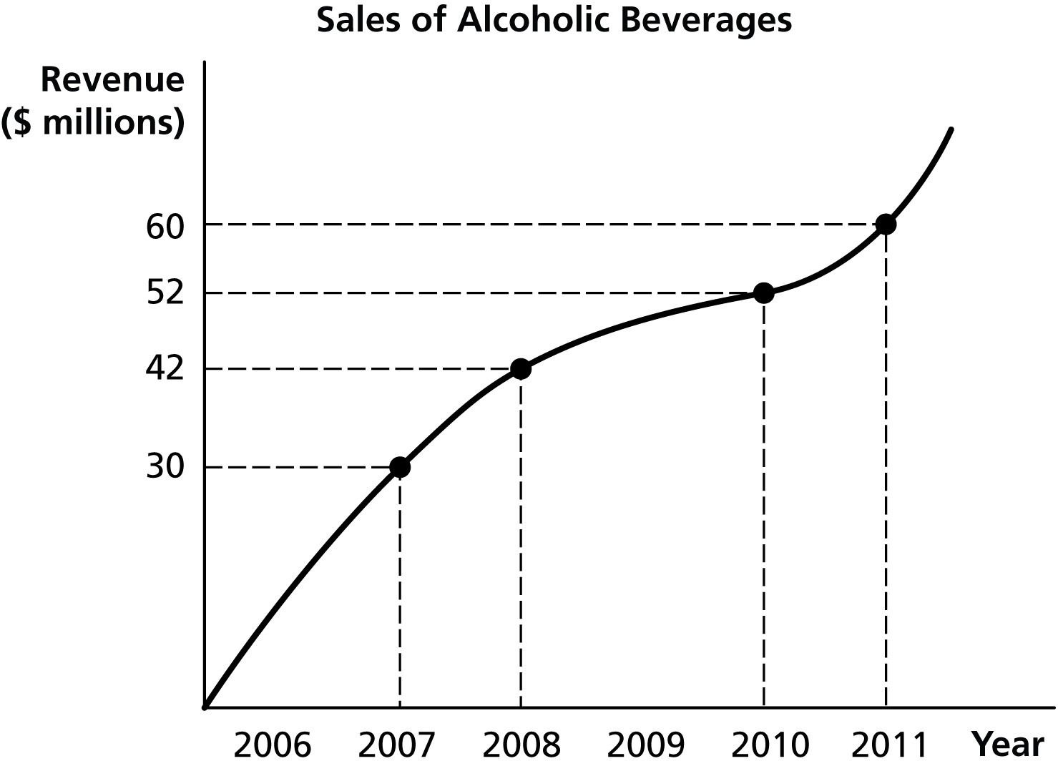
Alt text for Figure 1.1: In figure 1.1, a graph illustrates the revenue from sales of alcoholic beverages between 2006 and 2011.
Long description for Figure 1.1: The x-axis is labelled in years from 2006 to 2011. The y-axis is labelled, revenue, in millions of dollars, with the quantities 30, 42, 52 and 60 marked. The points (2007, 30), (2008, 42), (2010, 52), and (2011, 60) are plotted on the graph and joined with the vertex to form a curve. These plotted points are joined to the respective axes using dotted lines.

11) Refer to Figure 1.1. Using the information in the figure above, calculate the percentage change in sales of alcoholic beverages between 2008 and 2011.
A) 23.1%
B) 23.8%
C) 30%
D) 42.9%
Answer: D
Diff: 1 Page Ref: 30
Topic: Formulas
Learning Outcome: 1.6 Appendix A: Review the use of graphs and formulas
AACSB: Analytic Skills
Figure 1.2
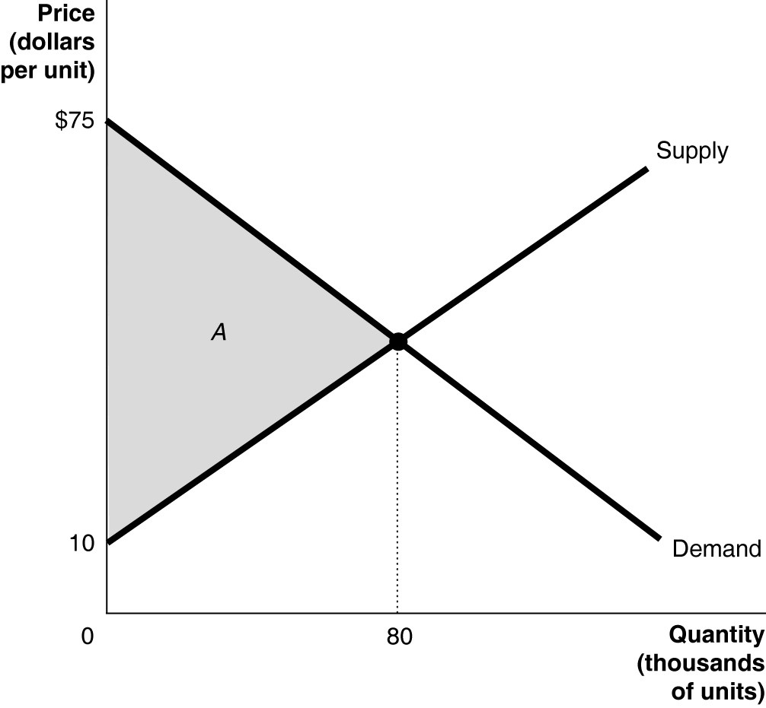
Alt text for Figure 1.2: In figure 1.2, a graph used to calculate the area of the triangle A is shown.
Long description for Figure 1.2: The x-axis is labelled with, quantity, in thousands of units, with 0 at the vertex, and point 80 marked midway on the axis. The y-axis is labelled, price, dollars per unit, with the points 10 and 75. A line, labelled, Demand, slopes downward from 75 on the y-axis, to the bottom right corner, near the end of the x-axis. Another line, labelled, Supply, slopes upward from 10 on the y-axis to the top right corner. Both these lines intersect at a point from which a vertical dotted line is drawn to point 80 on the x-axis. The area to the left of this intersection point, between the Demand and Supply curves, forms a triangle, and is shaded and labelled as, A.

12) Refer to Figure 1.2. Calculate the area of the triangle A.
A) $1.3 million
B) $2.6 million
C) $3.4 million
D) $5.2 million
Answer: B
Diff: 1 Page Ref: 30
Topic: Formulas
Learning Outcome: 1.6 Appendix A: Review the use of graphs and formulas
AACSB: Analytic Skills
Figure 1.3
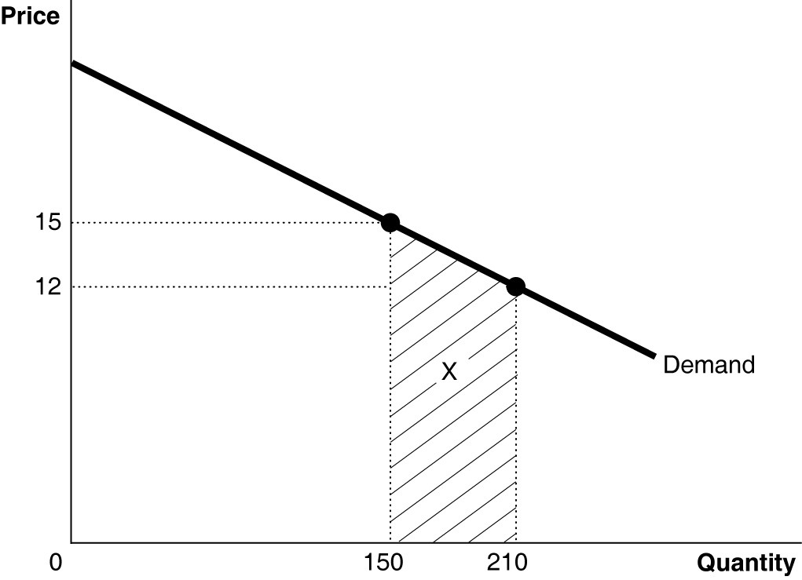
Alt text for Figure 1.3: In figure 1.3, a graph to calculate the area of the trapezoid X is shown.
Long description for Figure 1.3: The x-axis is labelled, quantity, with 0 at the vertex and points 150 and 210 marked. The y-axis is labelled price, with points 12 and 15 marked. The points (150, 15) and (210, 12) are plotted on the graph and joined to the respective axes using dotted lines. A line labelled, Demand. slopes downward from near the top of the y-axis and passes through these plotted points, down toward the bottom right corner. The area formed by these two plotted points with the x-axis and the demand curve is in the shape of a trapezoid shaded and labelled as X.

13) Refer to Figure 1.3. Calculate the area of the trapezoid X.
A) $270
B) $720
C) $810
D) $2,520
Answer: C
Diff: 2 Page Ref: 31
Topic: Formulas
Learning Outcome: 1.6 Appendix A: Review the use of graphs and formulas
AACSB: Analytic Skills

Figure 1.4
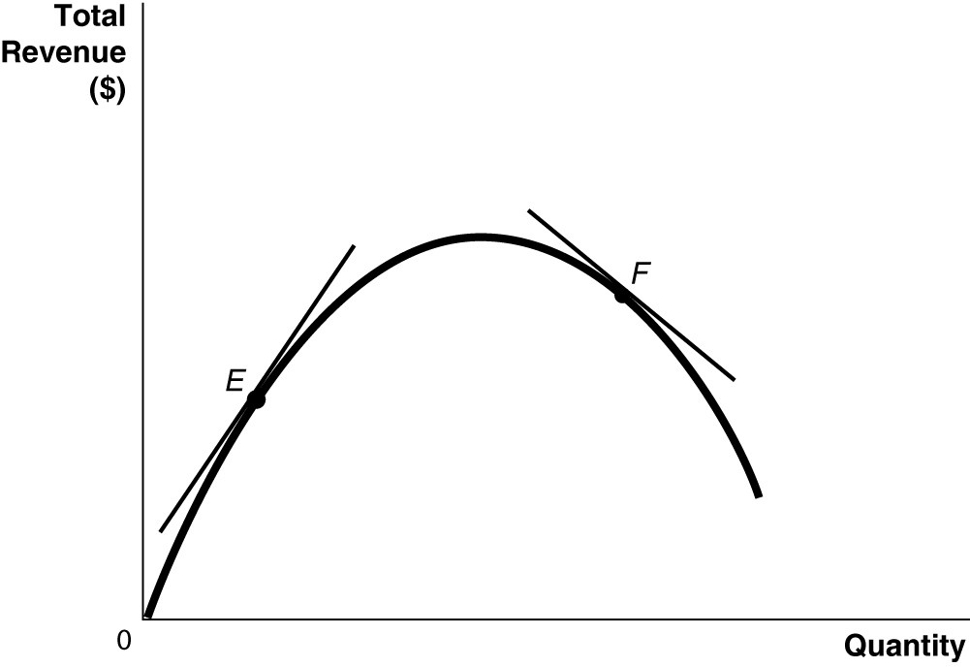
Alt text for Figure 1.4: In figure 1.4, a graph with the x-axis labelled quantity, and the y-axis labelled total revenue in dollars.
Long description for Figure 1.4: A wide, inverted U-shaped curve is drawn from the vertex upward to the center of the quadrant, and then, back down toward the x-axis. 2 points, E and F, are marked along the curve. Point E is positioned on the rising side of the curve, while point F is positioned on the falling side. A tangent passes through each of these points. The tangent for point E slopes upward from bottom left to top right of the quadrant. The tangent for point F, slopes downward from the top left to bottom right of the quadrant.

14) Refer to Figure 1.4. Which of the following statements is false?
A) The slope of the tangent at E is positive.
B) The slope of the tangent at F is negative.
C) The slope of the tangent at E and the slope of the tangent at F are equal.
D) Neither the slope of the tangent at E nor the slope of the tangent at F are equal to zero.
Answer: C
Diff: 1 Page Ref: 29-30
Topic: Slope
Learning Outcome: 1.6 Appendix A: Review the use of graphs and formulas
AACSB: Analytic Skills
15) What is the "omitted variable" problem in determining cause and effect?
A) It is a problem that arises when an insignificant variable is given too much weight in an economic analysis leading to skewed conclusions about cause and effect.
B) It is a problem that arises when a significant variable is not given enough weight in an economic experiment leading to skewed conclusions about cause and effect.
C) It is a problem that arises when an insignificant economic variable that should have been omitted is included in an economic experiment leading to false conclusions about cause and effect.
D) It is a problem that arises when an economic variable that affects other variables is omitted from an analysis and its omission leads to false conclusions about cause and effect.
Answer: D
Diff: 1 Page Ref: 26-27
Topic: Cause and Effect
Learning Outcome: 1.6 Appendix A: Review the use of graphs and formulas
AACSB: Reflective Thinking

16) ________ is a problem that occurs when one concludes that a change in variable X caused a change in variable Y when in actual fact, it is a change in variable Y that caused a change in variable X.
A) The omitted variable
B) The positive-to-negative relationship
C) Reverse causality
D) Nonlinear slope
Answer: C
Diff: 1 Page Ref: 26-27
Topic: Cause and Effect
Learning Outcome: 1.6 Appendix A: Review the use of graphs and formulas
AACSB: Reflective Thinking

17) The prevalence of Alzheimer's dementia is very high among residents living in nursing homes. A student concludes that it is likely that living in nursing home causes Alzheimer's dementia. What is the flaw in the student's reasoning?
A) The student has failed to take into account other causes of Alzheimer's disease.
B) The student is drawing a false conclusion; he is confusing cause and effect.
C) The student is using an inadequate sample size.
D) The student is drawing a false conclusion by making the mistake of omitting critical variables such as the age and gender of the residents.
Answer: B
Diff: 2 Page Ref: 26-27
Topic: Cause and Effect
Learning Outcome: 1.6 Appendix A: Review the use of graphs and formulas
AACSB: Analytic Skills
18) You explain to your roommate Surya, who makes beaded headbands, about an economic theory which asserts that consumers will purchase more of a product at lower prices than they will at higher prices. She contends that the theory is incorrect because over the past two years she has lowered the price of her headbands and yet has seen a decrease in sales. How would you respond to Surya?
A) Surya is right; she has evidence to back her claim. The theory must be erroneous.
B) Surya is making the mistake of assuming that correlation implies causation.
C) I will explain to her that she is making the error of reverse causality: it is the decrease in demand that has caused her to lower her prices.
D) I will explain to her that there are some omitted variables that have contributed to a decrease in her sales such as changes in income.
Answer: D
Diff: 2 Page Ref: 26-27
Topic: Cause and Effect
Learning Outcome: 1.6 Appendix A: Review the use of graphs and formulas
AACSB: Reflective Thinking

Table 1.2
Year | DVD Recorders (millions)
2007 | 12.5
2008 | 14.0
2009 | 17.2
2010 | 20.0
2011 | 21.7

19) Refer to Table 1.2. The table above shows the sales of DVD recorders in North America. Present the information using a bar graph.
Answer:
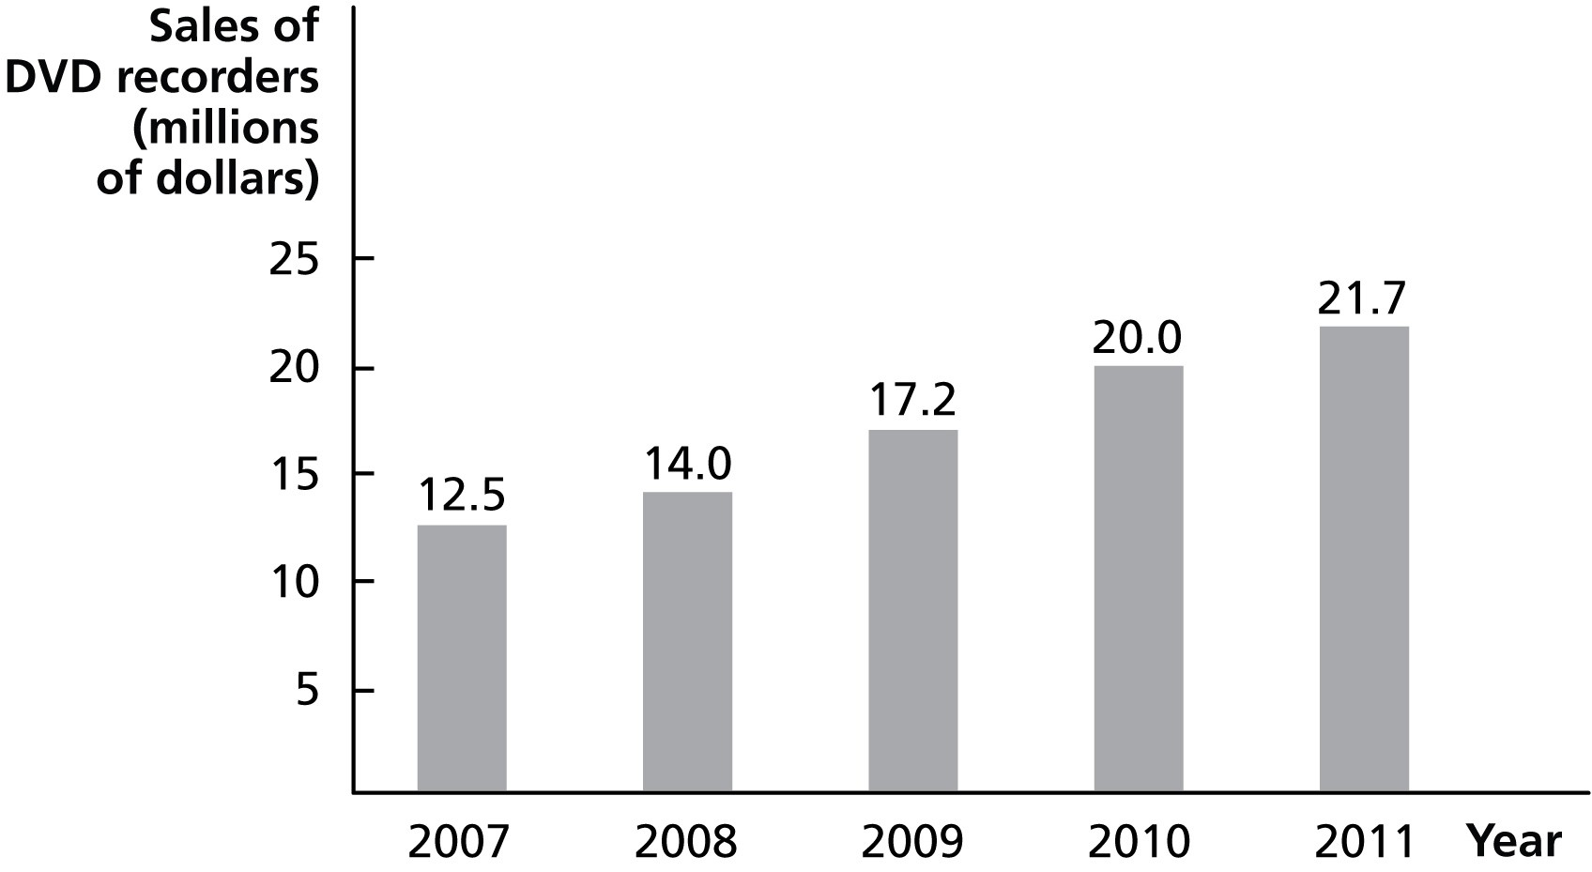
Diff: 1 Page Ref: 27/27
Topic: Graphs
Learning Outcome: 1.6 Appendix A: Review the use of graphs and formulas
AACSB: Analytic Skills

