1. Solve the equation.
​
​
a.
b.
c.
d.
e.

ANSWER: | c

2. Solve the equation.
​
​
 | a. | 9
 | b. | 4
 | c. | 5
 | d. | 1
 | e. | 0

ANSWER: | e

3. Solve the equation.
​
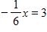
​
 | a. | ​–3
 | b. | 36
 | c. | –18
 | d. | 18
 | e. | –6

ANSWER: | c

4. Solve the equation.
​
​
 | a. | x = 66
 | b. | ​x =
 | c. | x =
 | d. | x =
 | e. | x = 7

ANSWER: | b

5. Solve the equation.
​
​
 | a.
 | b. | 28
 | c.
 | d.
 | e. | 7

ANSWER: | a

6. Solve the equation.
​
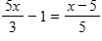
​
 | a. | ​
 | b.
 | c. | 8
 | d. | 0
 | e. | 2

ANSWER: | d

7. Solve the equation.
​
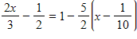
​
a.
b.
c.
d.
e.

ANSWER: | c

8. The equation in this problem leads to a linear equation. Solve for x. Because the solution to the linear equation may not be a solution to the original equation, be sure to check the solution in the original equation.
​
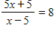
​
 | a. | x = 5
 | b. | x = 15
 | c. | x =
 | d. | x =
 | e. | no solution

ANSWER: | b

9. The equation in this problem leads to a linear equation. Solve for x. Because the solution to the linear equation may not be a solution to the original equation, be sure to check the solution in the original equation.
​
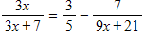
​
 | a. | x =
 | b. | x =
 | c. | x =
 | d. | x =
 | e. | no solution

ANSWER: | a

10. The equation in this problem leads to a linear equation. Solve for x. Because the solution to the linear equation may not be a solution to the original equation, be sure to check the solution in the original equation.
​
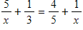
​
 | a. | x =
 | b. | x =
 | c. | x =
 | d. | x = –20
 | e. | no solution

ANSWER: | b

11. The equation in this problem leads to a linear equation. Solve for x. Because the solution to the linear equation may not be a solution to the original equation, be sure to check the solution in the original equation.
​
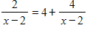
​
 | a. | x = 2
 | b. | x = –2
 | c. | x = 4
 | d. | x = 6
 | e. | x =

ANSWER: | e

12. Use a calculator to solve the equation. Round your answer to three decimal places.
​
​
 | a. | x = 1.639
 | b. | x = 0.61
 | c. | x = –0.779
 | d. | x = –1.284
 | e. | x = –1.397

ANSWER: | b

13. Use a calculator to solve the equation. Round your answer to three decimal places.
​
​
 | a. | x = 6.17
 | b. | x = 1.033
 | c. | x = 2.17
 | d. | x = 3.668
 | e. | x = 15.533

ANSWER: | d

14. Solve for y in terms of x.
​
​
a.
b.
c.
d.
e.

ANSWER: | c

15. Solve for y in terms of x.
​
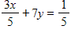
​
 | a.
 | b.
 | c.
 | d. | ​
 | e.

ANSWER: | b

16. Solve for t.
​
a.
b.
c.
d.
e.

ANSWER: | d

17. Solve 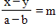 for .
​
a.
b.
c.
d.
e.

ANSWER: | d

18. Solve the inequality.
​
​
a.
b.
c.
d.
e.

ANSWER: | a

19. Solve the inequality.
​
​
a.
b.
c.
d.
e.

ANSWER: | d

20. Solve the inequality.
​
​
 | a. | x < 18
 | b. | x > 18
 | c. | x > –18
 | d. | x < –18
 | e. | x > 14

ANSWER: | b

21. Solve the inequality.
​
​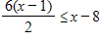
​
a.
b.
c.
d.
e.

ANSWER: | d

22. Solve the inequality.
​
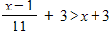
​
a.
b.
c.
d.
e.

ANSWER: | b

23. Solve the inequality and choose the graph of the solution.
​
​
 | a. | ​  ​
 | b. | ​  ​
 | c. | ​  ​
 | d. | ​  ​
 | e. | ​  ​

ANSWER: | c

24. Solve the inequality and choose the graph of the solution.
​
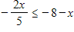
​
 | a. | ​  ​
 | b. | ​  ​
 | c. | ​  ​
 | d. | ​  ​
 | e. | ​  ​

ANSWER: | b

25. Solve the inequality and choose the graph of the solution.
​
​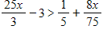
​
 | a. | ​  ​
 | b. | ​  ​
 | c. | ​  ​
 | d. | ​  ​
 | e. | ​  ​

ANSWER: | e

26. A $670,000 property is depreciated for tax purposes by its owner with the straight-line depreciation method. The value of the building y, after x months of use is given by dollars. After how many months will the value of the building be $339,000? Round your answer to the nearest whole number of months.
​
 | a. | 561 months
 | b. | 372 months
 | c. | 184 months
 | d. | 188 months
 | e. | 377 months

ANSWER: | c

27. When a $837,000 building is depreciated for tax purposes (by the straight-line method), its value y after x months of use is given by . How many months will it be before the building is fully depreciated (that is, its value is $0)?
​
 | a. | 37 months
 | b. | 372 months
 | c. | 4 months
 | d. | 27 months
 | e. | 270 months

ANSWER: | b

28. In seawater, the pressure p is related to the depth d according to , where d is in feet and p is in pounds per square inch. The Titanic was discovered at a depth of 12,460 ft. Find the pressure at this depth. Round your answer to the nearest whole number.
​
 | a. | 6,781 lb/sq in
 | b. | 22,871 lb/sq in
 | c. | 22,816 lb/sq in
 | d. | 6,811 lb/sq in
 | e. | 6796 lb/sq in

ANSWER: | d

29. Burnem, Inc. manufactures blank CDs and sells them to a distributor in packs of 500 CDs. Assume Burnem’s total cost and total revenue (in dollars) for x packs of 500 CDs are given by
​
Total cost =
Total revenue =
​
How many packs of 500 CDs must Burnem sell to break even?
​
 | a. | 490 packs
 | b. | 432 packs
 | c. | 500 packs
 | d. | 387 packs
 | e. | 865 packs

ANSWER: | a

30. Dish Systems manufactures satellite systems and has its monthly profit P in dollars related to the number of satellite systems x by . Find the number of systems that Dish Systems needs to produce and sell in order to break even.
​
 | a. | 256 systems
 | b. | 1,080 systems
 | c. | 285 systems
 | d. | 68 systems
 | e. | 270 systems

ANSWER: | e

31. The total price of a new car (including 5% sales tax) is $28,068. How much of this is tax? Round your answer to the nearest cent.
​
 | a. | $1,333.23
 | b. | $7,484,219.93
 | c. | $2,806.80
 | d. | $2,666.46
 | e. | $1,336.57

ANSWER: | e

32. Suppose a professor counts the final exam as being equal to each of the other tests in her course, and she will also change the lowest test score to match the final exam score if the final exam score is higher. If a student’s four test scores are 85, 83, 54, and 95, what is the lowest score the student can earn on the final exam and still obtain at least an 80 average for the course?
​
 | a. | 69
 | b. | 83
 | c. | 90
 | d. | 72
 | e. | 84

ANSWER: | b

33. A retired woman has $130,000 to invest. She has chosen one relatively safe investment fund that has an annual yield of 9% and another, riskier one that has an annual yield of 13%. How much should she invest in the fund yielding 9% if she would like to earn $14,000 per year from her investments?
​
 | a. | $11,700
 | b. | $16,900
 | c. | $57,500
 | d. | $72,500
 | e. | $113,100

ANSWER: | d

34. One safe investment pays 10% per year, and a more risky investment pays 18% per year. A woman who has $145,400 to invest would like to have an income of $20,000 per year from her investments. How much should she invest at in the 18% rate fund?
​
 | a. | $77,150
 | b. | $68,250
 | c. | $104,600
 | d. | $83,680
 | e. | $54,600

ANSWER: | b

35. In wildlife management, the capture-mark-recapture technique is used to estimate the populations of fish or birds in an area or to measure the infestation of insects such as Japanese beetles. Suppose 100 individuals of the species being studied are caught, marked, and released, and one week later 100 more are caught. To estimate the total number of individuals, the following relationship is used:
​
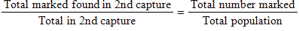
​
Suppose that 1000 beetles are captured, marked, and released. Suppose further that in the second capture of 1000 it is found that 61 are marked. What is the population estimate?
​
 | a. | 61,000
 | b. | 269
 | c. | 61
 | d. | 16,393
 | e. | 3,721

ANSWER: | d

36. For a certain product, the revenue function is and the cost function is . To obtain a profit, the revenue must be greater than the cost. Find the graph of x which shows when there is a profit.
​
 | a. | ​  ​
 | b. | ​  ​
 | c. | ​  ​
 | d. | ​  ​
 | e. | ​  ​

ANSWER: | e

37. Thrifty rents a compact car for $33 per day, and Budget rents a similar car for $21 per day plus an initial fee of $96. Which of the following graphs depicts the number of days for which it would be cheaper to rent from Budget?
​
 | a. | ​  ​
 | b. | ​  ​
 | c. | ​  ​
 | d. | ​  ​
 | e. | ​  ​

ANSWER: | b

38. In Sweetwater, Arizona, water bills are taxed on the basis of the amount of the monthly bill in order to encourage conservation. If the bill is more than $0 but less than $40, the tax is 3% of the bill; if the bill is $40 or more but less than $60, the tax is 5% of the bill; and if the bill is $60 or more, the tax is 7% of the bill. Choose the inequalities that represent the amounts of tax owed in these three cases, where T is the tax to be paid and B is the monthly bill.
​
 | a. | ​If , then  If , then  If , then
 | b. | ​If , then ​  If , then  If , then  ​
 | c. | ​If , then  If , then  If , then ​  ​
 | d. | ​If , then  If , then  If , then ​  ​
 | e. | ​If , then  If , then  If , then  ​

ANSWER: | c

39. The percent p of high school seniors who smoke cigarettes can be modeled by the equation
, where t is the number of years past 1975. Find the year in which p first becomes negative. Round your answer to the nearest year.
​
 | a. | 2576
 | b. | 2075
 | c. | 2005
 | d. | 4941
 | e. | 2074

ANSWER: | a

40. The combination of cold temperatures and wind speed determine what is called wind chill. The wind chill is a temperature that is the still-air equivalent of the combination of cold and wind. When the wind speed is 25 mph, the wind chill WC depends on the temperature t (in degrees Fahrenheit) according to . For what temperatures does it feel at least 30°F colder than the air temperature? That is, find t such that . Round your answer to two decimal places.
​ ​
a.
b.
c.
d.
e.

ANSWER: | a

41. Use the values in the following table.
​
x | -7 | -1 | 0 | 3 | 4.2 | 9 | 11 | 14 | 18 | 22
y | 0 | 0 | 1 | 5 | 9 | 12 | 35 | 22 | 22 | 60

​
If the function defined by the table is denoted by f, so that is an input or an output of f ?
​
 | a. | ​is an input of f.
 | b. | ​is an output of f.

ANSWER: | b

42. Determine whether the values in the table describe x as a function of y.
​
x | –7 | –1 | 0 | 3 | 4.2 | 9 | 11 | 14 | 18 | 22
y | –1 | 0 | 1 | 5 | 10 | 11 | 35 | 27 | 22 | 60

 | a. | True
 | b. | False

ANSWER: | True

43. Is the relation defined by the table a function of x?
​
x | 1 | 2 | 6 | 8 | 11
y | –4 | –4 | 5 | 16 | 5

 | a. | Yes
 | b. | No

ANSWER: | Yes

44. The relation defined by the table is a function. Choose the correct domain and range.
​
x | 1 | 2 | 4 | 8 | 12
y | –4 | –4 | 5 | 16 | 5
​
 | a.
 | b. | ​
 | c.
 | d.
 | e.

ANSWER: | d

45. Is the relation defined by the table a function of x?
​
x | –1 | 0 | 2 | 3 | 2
y | 0 | 2 | 4 | 6 | 9

 | a. | Yes
 | b. | No

ANSWER: | No

46. Which of the graphs below represent y as a function of x?
​
(a) | ​ | (b) | ​
​
 | a. | both (a) and (b)
 | b. | neither (a) nor (b)
 | c. | only (b)
 | d. | only (a)

ANSWER: | c

47. Which of the graphs below represent y as a function of x?
​
(a) | ​ | (b) | ​
​
 | a. | only (a)
 | b. | only (b)
 | c. | neither (a) nor (b)
 | d. | both (a) and (b)

ANSWER: | a

48. If , is y a function of x?
 | a. | Yes
 | b. | No

ANSWER: | Yes

49. If is y a function of x?
 | a. | Yes
 | b. | No

ANSWER: | No

50. If , is y a function of x?
​
 | a. | Yes
 | b. | No

ANSWER: | No

51. If , find .
​
 | a. | 3
 | b. | 15
 | c. | 27
 | d. | –3
 | e. | 45

ANSWER: | c

52. If , find .
​
 | a. | 39
 | b. | –15
 | c. | 45
 | d. | –3
 | e. | –21

ANSWER: | a

53. If , find .
​
 | a. | –2
 | b. | 0
 | c. | –2000
 | d. | –200
 | e. | 100

ANSWER: | b

54. If 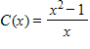, find 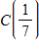.
​
 | a.
 | b.
 | c.
 | d.
 | e. | ​

ANSWER: | d

55. Let . Is ?
​
 | a. | Yes
 | b. | No

ANSWER: | No

56. Let . Find .
​
 | a.
 | b. | ​
 | c. | ​
 | d.
 | e.

ANSWER: | e

57. Let and . Does for all values of x and h?
​
 | a. | Yes
 | b. | No

ANSWER: | No

58. Let and . Does ?
​
 | a. | Yes
 | b. | No

ANSWER: | No

59. Let and . Find 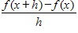 and simplify.
​
 | a.
 | b.
 | c. | ​
 | d.
 | e. | ​

ANSWER: | c

60. If and , find and simplify.
​
a.
b.
c.
d.
e.

ANSWER: | b

61. If and , find and simplify.
​
 | a. | ​
 | b.
 | c.
 | d. | ​
 | e.

ANSWER: | d

62. Suppose in the figure below. Find .
​
​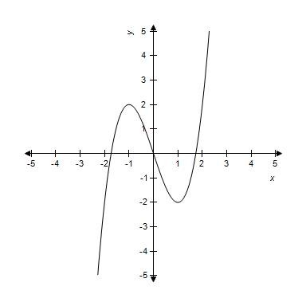
​
 | a. | 1.44225
 | b. | 1
 | c. | –1.414214
 | d. | 0
 | e. | 1.414214

ANSWER: | d

63. Suppose in the figure below. How many values of x satisfy ?
​
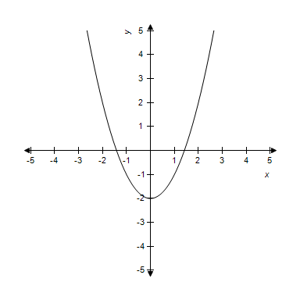
​
 | a. | 2
 | b. | 1
 | c. | 3
 | d. | 5
 | e. | 4

ANSWER: | a

64. The graph of is shown in the figure below.
​
​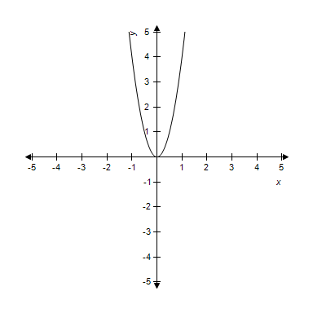
​
Does the point (2,2) lie on the graph? In other words, do the coordinates satisfy the equation?
​
 | a. | Yes
 | b. | No

ANSWER: | No

65. The graph of is shown in the figure below.
​
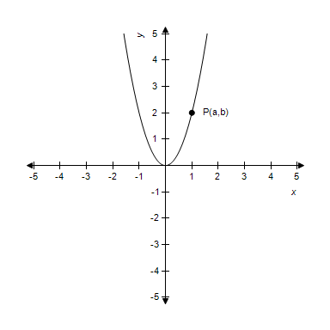
​
If the point P (with coordinates (a, b)) is on the graph, how are a and b related?
​
 | a. | ​
 | b.
 | c.
 | d.
 | e. | There is no relation.

ANSWER: | d

66. Find the domain and range of the function below.
​
​
 | a. | domain: all reals  range: real numbers
 | b. | domain: all reals  range: real numbers
 | c. | domain: real numbers  range: all reals
 | d. | domain: real numbers  range: all reals
 | e. | domain: all reals  range: real numbers

ANSWER: | a

67. Find the domain and range of the function below.
​
​
 | a. | domain: real numbers  range: real numbers
 | b. | domain: real numbers  range: real numbers
 | c. | domain: all reals  range: real numbers
 | d. | domain: real numbers  range: real numbers
 | e. | domain: all reals  range: real numbers

ANSWER: | b

68. State the domain and range of the function below.
​
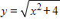
​
 | a. | domain: real numbers  range: real numbers
 | b. | domain: all reals  range: real numbers
 | c. | domain: real numbers  range: all reals
 | d. | domain: all reals  range: real numbers
 | e. | domain: real numbers  range: real numbers

ANSWER: | d

69. A function and its graph are given. Find the domain.
​
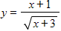
​
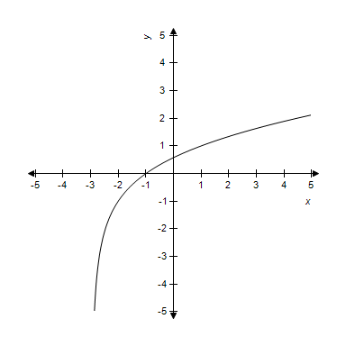
​
 | a. | domain: all real numbers
 | b. | domain: all real numbers
 | c. | domain: all real numbers
 | d. | domain: all real numbers
 | e. | domain: all real numbers

ANSWER: | a

70. A function and its graph are given. Find the domain.
​
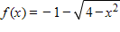
​
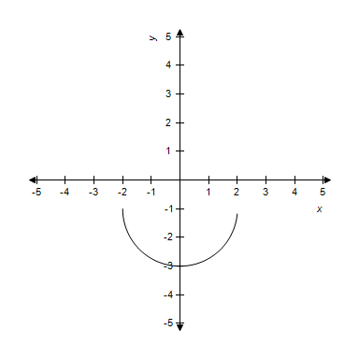​
​
 | a. | domain:
 | b. | domain:
 | c. | domain:
 | d. | domain:
 | e. | domain:

ANSWER: | d

71. For and , find .
​
 | a.
 | b. | ​
 | c.
 | d.
 | e.

ANSWER: | b

72. For and 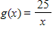, find .
​
a.
b.
c.
d.
e.

ANSWER: | c

73. For and , find .
​
a.
b.
c.
d.
e.

ANSWER: | d

74. For and , find .
​
a.
b.
c.
d.
e.

ANSWER: | c

75. For and , find .
​
a.
b.
c.
d.
e.

ANSWER: | b

76. For 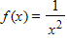 and , find .
​
a.
b.
c.
d.
e.

ANSWER: | e

77. For 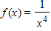, find .
​
 | a. | 1
 | b. | ​
 | c.
 | d. | ​
 | e. | x

ANSWER: | d

78. A couple seeking to buy a home decides that a monthly payment of $800 fits their budget. Their bank’s interest rate is 7.5%. The amount they can borrow A is a function of the time t in years that it will take to repay the debt. If we denote this function by , then the following table defines the function.
​
t | A | t | A
5 | 40,000 | 20 | 103,000
10 | 69,000 | 25 | 113,000
15 | 89,000 | 30 | 120,000

Source: Comprehensive Mortgage Payment Tables, Publication No. 492, Financial Publishing Co., Boston
Choose the expression in the form which describes how long they will have to make payments if they need to borrow $103,000.
​
 | a.
 | b.
 | c. | ​
 | d.
 | e. | ​

ANSWER: | e

79. When a debt is refinanced, sometimes the term of the loan (that is, the time it takes to repay the debt) is shortened. Suppose the current interest rate is 7%, and the current debt is $100,000. The monthly payment R of the refinanced debt is a function of the term of the loan t in years. If we represent this function by , then the following table defines the function.
​
t | R | t | R
5 | 1,980.12 | 15 | 898.83
10 | 1,161.09 | 20 | 775.30
12 | 1,028.39 | 25 | 706.78
​
Source: Comprehensive Mortgage Payment Tables, Publication No. 492, Financial Publishing Co., Boston
Choose the correct verbal description of .
​
 | a. | From the table, the value of is the yearly payment to repay a $100,000 loan in 12 years when the interest rate is 7%.
 | b. | From the table, the value of is the monthly payment to repay half of a $100,000 loan in 12 years when the interest rate is 7%.
 | c. | From the table, the value of is the weekly payment to repay a $100,000 loan in 12 years when the interest rate is 7%.
 | d. | From the table, the value of is the monthly payment to repay a $100,000 loan in 12 years when the interest rate is 7%.
 | e. | From the table, the value of is the monthly payment to repay a $100,000 loan in 12 years when the interest rate is 7%.

ANSWER: | e

80. If t represents the number of hours after 9:30 A.M. on Tuesday, October 5, 2004, then the graph defines the Dow Jones Industrial Average D as a function of time t. If we represent this function by use the graph to find f(6.5).
​
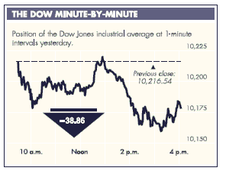
​
Source: Bloomberg Financial Markets, The New York Times, October 6, 2004. Copyright © 2004 The New York Times Co. Reprinted by permission.
​
 | a. | 10,160
 | b. | 10,175
 | c. | 10,190
 | d. | 10,217
 | e. | 10,220

ANSWER: | b

81. The number (in millions) of women in the work force, given as a function f, of the year for selected years from 1920 to 2000, is shown in the figure below. Estimate and explain its meaning.
​​
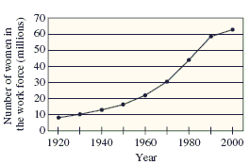
​
Source: 2004 World Almanac
​
 | a. | : The number of women in the work force increased by 59,000,000.
 | b. | : The number of women in the work force decreased by 16,000,000.
 | c. | : The number of women in the work force did not increase.
 | d. | : The number of women in the work force increased by 16,000,000.
 | e. | : The number of women in the work force decreased by 59,000,000

ANSWER: | d

82. The equation 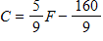 gives the relation between temperature readings in Celsius and Fahrenheit. If a temperature has reading of –20 Fahrenheit, what is the corresponding reading in Celsius?
​
 | a. | –28.89 C
 | b. | ​6.67C
 | c. | –53.78C
 | d. | –18.22C
 | e. | –11.17C

ANSWER: | a

83. The profit from the production and sale of a product is where x represents the number of units produced and sold. Give the value of P​(3,000).
​
 | a. | ​$–148,000
 | b. | $–53,000
 | c. | $–37,000
 | d. | $53,000
 | e. | $323,000

ANSWER: | b

84. Suppose that the cost C (in dollars) of removing p percent of the particulate pollution from the smokestacks of an industrial plant is given by 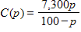. Find the domain of this function. Recall that p represents the percent pollution that is removed.
​
 | a.
 | b. | ​
 | c. | ​
 | d.
 | e.

ANSWER: | d

85. If a test that has reliability r is lengthened by a factor , the reliability R of the new test is given by
​
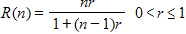
​
​If the reliability is r = 0.5, the equation becomes 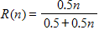. When the test length is unchanged, the reliability r = R(1) = 0.5. If the length of the test is doubled, the reliability r = R(2). What percent improvement is there in the reliability when the test length is doubled?
​
 | a. | 25.0%
 | b. | 33.3%
 | c. | 75.0%
 | d. | 66.7%
 | e. | 16.7%

ANSWER: | b

86. If 140 feet of fence is to be used to fence in a rectangular yard, then the resulting area of the fenced yard is given by A = x(70-x), where x is the width of the rectangle. Is A a function of x?
 | a. | Yes
 | b. | No

ANSWER: | Yes

87. If a box with a square cross section is to be sent by a delivery service, there are restrictions on its size such that its volume is given by the function , where x is the length of each side of the cross section (in inches). What restrictions must be placed on x (the domain) so that the volume makes physical sense?
​
 | a. | 0 < x < 66
 | b. | -66 < x < 0
 | c. | 0 < x < 22
 | d. | 0 < x < 3
 | e. | -3 < x < 3

ANSWER: | c

88. For many species of fish, the weight W is a function of the length L that can be expressed by
​
​
Suppose that for a particular species k = 0.03 and that for this species the length (in centimeters) is a function of the number of years t the fish has been alive, and that this function is given by
​
​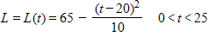
​
Find in order to express W as a function of the age t of the fish.
​
 | a.
 | b. | ​
 | c.
 | d.
 | e.

ANSWER: | e

89. Suppose that a company’s revenue is a function g of the number of customers C. Suppose also that the amount spent on advertising A affects the number of customers so that is a function f of A. The function is defined, since . Is defined?
​
 | a. | Yes
 | b. | No

ANSWER: | No

90. Two of the processes (functions) used by a manufacturer of factory-built homes are sanding (denote this as function p) and painting (denote this as function s). Choose the correct explanation for the functional expression .
​
 | a. | painting the door and then sanding
 | b. | sanding the door and then painting
 | c. | sanding the door twice
 | d. | sanding the door and then painting
 | e. | painting the door twice

ANSWER: | d

91. A shipping crate has a square base with sides of length x feet, and it is half as tall as it is wide. If the material for the bottom and sides of the box costs $2.25 per square foot and the material for the top costs $1.25 per square foot, express the total cost (in dollars) of material for the box as a function of x.
​
 | a.
 | b.
 | c. | ​
 | d. | ​
 | e.

ANSWER: | a

92. A company handles an apartment building with 50 units. Experience has shown that if the rent for each of the units is $380 per month, then all of the units will be filled; however, one unit will become vacant for each $30 increase in the monthly rate. If x represents the number of $30 increases, express the revenue R from the building as a function of x.
​
 | a. | ​R(x) = 380+30x
 | b. | R(x) = (380+30x)(50-x)
 | c. | R(x) = 50(380+30x)
 | d. | R(x) = 30(380-30x)(50-x)
 | e. | R(x) = 50(380-30x)

ANSWER: | b

93. Find the intercepts of the following function.
​
​
 | a. | x-intercept: 24  y-intercept: –15
 | b. | x-intercept: –15  y-intercept: 24
 | c. | x-intercept: –3  y-intercept: 3
 | d. | x-intercept: 15  y-intercept: –24
 | e. | x-intercept: 8  y-intercept: –5

ANSWER: | d

94. Find the intercepts of the following function.
​
​
 | a. | x-intercept: –8.5  y-intercept: 17
 | b. | x-intercept: 17  y-intercept: 34
 | c. | x-intercept: –34  y-intercept: 8.5
 | d. | x-intercept: –17  y-intercept: 2
 | e. | x-intercept: 8.5  y-intercept: –17

ANSWER: | a

95. Find the intercepts of the following function.
​
​
 | a. | x-intercept:  y-intercept:
 | b. | x-intercept:  y-intercept:
 | c. | x-intercept:  y-intercept:
 | d. | x-intercept:  y-intercept:
 | e. | x-intercept:  y-intercept:

ANSWER: | b

96. Find the slope of the line passing through the given pair of points.
​
and
​
 | a. | 10
 | b. | 3
 | c. | –2
 | d. | –7
 | e. | The slope is undefined.

ANSWER: | c

97. Find the slope of the line passing through the given pair of points.
​
and
​
 | a.
 | b. | 1
 | c.
 | d.
 | e. | The slope is undefined.

ANSWER: | b

98. Find the slope of the line passing through the given pair of points.
​
and
​
 | a.
 | b.
 | c.
 | d. | 0
 | e. | The slope is undefined.

ANSWER: | e

99. If a line is vertical, then its slope is undefined.
 | a. | True
 | b. | False

ANSWER: | True

100. What is the rate of change of the function whose graph is a line passing through and ?
​
 | a. | 1
 | b. | –4
 | c. | –4
 | d. | 0
 | e. | The rate of change is undefined.

ANSWER: | d

101. What is the rate of change of the function whose graph is a line passing through and ?
​
a.
b.
c.
d.
e.

ANSWER: | b

102. For the given graph, determine whether the line has a slope that is positive, negative, zero, or undefined.
​
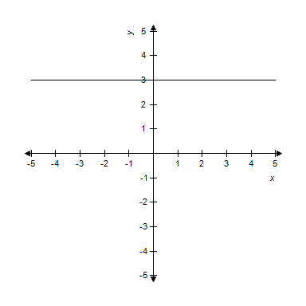
​
 | a. | undefined
 | b. | zero
 | c. | positive
 | d. | negative

ANSWER: | b

103. Find the slope m and y-intercept b of the line whose equation is given below.
​
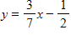
​
a.
b.
c.
d.
e.

ANSWER: | c

104. Choose the graph that represents the equation below.
​
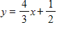​
​
 | a. | ​  ​ | b. | ​  ​
 | c. | ​  ​ | d. | ​  ​
 | e. | ​  ​

ANSWER: | e

105. Find the slope m and y-intercept b of the line whose equation is given below.
​
y = –1
​
 | a. | m = –1, b = 0
 | b. | m = 0, b = 0
 | c. | m = –1, b = 1
 | d. | m = 0, b = –1
 | e. | Both m and b are undefined.

ANSWER: | d

106. Find the slope m and y-intercept b of the line whose equation is given below.
​
x = –
​
 | a. | ​m = – , b = 0
 | b. | m = 0, b = 0
 | c. | m = – , b =
 | d. | m = 0, b = –
 | e. | Both m and b are undefined.

ANSWER: | e

107. Find the slope m and y-intercept b of the line whose equation is given below.
​
​
a.
b.
c.
d.
e.

ANSWER: | b

108. Choose the graph that represents the equation below.
​
​
​
 | a. | ​  ​ | b. | ​  ​
 | c. | ​  ​ | d. | ​  ​
 | e. | ​  ​

ANSWER: | b

109. Choose the equation of the line with the given slope and y-intercept.
​
slope: y-intercept :
​
a.
b.
c.
d.
e.

ANSWER: | c

110. Choose the equation of the line with the given slope and y-intercept.
​
slope: 8 y-intercept: 6
​
a.
b.
c.
d.
e.

ANSWER: | b

111. Choose the correct graph of the line with the given slope and y-intercept.​
​
slope: y-intercept:
​
 | a. | ​  ​ | b. | ​  ​
 | c. | ​  ​ | d. | ​  ​
 | e. | ​  ​

ANSWER: | d

112. Write the equation for line that passes through the given point and has the slope indicated.
​
​ with slope
​
a.
b.
c.
d.
e.

ANSWER: | e

113. Write the equation and graph the line that passes through the given point and has the slope indicated.
​
​ with slope
​
 | a. | ​ | b.
 | c. | ​ | d.
 | e. | ​

ANSWER: | b

114. Write the equation and graph the line that passes through the given point and has the slope indicated.
​
​(4,–2) with slope 2
​
 | a. | ​ | b. | ​  ​
 | c. |  | d.
 | e. | ​

ANSWER: | d

115. Write the equation and graph the line that passes through the given point and has the slope indicated.
​
​(3,3) with 0 slope
​
 | a. |  | b. | ​
 | c. |  | d.
 | e.

ANSWER: | b

116. Write the equation of the line passing through the given pair of points.
​
​(–6,5) and (–4,9)
​
 | a. | ​
 | b.
 | c.
 | d.
 | e. | ​

ANSWER: | d

117. Write the equation of the line passing through the given pair of points.
​
​ and
​
 | a. | ​
 | b. | ​
 | c.
 | d.
 | e.

ANSWER: | b

118. Write the equation of the line passing through the given pair of points.
​
​(5,11) and (12,4)
​
 | a.
 | b.
 | c.
 | d.
 | e. | ​

ANSWER: | a

119. Determine whether the following pairs of equations represent parallel lines, perpendicular lines, or neither of these.
​
​
​
 | a. | parallel lines
 | b. | perpendicular lines
 | c. | neither

ANSWER: | b

120. Determine whether the following pairs of equations represent parallel lines, perpendicular lines, or neither of these.
​
​
 | a. | parallel lines
 | b. | perpendicular lines
 | c. | neither

ANSWER: | a

121. Determine whether the following pairs of equations represent parallel lines, perpendicular lines, or neither of these.
​
​
 | a. | parallel lines
 | b. | perpendicular lines
 | c. | neither

ANSWER: | c

122. Determine whether the following pairs of equations represent parallel lines, perpendicular lines, or neither of these.
​
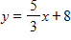
​
 | a. | parallel lines
 | b. | perpendicular lines
 | c. | neither

ANSWER: | b

123. Write the equation of the line through (2,4) that is parallel to

 | a.
 | b.
 | c. | ​
 | d.
 | e.

ANSWER: | b

124. Write the equation of the line through (8, –7) that is perpendicular to
​
 | a. | ​
 | b.
 | c. | ​
 | d. | ​
 | e.

ANSWER: | e

125. Using data from the Internal Revenue Service, the per capita tax burden T (in hundreds of dollars) can be described by , where t is the number of years past 1980. Find the value of T in 1990. Round your answer to the nearest dollar.
​
 | a. | $4,127
 | b. | $2,500
 | c. | $4,160
 | d. | $4,660
 | e. | $3,660

ANSWER: | c

126. The percent of the U.S. population with Internet service can be described by , where x is the number of years past 1995. What interpretation could be given to the y-intercept of this equation?
​
 | a. | In 1995, 13.13% more of the U.S. population had Internet access than in the previous year.
 | b. | In 1995, the number of people in the U.S. with Internet access increased at a rate of 13.13% per year.
 | c. | At present, the number of people in the U.S. with Internet access is increasing at a rate of 13.13% per year.
 | d. | In 1995, 13.13% of the U.S. population had Internet access.
 | e. | At present, 13.13% of the U.S. population has Internet access.

ANSWER: | d

127. The percent p of high school seniors who smoke cigarettes can be described by , where t is the number of years past 1975. Choose the sentence that correctly interprets the meaning of the slope as a rate of change.
​
 | a. | The slope represents the annual 28.68% increase of high school seniors who smoke.
 | b. | The slope represents the annual 6% decrease of high school seniors who smoke.
 | c. | The slope represents the annual 0.06% decrease of high school seniors who smoke.
 | d. | The slope represents the annual 0.06% increase of high school seniors who smoke.
 | e. | The slope represents the annual 28.68% decrease of high school seniors who smoke.

ANSWER: | c

128. Two models for measuring the effects of high temperature and humidity are the Summer Simmer Index and the Apparent Temperature. For an outside temperature of , these indices relate the relative humidity, H (expressed as a decimal), to the perceived temperature as follows.​
​
Summer Simmer:
Apparent Temperature:
​
For each index, find the point that corresponds to a relative humidity of 45%. Round your answer to two decimal places.
​
 | a. | ​S = 116.84 A = 110.61
 | b. | ​​S = 115.92 A = 109.79
 | c. | ​​​S = 115.01 A = 108.96
 | d. | ​​​S = 120.50 A = 113.92
 | e. | ​​​S = 121.07 A = 132.50

ANSWER: | b

129. According to the U.S. Bureau of the Census, the relation between the average annual earnings of males and females with various levels of educational attainment can be modeled by the function F = 0.551M + 6.686 , where M and F represent the average annual earnings (in thousands of dollars) of males and females, respectively. Choose the correct interpretation of the slope.​
​
 | a. | For each $1 increase in the males' earnings, the females' earning increases by $0.551.
 | b. | For each $1000 increase in the males' earnings, the females' earning increases by $55.1.
 | c. | For each $1000 increase in the males' earnings, the females' earning decreases by $55.1.
 | d. | For each $1 increase in the males' earnings, the females' earning decreases by $0.551.
 | e. | For each $100 increase in the males' earnings, the females' earning increases by $5.51.

ANSWER: | a

130. According to the U.S. Bureau of the Census, the relation between the average annual earnings of males and females with various levels of educational attainment can be modeled by the function F = 0.569M + 6.293 where M and F represent the average annual earnings (in thousands of dollars) of males and females, respectively. When the average annual earnings for males reach $70,000, what does the equation predict for the average annual earnings for females? Round your answer to the nearest dollar.
​
 | a. | $123,029
 | b. | $39,830
 | c. | $46,123
 | d. | $42,681
 | e. | $36,991

ANSWER: | c

131. Suppose the percent of U.S. high school seniors from 1975 to 2001 who used marijuana can be modeled by , where x is the number of years past 1975. What is the slope of the graph of this function?
​
 | a. | – 0.292
 | b. | 0.186
 | c. | – 2.917
 | d. | – 0.186
 | e. | 29.166

ANSWER: | d

132. Suppose the percent of U.S. high school seniors from 1975 to 2001 who used marijuana can be modeled by percent, where x is the number of years past 1975. Choose the correct interpretation the slope in this equation as a rate of change.
​
 | a. | The percentage of U.S. high school seniors who used marijuana increased at a rate of 0.177% per year.
 | b. | The percentage of U.S. high school seniors who used marijuana decreased at a rate of 17.7% per year.
 | c. | The percentage of U.S. high school seniors who used marijuana decreased at a rate of 0.177% per year.
 | d. | The percentage of U.S. high school seniors who used marijuana increased at a rate of 17.7% per year.
 | e. | The percentage of U.S. high school seniors who used marijuana decreased at a rate of 1.77% per year.

ANSWER: | c

133. Residential customers who heat their homes with natural gas have their monthly bills calculated by adding a base service charge of $5.72 per month and an energy charge of 46.87 cents per hundred cubic feet. Write an equation for the monthly charge y (in dollars) in terms of x, the number of hundreds of cubic feet used.
​
a.
b.
c.
d.
e.

ANSWER: | b

134. Data from 2003 for various groups shows that for each $100 increase in the median weekly income for whites, the median weekly income of blacks increases by $60.4. When the median weekly income for whites was $665 and for blacks was $517. Let W represent the median weekly income for whites and B the median weekly income for blacks, and write the equation of the line that gives B as a linear function of W.
​
 | a.
 | b. | ​
 | c.
 | d.
 | e.

ANSWER: | a

135. The retirement plan for Pennsylvania state employees is based on the following formula: “2.5% of average final compensation multiplied by years of credited service” (Source: Pennsylvania State Employees Retirement System, 2001). Let p represent annual retirement pension and y denote the years of service. For someone with average final compensation of $70,000, write the linear equation that gives p in terms of y.
​
 | a.
 | b.
 | c. | ​
 | d.
 | e.

ANSWER: | b

136. The retirement plan for Pennsylvania state employees is based on the following formula: “2.5% of average final compensation multiplied by years of credited service” (Source: Pennsylvania State Employees Retirement System, 2001). Let p represent annual retirement pension, and c denote the average final compensation. For someone who wants to retire in 5 years, write the linear equation that gives p in terms of c.
​
 | a.
 | b. | ​
 | c.
 | d. | ​
 | e.

ANSWER: | d

137. The following table gives the number of drinks and the resulting blood alcohol percent for a 180-pound man legally considered driving under the influence (DUI). Is the average rate of change of the blood alcohol percent with respect to the number of drinks a constant?
​
Number ofDrinks | 5 | 6 | 7 | 8 | 9 | 10
Blood Alcohol Percent | 0.2 | 0.22 | 0.24 | 0.26 | 0.28 | 0.3

 | a. | Yes
 | b. | No

ANSWER: | Yes

138. It has been estimated that a certain stream can support 90,000 fish if it is pollution-free. It has further been estimated that for each ton of pollutants in the stream, 1,700 fewer fish can be supported. Assuming the relationship is linear, write the equation that gives the population of fish p in terms of the tons of pollutants x.
​
a.
b.
c.
d.
e.

ANSWER: | e

139. Each day, a young person should sleep 8 hours, plus hour for each year that the person is under 19 years of age. Assuming the relation is linear, write the equation relating hours of sleep y and age x where .
​
a.
b.
c.
d.
e.

ANSWER: | c

140. Suppose the cost of a business property is $480,000, and a company wants to use a straight-line depreciation schedule for a period of 240 months. If y is the value of this property after x months, then the company’s depreciation schedule will be the equation of a line through (0,480000) and (240,0). Write the equation of this depreciation schedule.
​
a.
b.
c.
d.
e.

ANSWER: | c

141. Use a graphing utility with the standard viewing window and to graph the function. Choose the correct graph below.
​
​
 | a. | ​  ​ | b. | ​  ​
 | c. | ​  ​ | d. | ​  ​
 | e. | ​  ​

ANSWER: | c

142. Use a graphing utility with the standard viewing window and to graph the function. Choose the correct graph below.
​
​
 | a. | ​  ​ | b. | ​  ​
 | c. | ​  ​ | d. | ​  ​
 | e. | ​  ​

ANSWER: | b

143. Use a graphing utility with the standard viewing window and to graph the function. Choose the correct graph below.
​
​
 | a. | ​  ​ | b. | ​  ​
 | c. | ​  ​ | d. | ​  ​
 | e. | ​  ​

ANSWER: | d

144. Use a graphing utility with the standard viewing window and to graph the function. Choose the correct graph below.
​
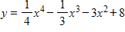
​
 | a. | ​  ​ | b. | ​  ​
 | c. | ​  ​ | d. | ​  ​
 | e. | ​  ​

ANSWER: | a

145. Use a graphing utility with the standard viewing window and to graph the function. Choose the correct graph below.
​
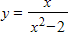
​
 | a. | ​  ​ | b. | ​  ​
 | c. | ​  ​ | d. | ​  ​
 | e. | ​  ​

ANSWER: | e

146. Use a graphing utility with the standard viewing window and to graph the function. Choose the correct graph below.
​​
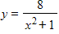
​
 | a. | ​  ​ | b. | ​  ​
 | c. | ​  ​ | d. | ​  ​
 | e. | ​  ​

ANSWER: | b

147. ​Use a graphing utility with the specified range to graph the equation. Is the graph below the graph of the given equation?
​
​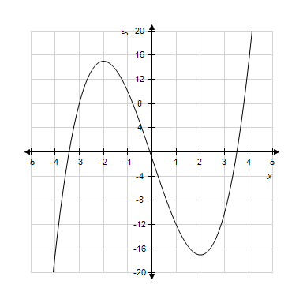
​
 | a. | ​No
 | b. | ​Yes

ANSWER: | b

148. ​Use a graphing utility with the specified range to graph the equation. Is the graph below the graph of the given equation?
​
​
​​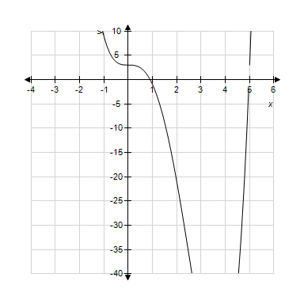
​
 | a. | ​No
 | b. | ​Yes

ANSWER: | a

149. Graph the equation with a graphing utility using the specified range and then using the standard viewing window. Does the graph below show the specified range or the standard window?
​
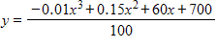
​
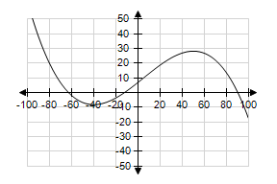
​
 | a. | specified range
 | b. | standard window

ANSWER: | a

150. ​Graph the equation with a graphing utility using the specified range. Is the graph below the graph of the given equation?
​
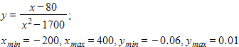
​
​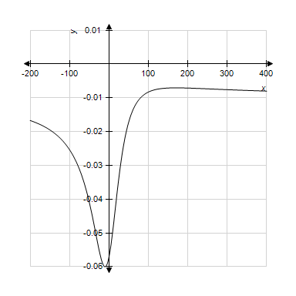
​
 | a. | ​yes
 | b. | ​no

ANSWER: | b

151. Graph the equation with a graphing utility; use a window that includes the intercepts. Which range shows both the intercepts?
​
​
 | a. | x-min = –100 x-max = 300  y-min = –10,000 y-max = 30,000
 | b. | x-min = –100 x-max = 300  y-min = –10,000 y-max = 50,000
 | c. | x-min = –100 x-max = 500  y-min = –10,000 y-max = 30,000
 | d. | x-min = –100 x-max = 500  y-min = –10,000 y-max = 50,000
 | e. | ​x-min = 100 x-max = 300  y-min = 10,000 y-max = 30,000

ANSWER: | d

152. Graph the function below and experiment with the viewing window to obtain a complete graph, adjusting the ranges where necessary. Does the figure below show the complete graph?
​
​​
​
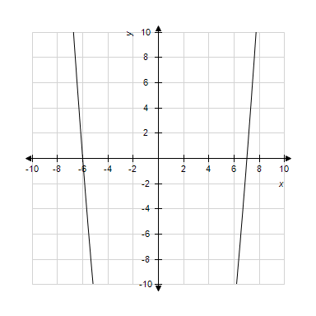
​
 | a. | Yes
 | b. | No

ANSWER: | No

153. Graph the function below and experiment with the viewing window to obtain a complete graph, adjusting the ranges where necessary. Does the figure below show the complete graph?
​
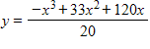
​
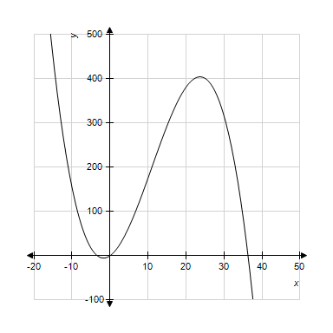
​
 | a. | Yes
 | b. | No

ANSWER: | Yes

154. ​Graph the equation with a standard window and on a graphing utility. Does the graph appear to be a linear function?
​
​​
​
 | a. | ​no
 | b. | ​yes

ANSWER: | a

155. ​Graph the equation with a standard window and on a graphing utility. Does the graph appear to be a linear function?
​
​
​
 | a. | ​no
 | b. | ​yes

ANSWER: | a

156. ​Graph the equation with a standard window and on a graphing utility. Does the graph appear to be a linear function?
​
​​
​
 | a. | ​yes
 | b. | ​no

ANSWER: | a

157. ​Graph the equation with a standard window and on a graphing utility. Does the graph appear to be a linear function?
​
​​
​
 | a. | ​no
 | b. | ​yes

ANSWER: | b

158. Complete the problem by using your calculator. Round your answer to three decimal places.
​
If find and
​
 | a. | and
 | b. | and
 | c. | and
 | d. | and
 | e. | and

ANSWER: | c

159. Complete the problem by using your calculator.​
​
If 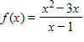, find and
​
 | a. | and
 | b. | and
 | c. | and
 | d. | and
 | e. | and

ANSWER: | b

160. Graph the function using a window that gives a complete graph. What does y approach as x gets large?
​
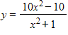
​
 | a. | 0
 | b. | –10
 | c. | 1
 | d. | 10
 | e. | 5

ANSWER: | d

161. Graph the function using a window that gives a complete graph. Does the figure below show the complete graph?
​
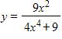
​
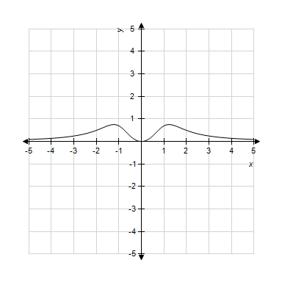
​
 | a. | Yes
 | b. | No

ANSWER: | Yes

162. Graph the function using a window that gives a complete graph. Does the figure below show the complete graph?
​
​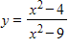
​
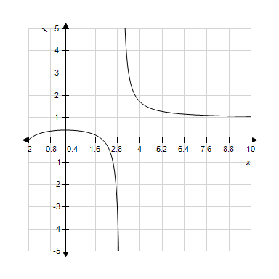
​
 | a. | Yes
 | b. | No

ANSWER: | No

163. Use the x-intercept method to find the solution to this equation.
​
​
a.
b.
c.
d.
e.

ANSWER: | e

164. Use the x-intercept method to find the solution of the equation below where . Round your answer to five decimal places.
​
​
 | a. | x = 0.71845
 | b. | x = –2.55178
 | c. | x = 3.46845
 | d. | x = –1.91319
 | e. | x = –0.07986

ANSWER: | a

165. Approximate the zeros of the function below by approximating the x-intercepts with a graphing utility. Round your answer to four decimal places
​
​
a.
b.
c.
d.
e.

ANSWER: | d

166. With U.S. Census Bureau data, the model that relates the per capita annual income (in thousands of dollars) of blacks B and whites W was found to be . Use a graphing utility to graph this equation for the range W-min = 0, W-max = 30; B-min = 0, B-max = 30. Is the image below the correct graph of the function?
​
​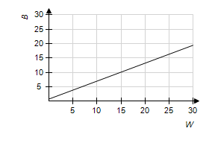
​
 | a. | ​no
 | b. | ​yes

ANSWER: | a

167. Suppose that the consumer expenditure E (in dollars) depends on the market price p per unit (in dollars) according to . Graph this equation with a graphing utility and the range Because E represents consumer expenditure, only values of have meaning. Determine the values of p for which .
​ ​
a.
b.
c.
d.
e.

ANSWER: | d

168. The height above ground, S (in feet), of a ball thrown vertically into the air is given by , where t is the time in seconds since the ball was thrown. Graph this equation with a graphing utility and the range . Estimate the time at which the ball is at its highest point. Round your answer to two decimal places.
​
 | a. | 10.18
 | b. | 0.20
 | c. | 0.05
 | d. | 20.36
 | e. | 5.09

ANSWER: | e

169. An advertising agency has found that when it promotes a new product in a city of 350,000 people, the rate of change R of the number of people who are aware of the product is related to the number of people x who are aware of it and is given by , where and Graph this equation with a graphing utility. Based on this graph, is the rate of change increasing or decreasing?
​
 | a. | decreasing
 | b. | increasing

ANSWER: | a

170. In a study using 50 foreign-language vocabulary words, the learning rate L (in words per minute) was found to depend on the number of words already learned x, according to the equation . Use the intercepts to determine a window, and then use a graphing utility to graph the equation for Based on the graph, is the learning rate increasing or decreasing?
​
 | a. | increasing
 | b. | decreasing

ANSWER: | b

171. The percent P of men 65 years of age or older in the labor force can be modeled by , where x is the number of years past 1890 (Source: U.S. Bureau of the Census). Plot this function using a graphing utility. What range of x-values and y-values do you need to use to view this graph for the years 1890 to 1990?
​
 | a. | x-min = 0, x-max = 100  y-min = 0, y-max = 60
 | b. | x-min = –100, x-max = 0  y-min = 0, y-max = 70
 | c. | x-min = –100 , x-max = 100  y-min = 0, y-max = 50
 | d. | x-min = 0, x-max = 70  y-min = 0, y-max = 50
 | e. | x-min = 0, x-max = 100  y-min = 0, y-max = 70

ANSWER: | e

172. The number (in millions) of U.S. cellular telephone subscribers can be described by , where x is the number of years past 1990. For years beyond 2010, does this graph increase or decrease? (Look at this graph in a window that includes these years.)
​
 | a. | increases
 | b. | decreases

ANSWER: | a

173. The Millcreek watershed area was heavily strip-mined for coal during the late 1960s. Because of the resulting pollution, the streams cannot support fish. Suppose the cost C of obtaining stream water that contains p percent of the current pollution levels is given by 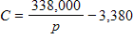. Because p is the percent of current pollution levels, . Use the restriction on p and determine a range for C so that an accurate graph can be obtained with a graphing utility. Describe what happens to the cost as p takes on positive values near 0.
​
 | a. | Near p = 0, the cost approaches $3,380.
 | b. | Near p = 0, the cost grows without bound.
 | c. | Near p = 0, the cost approaches $338,000.
 | d. | Near p = 0, cost approaches $0.
 | e. | Near p = 0, the cost becomes negative.

ANSWER: | b

174. Suppose the cost C of removing p percent of the particulate pollution from the exhaust gases at an industrial site is given by 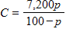. Because p is the percent particulate pollution, we know . Use the restriction on p and experiment with a C-range to obtain an accurate graph of the equation. Determine the p-intercept and explain its meaning.
​
 | a. | The p-intercept is (0,0) , meaning that it costs nothing to remove all of the particulate pollution.
 | b. | The p-intercept is (0,72), meaning that there is a cost of $72 before the removal of the particulate pollution begins.
 | c. | There is no p-intercept, which means that it is impossible to remove all of the particulate pollution.
 | d. | The p-intercept is (0,0), meaning that it costs nothing to remove none of the particulate pollution.
 | e. | The p-intercept is (0, -72), meaning that there is a negative cost of $72 before the removal of the particulate pollution begins.

ANSWER: | d

175. The number of millions of short tons of carbon monoxide emissions y in the United States can be described by , where x is the number of years past 1970 (Source: Environmental Protection Agency). Use a graphing utility to plot this function and then use the graph to determine how many short tons of emissions occurred in 1990?
​
 | a. | 177.57 million short tons
 | b. | 341.86 million short tons
 | c. | 126.54 million short tons
 | d. | 250.66 million short tons
 | e. | 149.86 million short tons

ANSWER: | e

176. The graphs of the two equations below are shown. The lines representing these equations may be the same, may intersect once, or may be parallel. Decide whether the system of equations in the problem has one solution, no solution, or an infinite number of solutions.
​
and
​
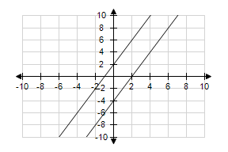
 | a. | infinite solutions
 | b. | no solution
 | c. | one solution

ANSWER: | b

177. The graphs of the two equations below are shown. The lines representing these equations may be the same, may intersect once, or may be parallel. Decide whether the system of equations in the problem has one solution, no solution, or an infinite number of solutions.
​
and
​
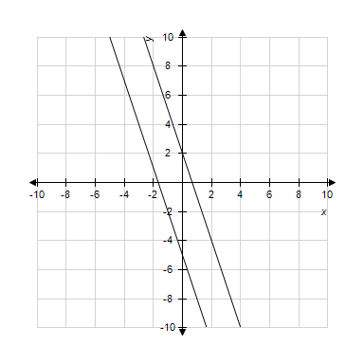
​
 | a. | no solution
 | b. | ​one solution
 | c. | infinite solutions

ANSWER: | a

178. Solve the system of equations by using graphical methods.
​
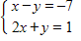
​
 | a. | (–5,5)
 | b. | (–5,–3)
 | c. | (–2,5)
 | d. | (–2,–5)
 | e. | There is no solution to the equations.

ANSWER: | c

179. Solve the system of equations by using graphical methods.
​
​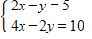
​
 | a. | (2,5)
 | b. | (–2,–5)
 | c. | (5,–2
 | d. | (–5,5)
 | e. | There are infinitely many solutions to the equations.

ANSWER: | e

180. Solve the system of equations by substitution.
​
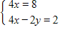
​
 | a. | ,
 | b. | ​,
 | c. | ,
 | d. | ,
 | e. | ,

ANSWER: | d

181. Solve the system of equations by substitution.
​
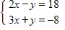
​
 | a. | (–30,11)
 | b. | (2,–30)
 | c. | (–14,11)
 | d. | (2,–14)
 | e. | (11,2)

ANSWER: | d

182. Solve the system by elimination, or by any convenient method.
​
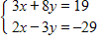
​
 | a. | (5,22)
 | b. | (–7,5)
 | c. | (10,5)
 | d. | (–7,55)
 | e. | (–1,5)

ANSWER: | b

183. Solve the system by elimination, or by any convenient method.
​
​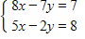
​
 | a.
 | b.
 | c.
 | d.
 | e. | There is no solution to the equations.

ANSWER: | a

184. Solve the system by elimination, or by any convenient method.
​
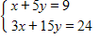
​
 | a. | ( –21, 3)
 | b. | ( 2, 22)
 | c. | ( 1, –21)
 | d. | ( –21, 2)
 | e. | There is no solution to the equations.

ANSWER: | e

185. Solve the system by elimination, or by any convenient method.
​
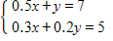
​
 | a. | and
 | b. | and
 | c. | and
 | d. | and
 | e. | and

ANSWER: | a

186. Solve the system by elimination, or by any convenient method.
​
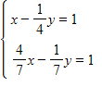
 | a. | and
 | b. | and
 | c. | and
 | d. | and
 | e. | There is no solution to the equations.

ANSWER: | e

187. Solve the system by elimination, or by any convenient method.
​
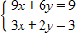
​
 | a. | and
 | b. | and
 | c. | and
 | d. | There are infinitely many solutions.
 | e. | There is no solution.

ANSWER: | d

188. Solve the system by elimination, or by any convenient method.
​
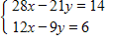
​
 | a. | ​ and
 | b. | ​ and
 | c. | ​​ and
 | d. | There are infinitely many solutions.
 | e. | There is no solution.

ANSWER: | d

189. Using a graphing utility or Excel to find the solution of the system.
​
​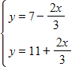
​
 | a. | ( –2, –9)
 | b. | ( –3, 9)
 | c. | ( –9, –3)
 | d. | ( –3, –2)
 | e. | There is no solution.

ANSWER: | b

190. Using a graphing utility or Excel to find the solution of the system.
​
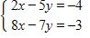
​
a.
b.
c.
d.
e.

ANSWER: | d

191. Use the left-to-right elimination method to solve the system.
​
​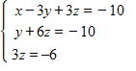
​
 | a. | solution:
 | b. | solution:
 | c. | solution:
 | d. | solution:
 | e. | solution:

ANSWER: | a

192. Use the left-to-right elimination method to solve the system.
​
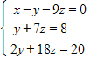
​
a.
b.
c.
d.
e.

ANSWER: | c

193. Use the left-to-right elimination method to solve the system.
​
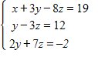
​
 | a. | solution:
 | b. | solution:
 | c. | solution:
 | d. | solution:
 | e. | solution:

ANSWER: | a

194. Use the left-to-right elimination method to solve the system.
​
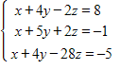
​
 | a. | solution:
 | b. | solution:
 | c. | solution:
 | d. | solution:
 | e. | solution:

ANSWER: | b

195. Use the left-to-right elimination method to solve the system.
​
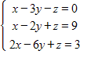
​
 | a. | solution:
 | b. | solution:
 | c. | solution:
 | d. | solution:
 | e. | solution:

ANSWER: | d

196. In the United States between 1970 and 2002, the number (in millions) of black children B(x) and Hispanic children H(x) can be described by and , where x is the number of years after December 31st, 1970. In what year were the numbers of children equal?
​
 | a. | 1976
 | b. | 1998
 | c. | 1977
 | d. | 1978
 | e. | 1983

ANSWER: | c

197. A concert promoter needs to make $42,000 from the sale of 2,000 tickets. The promoter charges $20 for some tickets and $30 for the others. Let x be the number of $20 tickets, and y be the number of $30 tickets. This yields the two equations and . Solve these equations simultaneously to find how many $30 tickets must be sold to yield $42,000.
​
 | a. | 200
 | b. | 1,800
 | c. | 100
 | d. | 600
 | e. | 900

ANSWER: | a

198. A woman has $525,000 invested in two rental properties. One yields an annual return of 10% of her investment, and the other returns 12% per year on her investment. Her total annual return from the two investments is $53,000. Let x represent the amount of the 10% investment and y represent the amount of the 12% investment. Find how much is invested in each property by solving the equations for the total amount invested and the return from each property.
​
 | a. | $131,250 at 10% and $290,000 at 12%
 | b. | $500,000 at 10% and $25,000 at 12%
 | c. | $240,000 at 10% and $235,000 at 12%​
 | d. | $290,000 at 10% and $25,000 at 12%
 | e. | $235,000 at 10% and $240,000 at 12%

ANSWER: | b

199. One safe investment pays 10% per year, and a more risky investment pays 18% per year. A woman who has $156,600 to invest would like to have an income of $25,000 per year from her investments. How much should she invest at each rate?
​
 | a. | She should put $43,848 in the safe investment and $28,188 in the risky investment.​
 | b. | She should put $19,575 in the safe investment and $35,235 in the risky investment.
 | c. | She should put $15,660 in the safe investment and $112,752 in the risky investment.
 | d. | She should put $39,850 in the safe investment and $116,750 in the risky investment.
 | e. | She should put $51,678 in the safe investment and $43,848 in the risky investment.

ANSWER: | d

200. A bank lent $127,500 to a company for the development of two products. If the loan for product A was for $21,500 more than that for product B, how much was lent for each product?
​
a.
b.
c.
d.
e.

ANSWER: | d

201. A woman has $289,000 invested in two rental properties. One yields 10% on the investment, and the other yields 12%. Her total income from them is $33,000. How much is her income from each property?
​
 | a. | She has invested $20,000 at 10% and $269,000 at 12%
 | b. | She has invested $84,000 at 10% and $205,000 at 12%
 | c. | She has invested $124,000 at 10% and $165,000 at 12%
 | d. | She has invested $81,000 at 10% and $208,000 at 12%
 | e. | She has invested $40,000 at 10% and $249,000 at 12%

ANSWER: | b

202. Mr. Jackson borrowed money from his bank and on his life insurance to start a business. His interest rate on the bank loan was 10%, and his rate on the insurance loan was 12%. If the total amount borrowed was $100,000 and his total yearly interest payment was $10,200, how much did he borrow from the bank?
​
 | a. | He borrowed $10,000 from the bank.
 | b. | He borrowed $69,600 from the bank.
 | c. | He borrowed $100,200 from the bank.
 | d. | He borrowed $200 from the bank.
 | e. | He borrowed $90,000 from the bank.

ANSWER: | e

203. A glass of skim milk supplies 0.1 mg of iron and 8.5 g of protein. A quarter pound of lean red meat provides 3.4 mg of iron and 22 g of protein. If a person on a special diet is to have 5.6 mg of iron and 73.75 g of protein, how many glasses of skim milk and how many quarter-pound servings of meat would provide this? Give the answer rounded to the nearest half serving.
​
 | a. | The proper nutrition would be provided with 1.5 glasses of milk and 2 servings of meat.
 | b. | The proper nutrition would be provided with 1 glassof milk and 3 servingsof meat.
 | c. | The proper nutrition would be provided with 5 glasses of milk and 1.5 servings of meat.
 | d. | The proper nutrition would be provided with 3 glasses of milk and 1 serving of meat.
 | e. | The proper nutrition would be provided with 2 glassesof milk and 2.5 servings of meat.

ANSWER: | c

204. A biologist has a 40% solution and a 10% solution of the same plant nutrient. How many cubic centimeters of each solution should be mixed to obtain 40 cc of a 25% solution?
​
 | a. | The biologist should mix 30 cc of 40% solution with 10 cc of 10% solution.
 | b. | The biologist should mix 20 cc of 40% solution with 20 cc of 10% solution.
 | c. | The biologist should mix 5 cc of 40% solution with 35 cc of 10% solution.
 | d. | The biologist should mix 10 cc of 40% solution with 30 cc of 10% solution.
 | e. | The biologist should mix 15 cc of 40% solution with 25 cc of 10% solution.

ANSWER: | b

205. Medication A is given every 4 hours and medication B is given twice each day. The total intake of the two medications is restricted to 45.7 mg per day, for a certain patient. If the ratio of the dosage of A to the dosage of B is 7 to 9, find the dosage for each administration of each medication.
​
 | a. | Each dosage of medication should be 6.5 mg of A and 5.1 mg of B.
 | b. | Each dosage of medication should be 108.7 mg of A and 84.5 mg of B.
 | c. | Each dosage of medication should be 5.3 mg of A and 6.9 mg of B.
 | d. | Each dosage of medication should be 5.1 mg of A and 3.9 mg of B.
 | e. | Each dosage of medication should be 10.2 mg of A and 7.9 mg of B.

ANSWER: | c

206. A nut wholesaler sells a mix of cashews and peanuts. He charges $2.80 per pound for cashews and $5.30 per pound for peanuts. If the mix is to sell for $3.1 per pound, how many pounds each of peanuts and cashews should be used to make 100 pounds of the mix?
​
 | a. | The wholesaler should mix 5.8 pounds of peanuts with 59 pounds of cashews.
 | b. | The wholesaler should mix 16 pounds of peanuts with 81.8 pounds of cashews.
 | c. | The wholesaler should mix 18.2 pounds of peanuts with 84 pounds of cashews.
 | d. | The wholesaler should mix 41 pounds of peanuts with 94.2 pounds of cashews.
 | e. | The wholesaler should mix 12 pounds of peanuts with 88 pounds of cashews.

ANSWER: | e

207. How many gallons of washer fluid that is 13.5% antifreeze must a manufacturer add to 500 gallons of washer fluid that is 11% antifreeze to yield washer fluid that is 13% antifreeze?
​
 | a. | 1,000
 | b. | 1,740
 | c. | 1,730
 | d. | 2,000
 | e. | 1,790

ANSWER: | d

208. Each ounce of substance A supplies 2% of the nutrition a patient needs. Substance B supplies 9% of the required nutrition per ounce, and substance C supplies 6% of the required nutrition per ounce. If digestive restrictions require that substances A and C be given in equal amounts, and the amount of substance B be one-fifth of either of these other amounts, find the number of ounces of each substance that should be in the meal to provide 100% of the required nutrition.
​
 | a. | The solution is 2.04 ounces of substance A, 10.20 ounces of substance B, and 2.04 ounces of substance C.
 | b. | The solution is 10.20 ounces of substance A, 2.04 ounces of substance B, and 10.20 ounces of substance C.
 | c. | The solution is 51.02 ounces of substance A, 10.20 ounces of substance B, and 51.02 ounces of substance C.
 | d. | The solution is 10.20 ounces of substance A, 51.02 ounces of substance B, and 10.20 ounces of substance C.
 | e. | The solution is 51.02 ounces of substance A, 2.04 ounces of substance B, and 51.02 ounces of substance C.

ANSWER: | b

209. A glass of skim milk supplies 0.1 mg of iron, 8.5 g of protein, and 1 g of carbohydrates. A quarter pound of lean red meat provides 3.4 mg of iron, 22 g of protein, and 20 g of carbohydrates. Two slices of whole grain bread supply 2.2 mg of iron, 10 g of protein, and 12 g of carbohydrates. If a person on a special diet must have 9.1 mg of iron, 62.5 g of protein, and 53 g of carbohydrates, how many glasses of skim milk, how many quarter-pound servings of meat, and how many two-slice servings of whole grain bread will supply this?
​
 | a. | The requirements will be met with 1 glass of milk, 2 servings of meat and 1 serving of bread.
 | b. | The requirements will be met with 4 glasses of milk, 1 serving of meat and 5 servings of bread.
 | c. | The requirements will be met with 5 glasses of milk, 2 servings of meat and 1 serving of bread.
 | d. | The requirements will be met with 3 glasses of milk, 2 servings of meat and 4 servings of bread.
 | e. | The requirements will be met with 2 glasses of milk, 1 serving of meat and 5 servings of bread.

ANSWER: | a

210. A social agency is charged with providing services to three types of clients, A, B, and C. A total of 450 clients are to be served, with $140,000 available for counseling and $100,000 available for emergency food and shelter. Type A clients require an average of $200 for counseling and $300 for emergencies, type B clients require an average of $500 for counseling and $200 for emergencies, and type C clients require an average of $300 for counseling and $100 for emergencies. How many of each type of client can be served?
​
 | a. | Substitution gives 40 type A clients, 300 type B clients, and 110 type C clients.
 | b. | Substitution gives 50 type A clients, 190 type B clients, and 210 type C clients.
 | c. | Substitution gives 210 type A clients, 130 type B clients, and 110 type C clients.
 | d. | Substitution gives 190 type A clients, 50 type B clients, and 210 type C clients.
 | e. | Substitution gives 300 type A clients, 110 type B clients, and 40 type C clients.

ANSWER: | c

211. Suppose a calculator manufacturer has the total cost function and the total revenue function , where x represents the number of calculators sold. What is the equation of the profit function, , for the calculator manufacturer?
​
 | a. | ​
 | b.
 | c.
 | d.
 | e.

ANSWER: | d

212. Suppose a stereo receiver manufacturer has the total cost function and the total revenue function , where x represents the number of units produced and sold. What is the equation of the profit function, , for this commodity?
​
a.
b.
c.
d.
e.

ANSWER: | e

213. Suppose a radio manufacturer has the total cost function and the total revenue function , where x represents the number of radios produced and sold. Write down the profit function and then use this function to determine how many radios must be sold to avoid losing money. Round your answer to the nearest whole number.
​
 | a. | 420
 | b. | 38
 | c. | 42
 | d. | 275
 | e. | 1,825

ANSWER: | a

214. Suppose a computer manufacturer has the total cost function and the total revenue function , where x represents the number of computers produced and sold. What is the profit on 341 items?
​
 | a. | $86,300
 | b. | $106,000
 | c. | $98,600
 | d. | $1,364,000
 | e. | $160,560

ANSWER: | c

215. A linear cost function is , where x represents the number of units produced. If 60 units are currently produced, determine the marginal cost.
​
​
 | a. | $225
 | b. | $235​
 | c. | $835
 | d. | ​$60
 | e. | $10

ANSWER: | e

216. A linear cost function is , where x represents the number of units produced. What is the cost of producing one more item if 100 are currently being produced? Round your answer to the nearest cent.
​
 | a. | $8,545.97
 | b. | $28.97
 | c. | $5,620.00
 | d. | $5,648.97
 | e. | $100.00

ANSWER: | b

217. A linear revenue function is , where x represents the number of units sold. What is the revenue received from selling one more item if 50 are currently being sold? Round your answer to the nearest cent.
​
 | a. | $1,377.00
 | b. | $50.00
 | c. | $1,350.00
 | d. | $27.00
 | e. | $2,079.00

ANSWER: | d

218. A linear revenue function is , where x represents the number of units sold. If 30 units are currently produced, determine the marginal revenue.
​
 | a. | $41.84
 | b. | $1,255.20
 | c. | $30.00
 | d. | $71.84
 | e. | $1,225.20

ANSWER: | a

219. Given a cost function and a revenue function, where x represents the number of units produced and sold, find the profit function and then determine the marginal profit.
​
 | a.
 | b. | ​
 | c.
 | d.
 | e.

ANSWER: | c

220. A company charting its profits notices that the relationship between the number of units sold x and the profit is linear. If 100 nits sold results in $2,900 profit and 150 units sold results in $6,000 profit. Use these two points on the graph of to find the marginal profit.
​
 | a. | $29.00
 | b. | $62.00
 | c. | $40.00
 | d. | $19.33
 | e. | $60.00

ANSWER: | b

221. Suppose that the total cost function for a radio is linear, that the marginal cost is $27, and that the total cost for 50 radios is $4,850. Write the equation of this cost function .
​
 | a. | ​
 | b.
 | c.
 | d.
 | e.

ANSWER: | d

222. A manufacturer of DVD players has monthly fixed costs of $9,000 and variable costs of $70 per unit for one particular model. For this model DVD player, find the function for monthly total costs where x denotes the number of units produced and sold.
​
a.
b.
c.
d.
e.

ANSWER: | b

223. A manufacturer of DVD players has monthly fixed costs of $8,800 and variable costs of $75 unit for one particular model. The company sells this model to dealers for $100 each. Find the function for total revenue where x denotes the number of DVD players produced and sold.
​
a.
b.
c.
d.
e.

ANSWER: | a

224. A manufacturer of DVD players has monthly fixed costs of $9,600 and variable costs of $65 unit for one particular model. The company sells this model to dealers for $100 each. Find the manufacturer's profit function where x denotes the number of DVD players produced and sold.
​
a.
b.
c.
d.
e.

ANSWER: | c

225. A manufacturer of shower-surrounds has a revenue function of and a cost function of , where x represents the number of units produced and sold. Find the number of units that must be sold to break even.
​
 | a. | 125
 | b. | 28
 | c. | 100
 | d. | 22
 | e. | 18

ANSWER: | c

226. A small business recaps and sells tires. The business has a revenue function and a cost function , where x represents the number of sets of four tires recapped and sold. Find the number of sets of recaps that must be sold to break even.
​
 | a. | 100
 | b. | 500
 | c. | 15
 | d. | 300
 | e. | 80

ANSWER: | a

227. A manufacturer sells watches for $60 per unit. The fixed costs related to this product are $10,000 per month, and the variable costs are $40 per unit. Which of the following is the equation for the profit function where x denotes the number of watches produced and sold?
​
a.
b.
c.
d.
e.

ANSWER: | e

228. A manufacturer sells watches for $75 per unit. The fixed costs related to this product are $10,000 per month, and the variable costs are $55 per unit. This gives a profit function , where r is the revenue per unit and c is the variable cost per unit. If the manufacturer has a profit of zero, how many watches were sold?
​
 | a. | 1,000
 | b. | 5,000
 | c. | 500
 | d. | 133
 | e. | 182

ANSWER: | c

229. Financial Paper, Inc. is a printer of checks and forms for financial institutions. For individual accounts, boxes of 200 checks cost $0.8 per box to print and package; they sell for $4.95 each. Financial Paper’s monthly fixed costs for printing and packaging these checks for individuals are $1,415. Which of the following is the equation for the profit function where x denotes the number of boxes of checks produced and sold?
​
 | a.
 | b. | ​
 | c.
 | d.
 | e.

ANSWER: | d

230. A company distributes college logo sweatshirts and sells them for $50 each. The total cost function is linear, and the total cost for 100 sweatshirts is $4,480, whereas the total cost for 250 sweatshirts is $7,480. Find the equation for the total cost function where x is the number of sweatshirts produced and sold.
​
a.
b.
c.
d.
e.

ANSWER: | d

231. Some of the graphs of total revenue R, total cost C, variable cost VC, fixed cost FC, and profit P are shown as functions of the number of units x. Choose the function represented by the line labeled b.
​
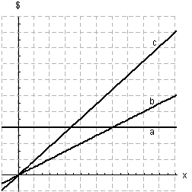
​
 | a. | FC
 | b. | VC
 | c. | R
 | d. | C
 | e. | P

ANSWER: | b

232. As the price of a commodity increases, what happens to supply?
​
 | a. | If the price increases, then the supply will decreases.
 | b. | If the price increases, then the supply will remain constant.
 | c. | If the price increases, then the supply will increases.

ANSWER: | c

233. The figure below is the graph of both the demand function D and the supply function S for the same product, where P is the price per unit and Q is the number of units produced. Will there be a market surplus or shortage when the price P is $150?
​
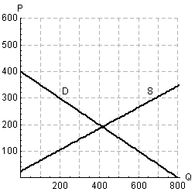
​
 | a. | There will be a market surplus.
 | b. | There will be a market shortage.

ANSWER: | b

234. Assume that the price for a pair of shoes has been set at $20. The demand for a pair of shoes is given by and the supply for the same pair of shoes is . In both cases p is price per pair and q is the quantity produced or sold. Compare the quantity demanded and the quantity supplied. Will there be a surplus or shortfall at this price?
​
 | a. | There will be a shortfall.
 | b. | There will be a surplus.

ANSWER: | a

235. If the demand and supply functions for Z-brand phones are and respectively, compare the quantity demanded and the quantity supplied when p = 46. Note that q is the quantity produced or sold. Are there surplus phones or not enough to meet demand?
​​
 | a. | There will be a surplus at a price of $46.
 | b. | There will be a shortage at a price of $46.

ANSWER: | a

236. Suppose a certain home improvement outlet knows that the monthly demand for framing studs is 1,500 when the price is $1.00 each but that the demand is 2,500 when the price is $0.90 each. Assume the demand function is linear. Choose the correct equation for demand where p denotes price and q denotes quantity.
​
a.
b.
c.
d.
e.

ANSWER: | e

237. Suppose a mining company will supply 80,000 tons of ore per month if the price is $25 per ton but will supply only 60,000 tons per month if the price is $20 per ton. Assume the demand function is linear. Choose the correct equation for demand in the form p for price in terms of q for quantity. Round your coefficients to five decimal places.
​
a.
b.
c.
d.
e.

ANSWER: | c

238. The figure below show the demand and supply functions for a product. Decide which line shows the supply function and which line the demand function.
​
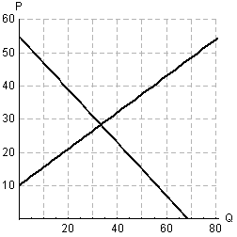
​
Is there a surplus or shortage when the price is $26?
​
 | a. | There is a shortage.
 | b. | There is a surplus.

ANSWER: | a

239. The figure below show the demand and supply functions for a product. Decide which line shows the supply function and which line the demand function.
​
​
Will a price above the equilibrium price result in a market surplus or shortage?
​
 | a. | shortage
 | b. | surplus

ANSWER: | b

240. Find the market equilibrium point for the following demand and supply functions below, where p is price per unit and q is the number of units produced and sold.
​
Demand:
Supply:
​
a.
b.
c.
d.
e.

ANSWER: | a

241. Find the equilibrium point for the following supply and demand functions below, where p is price per unit and q is the number of units produced and sold.
​
Demand:
Supply:
​
a.
b.
c.
d.
e.

ANSWER: | d

242. Retailers will buy 45 cordless phones from a wholesaler if the price is $10 each but only 20 if the price is $60. The wholesaler will supply 35 phones at $30 each and 42 at $42 each. Assuming the supply and demand functions are linear, find the market equilibrium point .
​
 | a. | market equilibrium point:
 | b. | market equilibrium point:
 | c. | market equilibrium point:
 | d. | market equilibrium point:
 | e. | market equilibrium point:

ANSWER: | c

243. A shoe store owner will buy 10 pairs of a certain shoe if the price is $75 per pair and 30 pairs if the price is $25. The supplier of the shoes is willing to provide 40 pairs if the price is $90 per pair but only 5 pairs if the price is $20. Assuming the supply and demand functions for the shoes are linear, find the market equilibrium point .
​
 | a. | market equilibrium point:
 | b. | market equilibrium point:
 | c. | market equilibrium point:
 | d. | market equilibrium point:
 | e. | market equilibrium point:

ANSWER: | d

244. The figure below is the graph of the demand function D, the supply function S, and the supply function after a $30 tax T for the same product. Is it possible for the government to earn no money if it keeps increasing taxes on this product?
​
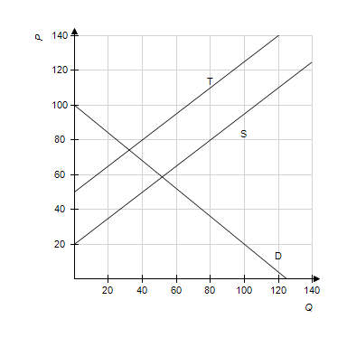
 | a. | Yes
 | b. | No

ANSWER: | Yes

245. Suppose that a certain product has the following demand and supply functions, where p is the price per unit in dollars and q is the quantity produced.
​
Demand:
Supply:
​
If a $44 tax is placed on each unit of the product of the following. What is the new equilibrium point?
​
a.
b.
c.
d.
e.

ANSWER: | b

246. Suppose that a certain product has the following demand and supply functions, where p is the price per unit in dollars and q is the quantity produced.
​
Demand:
Supply:
​
If a $10 tax per item is levied on the supplier, who passes it on to the consumer as a price increase, find the market equilibrium point after the tax.
​
a.
b.
c.
d.
e.

ANSWER: | d

247. Suppose that in a certain market, the demand function for a product is given by and the supply function is given by , where p is the price per unit in dollars and q is the quantity produced. If the government levies a tax of $7 per item on the supplier, who passes the tax on to the consumer as a price increase, find the equilibrium price and quantity after the tax is levied. Round q to the nearest whole number and round p to one decimal place.
​
a.
b.
c.
d.
e.

ANSWER: | c

