Managerial Decision Modeling w/ Spreadsheets, 3e (Balakrishnan/Render/Stair)
Chapter 1 Introduction to Managerial Decision Making

1.1 Chapter Questions

1) Which of the following variables is considered random or probabilistic?
A) future interest rates
B) last year's advertising budget
C) last week's sales data
D) historical stock prices
E) historical interest rates
Answer: A
Page Ref: 3
Topic: Types of Decision Models
Difficulty: Moderate

2) Which of the following variables is considered non-random or deterministic?
A) next year's cash flow projections
B) future interest rates
C) last year's income
D) projected value of the euro next week
E) projected NASDAQ index
Answer: C
Page Ref: 2
Topic: Types of Decision Models
Difficulty: Moderate

3) Determining how much the solution will change if there are changes in the input data is part of:
A) model formulation
B) model solution
C) model interpretation
D) model development
E) model assessment
Answer: C
Page Ref: 7
Topic: Steps Involved in Decision Modeling
Difficulty: Easy
4) If all the variables in a model are under the control of the decision maker, then the model is considered to be:
A) probabilistic
B) random
C) mathematical
D) schematic
E) deterministic
Answer: E
Page Ref: 2
Topic: Types of Decision Models
Difficulty: Easy

5) Which of the following models is a picture or drawing of reality?
A) physical model
B) schematic model
C) scale model
D) mathematical model
E) analytical model
Answer: B
Page Ref: 6
Topic: Steps Involved in Decision Modeling
Difficulty: Easy

6) Acquiring input data is part of:
A) model solution
B) model formulation
C) model interpretation
D) model testing
E) model identification
Answer: B
Page Ref: 6
Topic: Steps Involved in Decision Modeling
Difficulty: Easy

7) Which of the following variables is considered to be qualitative?
A) annual sales
B) earnings per share
C) age
D) method of payment (e.g., cash or credit card)
E) price
Answer: D
Page Ref: 4
Topic: Types of Decision Models
Difficulty: Easy
8) Which of the following variables is considered to be quantitative?
A) soft drink size
B) make of automobile
C) army rank
D) gender
E) none of the above
Answer: E
Page Ref: 4
Topic: Types of Decision Variables
Difficulty: Easy

9) The ABC Corporation is considering introducing a new product, which will require buying new equipment for a monthly payment of $5,000. Each unit produced can be sold for $20.00. ABC incurs a variable cost of $10.00 per unit. How many units must ABC sell each month to break even?
A) 500 units
B) 5000 units
C) 250 units
D) 2500 units
E) 25 units
Answer: A
Page Ref: 11
Topic: Spreadsheet Example of a Decision Model: Break-Even Analysis
Difficulty: Easy
AACSB: Analytic Skills

10) The ABC Corporation is considering introducing a new product, which will require buying new equipment for a monthly payment of $5,000. Each unit produced can be sold for $20.00. ABC incurs a variable cost of $10.00 per unit. What is ABC's monthly break-even amount in dollars?
A) $100,000
B) $10,000
C) $5,000
D) $50,000
E) $1,000
Answer: B
Page Ref: 12
Topic: Spreadsheet Example of a Decision Model: Break-Even Analysis
Difficulty: Easy
AACSB: Analytic Skills
11) The ABC Corporation is considering introducing a new product, which will require buying new equipment for a monthly payment of $5,000. Each unit produced can be sold for $20.00. ABC incurs a variable cost of $10.00 per unit. Suppose that ABC would like to realize a monthly profit of $50,000. How many units must they sell each month to realize this profit?
A) 500 units
B) 450 units
C) 4500 units
D) 5000 units
E) 5500 units
Answer: C
Page Ref: 12
Topic: Spreadsheet Example of a Decision Model: Break-Even Analysis
Difficulty: Moderate
AACSB: Analytic Skills

12) The ABC Corporation is considering introducing a new product, which will require buying new equipment for a monthly payment of $5,000. Each unit produced can be sold for $20.00. ABC incurs a variable cost of $10.00 per unit. Suppose that ABC anticipates selling 100 units of the new product next month. Moreover, they would like to realize a monthly profit of $5000. What should the selling price per unit be to realize this profit?
A) $100
B) $120
C) $130
D) $115
E) $110
Answer: E
Page Ref: 12
Topic: Spreadsheet Example of a Decision Model: Break-Even Analysis
Difficulty: Moderate
AACSB: Analytic Skills

13) Which of the following is an equation to determine the break-even point (BEP) in units?
A) BEP = fixed cost / selling price per unit - variable cost per unit)
B) BEP = fixed cost / (selling price per unit - variable cost per unit)
C) BEP = variable cost / (selling price per unit - fixed cost)
D) BEP = variable cost / (fixed cost - selling price per unit)
E) BEP = fixed cost / (selling price per unit + variable cost per unit)
Answer: B
Page Ref: 12
Topic: Spreadsheet Example of a Decision Model: Break-Even Analysis
Difficulty: Easy
14) The break-even volume (BEP) occurs at the point where:
A) total profit = total cost
B) fixed cost = total variable cost
C) total revenue = total cost
D) selling price per unit = variable cost per unit
E) total revenue = total variable cost
Answer: C
Page Ref: 12
Topic: Spreadsheet Example of a Decision Model: Break-Even Analysis
Difficulty: Easy

15) Which of the following is an equation to determine the break-even point in dollars?
A) (BEP) * (total variable cost) + fixed cost
B) (BEP) * (variable cost per unit)
C) (BEP) / (selling price)
D) (BEP) * (selling price) / (variable cost per unit)
E) (BEP) * (selling price)
Answer: A
Page Ref: 13
Topic: Spreadsheet Example of a Decision Model: Break-Even Analysis
Difficulty: Easy

16) All of the following are considered typical roadblocks in defining a problem for Decision Analysts EXCEPT:
A) Impact on other departments
B) Solution outdated
C) Lack of leadership
D) Beginning assumptions
E) Conflicting viewpoints
Answer: C
Page Ref: 13
Topic: Possible Problems in Developing Decision Models
Difficulty: Moderate

17) Which of the following statements is FALSE regarding possible problems in developing decision models?
A) It is difficult to develop a model that is not understandable.
B) Assumptions are made when developing solutions.
C) Accounting data is not always conducive as input data.
D) The limitation of only one answer when developing a solution
E) The validity of the data being used as input data
Answer: B
Page Ref: 14
Topic: Possible Problems in Developing Decision Models
Difficulty: Moderate
18) A measurable quantity that is inherent in a problem is known as a(n):
A) problem parameter
B) variable
C) model
D) assumption
E) factor
Answer: A
Page Ref: 6
Topic: Steps Involved in Decision Modeling
Difficulty: Moderate

19) If all the values of the input variables in a decision model are known with certainty, then the model is considered to be deterministic.
Answer: TRUE
Page Ref: 2
Topic: Types of Decision Models
Difficulty: Easy

20) If all the values of the input variables in a decision model are random in nature, then the model is considered to be probabilistic.
Answer: TRUE
Page Ref: 3
Topic: Types of Decision Models
Difficulty: Easy

21) A decision model has the following input variables: projected sales data and historical advertising budget. This model is considered to be deterministic.
Answer: FALSE
Page Ref: 2
Topic: Types of Decision Models
Difficulty: Moderate

22) A decision model has the following input variables: Historical sales data and historical advertising budget. The model is considered to be probabilistic.
Answer: FALSE
Page Ref: 3
Topic: Types of Decision Models
Difficulty: Moderate

23) If a decision model has one variable with a certain/deterministic input value and another variable with a random/probabilistic input, then the outcome of this model which is based on both variables will be probabilistic.
Answer: TRUE
Page Ref: 3
Topic: Types of Decision Models
Difficulty: Moderate
24) The order of the three sequential steps involved in decision modeling is: formulation, solution, and interpretation.
Answer: TRUE
Page Ref: 6
Topic: Steps Involved in Decision Modeling
Difficulty: Easy

25) Identifying the key decision variables in a decision model is considered to be part of "model solution."
Answer: FALSE
Page Ref: 6
Topic: Steps Involved in Decision Modeling
Difficulty: Easy

26) Determining how much the solution will change if there are changes in the input data of the model is referred to as sensitivity analysis.
Answer: TRUE
Page Ref: 7
Topic: Steps Involved in Decision Modeling
Difficulty: Easy

27) Suppose you have a decision model that contains the input variable "number of labor hours." You would like to test how the solution changes if a labor strike takes effect. This type of analysis is called sensitivity analysis.
Answer: TRUE
Page Ref: 7
Topic: Steps Involved in Decision Modeling
Difficulty: Easy

28) At the break-even point (BEP), total profit is typically greater than zero.
Answer: FALSE
Page Ref: 11
Topic: Spreadsheet Example of a Decision Model: Break-Even Analysis
Difficulty: Easy

29) Suppose that the break-even point (BEP) for a given product is 200 units. This means that if 198 units are produced, then this product is not profitable.
Answer: TRUE
Page Ref: 11
Topic: Spreadsheet Example of a Decision Model: Break-Even Analysis
Difficulty: Moderate
30) Suppose that the break-even point (BEP) for a product is 300 units. This means if 310 units are produced, then this product is profitable.
Answer: TRUE
Page Ref: 11
Topic: Spreadsheet Example of a Decision Model: Break-Even Analysis
Difficulty: Moderate

31) Models that have random variables as input data are considered to be deterministic.
Answer: FALSE
Page Ref: 3
Topic: Types of Decision Models
Difficulty: Easy

32) In dealing with business models, managers need to consider only quantitative data while making decisions in practice.
Answer: FALSE
Page Ref: 4
Topic: Types of Decision Models
Difficulty: Easy

33) A quantitative model can still yield acceptable results even if the input data is unreliable.
Answer: FALSE
Page Ref: 5
Topic: Steps Involved in Decision Modeling
Difficulty: Easy

34) The validity of input data is not a typical concern for analysts in decision modeling.
Answer: FALSE
Page Ref: 15
Topic: Possible Problems in Decision Modeling
Difficulty: Easy

35) One possible problem in decision modeling is for analysts to have conflicting viewpoints.
Answer: TRUE
Page Ref: 13
Topic: Possible Problems in Decision Modeling
Difficulty: Easy
1.2 Excel Problems

1) Set up the following cell entries in Excel:

Variable cost/unit | $1.5
Fixed cost | $90
Selling price/unit | $3
Breakeven (units) | 60
Breakeven in dollars ($) | $180

Using Goal Seek, what should the selling price per unit be in order to realize a breakeven amount of $200?

Answer:
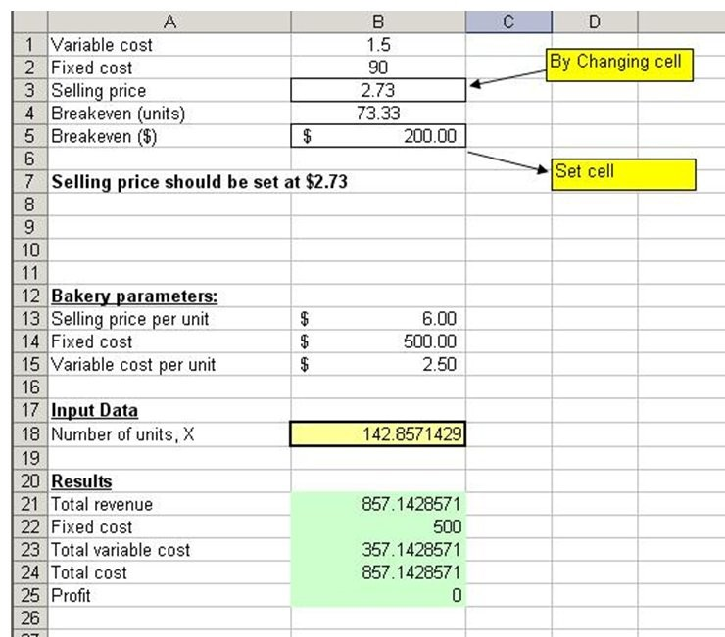

2) A hotel typically incurs a cost of $45 to clean each room before guest arrival. Each room generates revenue of $155.00 per night. Using Goal Seek, how many rooms must be occupied nightly in order to realize a daily profit of $20,000?

Answer:
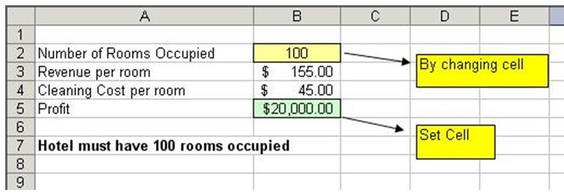

3) A professor that teaches Management Science assigns the final grade based on three examinations. To earn an A, the overall average on the three exams must be at least 89%. Suppose that you score 80% and 79% on exams 1 and 2, respectively. Using Goal Seek, what is the minimum score that you need to earn on exam 3 to get an A?

Answer:
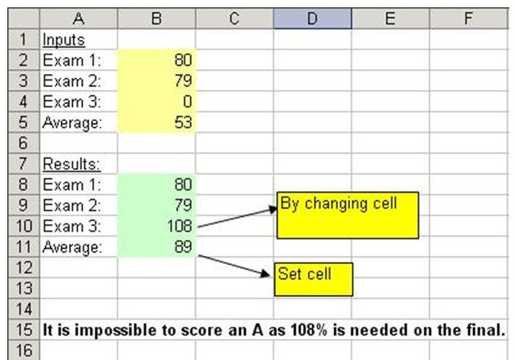

4) A bakery sells its pies for $6.00 each. The bakery incurs a daily fixed cost of $500 which includes salaries and rental. The variable cost per pie is $2.50. Set up this problem in Excel as shown below to compute the number of pies (X) that must be baked daily in order to break even. Model the problem mathematically without using Goal Seek.

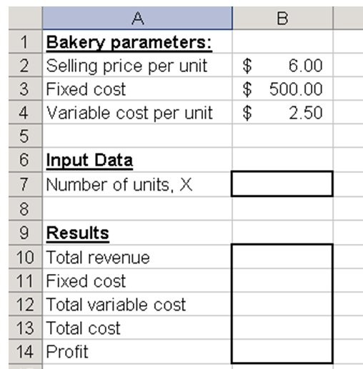

Answer:
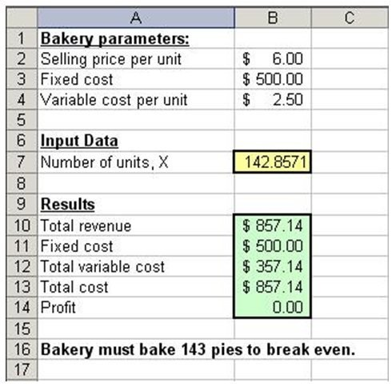

5) A bakery sells its pies for $6.00 each. The bakery incurs a daily fixed cost of $500 which includes salaries and rental. The variable cost per pie is $2.50. Use Goal Seek to compute the number of pies (X) that must be baked daily in order to break even if the variable cost per pie increases to $3.00.

Answer:
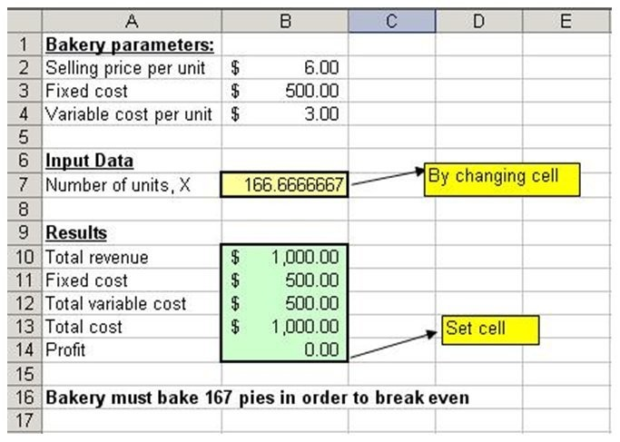

6) Jim and Shirley Irvin, a newly married couple, will be filing a joint tax return for the first year. Because both work as independent contractors (both are soccer coaches), their income is subject to some variability. However, because their earnings are not taxed at the source, they know that they have to pay estimated income taxes on a quarterly basis, based on their estimated taxable income for the year. To help calculate this tax, the Irvins would like to set up a spreadsheet-based decision model. Assume that they have the following information available:

Their only source of income is from their jobs as soccer coaches. The would like to put away 3% of their total income in a retirement account, up to a maximum of $4,000. Any amount the put in that account can be deducted from their total income for tax purposes. They are entitled to a personal exemption of $3,300 each. There is a standard deduction for married couples of $11,500, meaning this amount is free from any taxes and can be deducted from total joint income. Jim makes an estimated $41,000 and Shirley makes an estimated $36,000. The tax brackets are 9% for up to $17,000, 14% for $17,001 to $70,000, and 21% for $70,001 to $140,000. What are the estimated taxes per quarter that Jim and Shirley will have to pay?

Answer:
