International Economics: Theory and Policy, 11e (Krugman et al.)
Chapter 13 National Income Accounting and the Balance of Payments

13.1 The National Income Accounts

1) A country's gross national product (GNP) is
A) the value of all final goods and services produced by its factors of production and sold on the market in a given time period.
B) the value of all intermediate goods and services produced by its factors of production and sold on the market in a given time period.
C) the value of all final goods produced by its factors of production and sold on the market in a given time period.
D) the value of all final goods and services produced by its factors of production and sold on the market.
E) the value of all final goods and services produced by its factors of production, excluding land, and sold on the market in a given time period.
Answer: A
Page Ref: 323
Difficulty: Easy

2) For most macroeconomists
A) national income accounts is much more important than national output accounts.
B) it is impossible to tell whether national income accounts equal to national output accounts.
C) national output accounts exceed national income accounts.
D) national income accounts exceed national output accounts.
E) national income accounts and national output accounts are equal to each other.
Answer: E
Page Ref: 323-325
Difficulty: Easy

3) For most macroeconomists
A) gross national income exceeds gross national product.
B) it is hard to tell whether gross national income equals gross national product.
C) gross national product exceeds gross national income.
D) gross national product is much more important than gross national income.
E) gross national income and gross national product are the same.
Answer: E
Page Ref: 323-325
Difficulty: Easy

4) The largest component of GNP is
A) the current account.
B) investment.
C) government purchases.
D) consumption.
E) trade.
Answer: D
Page Ref: 326
Difficulty: Easy
5) An example of how GNP accounts for services provided by foreign-owned capital (and GDP does not) is
A) earnings of a Spanish factory with British owners counts only in Spain's GDP.
B) earnings of a Spanish factory with British owners counts only in Britain's GNP.
C) earnings of a Spanish factory counts in Spain's GNP but are part of Britain's GDP.
D) earnings of a Spanish factory counts in Spain's GDP but are part of Britain's GNP.
E) earnings of a Spanish factory counts in Spain's GNP but not in Britain's GDP or GNP.
Answer: D
Page Ref: 326
Difficulty: Easy

6) The sale of
A) a used textbook does enter GNP.
B) a used textbook does not enter GNP, but the sale of a used house does.
C) both a used textbook and a used house do not enter GNP.
D) a used house does not enter GNP, but the sale of a used book does.
E) the GNP does not include sale of used items priced below $1000.
Answer: C
Page Ref: 325
Difficulty: Easy

7) Which one of the following statements is the MOST accurate?
A) The sale of a used textbook does generate income for factors of production.
B) The sale of a used textbook does not generate income for any factor of production.
C) The sale of a used textbook sometimes does and sometimes does not generate income for factors of production.
D) It is hard to tell whether a sale of a used textbook does or does not generate income for factors of production.
E) The sale of a used textbook is a part of the GNP.
Answer: B
Page Ref: 325
Difficulty: Easy

8) Which one of the following statements is the MOST accurate?
A) GNP plus depreciation is called net national product (NNP).
B) GNP less depreciation is called net national product (NNP).
C) GNP less depreciation is called net factor product (NFP).
D) GDP plus depreciation is called net national product (NNP).
E) GDP less depreciation is called net national product (NNP).
Answer: B
Page Ref: 325
Difficulty: Easy

9) National income equals GNP
A) less depreciation, less net unilateral transfers.
B) less depreciation or net unilateral transfers.
C) plus depreciation, less net unilateral transfers.
D) plus depreciation, plus net unilateral transfers.
E) less depreciation, plus net unilateral transfers.
Answer: E
Page Ref: 325
Difficulty: Easy
10) The United States began to report its gross domestic product (GDP) only since
A) 1900.
B) 1921.
C) 1931.
D) 1941.
E) 1991.
Answer: E
Page Ref: 325
Difficulty: Easy

11) GDP is supposed to measure
A) the volume of production within a country's borders.
B) the volume of services generated within a country's borders.
C) the volume of production of a country's output.
D) GNP plus depreciation.
E) net unilateral transfers from foreigners.
Answer: A
Page Ref: 325
Difficulty: Easy

12) GNP equals GDP
A) minus net receipts of factor income from the rest of the world.
B) plus receipts of factor income from the rest of the world.
C) minus receipts of factor income from the rest of the world.
D) plus net receipts of factor income from the rest of the world.
E) minus depreciation.
Answer: D
Page Ref: 325
Difficulty: Easy

13) In 2015, the United States had
A) a surplus in the current account.
B) a balance in the current account.
C) a deficit in the current account.
D) a positive balance of net financial flows.
E) From 2015 data, it is too difficult to determine whether a surplus or a deficit existed in the current account.
Answer: C
Page Ref: 330
Difficulty: Easy

14) Net unilateral transfers
A) are part of a national income.
B) are part of a country's product.
C) must be added to NNP in calculations of national income.
D) are part of a country's GNP.
E) Only A and C.
Answer: E
Page Ref: 325
Difficulty: Easy
15) GDP is different than GNP in that
A) it accounts for net unilateral transfers.
B) it does not account for indirect business taxes.
C) it does not account for a country's production using services with foreign-owned capital.
D) it accounts for depreciation.
E) it is unhelpful when tracking national income.
Answer: C
Page Ref: 326
Difficulty: Easy

16) What are the main aspects of economic life that macroeconomics analysis is most concerned with?
Answer: There are four main aspects: unemployment, saving, trade imbalances, and money and the price level.
Page Ref: 322
Difficulty: Easy

17) What can you learn from the figure below (Figure 13-1 from the text) which depicts the U.S. GNP and its components for the 1st quarter of 2016?

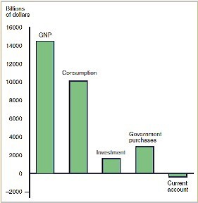
Answer: The largest component of GNP is consumption and the U.S. has a negative current account balance.
Page Ref: 324, 326
Difficulty: Easy
13.2 National Income Accounting for an Open Economy

1) Movements in GDP
A) differ greatly from movements in GNP.
B) do not differ greatly from movements in GNP.
C) are not allowed to differ at all from movements in GNP by definition.
D) need to be inflation adjusted in order to match movements in GNP.
E) are not relevant to an examination of national income.
Answer: B
Page Ref: 326
Difficulty: Easy

2) Purchases of inventories by
A) firms are not counted in investment spending.
B) firms are also counted in investment spending.
C) households are also counted in investment spending.
D) households and Firms are also counted in investment spending.
E) foreign consumers are counter in investment spending.
Answer: B
Page Ref: 326
Difficulty: Easy

3) In open economies
A) saving and investment are necessarily equal.
B) as in a closed economy, saving and investment are not necessarily equal.
C) saving and investment are not necessarily equal as they are in a closed economy.
D) saving and investment are necessarily equal contrary to the case of a closed economy.
E) investment always refers to the domestic stock market.
Answer: C
Page Ref: 331
Difficulty: Moderate

4) Investment is usually
A) more variable than consumption.
B) less variable than consumption.
C) as variable as consumption.
D) a larger component of the GNP than consumption.
E) It is hard to tell from the data whether investment is more or less variable than consumption.
Answer: A
Page Ref: 327
Difficulty: Easy

5) Government purchases are defined as
A) only goods purchased by federal, state, or local governments.
B) all goods and services purchased by the federal government.
C) all goods and services purchased by the federal or state government.
D) all goods and services purchased by the federal, state, or local government.
E) goods and services purchased from the government.
Answer: D
Page Ref: 327
Difficulty: Easy
6) Government transfer payments like social security and unemployment benefits are
A) included in government purchases.
B) not included in government purchases.
C) not included in government purchases, but they are included in the consumption component of GNP.
D) not included in government purchases, but they are part of the investment component of GNP.
E) included in government purchases but not in the GNP.
Answer: B
Page Ref: 327
Difficulty: Moderate

7) In 1929, government purchases accounted for
A) only 18.5 percent of U.S. GNP.
B) only 8.5 percent of U.S. GNP.
C) 28.5 percent of U.S. GNP.
D) 38.5 percent of U.S. GNP.
E) 48.5 percent of U.S. GNP.
Answer: B
Page Ref: 327
Difficulty: Easy

8) Which one of the following expressions is the MOST accurate?
A) CA = EX - IM
B) CA = IM - EX
C) CA = EX = IM
D) CA = EX + IM
E) CA - IM = EX
Answer: A
Page Ref: 328
Difficulty: Easy

9) A country's current account
A) balance equals the change in its net foreign wealth.
B) balance equals the change in its foreign wealth.
C) surplus equals the change in its foreign wealth.
D) deficit equals the change in its foreign wealth.
E) balance equals its GNP.
Answer: A
Page Ref: 329
Difficulty: Easy

10) In an open economy, the CA is equal to
A) Y - (C + I + G).
B) Y + (C + I + G).
C) Y - (C - I + G).
D) Y - (C + I - G).
E) Y + (C - I - G).
Answer: A
Page Ref: 329
Difficulty: Easy
11) Which of the following is TRUE?
A) A country with a current account surplus is earning more from its exports than it spends on imports.
B) A country could finance a current account deficit by using previously accumulated foreign wealth to pay for its imports.
C) A country with a current account deficit must be increasing its net foreign debts by the amount of the deficit.
D) We can describe the current account surplus as the difference between income and absorption.
E) All of the above are true of current account balances.
Answer: E
Page Ref: 329
Difficulty: Moderate

12) Over the 1980s
A) there is no question that a large increase in U.S. foreign assets did occur.
B) there is a question whether a large decrease in U.S. foreign assets did occur.
C) there is no question that a large decrease in U.S. foreign assets did occur.
D) there is no question that there was almost no change in U.S. foreign assets.
E) there is no question that rising exports exceeded U.S. foreign debt.
Answer: C
Page Ref: 330
Difficulty: Easy

13) In a closed economy, national saving
A) sometimes equals investment.
B) always equals investment.
C) is always less than investment.
D) is always more than investment.
E) is never equal to investment.
Answer: B
Page Ref: 331
Difficulty: Easy

14) For open economies,
A) S = I.
B) S = I + CA.
C) S = I - CA.
D) S > I + CA.
E) S < I + CA.
Answer: B
Page Ref: 331
Difficulty: Easy
15) An open economy
A) can save only by building up its capital stock.
B) can save only by acquiring foreign wealth.
C) cannot save either by building up its capital stock or by acquiring foreign wealth.
D) can save either by building up its capital stock or by acquiring foreign wealth.
E) can save by avoiding excessive imports.
Answer: D
Page Ref: 331
Difficulty: Easy

16) A closed economy
A) can save either by building up its capital stock or by acquiring foreign wealth.
B) can save only by building up its capital stock.
C) can save only by acquiring foreign wealth.
D) cannot save either by building up its capital stock or by acquiring foreign wealth.
E) can save by avoiding excessive imports.
Answer: B
Page Ref: 331
Difficulty: Easy

17) Disposable income is national income
A) less taxes collected from households and firms by the government.
B) plus net taxes collected from households and firms by the government.
C) less net taxes collected from firms by the government.
D) less net taxes collected from households by the government.
E) less net taxes collected from households and firms by the government.
Answer: E
Page Ref: 332
Difficulty: Easy

18) Government savings, 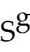, is equal to
A) T - G.
B) T + G.
C) T = G.
D) T + G - I.
E) T - G = I.
Answer: A
Page Ref: 332
Difficulty: Easy

19) Which of the following is FALSE about private savings and government savings?
A) SP = Y - T - C
B) Unlike private saving decisions, government saving decisions are often made with an eye toward their effect on output and employment.
C) Total savings (S) = SP +
D) The national income identity can help us to analyze the channels through which government saving decisions influence macroeconomic conditions.
E) None of the above; all statements are true.
Answer: E
Page Ref: 331-332
Difficulty: Moderate
20) In a closed economy, private saving, 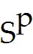, is equal to
A) I - (G - T).
B) I + (G - T).
C) I + (G + T).
D) I - (G + T).
E) I + (G - T) + C.
Answer: B
Page Ref: 332
Difficulty: Moderate

21) In an open economy, private saving, , is equal to
A) I - CA + (G - T).
B) I + CA - (G - T).
C) I + CA + (G - T).
D) I - CA - (G - T).
E) I + CA + (G + T).
Answer: C
Page Ref: 332
Difficulty: Moderate

22) In the United States over the past sixty years, the fraction of GNP devoted to consumption has fluctuated in a range of about
A) 42 to 49 percent.
B) 32 to 39 percent.
C) 22 to 29 percent.
D) 82 to 89 percent.
E) 62 to 70 percent.
Answer: E
Page Ref: 326
Difficulty: Easy

23) In the United States, (gross) investment has fluctuated between ________ of GNP in recent years.
A) 2 and 12 percent
B) 11 and 22 percent
C) 22 and 32 percent
D) 32 and 42 percent
E) 42 and 52 percent
Answer: B
Page Ref: 327
Difficulty: Easy

24) Government purchases currently take up about
A) 17 percent of U.S. GNP, and this share has not changed much since the late 1950s.
B) 38 percent of U.S. GNP, and this share has not changed much since the late 1950s.
C) 18 percent of U.S. GNP, and this share has been increasing since the late 1950s.
D) 18 percent of U.S. GNP, and this share has been decreasing since the late 1950s.
E) 25 percent of U.S. GNP, and this share has been decreasing since the late 1950s.
Answer: A
Page Ref: 327
Difficulty: Easy
25) The position of the United States current account balance in 2015 was
A) lent roughly 6 percent of its GNP, resulting in a large current account surplus.
B) borrowed roughly 3 percent of its GNP, leading to a large current account deficit.
C) achieved a currant account balance of zero.
D) borrowed roughly 10 percent of its GNP, leading to a large current account deficit.
E) borrowed less then 5 percent of its GNP, leading to a large current account surplus.
Answer: B
Page Ref: 329
Difficulty: Easy

26) Which one of the following statements is FALSE?
A) The United States had accumulated substantial foreign wealth by the early 1980s.
B) The 1980s witnessed a sustained current account deficit of proportions unprecedented in the twentieth century.
C) In 1989, the country became a net debtor to foreigners for the first time since World War I.
D) U.S. foreign debt has continued to grow and now stands at 40 percent of GNP.
E) The U.S. foreign debt was paid off in the 1990s, allowing the U.S. to attain a current account surplus. However, the deficit has returned in recent years.
Answer: E
Page Ref: 330
Difficulty: Moderate

27) What is the national income identity for a closed economy?
Answer: Y = C + I + G
Page Ref: 327
Difficulty: Easy

28) What is the national income identity for an open economy?
Answer: Y = C + I + G + EX - IM
Page Ref: 328
Difficulty: Easy

29) Discuss the values of private saving in closed and open economies.
Answer: In a closed economy, private saving, , is equals to, I + (G - T). In a open economy, private saving, , is equals to I + CA + (G - T). Open economy helps in extending the opportunities for private saving or dis-saving, or borrowing.
Page Ref: 332
Difficulty: Moderate
30) Assume in a closed economy:
C = 40 + 0.8(Y - T)
G = 10
I = 20
T = 0, where T are taxes.
(a) Calculate Y at equilibrium.
(b) Calculate C, I, and G at equilibrium.
(c) Now assume the economy is open with exports and imports activities,
EX = 5 + 4EP/P
IM = 10 + 0.1 (Y - T) - 3EP/P
E = 3
P = 1.5
P = 2
Find equilibrium Y.
Answer:
(a) Y = C + I + G
Y = 350
(b) C = 40 + 0.8 Y = 320
I = 20
G = 10
(c) Y = 269.1667
Page Ref: 328
Difficulty: Moderate
31) Fill in the following table.

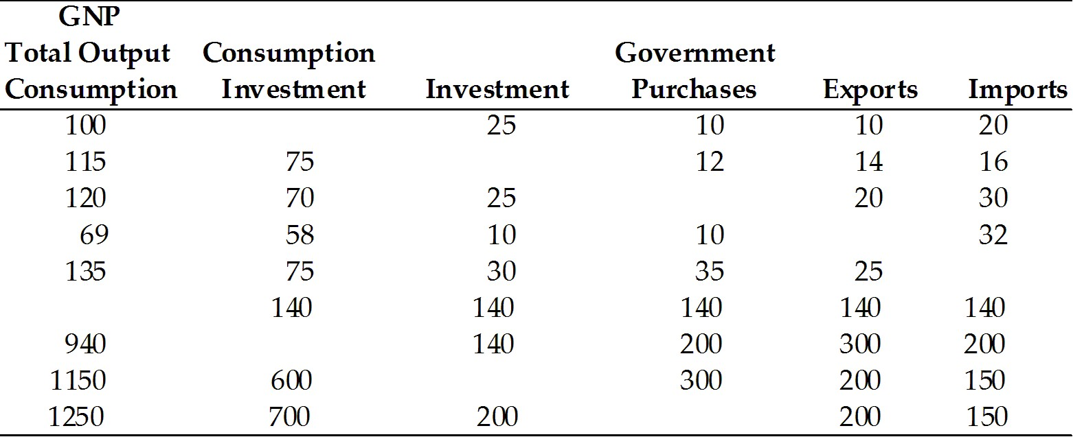
Answer:
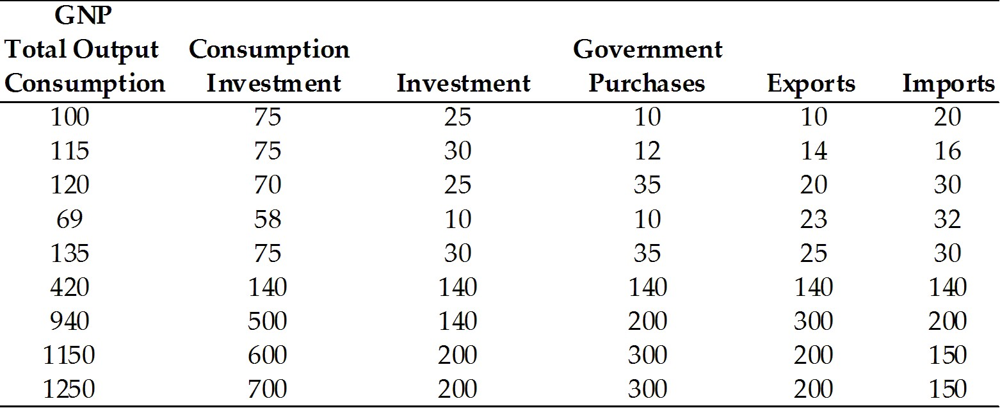
Page Ref: 328
Difficulty: Moderate
32) What can one learn from the following figure?

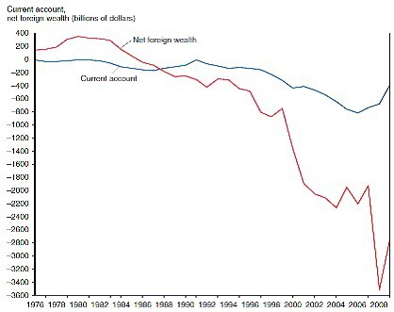

Answer: The figure shows the U.S. current account and net foreign wealth from 1976 until 2008. It shows that a string of current account deficits in the 1980s reduced America's net foreign wealth until, by the end 2008, the country had accumulated a substantial net foreign debt. In 1989 the country became a net debtor to foreigners for the first time since World War I.
Page Ref: 330
Difficulty: Moderate

33) Assume in a closed economy:
C = 50 + 0.6 (Y - T)
G = 15
I = 15
T = 2
(a) Calculate Y at equilibrium
(b) Calculate C
(c) Assume the economy is open
EX = 4 + 3EP/P
IM = 8 + 0.1 (Y - T) - 2EP/P
E = 3
P = 1
P = 1.5
Find equilibrium Y.
Answer:
(a) Y = C + I + G
Y = 50 + 0.6(Y - 2 + 15 + 15)
Y = 197
(b) C = 50 + 0.6 (197 - 2) = 50 + 117 = 167
(c) Y = 170
Page Ref: 328
Difficulty: Moderate
34) Fill in the following table.

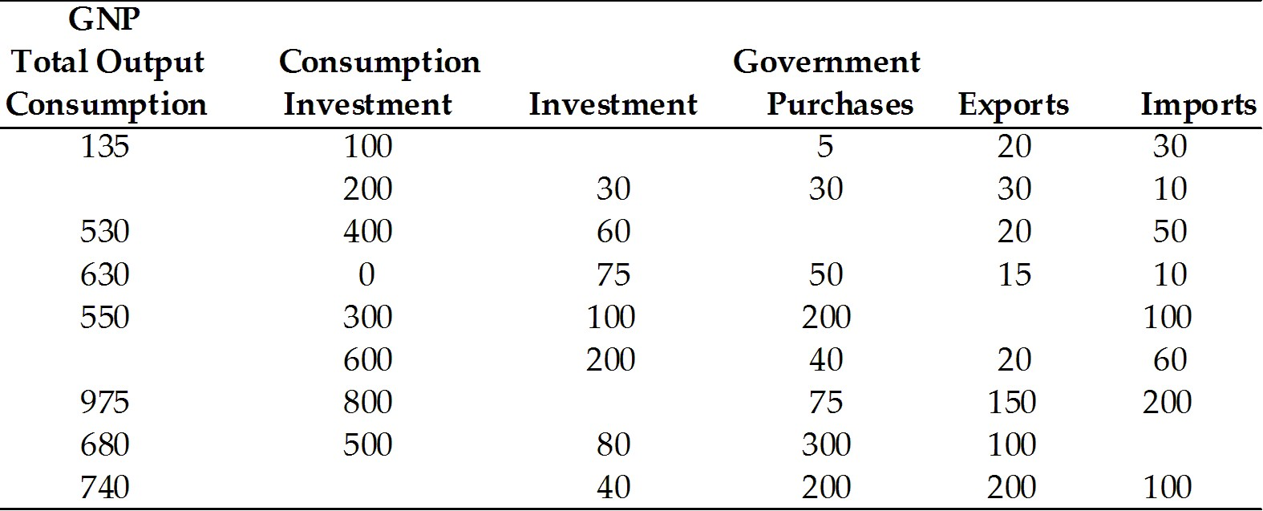
Answer:
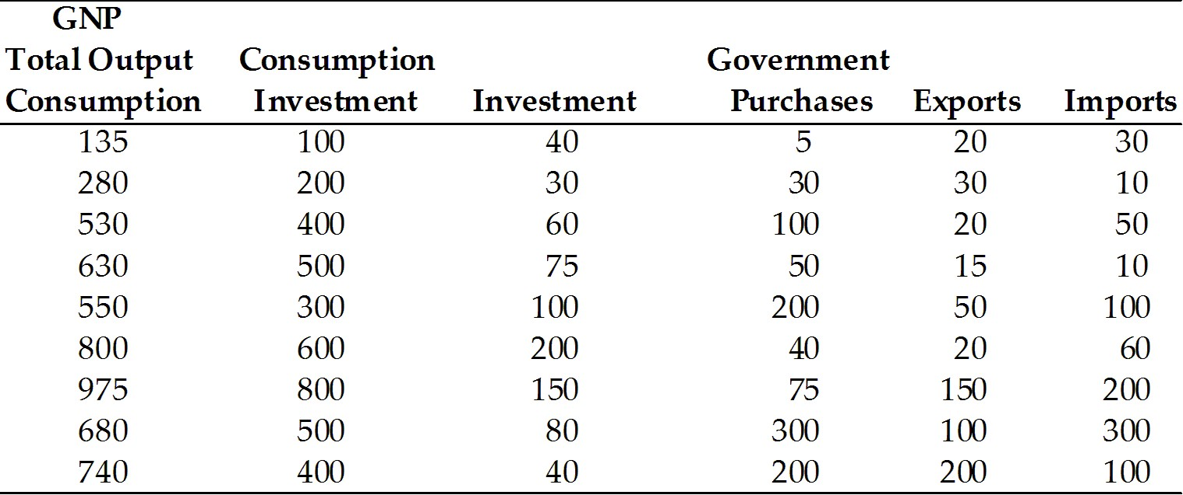
Page Ref: 328
Difficulty: Moderate
35) Fill in the following table.

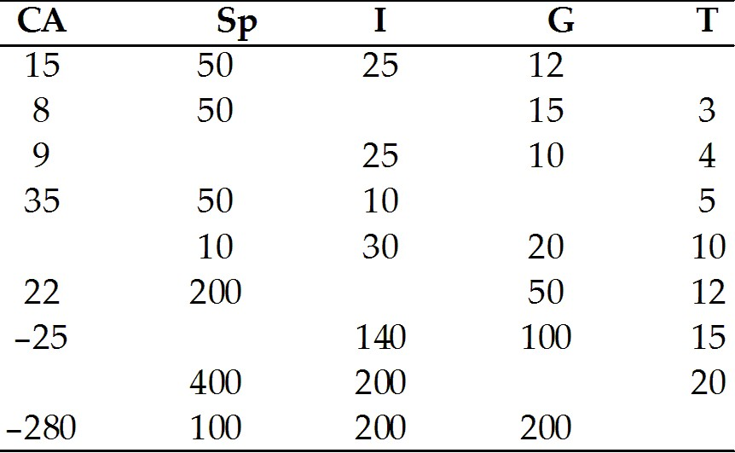
Answer:
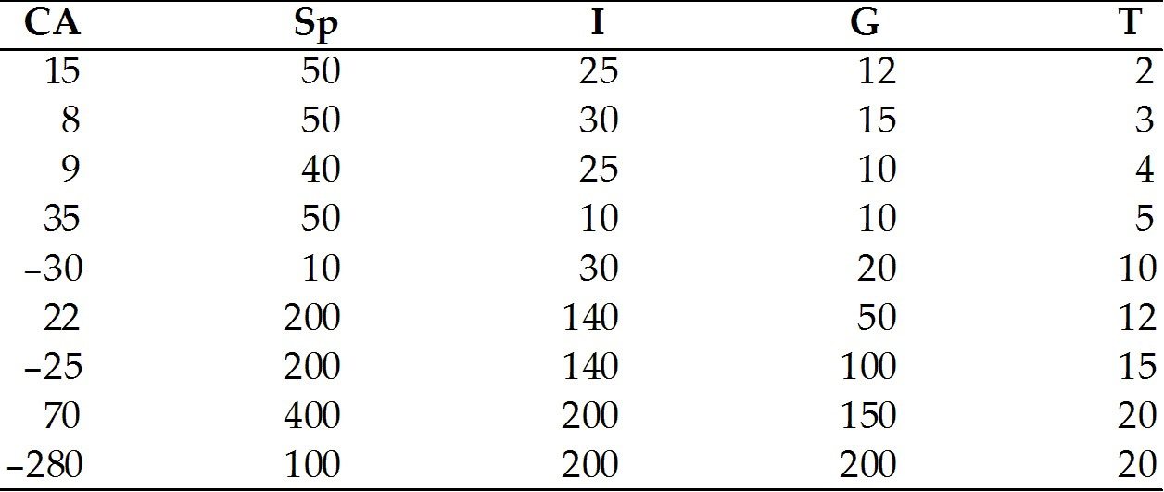
Page Ref: 332
Difficulty: Moderate

13.3 The Balance of Payments Accounts

1) Every international transaction automatically enters the balance of payments
A) once either as a credit or as a debit.
B) twice, once as a credit and once as a debit.
C) once as a credit.
D) twice, both times as debit.
E) three times, once as a credit, once as a debit, and once as an exchange.
Answer: B
Page Ref: 334-335
Difficulty: Easy

2) The official settlements balance or balance of payments is the sum of
A) the current account balance, and the capital account balance, less the non-reserve portion of the financial account balance.
B) the current account balance and the capital account balance.
C) the current account balance, the capital account balance, the non-reserve portion of the financial account balance, the statistical discrepancy.
D) the current account balance and the non-reserve portion of the financial account balance.
E) the current account balance and the interest in all investments.
Answer: A
Page Ref: 341
Difficulty: Easy
3) An American buys a Japanese car, paying by writing a check on an account with a bank in New York. How would this be accounted for in the balance of payments?
A) current account, a Japanese good import
B) current account, a U.S. good import
C) financial account, a U.S. asset import
D) financial account, a U.S. asset export
E) a current account as a U.S. good import and a financial account, a U.S. asset export
Answer: E
Page Ref: 335-336
Difficulty: Moderate

4) The United States issues a $10,000 debt forgiveness to Argentina. How is this accounted for in the balance of payments?
A) financial account, U.S. asset import
B) current account, Argentina transfer payment
C) current account, U.S. service export
D) capital account, U.S. transfer payment
E) current account, Argentina good import
Answer: D
Page Ref: 335-336
Difficulty: Moderate

5) A U.S. citizen buys a newly issued share of stock in England, paying for his order with a check, which the British company deposits in its own U.S. bank account in New York. How is this transaction accounted for in the balance of payments?
A) financial account, U.S. asset import
B) current account, U.S. service import
C) current account, British good export
D) financial account, British asset import
E) financial account, U.S. asset export
Answer: A
Page Ref: 335-336
Difficulty: Difficult

6) You travel to Paris and pay for a $100 dinner with your credit card. How is this accounted for in the balance of payments?
A) current account, French service import
B) current account, U.S. good export
C) financial account, U.S. asset export
D) financial account, U.S. asset import
E) financial account, French asset export
Answer: C
Page Ref: 335-336
Difficulty: Moderate
7) The German government carries out an official foreign exchange intervention in which it uses dollars held in an American bank to buy French currency from its citizens. How is this accounted for in the balance of payments?
A) current account, French good export
B) current account, German good import
C) financial account, French asset export
D) financial account, German asset export
E) financial account, German asset import
Answer: C
Page Ref: 335-336
Difficulty: Difficult

8) The profits of a Spanish factory with British owners are
A) counted in Spain's GNP.
B) not part of Britain's GDP.
C) counted in Britain's GDP.
D) part of Spain's GNP.
E) counted in Spain's GDP and are a part of Britain's GNP.
Answer: E
Page Ref: 326
Difficulty: Difficult

9) The services British capital provides in Spain are a service export from Britain
A) therefore they are subtracted from British GDP in calculating British GNP.
B) therefore they are added to Spanish GDP in calculating Spanish GDP.
C) therefore they are added to British GDP in calculating British GNP.
D) therefore they are added to Spanish GNP in calculating Spanish GDP.
E) therefore they are subtracted from Spanish GNP.
Answer: C
Page Ref: 326
Difficulty: Difficult

10) Unilateral transfers between countries are
A) long-term loans.
B) part of national income, but not part of the current account
C) part of the current account, but not a part of national income.
D) known for reducing the income of capital owners.
E) international gifts or payments that do not correspond to the purchase of any good, service, or asset.
Answer: E
Page Ref: 338
Difficulty: Moderate
11) Which of the following statements about the central bank is TRUE?
A) Only the central bank may hold foreign reserves and intervene officially in exchange markets.
B) Central banks have little power to affect macroeconomic conditions.
C) Today, central banks' reserves consist largely of gold.
D) The Federal Reserve holds only a small level of official reserve assets other than gold.
E) Central banks never inject money into the economy.
Answer: D
Page Ref: 340
Difficulty: Moderate

12) How do we allocate statistical discrepancy among the current, capital, and financial accounts?
A) We have no way of knowing exactly how to allocate this discrepancy.
B) Depend on the degree of certainty which we attribute to these accounts.
C) Divide it evenly amongst the three accounts.
D) Depend on the convention adopted by the specific financial institution.
E) Statistical discrepancy signals human errors made when dealing with financial accounts.
Answer: A
Page Ref: 339-340
Difficulty: Easy

13) Which of the following is TRUE about current cost method and market value method?
A) They are used by the BEA to place current values on foreign indirect investments.
B) These methods lead to the same valuations.
C) Based on the current cost method, the BEA's 2015 estimate of U.S. net foreign wealth was -$7,280.6 billion.
D) The market value cost method is preferred by the BEA.
E) Foreign direct investments of the U.S. are valued at their original purchase price.
Answer: C
Page Ref: 342
Difficulty: Moderate

14) What types of international transactions are recorded in the balance of payment accounts?
Answer: Three types: (1) transactions that involve exports and imports of goods and services; (2) transactions that involve the purchase or sale of financial assets; (3) other activities resulting in transfer of wealth between countries which are recorded in the capital account.
Page Ref: 334
Difficulty: Moderate

15) "If the simple rule of double-entry bookkeeping holds true, the Balance of payments is always in balance." Discuss.
Answer: True. Every international transaction automatically enters the balance of payments twice, once as a credit and once as a debit.
Current account + financial account + capital account = 0
Page Ref: 334-336
Difficulty: Moderate
16) "The balance of payments is seldom in balance in practice." Discuss.
Answer: True. The main reasons are due to the fact that data collected or received from different sources may differ in coverage, accuracy, and timing. In addition, data on services are not reliable as well as data from the financial account. Moreover, accurate measurements of international interest and dividend receipts are particularly difficult.
Page Ref: 339-340
Difficulty: Moderate

17) How does an economy's central bank manage the supply of money through official reserve transactions?
Answer: Official foreign exchange interventions are a way for the central bank to inject money into the economy or withdraw it from circulation. They can buy or sell international reserves in private asset markets in order to affect macroeconomic conditions without noticeably impacting the money supply. When a central bank purchases or sells a foreign asset, the transaction appears in its country's financial account as if a private citizen had carried out the same transaction.
Page Ref: 340
Difficulty: Moderate

18) How can changes in the market price of wealth previously acquired alter a country's net foreign wealth?
Answer: When Japan's stock market lost value in the 1990s, American and European owners of Japanese assets lost value in their claims, while Japan's net foreign wealth increased. Similarly, exchange rate changes can have this effect. When the dollar depreciates against foreign currency, foreigners who hold dollar assets will see their wealth fall when measured in their home currencies.
Page Ref: 341
Difficulty: Moderate

19) Discuss the two different methods the Bureau of Economic Analysis (BEA) uses to place current values on foreign direct investments.
Answer: The current cost method values direct investments at the cost of buying them today. The market value method is meant to measure the price at which the investments could be sold. These two methods can lead to different valuations because the cost of replacing a particular direct investment and the price it would command if sold on the market may be hard to measure.
Page Ref: 342
Difficulty: Moderate

20) Consider how the United States balance of payments accounts are affected when U.S. banks forgive two billion in debt owed to them by the government of Argentina.
Answer: In this case, the United States makes a two billion dollar capital transfer to Argentina, which should appear as a negative two billion entry in the capital account. The associated credit is in the financial account, in the form of a two billion dollars reduction in U.S. assets held abroad, i.e., a net asset "export," and therefore a positive balance of payments entry.
Page Ref: 334-336
Difficulty: Moderate
21) What can one learn from Figure 13-2 from the text, shown below?

Answer: This figure shows that since the 1980s, United States foreign assets and liabilities have both increased rapidly. However, liabilities have risen faster than U.S. foreign assets, resulting in a substantial net foreign debt.
Page Ref: 330
Difficulty: Easy

