Genetics: An Integrated Approach (Sanders)
Chapter 1 The Molecular Basis of Heredity, Variation, and Evolution
1.1 Multiple-Choice Questions
1) Bacteria are single-celled organisms with a single chromosome found in which cell space?
A) nucleus
B) nucleolus
C) nucleoid
D) nuclear envelope
E) mitochondria
Answer: C
Section: 1.1
Skill: Knowledge/Comprehension
2) Sexual reproduction uses __________ to generate _______ gametes, which join at fertilization.
A) meiosis; haploid
B) mitosis; haploid
C) meiosis; diploid
D) mitosis; diploid
E) mitosis; identical
Answer: A
Section: 1.1
Skill: Knowledge/Comprehension
3) When a diploid cell divides by mitosis, the result is __________.
A) identical haploid cells
B) identical diploid cells
C) unique diploid cells
D) unique haploid cells
E) a zygote.
Answer: B
Section: 1.1
Skill: Knowledge/Comprehension
4) Modern genetics consists of three major branches. Which of these branches, also known as “transmission genetics,” involves the study of the transmission of traits and characteristics in successive generations?
A) evolutionary
B) Mendelian
C) molecular
D) population
E) reproductive
Answer: B
Section: 1.1
Skill: Knowledge/Comprehension
5) You identify a new unicellular organism with multiple chromosomes organized by proteins within the cell’s nucleus. Into which of the three domains of life might this organism fit?
A) Archaea
B) Bacteria
C) Eukarya
D) Archaea or Bacteria
E) Archaea or Eukarya
Answer: C
Section: 1.1
Skill: Application/Analysis
6) Watson and Crick used evidence from several studies to determine the structure of DNA. What conclusion were they able to draw from Rosalind Franklin’s X-ray diffraction data, specifically?
A) DNA consists of four types of nucleotide bases: A, T, C, and G.
B) DNA nucleotides form complementary base pairs.
C) Adenine pairs with thymine and cytosine pairs with guanine when they are on opposite DNA strands.
D) DNA is a duplex, with two strands forming a double helix.
E) The DNA strands are antiparallel, and the strands are held together by hydrogen bonds.
Answer: D
Section: 1.2
Skill: Knowledge/Comprehension
7) What kind of bond is formed between the 5′ phosphate group of one nucleotide and the 3′ hydroxyl (OH) group of the adjacent nucleotide?
A) ionic bond
B) phosphodiester bond
C) hydrogen bond
D) disulfide bond
E) hydroxyl bond
Answer: B
Section: 1.2
Skill: Knowledge/Comprehension
8) What kind of bond is formed between complementary base pairs to join the two DNA strands into a double helix?
A) ionic bond
B) phosphodiester bond
C) hydrogen bond
D) disulfide bond
E) peptide bond
Answer: C
Section: 1.2
Skill: Knowledge/Comprehension
9) Which type(s) of RNA is/are translated into proteins?
A) mRNA
B) rRNA
C) tRNA
D) mRNA and rRNA
E) mRNA, rRNA, and tRNA
Answer: A
Section: 1.3
Skill: Knowledge/Comprehension
10) Which enzyme is active in DNA replication?
A) DNA polymerase
B) RNA polymerase
C) reverse transcriptase
D) aminoacyl-tRNA synthetase
E) RNase
Answer: A
Section: 1.2
Skill: Knowledge/Comprehension
11) The promoter is bound by which enzyme?
A) DNA polymerase
B) RNA polymerase
C) Reverse transcriptase
D) DNase
E) RNase
Answer: B
Section: 1.3
Skill: Knowledge/Comprehension
12) What is the process of synthesizing proteins from mRNA sequences?
A) replication
B) transcription
C) translation
D) transformation
E) transduction
Answer: C
Section: 1.3
Skill: Knowledge/Comprehension
13) What is the process of synthesizing single-stranded RNA from template DNA?
A) replication
B) transcription
C) translation
D) transformation
E) transduction
Answer: B
Section: 1.3
Skill: Knowledge/Comprehension
14) What kind of bond is formed between successive amino acids during translation?
A) ionic bond
B) phosphodiester bond
C) hydrogen bond
D) disulfide bond
E) peptide bond
Answer: E
Section: 1.3
Skill: Knowledge/Comprehension
15) Which evolutionary process describes the movement of members of a species from one population to another?
A) natural selection
B) migration
C) mutation
D) random genetic drift
E) population genetics
Answer: B
Section: 1.4
Skill: Knowledge/Comprehension
16) Which evolutionary process is most pronounced in small populations where statistical fluctuations in allele frequencies can be significant from one generation to the next?
A) natural selection
B) migration
C) mutation
D) random genetic drift
E) population genetics
Answer: D
Section: 1.4
Skill: Knowledge/Comprehension
17) Which evolutionary process involves the slow addition of allelic variation that increases the hereditary diversity of populations, ultimately leading to evolutionary change?
A) natural selection
B) migration
C) mutation
D) random genetic drift
E) population genetics
Answer: C
Section: 1.4
Skill: Knowledge/Comprehension
18) Which evolutionary process relies on the premise that individuals with the best adaptations are most successful at reproducing and leave more offspring than those with less adaptive forms?
A) natural selection
B) migration
C) mutation
D) random genetic drift
E) population genetics
Answer: A
Section: 1.4
Skill: Knowledge/Comprehension
19) Which term describes a set of organisms that descended from a single common ancestor and are more closely related to other members of the group than to organisms outside the group?
A) paraphyletic group
B) phylogeny
C) species
D) monophyletic group
E) parsimony
Answer: D
Section: 1.4
Skill: Knowledge/Comprehension
20) Morphological or molecular characters shared by members of a clade are called ______.
A) common ancestors
B) paraphyletic groups
C) homoplasys
D) monophyletic groups
E) synapomorphies
Answer: E
Section: 1.4
Skill: Knowledge/Comprehension
21) What is the sequence and polarity of the DNA strand complementary to the strand
5′ AAATGTCCATGC 3′?
A) 5′ TTTACAGGTACG 3′
B) 3′ AAATGTCCATGC 5′
C) 3′ TTTACAGGTACG 5′
D) 5′ UUUACAGGUACG 3′
E) 3′ UUUACAGGUACG 5′
Answer: C
Section: 1.2
Skill: Application/Analysis
1.2 Short-Answer Questions
1) What are the three domains of life?
Answer: Bacteria, Archaea, and Eukarya
Section: 1.1
Skill: Knowledge/Comprehension
2) With the assistance of William Bateson, Archibald Garrod produced the first documented example of a human hereditary disorder. Which disorder were they describing?
Answer: alkaptonuria
Section: 1.1
Skill: Knowledge/Comprehension
3) After replication, chromosomes consist of how many molecules of DNA (assuming one chromatid is equal to one molecule of DNA)?
Answer: two
Section: 1.2
Skill: Application/Analysis
4) The physical units of heredity composed of defined DNA sequences that collectively control gene transcription and contain the information to produce RNA molecules or proteins are better known as what?
Answer: genes
Section: 1.2
Skill: Knowledge/Comprehension
5) A complete set of chromosomes is transmitted to produce identical daughter cells in which cell division process?
Answer: mitosis
Section: 1.1
Skill: Knowledge/Comprehension
6) In eukaryotes, most of the cells’ DNA is found in the form of chromosomes in the nucleus. Which organelles contain their own genomes (descended from ancient endosymbiotic bacteria)?
Answer: mitochondria and chloroplasts
Section: 1.1
Skill: Knowledge/Comprehension
7) What are the three principal components of a DNA nucleotide?
Answer: sugar (deoxyribose), phosphate, and nitrogenous base (nucleobase)
Section: 1.2
Skill: Knowledge/Comprehension
8) In double-stranded DNA, the percentages of adenine and thymine are approximately equal to each other, as are the percentages of cytosine and guanine. This relationship is better known as what (named for the person who made this discovery)?
Answer: Chargaff’s rule
Section: 1.2
Skill: Knowledge/Comprehension
9) The polarities of complementary nucleic acid strands run in opposite directions: 5′-to-3′ and
3′-to-5′. The 5′ designation refers to the placement of what chemical group on the 5′ carbon of
the deoxyribose sugar?
Answer: phosphate group
Section: 1.2
Skill: Knowledge/Comprehension
10) During DNA replication, nascent DNA strands are synthesized in only one direction. Nucleotides are added only to which end of the nascent strand?
Answer: the 3′ hydroxyl end
Section: 1.2
Skill: Knowledge/Comprehension
11) In retroviruses, DNA is synthesized from an RNA template using which enzyme?
Answer: reverse transcriptase
Section: 1.3
Skill: Knowledge/Comprehension
12) Messenger RNA codons pair with tRNA anticodons at which cell structure?
Answer: the ribosome
Section: 1.3
Skill: Knowledge/Comprehension
13) Peptidyl transferase and other proteins power the continuous progression of the ribosome along mRNA and catalyze what type of bond formation in the growing polypeptide chain?
Answer: peptide bonds
Section: 1.3
Skill: Knowledge/Comprehension
14) Only sixty one of the sixty four codons specify an amino acid. What is the function of the other three codons?
Answer: stop codons
Section: 1.3
Skill: Knowledge/Comprehension
15) What process proposed by Wallace and Darwin describes the higher rates of survival and reproduction of certain forms of a species over alternative forms?
Answer: natural selection
Section: 1.4
Skill: Knowledge/Comprehension
16) As natural selection increases the frequency of one morphological form over another in the population, what changes at the genotypic level?
Answer: allele frequency
Section: 1.4
Skill: Application/Analysis
17) Theodosius Dobzhansky and Ernst Mayr drew on ideas from Darwin, Fisher, Wright, Haldane, and others to demonstrate how evolution operates in real populations. These observations led to which evolutionary genetics theory?
Answer: modern synthesis of evolution
Section: 1.4
Skill: Knowledge/Comprehension
18) What type of diagram would you use to depict morphological or molecular similarities and differences that identify evolutionary relationships?
Answer: phylogenetic tree
Section: 1.4
Skill: Knowledge/Comprehension
19) Both sugar gliders and flying squirrels have evolved characteristics that allow them to glide, despite being geographically separated. Similar traits that have independent origins arise as a result of what phenomenon?
Answer: convergent evolution
Section: 1.4
Skill: Application/Analysis
20) Phylogenetic trees are constructed based on morphological characteristics, but molecular phylogenetic trees are constructed based on which feature?
Answer: nucleic or amino acid sequence
Section: 1.4
Skill: Knowledge/Comprehension
1.3 Fill-in-the-Blank Questions
1) The work of Walter Sutton and Theodor Boveri suggested that the hereditary units, or genes, described by Mendel are located on ________.
Answer: chromosomes
Section: 1.1
Skill: Knowledge/Comprehension
2) Genetic experiments have revealed the relationship between the observable traits of an organism, or ________, and the genetic constitution of an organism, or ________.
Answer: phenotype; genotype
Section: 1.1
Skill: Knowledge/Comprehension
3) DNA replication is called ________ because the newly replicated DNA consists of a parental strand (from the original DNA) and a newly synthesized daughter strand.
Answer: semiconservative
Section: 1.2
Skill: Knowledge/Comprehension
4) The ________, first proposed by Francis Crick, summarizes the relationships between DNA, RNA, and protein.
Answer: central dogma of biology
Section: 1.3
Skill: Knowledge/Comprehension
5) There are sixty one different codons that code for amino acids, but only twenty different amino acids, meaning that the genetic code is ________.
Answer: redundant
Section: 1.3
Skill: Knowledge/Comprehension
1.4 Essay Questions
1) The DNA sequence below encodes the first five amino acids of a large protein.
5′ ATGTTAGGATATCAG 3′
3′ TACAATCCTATAGTC 5′
a. Identify the coding and template strands.
b. Write the sequence and polarity of the mRNA transcript produced by this sequence. Where does this process occur in eukaryotes?
c. Write the amino acid sequence of the amino acids produced using the three-letter code for amino acids. (See genetic code table in text.) Where does this process occur in eukaryotes?
Answer:
a. The top strand is the coding strand. The bottom strand is the template.
b. 5′ AUGUUAGGAUAUCAG 3′. Transcription occurs in the nucleus in eukaryotes.
c. Met-Leu-Gly-Tyr-Gln. Translation occurs on ribosomes.
Section: 1.3
Skill: Synthesis/Evaluation
2) What are the three major types of RNA and their functions? What would happen to translation if each type of RNA were degraded?
Answer:
1. Messenger RNA (or mRNA) is transcribed from the DNA template and translated into proteins.
2. Ribosomal RNA (rRNA) forms part of the ribosomes, the plentiful cellular structures where protein assembly takes place.
3. Transfer RNA (tRNA) carries amino acids, the building blocks of proteins, to ribosomes.
If any of these types of RNA were degraded, then translation would not occur. Degrading mRNA would prevent translation of that particular gene. Degrading rRNA or tRNA would prevent translation of any mRNAs because the ribosome would not form properly, and the transfer RNA would not bring the correct amino acid to the growing polypeptide chain.
Section: 1.3
Skill: Synthesis/Evaluation
3) DNA strands can be pulled apart by adding heat and “melting” the double-stranded DNA. The temperature required to melt a region of DNA changes based on the base-pair composition. Based on the structure of the A-T and C-G bonds in the accompanying figure, which bonds would require more energy (heat) to break them? How might this help you predict which regions of the DNA helix may be the most stable and harder to break apart?
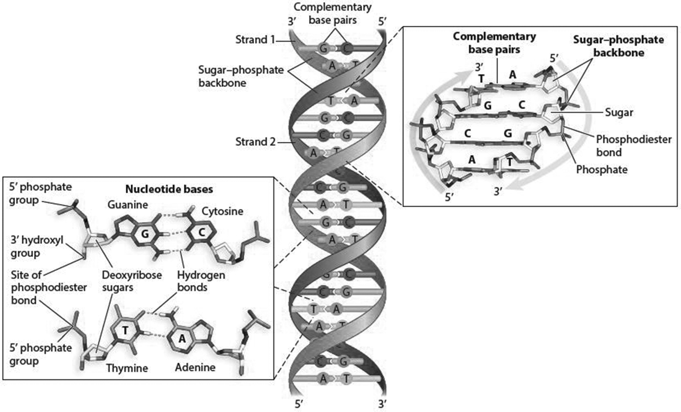
Answer: C-G bonds contain three hydrogen bonds, whereas A-T bonds have only two hydrogen bonds. The more hydrogen bonds in a particular region of DNA, the more energy required to break those bonds apart. Thus, regions of DNA with large numbers of C and G residues will be more heat resistant (and probably transcribed less often) than A-T rich regions.
Section: 1.2
Skill: Synthesis/Evaluation
4) Describe what is meant by adaptive and nonadaptive evolution. Which type of evolution might be represented by the differences in the shape of finch beaks on different islands with different food sources, and which type by the presence of both attached and detached earlobes in a given population?
Answer: Adaptive evolution implies that one form reproduces in greater numbers than others in a population because of being better adapted to the conditions driving natural selection. Finch beak shape is an example of adaptive evolution. Nonadaptive evolution describes the evolution of characteristics that are reproductively equivalent to other forms in the population. Nonadaptive traits are neutral with respect to natural selection, conferring neither a selective advantage nor a selective disadvantage to their bearer (e.g., attached versus detached earlobes).
Section: 1.4
Skill: Synthesis/Evaluation
5) Describe the evolutionary relationship of lancelets to tunicates and to hagfishes. Are lancelets more closely related to tunicates or to hagfishes, or are they equally related?
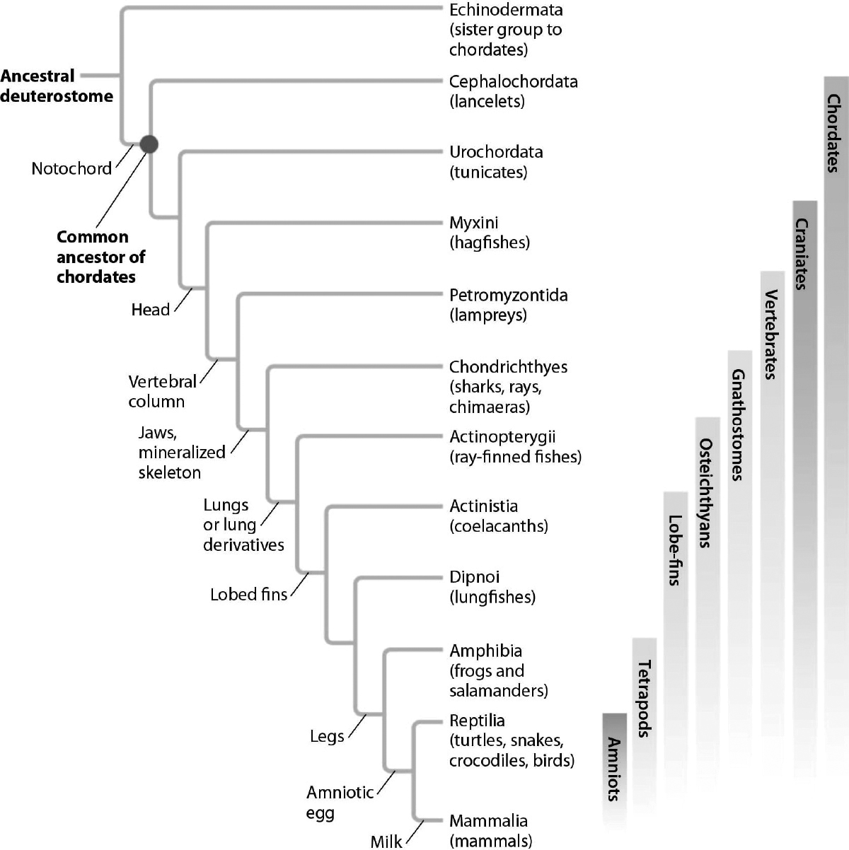
Answer: Lancelets are equally related to tunicates and to hagfishes. The most recent common ancestor of lancelets and tunicates is the common ancestor of chordates. The most recent common ancestor of lancelets and hagfishes is the same (the common ancestor of chordates).
Section: 1.4
Skill: Synthesis/Evaluation
6) Based on molecular evidence, the ancestor of snakes had legs. How might you explain the loss of legs in modern snakes?
Answer: In a given environment, it was an advantage for the ancestors of modern snakes to be limbless. Due to natural selection, the legs became minimized over many generations to the point where they were eventually lost. So, just as traits can be gained by evolution, they can be lost if there is an evolutionary advantage to that change.
Section: 1.5
Skill: Synthesis/Evaluation
7) You obtain the following sequence data from a group of related populations:
Base #: 123 456 789
Ancestral sequence: TTT CAT CCG
Descendant population #1: TTG CAT CCA
Descendant population #2: TTG CAT CCG
Descendant population #3: TTT CAA CCG
Descendant population #4: TTT CAA CGG
Construct a phylogenetic tree that fits the data and requires the least amount of genetic change. Indicate where genetic changes occurred that were passed down to descendant populations.
Answer:
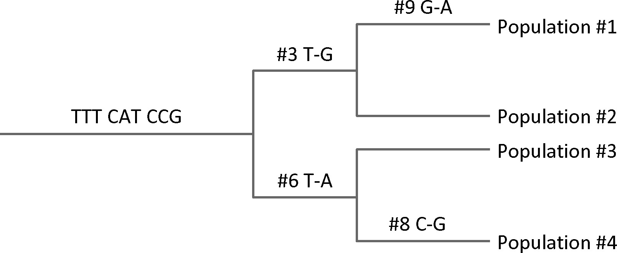
Section: 1.5
Skill: Synthesis/Evaluation

