Chapter 01
Overview of Financial Statement Analysis

Multiple Choice Questions
1. | Which of the following is likely to be the most informative source if you were interested in a company's business plan or strategy?
  A. | Auditor's letter
  B. | Management discussion and analysis
  C. | Proxy statement
  D. | Footnotes

2. | Which of the following would not be considered a source of financing?
  A. | Notes receivable
  B. | Common stockholders' equity
  C. | Retained earnings
  D. | Debentures

3. | Wilco Company reports the following:  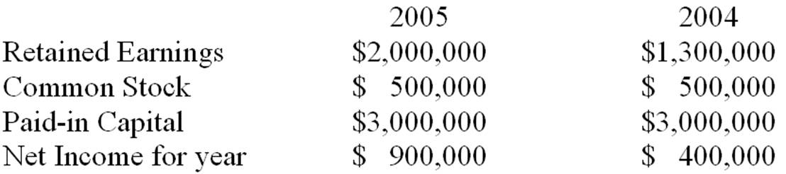  Dividend payout ratio for 2005 was:
  A. | 27%.
  B. | 12%.
  C. | 22.2%.
  D. | Not determinable

4. | If a company receives an unqualified audit opinion it means the auditors:
  A. | did not complete a full audit and therefore do not feel qualified to give an opinion on financial statements.
  B. | are providing assurance that the company will remain financially viable for at least the next year.
  C. | are providing assurance that the company's financial statements fairly present company's financial performance and position.
  D. | are providing assurance that the company's financial statements are free from misstatement, fraudulent accounting and fairly indicate future performance.

5. | The Management Discussion and Analysis Section of an annual report:
  A. | is required by the SEC.
  B. | is optional but normally included in the annual report.
  C. | is required by the SEC only if the company has suffered from unfavorable trends or there are significant uncertainty concerning liquidity of the company.
  D. | is required by the SEC only if they have a qualified audit opinion.

You are analyzing a large stable company. For the year ending 12/31/05 the company reported earnings of $58,900 and book value at the end of 2005 was $371,700. You expect earnings to grow at 5% a year in perpetuity, and the dividend payout ratio of 70% to continue. The company borrows at 8%, and has a cost of equity of 12%. The company has 25,000 shares outstanding.

6. | What is your estimate of price per share using the dividend discount model at 12/31/05?
  A. | $20.62
  B. | $21.65
  C. | $23.56
  D. | $24.74

7. | What is your estimate of price using the residual income valuation model at 12/31/05?
  A. | $20.62
  B. | $21.65
  C. | $23.56
  D. | $24.72

8. | Which of the following is not a common tool used in financial statement analysis?
  A. | Random walk analysis
  B. | Ratio analysis
  C. | Common-size statement analysis
  D. | Credit analysis

9. | A common-size income statement would typically be prepared by dividing:
  A. | all items on income statement in Year t by their corresponding value in Year t-1.
  B. | all items on income statement in Year t by their corresponding balance sheet accounts in Year t.
  C. | all items on income statement in Year t by net income in Year t-1.
  D. | all items on income statement in Year t by sales in Year t.

10. | When conducting comparative analysis by reviewing consecutive balance sheets:
  A. | all items on the balance sheet in Year t must be divided by their corresponding value in Year t-1 and subtract 1 to calculate the percentage change.
  B. | all items on the balance sheet in Year t-1 must be subtracted from their corresponding value in Year t to calculate the dollar change.
  C. | all items on the balance sheet in Year t must be divided by net income in Year t-1 to calculate the percentage change.
  D. | Both A and B are correct.

You have prepared a trend series for Company XYZ for three years, 2004-2006 inclusive, using 2004 as the base year. Below are selected data.
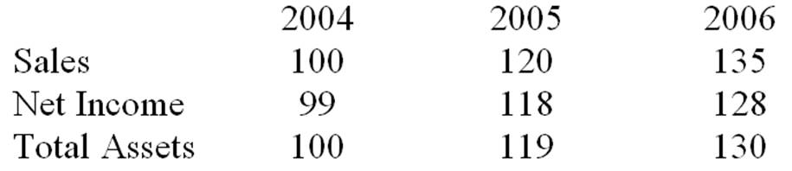

11. | From the above information, you can infer that:
  A. | rate of sales growth has decreased.
  B. | net income to sales (return on sales) is increasing over time.
  C. | asset turnover is decreasing over time.
  D. | None of the above

12. | Which of the following statements is incorrect?
  A. | Net income in 2006 increased by 29.29% compared to 2004.
  B. | XYZ's net income to sales (return on sales) is higher in 2006 as compared to 2004.
  C. | XYZ's net income to sales (return on sales) is lower in 2005 as compared to 2004.
  D. | Assets have increased over time.

Part of the demonstration, if you need more samples, please contact the customer service

From qidiantiku.com

