Biology: Science for Life with Physiology, 5e (Belk)
Chapter 1 Can Science Cure the Common Cold? Introduction to the Scientific Method

1) Why is the scientific method used?
A) to answer specific questions about the natural world
B) to determine absolute truth
C) to distinguish good from evil
D) to establish moral codes
Answer: A
Section: 1.1
Skill: Knowledge (Remember)
Learning Outcome: 1.1

2) Which feature is necessary for a scientific hypothesis?
A) It is able to be proven true.
B) It is falsifiable.
C) It is a theory about something.
D) It is not based on observations.
Answer: B
Section: 1.1
Skill: Knowledge/Comprehension (Remember/Understand)
Learning Outcome: 1.1

3) Which of the following is an appropriate scientific hypothesis?
A) Bad people catch more colds than good people.
B) Cold viruses should be allowed to reproduce just like anything else.
C) It is unethical to go to school when you have a cold.
D) People catch colds because of exposure to cold temperature.
Answer: D
Section: 1.1
Skill: Comprehension/Application (Understand/Apply)
Learning Outcome: 1.1

4) What is a scientific theory?
A) an explanation supported by large amounts of experimental evidence
B) an explanation that cannot be modified with new experimental evidence
C) little more than one person's educated guess
D) any testable explanation for a question or problem
Answer: A
Section: 1.1
Skill: Knowledge (Remember)
Learning Outcome: 1.2
5) Deductive reasoning is used to make ________ based on a hypothesis.
A) correlations
B) data
C) predictions
D) statistical tests
Answer: C
Section: 1.1
Skill: Knowledge/Comprehension (Remember/Understand)
Learning Outcome: 1.3

6) Which hypothesis was tested by Warren and Marshall during their research involving Helicobacter pylori bacteria and stomach ulcers?
A) Eating spicy food increases populations of H. pylori in the stomachs of people susceptible to ulcers.
B) The cause of many stomach ulcers is the bacterium H. pylori, not spicy food.
C) Stomach acid production is decreased by H. pylori bacteria in the stomachs of people with ulcers.
D) Acute stomach pain is often caused by H. pylori bacteria, not ulcers.
Answer: B
Section: 1.1
Skill: Comprehension/Application (Understand/Apply)
Learning Outcome: 1.1

7) Which microbiologists contributed to the germ theory of disease?
A) Warren and Marshall
B) Pasteur and Koch
C) Watson and Crick
D) Jacob and Monod
Answer: B
Section: 1.1
Skill: Knowledge/Comprehension (Remember/Understand)
Learning Outcome: 1.2

8) Which statement would be correct if an inductively reasoned hypothesis makes sense, based on all available and historical observations?
A) The hypothesis must be true.
B) The hypothesis cannot possibly be true.
C) The hypothesis must be tested.
D) Experimentation is not necessary.
Answer: C
Section: 1.1
Skill: Application (Apply)
Learning Outcome: 1.4

9) Why are hypotheses never accepted as proven by scientists?
A) A hypothesis cannot ever be true or false because it is an opinion.
B) Experimentation cannot support a hypothesis because it only tests predictions.
C) Hypotheses change every time a new experiment is conducted.
D) Alternative hypotheses might provide a better answer to the research question.
Answer: D
Section: 1.1
Skill: Analysis (Analyze)
Learning Outcome: 1.4
10) What is the result when a well-tested hypothesis is supported by many independent studies in the scientific community?
A) The hypothesis would be considered a scientific theory.
B) The hypothesis is now be referred to as a prediction.
C) Further experiments would not occur unless a sufficient alternative is proposed.
D) The hypothesis is a fact that cannot be refuted.
Answer: A
Section: 1.2
Skill: Comprehension/Application (Understand/Apply)
Learning Outcome: 1.5

11) Consider this hypothesis: "Drinking Echinacea tea reduces the duration and severity of colds." Which of the following statements is the best prediction based on this hypothesis?
A) If people with a cold drink Echinacea tea, then they will feel better sooner.
B) If people with a cold drink Echinacea tea, then a tea ingredient will destroy the cold viruses.
C) If people with a cold drink Echinacea tea, then the tea will reduce their stress.
D) If a person doesn't drink Echinacea tea, then he or she will catch a cold very easily.
Answer: A
Section: 1.1
Skill: Application/Analysis (Apply/Analyze)
Learning Outcome: 1.3

12) Which of the following is a testable hypothesis?
A) Taking zinc lozenges at the first sign of cold symptoms is wise.
B) Avoiding contact with other people reduces the chance of catching a cold.
C) Being a good driver makes you less likely to catch a cold.
D) Sleeping 8 hours a night makes you feel better when you have a cold.
Answer: B
Section: 1.1
Skill: Comprehension/Application (Understand/Apply)
Learning Outcome: 1.1

13) Which of the following hypotheses is testable using scientific methods?
A) Bees can see ultraviolet light that humans can't.
B) The dinosaur Tyrannosaurus rex was a scavenger, not a predator.
C) Peacocks like to display their large tail feathers.
D) People with type O blood are natural meat eaters.
Answer: A
Section: 1.1
Skill: Comprehension/Application (Understand/Apply)
Learning Outcome: 1.1

14) Which of the following statements is a testable scientific hypothesis?
A) Antioxidants from food are better than antioxidants from a vitamin pill.
B) Eating fish reduces the chance of having a stroke.
C) Embryonic stem cell research will allow scientists to find a cure for diabetes.
D) Smoking makes people less attractive.
Answer: B
Section: 1.1
Skill: Comprehension/Application (Understand/Apply)
Learning Outcome: 1.1
15) Which statement makes a prediction for the hypothesis "bird species have decreased in number in a particular wetland due to construction traffic"?
A) If a wetland area is disturbed by construction vehicles, then the number of bird species will decrease.
B) If construction vehicles are in a wetland, then the birds will become too frightened to reproduce.
C) If bird numbers decrease in a wetland, then construction vehicles must have polluted the environment.
D) If construction vehicles enter a wetland, then new predators will arrive and reduce the bird populations.
Answer: A
Section: 1.1
Skill: Application/Analysis (Apply/Analyze)
Learning Outcome: 1.3

16) Certain researchers have published peer-reviewed reports that the use of zinc lozenges reduces the length and severity of cold symptoms. Why are some scientists still skeptical about the merits of using zinc lozenges during a cold?
A) Most people get zinc in their diet so extra zinc lozenges may not affect a cold.
B) Ideas about vitamin C have been discredited, so zinc will also be ineffective.
C) There is no way of knowing if the original work was properly controlled.
D) There may be other reasons why the people taking zinc lozenges recovered faster.
Answer: D
Section: 1.1
Skill: Application (Apply)
Learning Outcome: 1.4

17) What type of reasoning takes the form of "if/then" statements?
Answer: Deductive
Section: 1.1
Skill: Knowledge/Comprehension (Remember/Understand)
Learning Outcome: 1.3

18) What type of reasoning is used to make a hypothesis based on previously established observations?
Answer: Inductive
Section: 1.1
Skill: Knowledge/Comprehension (Remember/Understand)
Learning Outcome: 1.3

19) What two-word phrase is an explanation of a set of related observations based on well-supported hypotheses from a number of different, independent lines of research?
Answer: scientific theory
Section: 1.1
Skill: Knowledge/Comprehension (Remember/Understand)
Learning Outcome: 1.2

20) What type of reasoning is used to make predictions based on a hypothesis?
Answer: Deductive
Section: 1.1
Skill: Knowledge/Comprehension (Remember/Understand)
Learning Outcome: 1.3
21) A researcher has hypothesized that the chemical tributyltin (an additive in boat paint) seeps into the water causing reproductive defects in developing marine snails. In an experiment testing the effects of tributyltin on developing snails, which condition should be used as a control?
A) Developing snails are kept in a tank of water and exposed to below-expected levels of tributyltin.
B) Developing snails are kept in a tank of water and exposed to boat paint without tributyltin.
C) Developing snails are kept in a dry tank to avoid exposure to contaminated water.
D) Developing snails are kept in a tank of water that has been cleaned with chlorine bleach.
Answer: B
Section: 1.2
Skill: Comprehension/Application (Understand/Apply)
Learning Outcome: 1.5

22) Mehran heard that drinking a high protein supplement after football training would improve his muscle mass. To test his hypothesis, the experimental group would receive a high protein drink and the control group would drink only water. Who should be selected for the control group in this experiment?
A) randomly selected teammates who are given only small amounts of a protein drink
B) randomly selected teammates in training who are given a placebo instead of a protein drink
C) volunteers from the general campus population who are not given any protein drink
D) volunteers from the football team who agree to take a placebo instead of a protein drink
Answer: B
Section: 1.2
Skill: Comprehension/Application (Understand/Apply)
Learning Outcome: 1.5

23) Which situation describes potential observer bias in an experimental process?
A) Dr. Jones is evaluating cancer patients for their responses to a new therapeutic drug. She knows which patients are receiving the placebo and which are receiving the drug.
B) Mr. Bromley is conducting a survey of weight loss for his professor. He asks each student in the study the same questions.
C) Ms. Bradley is an outside consultant who is conducting a health and wellness survey for a pharmaceutical company. She does not know the name of the company nor does she know the name of the drug being tested during the survey.
D) Dr. Postgate is analyzing biopsy samples from rats that have been given either a placebo or an experimental drug believed to reduce inflammation. Each sample is identified by a code number so that Dr. Postgate cannot tell which treatment the rats received.
Answer: A
Section: 1.2
Skill: Application/Analysis (Apply/Analyze)
Learning Outcome: 1.6
24) Which factor in an experiment can be manipulated?
A) bias
B) control
C) placebo
D) variable
Answer: D
Section: 1.2
Skill: Knowledge/Comprehension (Remember/Understand)
Learning Outcome: 1.5

25) Experimental subjects are given a pill to test its effectiveness on reducing the duration of a cold. How should the control group be treated?
A) Do nothing with the control group.
B) Give the control group two pills instead of one.
C) Give the control group a pill that does not affect the duration of colds.
D) Let the control group choose whether or not to take any pills.
Answer: C
Section: 1.2
Skill: Application (Apply)
Learning Outcome: 1.5

26) Which group would be the most effective control subjects in a test of an experimental treatment?
A) The control group should be a different age or gender than the experimental subjects.
B) The control group should be given different doses of the experimental treatment.
C) The control group should be kept well informed of what treatment they are getting.
D) The control group should have characteristics very similar to the experimental subjects.
Answer: D
Section: 1.2
Skill: Comprehension/Application (Understand/Apply)
Learning Outcome: 1.5

27) What is the purpose of double-blind experiments?
A) to ensure that the hypothesis is scientifically testable
B) to see if the experimental group responds differently than the control group
C) to help the subjects in an experiment understand the treatment they are receiving
D) to minimize the effects of human bias on the results
Answer: D
Section: 1.2
Skill: Comprehension/Application (Understand/Apply)
Learning Outcome: 1.6

28) Why are model organisms used to test hypotheses?
A) The hypotheses are likely to apply only to the model organism.
B) The hypotheses are potentially too dangerous to perform on human subjects.
C) Human subjects have already been tested.
D) The hypotheses have results that are always applicable to humans.
Answer: B
Section: 1.2
Skill: Application/Analysis (Apply/Analyze)
Learning Outcome: 1.7
29) It has been observed that people with relatively high stress levels get a relatively high number of colds. What would this be an example of?
A) correlation
B) experiment
C) variable
D) hypothesis
Answer: A
Section: 1.2
Skill: Comprehension/Application (Understand/Apply)
Learning Outcome: 1.7

30) There is a strong correlation between stress and susceptibility to colds. What does this mean?
A) Stress must directly cause susceptibility to colds.
B) A high susceptibility to colds must directly cause stress.
C) People with high stress must come into contact with more cold viruses.
D) Stress might or might not affect susceptibility to colds.
Answer: D
Section: 1.2
Skill: Comprehension/Application (Understand/Apply)
Learning Outcome: 1.7

31) When is an experiment considered to be double-blind?
A) The hypothesis being tested is not based on previous observations.
B) It has already been performed by different researchers.
C) Neither the subjects nor the researchers know who is in the experimental and control groups.
D) The results of the experiment are only revealed to certain researchers.
Answer: C
Section: 1.2
Skill: Knowledge/Comprehension (Remember/Understand)
Learning Outcome: 1.6

32) Ideally, what should an experiment studying the effect of a cold medicine have?
A) no control group
B) double-blind procedures
C) a small sample size
D) subjects of only one gender
Answer: B
Section: 1.2
Skill: Comprehension (Understand)
Learning Outcome: 1.5

33) Why are correlations less convincing than controlled experimental results?
A) Correlations are subject to greater bias than experimental results.
B) Correlations cannot be observed outside the laboratory.
C) Correlations cannot be statistically significant.
D) Correlations do not eliminate as many alternative hypotheses.
Answer: D
Section: 1.2
Skill: Analysis (Analyze)
Learning Outcome: 1.7
34) Which of the following is a true statement about experimentation?
A) Variables in an experiment cannot be manipulated by the researcher.
B) Some hypotheses cannot be tested by experimentation.
C) Experimentation should test at least two or more hypotheses at the same time.
D) True randomization of subjects is impossible during experimentation.
Answer: B
Section: 1.2
Skill: Knowledge/Comprehension (Remember/Understand)
Learning Outcome: 1.5

35) A botanist conducted an experiment to test the effect of light on plants. Fifty plants of a flowering species were grown for 60 days under different lengths of artificial daylight. Flowers could be white or pink based on the parent plant genes. The amount of water and fertilizer provided was constant. At the end of the experiment, the size of each leaf for all plants is measured. What is the dependent variable in this experiment?
A) duration of artificial daylight
B) flower's color
C) leaf's size
D) duration of the experiment
Answer: C
Section: 1.2
Skill: Application (Apply)
Learning Outcome: 1.5

36) Why is the random assignment of individuals to experimental and control groups important for an experiment?
A) It ensures that bias has been completely eliminated from the experiment.
B) It ensures that the results of the experiment will be statistically significant.
C) It ensures that the sampling error will have no effect on the results of the experiment.
D) It ensures that each group will better represent the population as a whole.
Answer: D
Section: 1.2
Skill: Analysis (Analyze)
Learning Outcome: 1.6

37) When might bias in an experiment occur?
A) A subject does not know who is in the control or experimental groups.
B) A technician knows which samples are from the control group.
C) A subject finds out the results of the experiment after it is finished.
D) A researcher randomly assigns subjects to the control or experimental group.
Answer: B
Section: 1.2
Skill: Application/Analysis (Apply/Analyze)
Learning Outcome: 1.6
38) In an experiment testing the prediction that a certain drug prevents cataracts in females over the age of 65, which control should be used?
A) male subjects
B) female subjects younger than 65
C) alternative drugs that are suspected to prevent cataracts
D) female subjects over 65 that are given placebos
Answer: D
Section: 1.2
Skill: Comprehension/Application (Understand/Apply)
Learning Outcome: 1.5

39) Which experimental scenario would likely produce the most trustworthy results?
A) a double-blind study involving a new heart disease treatment
B) an unbiased investigation that shows a strong correlation between two variables
C) a single-blind experiment testing the effects of caffeine on blood pressure
D) an experiment that is slightly biased but does not use a model organism
Answer: A
Section: 1.2
Skill: Application/Analysis (Apply/Analyze)
Learning Outcome: 1.6

40) When graphing data, what scientific information do scientists plot on the x-axis?
A) independent variable
B) dependent variable
C) control
D) sampling error
Answer: A
Section: 1.2
Skill: Comprehension (Understand)
Learning Outcome: 1.5

41) The average annual temperature among geographic regions is plotted on the x-axis of a graph and the spiciness of local food in that region is plotted on the y-axis. If the hotness of local food increases as the average annual temperature increases, then what can be concluded?
A) The spiciness of local food does not correlate with the regional average annual temperature.
B) Food is spicy in warm climates because the warm temperatures make local foods more spicy.
C) The relationship between the two variables shows causation but is not correlation.
D) Spiciness of food and annual average temperature are correlated, but causation is not implied.
Answer: D
Section: 1.3
Skill: Analysis (Analyze)
Learning Outcome: 1.8
42) Which of the following is an example of a cohort study?
A) Compare lifetime exposure to coal plant emissions between individuals with lung cancer and individuals without lung cancer in the general population.
B) Measure lifetime exposure to coal plant emissions and the incidence of lung cancer in a group of individuals living in a small town.
C) Question all people in an area about their exposure to coal plant emissions and whether they have any lung diseases.
D) Examine the incidence of lung disease in all females over the age of 50 in a city by a coal plant.
Answer: B
Section: 1.2
Skill: Comprehension/Application (Understand/Apply)
Learning Outcome: 1.7

43) Which of the following is a disadvantage of a correlational experiment?
A) Subjects may not know exposure levels.
B) It is expensive and time consuming.
C) It is not feasible for rare diseases or environmental factors of interest.
D) It is only feasible for hypotheses for which an experimental treatment can be applied.
Answer: D
Section: 1.2
Skill: Comprehension/Application (Understand/Apply)
Learning Outcome: 1.7

44) The incidence of cancer in people living within 100 yards of overhead power lines is recorded. This would be an example of what type of epidemiological technique?
A) ecological study
B) cross-sectional survey
C) cohort study
D) correlational experiment
Answer: A
Section: 1.2
Skill: Comprehension/Application (Understand/Apply)
Learning Outcome: 1.7

45) Which type of study observes specific human populations for unusually high levels of a disease?
A) a case-control study
B) a cross-sectional survey
C) an ecological study
D) a correlational experiment
Answer: C
Section: 1.2
Skill: Comprehension (Understand)
Learning Outcome: 1.7
46) Why are double-blind experiments used?
A) The results will be more biased.
B) The results will be more controlled.
C) The results will be more objective.
D) The results will be more statistically significant.
Answer: C
Section: 1.2
Skill: Comprehension/Application (Understand/Apply)
Learning Outcome: 1.6

47) Why might scientists often be hesitant to believe the results of a single experiment testing a particular treatment, even when the results are peer reviewed and statistically significant?
A) The experimental and control groups may be too alike.
B) The results may not be true for humans if the experiment used a model organism.
C) A single experiment may have eliminated most of the alternative hypotheses.
D) The experiment was likely to have had many biases that affected the results.
Answer: B
Section: 1.1, 1.2
Skill: Application/Analysis (Apply/Analyze)
Learning Outcome: 1.4, 1.5, 1.6

48) What type of subject is treated as closely as possible to an experimental subject except that he or she does not get the experimental treatment?
Answer: control
Section: 1.2
Skill: Knowledge/Comprehension (Remember/Understand)
Learning Outcome: 1.5

49) What is an intentionally ineffective treatment given to members of a control group in an experiment?
Answer: placebo
Section: 1.2
Skill: Knowledge/Comprehension (Remember/Understand)
Learning Outcome: 1.5

50) What is the scientific information collected from well-designed experiments that should allow researchers to either reject or support a hypothesis?
Answer: data
Section: 1.2
Skill: Knowledge/Comprehension (Remember/Understand)
Learning Outcome: 1.5

51) What type of experimental result (two words) is one that is very unlikely to be due to chance differences between the experimental and control groups?
Answer: statistically significant
Section: 1.3
Skill: Knowledge/Comprehension (Remember/Understand)
Learning Outcome: 1.8
52) What is the specialized branch of mathematics that is used to compare data?
A) epidemiology
B) computational mathematics
C) cross-sectional mathematics
D) statistics
Answer: D
Section: 1.3
Skill: Knowledge/Comprehension (Remember/Understand)
Learning Outcome: 1.8

53) When an experiment has a large sample size, and there is a large difference between the results in the experimental and control groups, how likely is it that the experimental results are statistically significant?
A) very unlikely
B) unlikely
C) somewhat likely
D) very likely
Answer: D
Section: 1.3
Skill: Application/Analysis (Apply/Analyze)
Learning Outcome: 1.8

54) What does sampling error refer to?
A) the difficulty in accurately measuring results that are incalculable
B) the differences between a group of experimental subjects and the population as a whole
C) the experimental results that do not support the hypothesis being tested
D) the intentional biases on the part of researchers
Answer: B
Section: 1.3
Skill: Knowledge/Comprehension (Remember/Understand)
Learning Outcome: 1.8

55) How can sampling error be reduced?
A) by increasing the sample size
B) by performing statistical tests on experimental data
C) by performing double-blind experiments
D) by monitoring changes in the experimental and control groups
Answer: A
Section: 1.3
Skill: Application (Apply)
Learning Outcome: 1.8

56) In statistics, what is a sample?
A) the mean of a population to be studied
B) a small subgroup of a population to be studied
C) the correlation between the two different experimental factors
D) a range of values with a high probability of containing the true mean
Answer: B
Section: 1.3
Skill: Knowledge/Comprehension (Remember/Understand)
Learning Outcome: 1.8
57) What is a statistically significant result?
A) a result that is unlikely due to chance
B) a result that has real-world importance but is not necessarily based on mathematical probability
C) a result that is likely due to chance differences between groups
D) a result that the media can report as valid but scientists must consider unsupported by research
Answer: A
Section: 1.3
Skill: Knowledge/Comprehension (Remember/Understand)
Learning Outcome: 1.8

58) When would a large difference between the means of the control and treatment groups be very likely to be statistically significant?
A) only if the hypothesis is false
B) only if the sample size is large
C) only if the experimental result is practically significant
D) only if the experimental result is not practically significant
Answer: B
Section: 1.3
Skill: Comprehension/Application (Understand/Apply)
Learning Outcome: 1.8

59) What would experimental results with very high statistical significance mean?
A) The hypothesis being tested is correct.
B) The experiment had no bias.
C) The experiment had proper controls.
D) A true difference between treatment and control groups likely exists.
Answer: D
Section: 1.3
Skill: Comprehension/Application (Understand/Apply)
Learning Outcome: 1.8

60) What would result from an ideal experiment?
A) high sampling error
B) small treatment effect
C) low standard error
D) large confidence interval
Answer: C
Section: 1.2, 1.3
Skill: Application (Apply)
Learning Outcome: 1.5, 1.8

61) What does it mean if the reported confidence interval for a population mean is 95%?
A) There is a 5% chance that the results are statistically significant.
B) There is a 95% chance that the results are statistically significant.
C) There is a 5% probability that the true mean is in the reported range.
D) There is a 95% probability that the true mean is in the reported range.
Answer: D
Section: 1.3
Skill: Application/Analysis (Apply/Analyze)
Learning Outcome: 1.8
62) What is a standard probability that is accepted by most researchers as statistical significance?
A) 10%
B) 5%
C) 0.05%
D) 0.01%
Answer: B
Section: 1.3
Skill: Comprehension/Application (Understand/Apply)
Learning Outcome: 1.8

63) What does statistical analysis of experimental results determine?
A) the amount of bias in the experimental design
B) the likelihood that the results are due to the experimental treatment
C) whether the experiment proves that the hypothesis being tested is correct
D) whether the proper controls were used in the experiment
Answer: B
Section: 1.3
Skill: Comprehension/Application (Understand/Apply)
Learning Outcome: 1.8

64) When would an experimental result be considered statistically significant?
A) The experiment is double blind.
B) Experimental and control subjects are randomly assigned.
C) The result is unlikely to be due to chance alone.
D) The result supports the hypothesis being tested.
Answer: C
Section: 1.3
Skill: Application/Analysis (Apply/Analyze)
Learning Outcome: 1.8

65) What might be the next step if the results from one test of a new drug are found to be statistically significant?
A) The hypothesis is accepted as correct.
B) The hypothesis will be called a theory.
C) The hypothesis is rejected.
D) The hypothesis should be tested again.
Answer: D
Section: 1.3
Skill: Application (Apply)
Learning Outcome: 1.8

66) Which of the following statements is an example of anecdotal evidence?
A) Dr. Chowdury's research on bowel disorders, which was published in a scientific journal
B) Dr. Jackson's infomercial statement "I believe my personal cure for bowel disorders is more effective than any drug I've ever prescribed in 20 years of practicing medicine."
C) information about side effects on the label of a bowel disorder drug
D) an article on bowel disorders on a medical website
Answer: B
Section: 1.4
Skill: Comprehension/Application (Understand/Apply)
Learning Outcome: 1.9, 1.10
67) What does it mean to say that experimental results are peer reviewed?
A) The results are analyzed by other scientists before they are published.
B) The results are obtained from double-blind experiments.
C) The results are obtained from experiments with a large sample size.
D) The results are obtained from experiments with a low sampling error.
Answer: A
Section: 1.4
Skill: Knowledge/Comprehension (Remember/Understand)
Learning Outcome: 1.9

68) What would a news report on CNN that describes recently published research on a new treatment for colds be an example of?
A) anecdote
B) primary source
C) secondary source
D) peer-reviewed report
Answer: C
Section: 1.4
Skill: Knowledge/Comprehension (Remember/Understand)
Learning Outcome: 1.9

69) What would be the most trustworthy source of scientific information?
A) anecdotal evidence
B) paid advertisements
C) peer-reviewed research publications
D) science reports in newspapers and on TV
Answer: C
Section: 1.4
Skill: Comprehension (Understand)
Learning Outcome: 1.9, 1.10

70) Which of the following is a sign that scientific information on a website may be unreliable?
A) The site avoids anecdotal evidence.
B) The site backs up its claims with references to primary sources.
C) A reputable medical establishment maintains the site.
D) The site is set up to allow you to buy the product being described.
Answer: D
Section: 1.4
Skill: Comprehension/Application (Understand/Apply)
Learning Outcome: 1.9, 1.10

71) What type of evidence would include a personal opinion on the effectiveness of a dietary supplement in preventing colds?
Answer: anecdotal
Section: 1.4
Skill: Knowledge/Comprehension (Remember/Understand)
Learning Outcome: 1.9
72) What type of scientific information would include a news report?
A) primary source
B) secondary source
C) tertiary source
D) anecdotal evidence
Answer: B
Section: 1.4
Skill: Knowledge/Comprehension (Remember/Understand)
Learning Outcome: 1.9

73) In science, what would an individual's personal experience or endorsement be considered?
A) anecdotal evidence
B) circumstantial evidence
C) a primary source
D) a peer review
Answer: A
Section: 1.4
Skill: Knowledge/Comprehension (Remember/Understand)
Learning Outcome: 1.9

74) According to scientific evidence, what is the best prevention method known for reducing the chance of contracting a common cold?
A) drinking Echinacea tea at least once a day
B) eating 500 mg of vitamin C a day
C) using throat lozenges that contain zinc
D) washing your hands frequently and effectively
Answer: D
Section: 1.5
Skill: Comprehension/Application (Understand/Apply)
Learning Outcome: 1.8

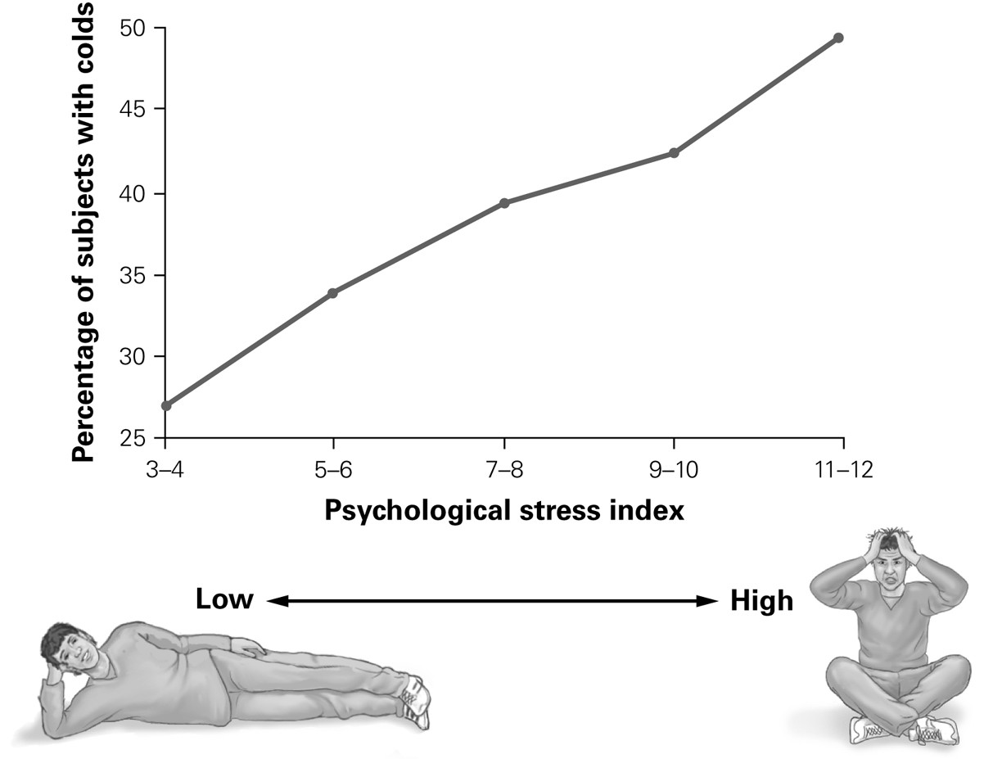

75) According to the graph, what is the relationship between stress and the likelihood of infection by a cold virus?
A) People with a stress index of 3-4 are more likely to catch a cold.
B) People with a stress index of 5-6 are more likely to catch a cold.
C) People with a stress index of 11-12 are more likely to catch a cold.
D) People at all stress levels have an equal chance of catching a cold.
Answer: C
Section: 1.2
Skill: Analysis (Analyze)
Learning Outcome: 1.7

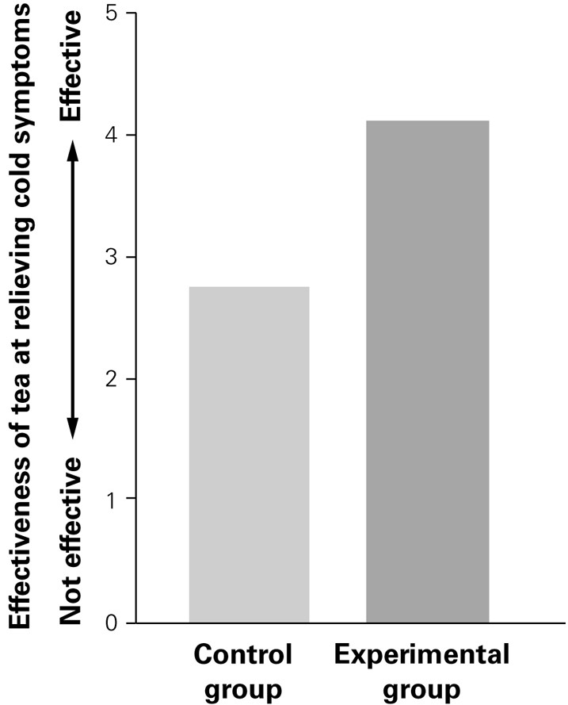

76) According to the graph, how did the results of the control group compare to the results of the experimental group?
A) There was no difference between the results from both groups.
B) Echinacea tea was more effective for the experimental group.
C) Placebo tea was more effective for the control group.
D) Echinacea tea was more effective for the control group.
Answer: B
Section: 1.2
Skill: Analysis (Analyze)
Learning Outcome: 1.5

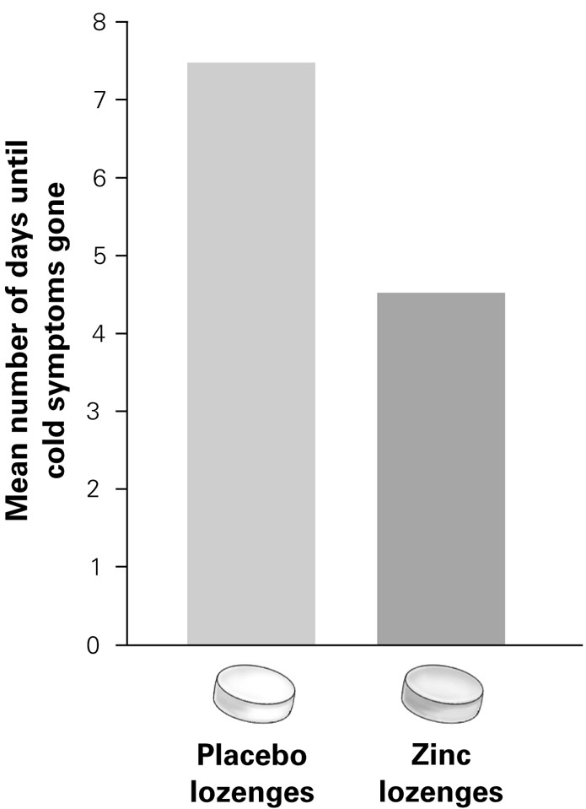

77) According to the graph, how did the number of days with cold symptoms compare for people taking placebo and zinc lozenges?
A) People taking the placebo had cold symptoms for three more days than people taking the zinc lozenges.
B) People taking the placebo had cold symptoms for seven more days than people taking the zinc lozenges.
C) People taking the zinc lozenges had cold symptoms for three more days than people taking the placebo.
D) People taking the zinc lozenges had cold symptoms for seven more days than people taking the placebo.
Answer: A
Section: 1.2, 1.3
Skill: Analysis (Analyze)
Learning Outcome: 1.5, 1.8

78) How did Barry Marshall test the hypothesis that H. pylori causes stomach ulcers?
A) He surveyed people with stomach ulcers about the acidity of their food.
B) He ingested live H. pylori and developed acute stomach pain.
C) He interviewed physicians who performed surgeries on ulcer patients.
D) He fed spicy foods to laboratory rats to eliminate an alternate hypothesis.
Answer: B
Section: 1.1
Skill: Application (Apply)
Learning Outcome: 1.1
79) In which situation might observations be used to test a hypothesis rather than a laboratory experiment?
A) to test the effects of caffeine on the behavior of adolescent males and females
B) to test the relationship between dinosaur fossils found in Canada and the United States
C) to test how antioxidants in vitamins will affect skin cancer cells in college students
D) to test the ability of Alzheimer's patients to identify the smell of specific odors
Answer: B
Section: 1.2
Skill: Application (Apply)
Learning Outcome: 1.5

