Chapter 1:

Describing Data: Graphical

1.1
a. Numerical – discrete. Since the purchase price comes from a counting process.
- Categorical – nominal. Since the state (or country) does not imply ranking of residence, it is nominal.
- Categorical – ordinal. Owner’s satisfaction level indicates rank ordering.
- Numerical–discrete. The number comes from a counting process.

1.2
a. Categorical, nominal (The response is categorical because the responses can be grouped into classes or categories, in this case yes/no. The measurement levels are nominal because the responses are words that describe the categories.)
b. Categorical, ordinal (The response is categorical because the responses can be grouped into classes or categories. The measurement levels are ordinal because these are rankings of the data.)
c. Numerical, discrete (The response is numerical because the responses cannot be grouped into classes or categories. Since the response is an actual cost, it is discrete because the value comes from a counting process.)

1.3
The response is categorical because the responses can be grouped into classes or categories. The measurement levels are ordinal because these are rankings of the data.

1.4
a. Categorical – Qualitative – ordinal
- Numerical – Quantitative – discrete
- Categorical – Qualitative – nominal
- Categorical – Qualitative – nominal

1.5
a. Categorical, nominal (The response is categorical because the responses can be grouped into classes or categories. The measurement levels are nominal because the responses are words that describe the categories.)
b. Numerical, discrete (The response is numerical because the responses cannot be grouped into classes or categories. It is discrete because the value comes from a counting process.)
c. Categorical, nominal (The response is categorical because the responses can be grouped into classes or categories, in this case yes/no. The measurement levels are nominal because the responses are words that describe the categories.)
d. Categorical, ordinal (The response is categorical because the responses can be grouped into classes or categories. The measurement levels are ordinal because these are rankings.)

1.6
a. Categorical – Qualitative – nominal
- Numerical – Quantitative - discrete
- Categorical – Qualitative – nominal: yes/no response
- Categorical – Qualitative – ordinal

1.7
a. An example of ordinal responses: Benefits (1 to 5)
- An example of nominal responses: Gender (male/female– 1/2)
- An example of a numerical variable: Time (in seconds)

1.8
a. Various answers – Categorical variable with ordinal responses: PIR_grp (1-5)
b. Various answers – Categorical variable with nominal responses: female (male/female – 0/1)
- Various answers – Numerical variable with continuous responses: daily_cost
- Various answers – Numerical variable with discrete responses: PIR_p

1.9
a. Pie chart

b. Bar chart

1.10
Pareto diagram – possible defects for a product line

1.11
a. Bar chart

b. Pie chart
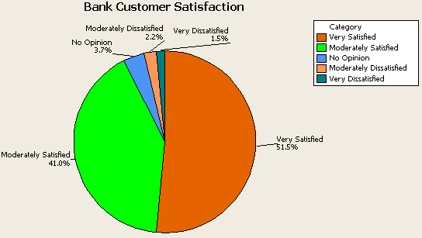

1.12

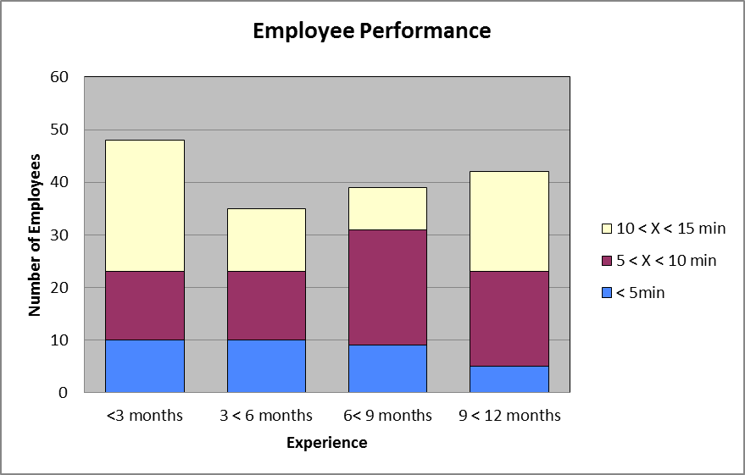

1.13
Pie chart – U.S. federal budget spending

1.14
a. Bar chart of the number of endangered wildlife species in the United States

b. Bar chart of the number of endangered wildlife species outside the United States

c. Bar chart to compare the number of endangered species in the United States to the number of endangered species outside the United States

1.15
a. Pareto diagram of most serious errors by all players

b. Pareto diagram of most serious errors by male players

c. Pareto diagram of most serious errors by female players

d. Component (stacked) bar chart of errors and gender

1.16
Describe the data graphically
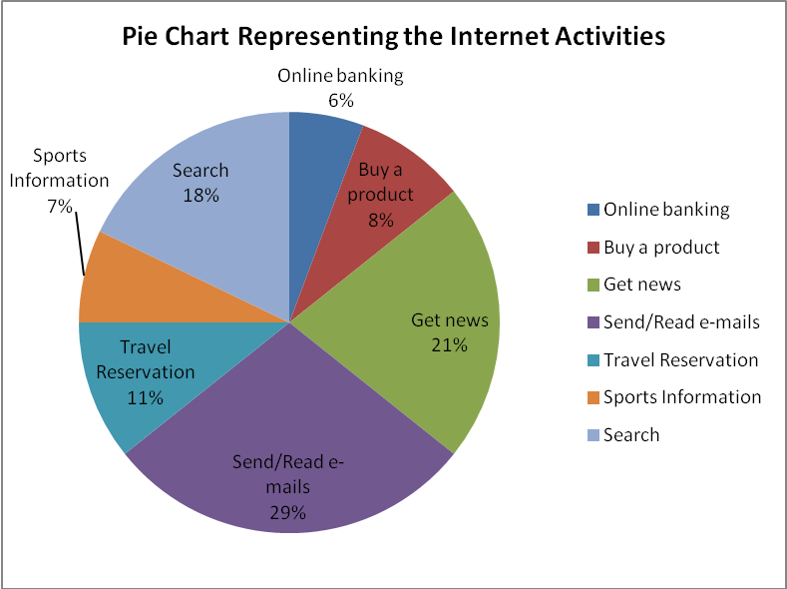

1.17
a. Cluster bar chart of the respondents’ major and gender

b. Pie chart of their majors
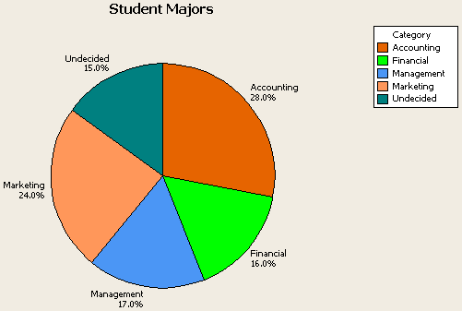

1.18
a. Pie chart of the percent of males in each of the activity level categories.

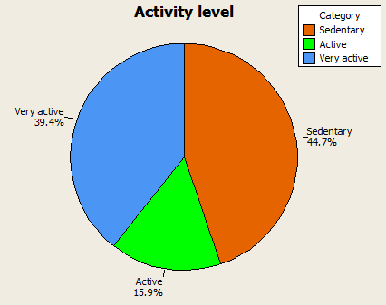

b. Pie chart of the percent of females in each of the activity level categories.

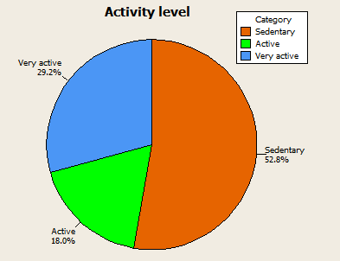

1.19
a. Pie chart for worldwide market shares for February 2011.

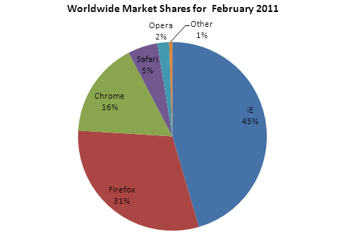

b. Answer will vary: Pie chart for worldwide market shares for October 2011.

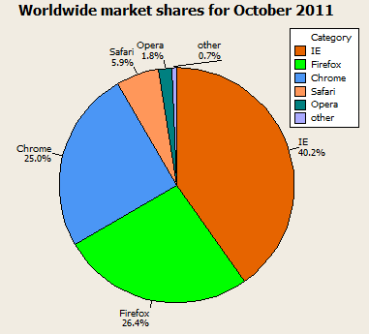

c. Answers will vary; Pie chart for Asian market shares for October 2011.
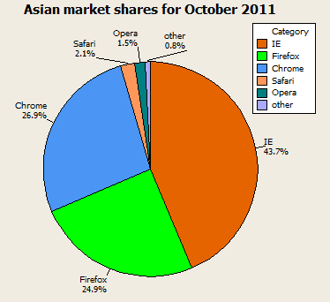

1.20

1.21
Time-series plot of number of males and females enrolled in colleges (undergraduate and postbaccalaureate) in the United States from 2000 through 2008.

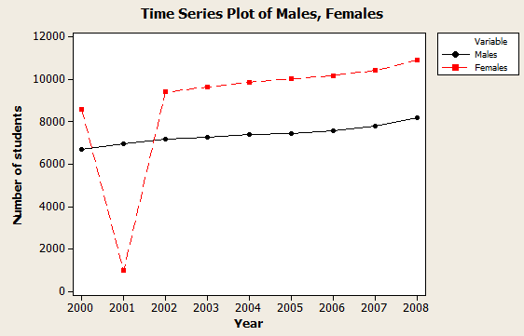

1.22
a. Time-series plot of Gross domestic investment and Gross private domestic

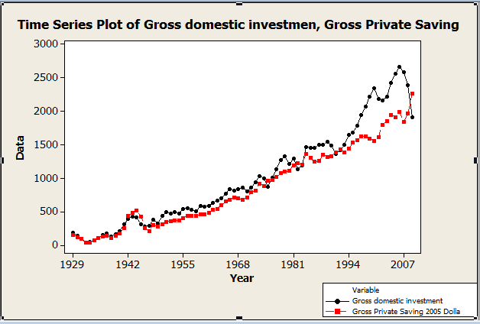

1.23
a. Time-series plot of the Gross Domestic Product in Manufacturing in current
and real (2005) dollars by industry for durable goods from 2000 to 2009.

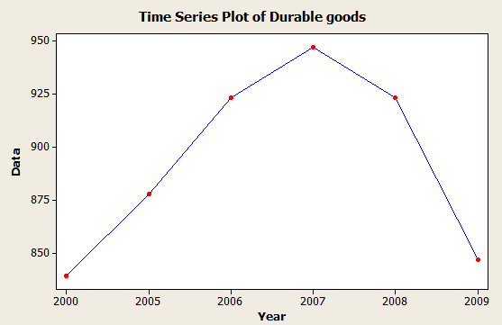

b. Time-series plot of Gross Domestic Product in Manufacturing in chained dollars (2005) by industry for nondurable goods from 2000 to 2009.

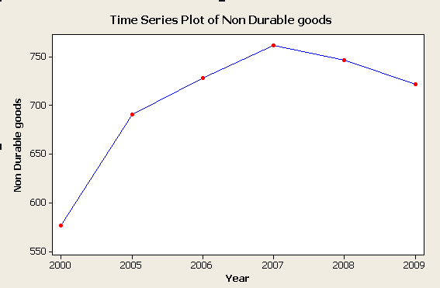

1.24
a. The Euro (EUR) compared to 1 U.S. Dollar (USD)

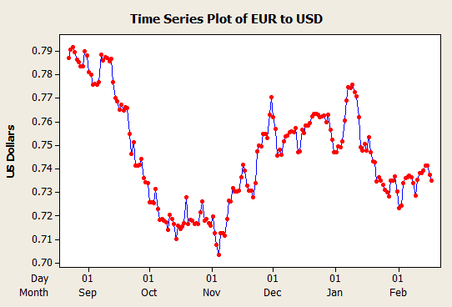

b. The GBP compared to 1 U.S. Dollar (USD)
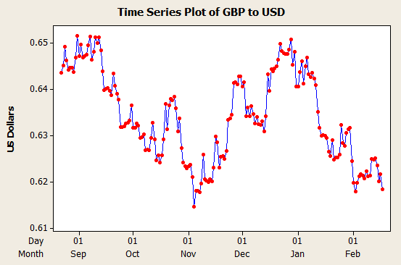

c. Answers may vary.

1.25
a. Time-series plot of worldwide market shares of IE, Firefox, Chrome, Safari, and Opera.
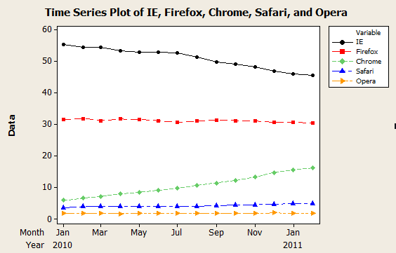

b. Time-series plot of European market shares of IE, Firefox, Chrome, Safari, and Opera.

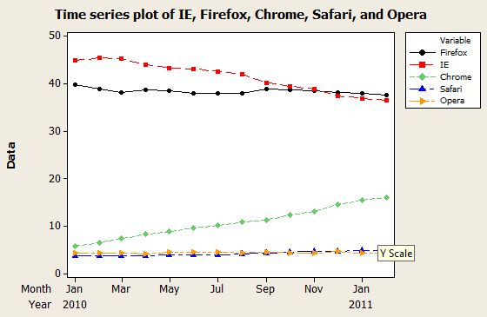

c. Time-series plot of North American market shares of IE, Firefox,
Chrome, Safari, and Opera.

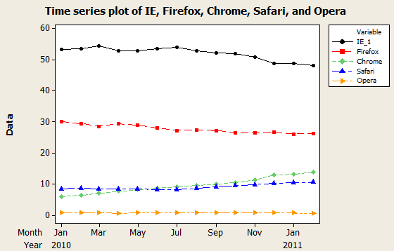

1.26
Time-series plot of a stock market index (Dow Jones Industrial Average) over 14 years from the internet

1.27
Time-series plot of Gold Price data

1.28
Time-series plot of Housing Starts data

1.29
Time-series plot of Earnings per Share

1.30
a. 5 – 7 classes
- 7 – 8 classes
- 8 – 10 classes
- 8 – 10 classes
- 10 – 11 classes

1.31
a.
b.
c.
d.

1.32
a. frequency distribution

 | Bin | Frequency
 | 10 | 0
 | 20 | 5
 | 30 | 3
 | 40 | 8
 | 50 | 3
 | 60 | 5
 | 70 | 4
 | More | 0

b. histogram and
c. ogive

d. stem-and-leaf display

Stem-and-Leaf Display: Data_Ex1.32
Stem-and-leaf of Data_Ex1.32 N = 28
Leaf Unit = 1.0

2 1 23
5 1 557
7 2 14
8 2 8
9 3 2
(6) 3 567799
13 4 0144
9 4
9 5 14
7 5 699
4 6 24
2 6 55

1.33
Stem-and-leaf display

Stem-and-Leaf Display: StudyHrs_Ex1.33
Stem-and-leaf of StudyHrs_Ex1.33 N = 20
Leaf Unit = 0.10

1 1 0
1 1
3 2 34
7 2 6889
8 3 0
(4) 3 5669
8 4 4
7 4 58
5 5 02
3 5 5
2 6 2
1 6 7

1.34
Classes | Frequency | a. Relative Frequency | b. Cumulative Frequency | c. Cumulative Relative Frequency
0<10 | 8 | 16.33% | 8 | 16.33%
10<20 | 10 | 20.41% | 18 | 36.74%
20<30 | 13 | 26.53% | 31 | 63.27%
30<40 | 12 | 24.49% | 43 | 87.76%
40<50 | 6 | 12.24% | 49 | 100.00%
Total | 49 | 100.00%

1.35
Scatter plot

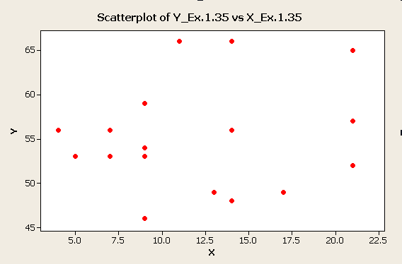

1.36
a. Construct a cumulative relative frequency distribution
Age | Percent | Relative Cumulative Frequency
18-24 | 11.30% | 11.30%
25-34 | 19.11% | 30.41%
35-44 | 23.64% | 54.05%
45-54 | 23.48% | 77.53%
55+ | 22.48% | 100.01%
Total
- 54.05%
- 69.59%

1.37
For the file Water - construct a frequency distribution, cumulative frequency distribution, histogram, ogive and stem-and-leaf display. Various answers – one possibility is to use 8 classes with a width of .1.
Bin | Frequency | Cum Freq
3.5 | 0 | 0
3.6 | 1 | 1
3.7 | 8 | 9
3.8 | 30 | 39
3.9 | 22 | 61
4 | 12 | 73
4.1 | 1 | 74
4.2 | 1 | 75
More | 0

Stem-and-Leaf Display: Volume
Stem-and-leaf of Volumes N = 75
Leaf Unit = 0.010

1 35 7
3 36 34
9 36 577799
21 37 111122344444
(17) 37 55566777777889999
37 38 0111112222244
24 38 556677899
15 39 01334444
7 39 56689
2 40
2 40 6
1 41 1

1.38
a. Histogram of the Returns data

- stem-and-leaf display

Stem-and-Leaf Display: Returns
Stem-and-leaf of Returns N = 25
Leaf Unit = 10

1 1 3
4 1 899
11 2 0014444
(3) 2 589
11 3 0000122
4 3 689
1 4
1 4
1 5 0

1.39
Describe the data in the Sun data file.

Stem-and-Leaf Display: weights
Stem-and-leaf of weights N = 100
Leaf Unit = 1.0

1 22 4
1 22
5 22 8999
16 23 11111111111
25 23 222223333
38 23 4444444445555
(17) 23 66666666677777777
45 23 8888888888999
32 24 000000111111
20 24 22222222333
9 24 44455
4 24 67
2 24 99

1.40
Scatter plot
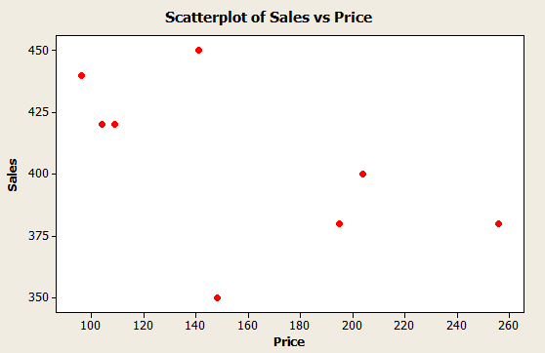

1.41
Scatter plot
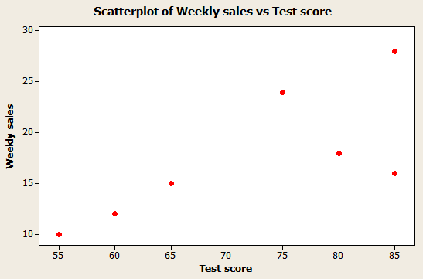

1.42
Scatter plot
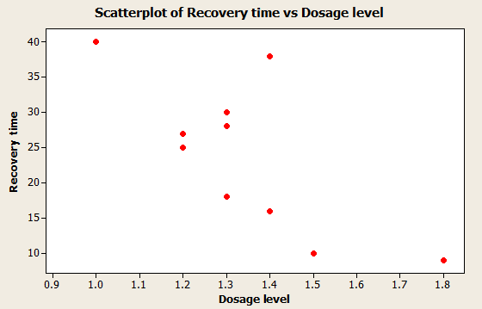
1.43
Scatter plot of price of orange juice vs. weekly quantities sold – Bishops data file

Scatter plot – Bishop’s Supermarket
The scatter plot shows the expected negative relationship between price and quantity demanded per unit of time. This is what economic theory suggests for a typical demand curve.

1.44
Acme Delivery – relation between shipping cost and number of delivery days

The relationship appears to be negative; however there is significant variability in delivery time at each of the three shipping costs – regular, $3; fast, $5; and lightning, $10.

1.45
a. Row percentages are listed below

Rows: Dayweek Columns: SlsLevel

1 2 3 4 All RowPcts

1 6 4 27 41 78 .1667
2 29 27 11 11 78 .1667
3 29 24 12 14 79 .1688
4 28 14 23 11 76 .1624
5 18 27 19 15 79 .1688
6 7 21 24 26 78 .1667
All 117 117 116 118 468

b. Major differences in sales level by day of week indicate that sales levels are highest for days 1 and 6. This is where the largest number of Sales Level ‘4’ occur (the largest daily sales). Days 2 and 3 are similar with most of the sales in the lowest two levels. Days 4 and 5 have sales that are building towards the two largest days of 6 and 1.

1.46
Scatter plot of Citydat – taxbase versus comper
No relationship between the two variables and hence no evidence that emphasis on attracting a larger percentage of commercial property increases the tax base. The two outlier points on the right side of the plot might be used to argue that a very high percentage of commercial property will provide a larger tax base. That argument, however, is contrary to the overall pattern of the data.

1.47
a. Misleading histogram of the data (Error: Unequal class widths)

- Errors include unequal class widths. The first class intervals have widths of 10 whereas later class intervals have widths of 20 and even 50. The classes also overlap. This graph does not accurately reflect the data.

1.48
a. Time-series plot with vertical scale from 5000 to 5700.

b. Time-series plot with vertical scale from 4000 to 7000.

- Differences between the two graphs include the variability of the data series. One graph suggests greater variability in the data series while the other one suggests a relatively flat line with less variability. Keep in mind the scale on which the measurements are made.

1.49
a. Time-series plot of Exchange Rates with vertical axis from 92 to
106.

b. Time-series plot of Exchange Rates with vertical axis from 75 to
120.

c. Differences between the two graphs include the variability of the data series. One graph suggests greater variability in the data series while the other one suggests a relatively flat line with less variability. Keep in mind the scale on which the measurements are made.

1.50
Draw two time-series plots for Inventory Sales with different vertical ranges.

Differences between the two graphs include the variability of the data series. One graph suggests greater variability in the data series while the other one suggests a relatively flat line with less variability. Keep in mind the scale on which the measurements are made.

1.51
Describe graphically the time (in hours) that 20 students studied.

Stem-and-Leaf Display: Hours_Ex1.51
Stem-and-leaf of Hours_Ex1.51 N = 20
Leaf Unit = 0.10

1 2 4
3 2 89
4 3 0
7 3 669
9 4 04
(3) 4 568
8 5 02
6 5 58
4 6 2
3 6 57
1 7 3

1.52
a. Draw a histogram of 20 forecasted earnings per share.

Answer to b., c. and d. are:
(b) (c) (d)
Frequency | Relative Freq. | Cumulative Freq. | Cumulative %
2 | 0.1 | 2 | 10.00%
8 | 0.4 | 10 | 50.00%
6 | 0.3 | 16 | 80.00%
3 | 0.15 | 19 | 95.00%
1 | 0.05 | 20 | 100.00%

d. Cumulative relative frequencies are in the last column of the table above. These numbers indicate the percent of analysts who forecast that level of earnings per share and all previous classes, up to and including the current class. The third bin of 80% indicates that 80% of the analysts have forecasted up to and including that level of earnings per share.

1.53
Use a pie chart or bar chart to plot internet usage and income data

1.54

Cluster bar chart for impact of SOX
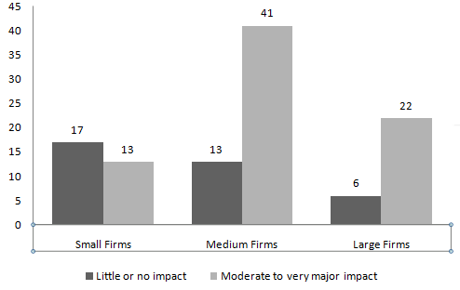

1.55
Describe the familiarity with tax law data graphically

1.56
County Appraiser’s Office – Data Entry Process
- Pareto diagram

- Recommendations should include a discussion of the data entry process. The data entry was being made by individuals with no knowledge of the data. Training of the data entry personnel should be a major recommendation. Increasing the size of the monitors used by the data entry staff would also reduce the number of errors.

1.57 a. Pie chart for Groupons purchased during past week
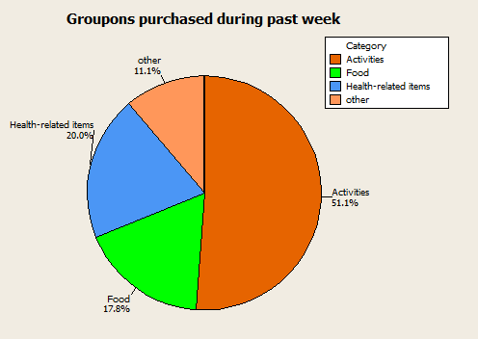

b. Bar chart for Groupons purchased during past week
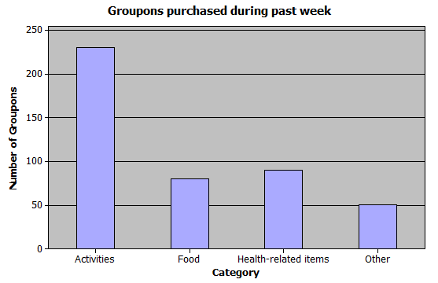

1.58

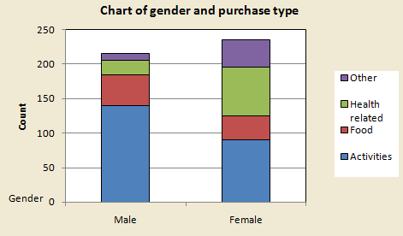

1.59
Scatter plot of price of paint versus demand for paint.
Price and quantity demanded per unit of time are negatively related as predicted by the law of demand.

1.60
Plot the data for advertising expenditures and total sales

1.61
Plot of quantity versus price, with price on the horizontal axis

1.62
Plot the batting averages vs. hours spent per week in a weight-training program.

It appears that the number of hours spent per week in a special weight-training program is positively related to the change in their batting averages from the previous season.

1.63
a. Describe the data with a cross table
Type of Account | Male | Female | Subtotal
Easy Checking | 80 | 100 | 180
Intelligent Checking | 12 | 24 | 36
Super Checking | 27 | 27 | 54
Ultimate Checking | 24 | 6 | 30
Subtotal | 143 | 157 | 300

b. Describe the data graphically

1.64
a. Describe the new product data with a cross table
Age | Friend | Newspaper | Subtotal
<21 years | 30 | 20 | 50
21-35 | 60 | 30 | 90
35+ | 18 | 42 | 60
Subtotal | 108 | 92 | 200
b. Describe the data graphically

1.65
a. Pie chart of soft drink preferences

b. Construct a bar chart

1.66
a. Scatterplot
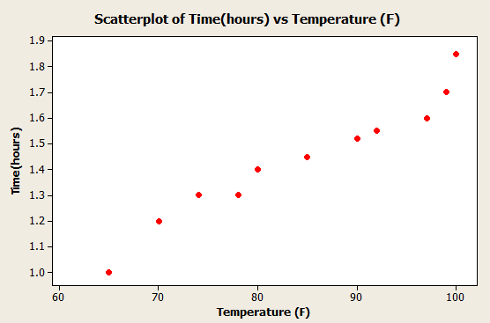
From the graph, it is evident that the temperature is positively related to the time it takes to mow.

1.67
Time-series plot of population growth for the state of New York

1.68
a. Cross table of method of payment and day of purchase for Florin data file.

Payment | M | T | W | Th | F | S | Tot
Am Ex | 7 | 0 | 3 | 4 | 3 | 6 | 23
MC | 1 | 4 | 4 | 2 | 4 | 9 | 24
Visa | 6 | 6 | 4 | 5 | 8 | 10 | 39
Cash | 3 | 1 | 0 | 0 | 3 | 9 | 16
Other | 2 | 0 | 4 | 4 | 7 | 6 | 23
Subtotal | 19 | 11 | 15 | 15 | 25 | 40 | 125

b. Pie chart of day of purchase

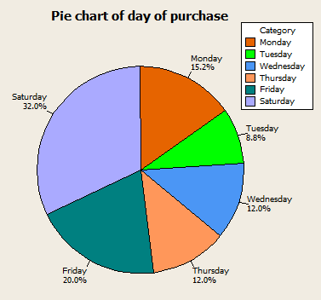

1.69
Cross table and bar chart of drink preference vs. type of vehicle

Vehicle | Beer | Wine | Subtotal
Pickup | 71 | 29 | 100
Car | 32 | 68 | 100
Subtotal | 103 | 97 | 200

1.70
a. Time-series plot of the closing costs
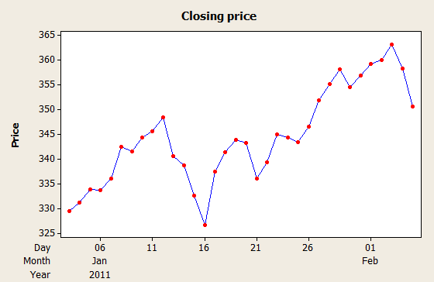

b. Answers may vary.

1.71
Time-Series Plot of Facebook New Visitors
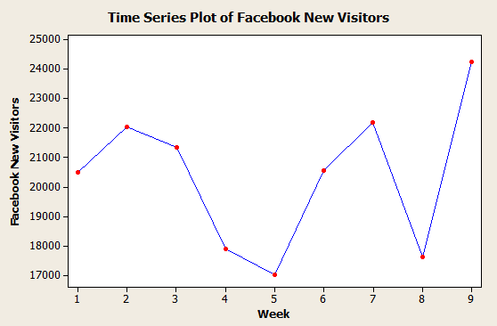

1.72
a. Histogram of shopping times
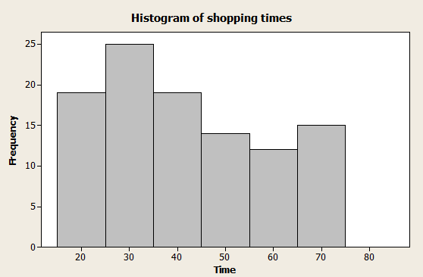
b. Stem-and-leaf display
Stem-and-Leaf Display: Time

Stem-and-leaf of Time N = 104
Leaf Unit = 1.0

9 1 888888899
19 2 0011111333
26 2 5555558
44 3 000011113344444444
52 3 77777788
52 4 00001222233
41 4 555678
35 5 00112222
27 5 5777799
20 6 00334
15 6 7889999
8 7 00001133

1.73
Stem-and-leaf display
Stem-and-Leaf Display: GPA

Stem-and-leaf of GPA N = 156
Leaf Unit = 0.010

4 21 2689
6 22 25
9 23 013
11 24 56
23 25 113345555668
25 26 25
28 27 889
35 28 2788888
40 29 01289
45 30 15678
60 31 000488888888888
74 32 01112444568999
(53) 33 11111111111222223333444444444555566666666677777777999
29 34 00000022222222222222222
6 35
6 36 57
4 37 012
1 38 5

1.74
Scatter plot
