Chapter 1
What Is Statistics?
1. a. Interval b. Ratio
c. Nominal d. Nominal
e. Ordinal f. Ratio (LO1-5)

2. a. Ratio b. Nominal
c. Ratio d. Ratio (LO1-5)

3. Answer will vary. (LO1-5)

4. a. Sample b. Population
c. Population d. Sample (LO1-3)

5. Qualitative data is not numerical, whereas quantitative data is numerical. Examples will vary by student. (LO1-4)

6. A population is the entire group which you are studying. A sample is a subset taken from a population. (LO1-3)

7. Discrete variables can assume only certain values, but continuous variables can assume any values within some range. Examples will vary. (LO1-4)

8. a. A population is used because the professor likely has grades readily available from every student over the past 5 years.
b. A population is employed because the information is easy to find.
c. A population is used because the information is easy to find.
d. A sample works because it is difficult to locate every musical. (LO1-3)

9. a. Ordinal
b. Ratio
c. The newer system provided information on the distance between exits. (LO1-5)

10. The cell phone provider is nominal level data. The minutes used are ratio level. Satisfaction is ordinal level. (LO1-5)

11. If you were using this store as typical of all Barnes & Noble stores then it would be sample data. However, if you were considering it as the only store of interest, then the data would be population data. (LO1-3)

12. In a presidential election all votes are counted, thus it is similar to a census of the entire population. However, an “exit” poll consists of only some voters and thus is more like a sample of the entire population. (LO1-3)

13.

 | Discrete | Continuous
Qualitative | b. Gender  d. Soft drink preference  g. Student rank in class  h. Rating of a finance professor
Quantitative | c. Sales volume of MP3 players  f. SAT scores  i. Number of home computers | a. Salary  e. Temperature

 | Discrete | Continuous
Nominal | b. Gender
Ordinal | d. Soft drink preference  g. Student rank in class  h. Rating of a finance professor
Interval | f. SAT scores | e. Temperature
Ratio | c. Sales volume of MP3 players  i. Number of home computers | a. Salary

(LO1-4 and LO1-5)

14. Answers will vary. (LO1-5)

15. As a result of these sample findings, we can conclude that 120/300 or 40% of the white-collar workers would transfer outside the U.S. (LO1-3)

16. The obvious majority of consumers (400/500, or 80%) believe the policy is fair. On the strength of these findings, we can anticipate a similar proportion of all customers to feel the same. (LO1-3)

Manufacturer | Difference
General Motors Corp. | 128,133
Chrysler | 126,955
Ford Motor Company | 112,975
Toyota Motor Sales USA Inc. | 96,078
Nissan North America Inc. | 72,146
Subaru of America Inc. | 61,834
American Honda Motor Co Inc. | 38,440
Kia Motors America Inc. | 36,313
Hyundai Motor America | 30,656
Mercedes-Benz | 20,187
Audi of America Inc. | 18,970
Mitsubishi Motors N A, Inc. | 16,119
Land Rover | 13,535
BMW of North America Inc. | 12,202
Mazda Motor of America Inc. | 7,407
Volvo | 5,980
Mini | 4573
Porsche Cars NA Inc. | 4,337
Tesla | 1,850
Lamborghini | 372
Ferrari | 164
Rolls Royce | 19
Bentley | -351
Jaguar | -633
Maserati | -783
Smart | -2,512
Fiat | -3,650
Volkswagen of America Inc. | -6,585
17. a.

b. Percentage differences with top five and bottom five.

Manufacturer | % change from 2014
Lamborghini | 75%
Land Rover | 32%
Mitsubishi Motors N A, Inc. | 25%
Subaru of America Inc. | 15%
Audi of America Inc. | 13%
Volvo | 13%
Tesla | 12%
Porsche Cars NA Inc. | 11%
Mini | 10%
Ferrari | 9%
Chrysler | 8%
Kia Motors America Inc. | 7%
Mercedes-Benz | 7%
Nissan North America Inc. | 6%
Ford Motor Company | 5%
General Motors Corp. | 5%
Hyundai Motor America | 5%
Toyota Motor Sales USA Inc. | 5%
BMW of North America Inc. | 5%
American Honda Motor Co Inc. | 3%
Mazda Motor of America Inc. | 3%
Rolls Royce | 3%
Volkswagen of America Inc. | -2%
Jaguar | -5%
Maserati | -8%
Fiat | -9%
Bentley | -15%
Smart | -29%

c. (LO1-2)

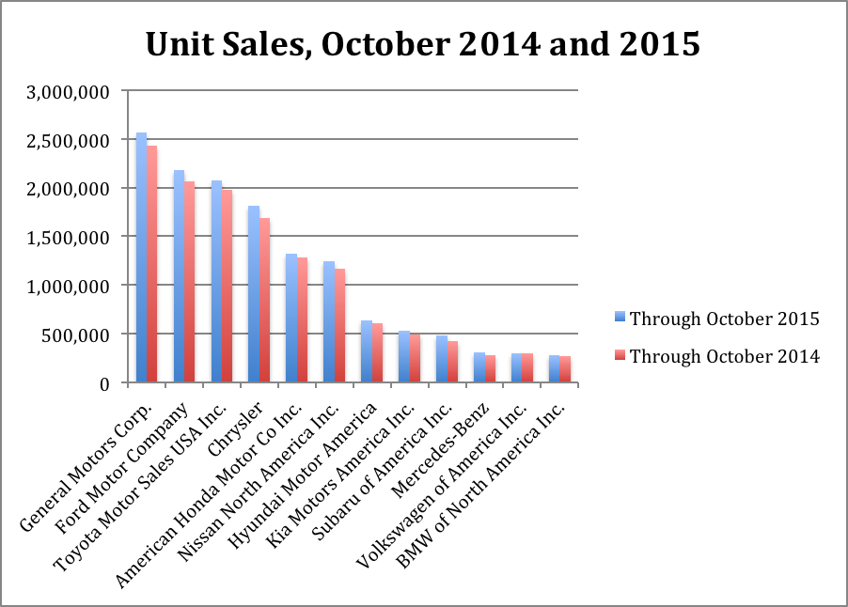

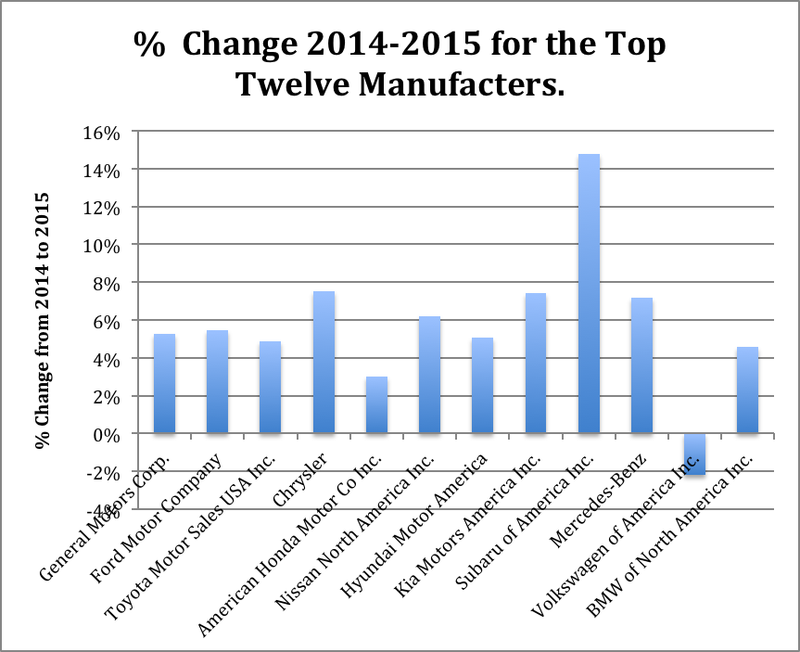

18. The total amount spent is $603.86. The percents by group are: 75, 14, 4, and 7, respectively. (LO1-2)

19. Earnings increase about $3 billion per year over the period. However 2008 sees a very large increase and 2009 sees a large decrease.
Perhaps the earnings were affected by the financial “collapse” during the years 2008-2010.
Perhaps $15 billion of 2008 earnings were somehow “advanced” from the next year or two?
(LO1-2)

20. a. Qualitative variables: Pool, Garage, Township, Mortgage type, Default
Quantitative variables: Price, Bedrooms, Size, Baths, FICO Years (LO1-4)

b. Price measured in dollars: Continuous, Ratio scale
Agent: Nominal
Bedrooms are counted: Discrete, Ordinal??? Ratio scale
Size measured in area of square feet: Contiguous, Ratio scale
Pool measured as present or not: nominal
Garage measured as present or not: nominal
Baths are counted: Discrete, Ordinal?? Ratio scale
Township is labeled: nominal
Mortgage type measures as adjustable or fixed: nominal
FICO is an index of a person’s ability to pay their bills: ratio
Years are counted: ordinal
Default: measured as yes or no: nominal (LO1-5)

21. a. League is a qualitative variable; the others are quantitative. (LO1-4)
b. League is a nominal level variable; the others are ratio level variables. (LO1-5)

22. a. Bus Number, Manufacturer, and engine type are qualitative variables, the others are quantitative. (LO1-4)
b. Bus Number, Manufacturer, and Engine Type nominal level variables; the others are ratio level variables. (LO1-5)

