Instructor’s
Resource Guide

to accompany

Principles of Economics, 2nd edition

by Stiglitz et al.

Prepared by
David Walker, La Trobe University



© John Wiley & Sons Australia, Ltd

Chapter 1

Modern economics and thinking like an economist

In-chapter Questions

Critical thinking

Do consumers have the same level of protection under law when purchasing from auction websites compared to a normal shopfront store? (page 6)

Consumers have the same level of protection under law and the increasing number of auction websites reflects individuals are willing to exchange goods in this way. However, given the lack of hands on inspection of goods, there are potential fraud and security risks when purchasing goods on online websites.

What is the optimal mix of time and money when (a) you are a relatively ‘poor’ university student or (b) a billionaire like Gina Rinehart or Clive Palmer? (page 25)

A relatively ‘poor’ university student will have less money than time and a billionaire will have more money than time. As a consequence for a student money is likely to be the binding constraint, while for a billionaire time is likely to be the binding constraint. The opportunity sets for a student and a billionaire will reflect these trade-offs as will the optimal mix of time and money.

Do you think that young people who forgo a university education will have higher or lower lifetime incomes than someone who does go to university? What are the factors which will determine your answer? (page 26)

Typically young people that do not obtain university education will have lower lifetime incomes than those who do go to university. The key factor to consider is that people who go to university forego income while they studied a degree, which is a significant opportunity cost. However, it is expected that the additional income earned as a result of having a university degree offsets this opportunity cost.

End of Chapter Questions

Review questions

- Why are trade-offs unavoidable? Why are incentives important in understanding choices?

Trade-offs are unavoidable because resources are scarce and we must make choices. Economists believe that all economic agents, consumers, business firms, and the government respond to incentives by changing the decisions they make.

- After a voluntary exchange, why are both parties better off?

After a voluntary exchange, both parties are better off or they would not have made the exchange.

- Why might there be a trade-off between equity and efficiency?

Government programs to promote equity, that is, to soften the disparity of income, such as generous unemployment benefits, may discourage workers from seeking and finding jobs. This may mean greater unemployment for a longer period of time, which reduces the economy’s efficiency. That is, programs to support incomes dampen one of the incentives to work.

- What is a mixed economy? Describe some of the roles government might play, or not play, in a mixed economy.

In a mixed economy, there is a mix between public and private policymaking. In general, the government sets the legal structure under which private firms and individuals operate. It regulates businesses to ensure that they do not mislead customers, that they are careful about the safety of their employees, and that they do not pollute the air and water. The government provides goods and services for national defence, build roads, and prints money. Government programs provide for the elderly through the pension and Medicare. The government helps those who have suffered some sort of dislocation and attempts to provide support for the poor through welfare programs.

- Name the three main economic markets, and describe how an individual might participate in each one as a buyer or a seller.

Firms sell goods to households in the product market. Firms hire labour and households sell labour in the labour market. Firms invest in capital goods, and households invest and borrow money in the capital market.

- Give two examples of economic issues that are primarily microeconomic and two examples that are primarily macroeconomic. What is the general difference between microeconomics and macroeconomics?

Microeconomic issues include the behaviour and decision-making processes of firms, households, and individuals. Macroeconomic issues include unemployment, inflation, economic growth, and the balance of trade. The general difference between the two is that macroeconomics looks at the economy as a whole while microeconomics looks at the behaviour of the units that make up the economy.

- What is a model? Why do economists use models?

A model is a theoretical construct designed to mirror the essential characteristics of the particular phenomena under study. Economists use models to study the workings of the economy and to make predictions about how the economy will respond to changes.

- What are the essential elements of the competitive model?

The essential elements of the competitive model are rational, self-interested, utility-maximising individuals and rational profit-maximising firms. In addition, each agent in the economy, whether consumer or firm, is small in size relative to the size of the market. So each is a price taker who interacts in competitive markets.

- Why might government policy to make the distribution of income more equitable lead to less efficiency?

There is a trade-off between incentives and equality. Increased equality leads to reduced incentives for performance; if everyone receives the same income regardless of the work effort or risks taken, then there is no reason to work hard or efficiently or to take the risks of starting up new enterprises. The result is likely to be a decline in output.

- What are some of the opportunity costs of studying at university? What are some of the opportunity costs a government should consider when deciding whether to widen a highway?

One opportunity cost of going to university is the income that is forgone while one is in school. In addition, there is the opportunity cost of lost leisure. The opportunity cost of widening a highway is the reduction in money that can be used on other programs. By improving the highway, the government forgoes the opportunity to spend the money on another project or social program.

- How is marginal analysis relevant in the decision about which car to purchase? After deciding the kind of car to purchase, how is marginal analysis relevant?

In choosing between two similar cars that have different prices, the consumer would weigh the benefits of the more expensive car, styling, performance, extras, and so on, against the extra cost of purchasing it. This is marginal cost analysis. After buying the car, the owner must weigh the extra (or marginal) costs of servicing the car against the extra (or marginal) benefit from having a car in good repair.

Problems

- Characterise the following events as microeconomic, macroeconomic, or both.
- Unemployment increases this month.
- A pharmaceutical company invents and begins to market a new medicine.
- A bank lends money to a large company but turns down a small business.
- Interest rates decline for all borrowers.
- A union negotiates for higher pay and better health insurance.
- The price of petrol increases.

- Macroeconomic
- Microeconomic
- Microeconomic
- Macroeconomic
- Microeconomic
- Macroeconomic

- Characterise the following events as part of the labour market, the capital market or the product market.
- An investor tries to decide which company to invest in.
- With practice, the workers on an assembly line become more efficient.
- The opening up of economies in eastern Europe offers new markets for Australian products.
- A big company that is losing money decides to offer its workers special incentives to retire early, hoping to reduce its costs.
- A consumer roams around a shopping mall looking for birthday gifts.
- The federal government uses a surplus to pay off some of its debt.

- Capital
- Labour
- Product
- Labour
- Product
- Capital

- During 2011, some economists argued that the Reserve Bank of Australia should undertake policies to slow the economic expansion in Australia as a result of the mining boom in order to ensure low inflation. Other economists are opposed to such policies, arguing that the dangers of inflation were exaggerated and attempts by the Reserve Bank to slow the economy would lead to higher unemployment. Is this a disagreement about positive economics, or about normative economics? Explain.

This is a disagreement in normative economics. Both sides to this debate agreed on how the economy operates (which is positive economics). That is, they agreed that the Reserve Bank of Australia could slow down the economy. The participants of this debate disagreed on what ought to be done, which is a normative question.

- Suppose an underground reservoir of coal seam gas is located under properties owned by several different individuals. As each well is drilled, it reduces the amount of coal seam gas that others can take out. Compare how quickly the coal seam gas is likely to be extracted in this situation with how quickly it would be extracted if one person owned the property rights to drill for the entire seam of goal gas.

Each of the individuals will want to extract the coal seams gas as fast as possible before the others do. If one person owned the property rights to drill for the entire seam of coal gas it would be extracted in a more efficient manner.

- Kathy, a university study, has $20 a week to spend. She spends it either on junk food at $2.50 a snack, or on petrol at $2 per litre. Draw Kathy’s opportunity set. What is the trade-off between junk food and petrol? Now draw each new budget constraint she would face if:
- a kind relative started sending her an additional $20 per week
- the price of a junk food snack fell to $2
- the price of petrol rose to $2.50 a litre.
In each case, how does the trade-off between junk food and petrol change?

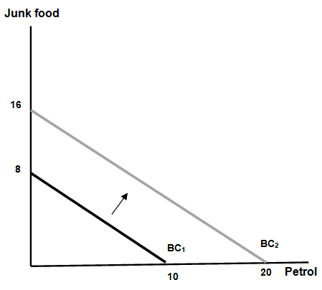

- With the extra $20 she can buy more junk food or petrol, or more of both goods and the budget constraint shifts out. It is still the case that if she buys one snack she must give up 1.25 litres of petrol.

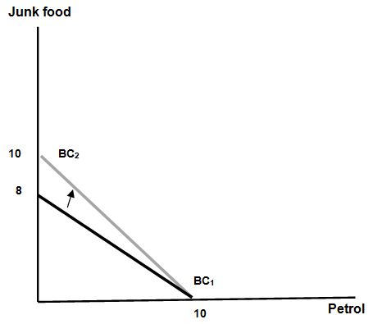

- When the price of a snack is $2 she now gives up 1 litre of petrol for every snack, so snacks are relatively cheaper. This is reflected by a pivot of the budget constraint.

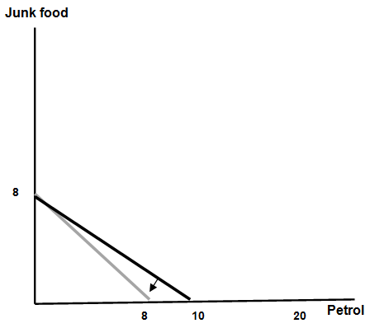

- If the price of petrol rises to $2.50 a litre and the price of a snack is $2.50, she can buy 1 litre of petrol for every snack. This is reflected by a pivot of the budget constraint.

- Why is the opportunity cost of going to medical school likely to be greater than the opportunity cost of studying science at university? Why is the opportunity cost of a woman with a university education having a child greater than the opportunity cost of a woman with just a high school education having a child?

Someone who is planning to go to medical school can be expected to earn more income than someone without a university degree. Thus, a woman who has a university education forgoes more income to have children than a woman with a high school education does.

- Damian likes to divide his recreational time between going to movies and reading magazines. He has twenty hours a week available for recreation; a movie takes two hours, and a magazine takes one hour to read. Draw his ‘time-budget constraint’ line. Damian also has a limited amount of income to spend on recreation. He has $60 a week to spend on recreational activities; a movie costs $15, and a magazine costs $10. (He never likes to read the same twice.) Draw his budget constraint line. What is his opportunity set?

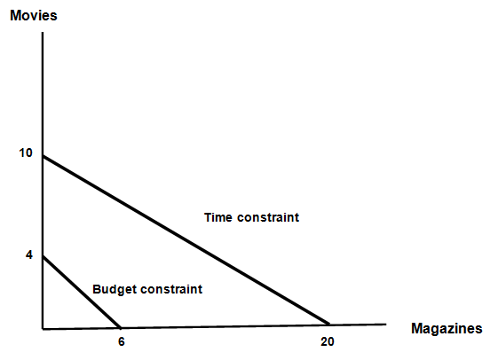

His opportunity set is the points which are inside both the time constraint and the budget constraint. In this case money is the more binding constraint on his recreational activities.

