Chapter
1
Operations and Productivity

Discussion Questions
1. The text suggests four reasons to study OM. We want to understand (1) how people organize themselves for productive enterprise, (2) how goods and services are produced, (3) what operations managers do, and (4) this costly part of our economy and most enterprises.
LO 1.1: Define operations management
AACSB: Application of knowledge
2. Possible responses include: Adam Smith (work specialization/ division of labor), Charles Babbage (work specialization/division of labor), Frederick W. Taylor (scientific management), Walter Shewart (statistical sampling and quality control), Henry Ford (moving assembly line), Charles Sorensen (moving assembly line), Frank and Lillian Gilbreth (motion study), Eli Whitney (standardization).
LO 1.1: Define operations management
AACSB: Application of knowledge
3. See references in the answer to Question 2.
LO 1.1: Define operations management
AACSB: Application of knowledge
4. The actual charts will differ, depending on the specific
organization the student chooses to describe. The important thing is for students to recognize that all organizations require, to a greater or lesser extent, (a) the three primary functions of operations, finance/accounting, and marketing; and (b) that the emphasis or detailed breakdown of these functions is dependent on the specific competitive strategy employed by the firm.
LO 1.1: Define operations management
AACSB: Application of knowledge
5. The answer to this question may be similar to that for Question 4. Here, however, the student should be encouraged to utilize a more detailed knowledge of a past employer and indicate on the chart additional information such as the number of persons
employed to perform the various functions and, perhaps, the position of the functional areas within the overall organization hierarchy.
LO 1.1: Define operations management
AACSB: Application of knowledge
6. The basic functions of a firm are marketing, accounting/
finance, and operations. An interesting class discussion: “Do all firms/organizations (private, government, not-for-profit) perform these three functions?” The authors’ hypothesis is yes, they do.

LO 1.1: Define operations management
AACSB: Application of knowledge
7. The 10 strategic decisions of operations management are product design, quality, process, location, layout, human resources, supply-chain management, inventory, scheduling (aggregate and short term), and maintenance. We find this structure an excellent way to help students organize and learn the material.
LO 1.1: Define operations management
AACSB: Application of knowledge
8. Four areas that are important to improving labor productivity are (1) basic education (basic reading and math skills), (2) diet of the labor force, (3) social overhead that makes labor available (water, sanitation, transportation, etc.), and (4) maintaining and expanding the skills necessary for changing technology and knowledge, as well as for teamwork and motivation.
LO 1.6: Identify the critical variables in enhancing productivity
AACSB: Application of knowledge
9. Production deals with the transformation of inputs into outputs. Productivity, on the other hand, is the ratio of outputs (goods and services) divided by the inputs (resources such as labor and capital). Increase in production can be attained by engaging more labor, adding more equipment, etc., regardless of the cost to attain this increase, while higher productivity can be achieved through efficient and effective use of resources. Therefore, an increase in production does not necessarily mean an increase in productivity. For example, if 90 people are employed in a meat food production line and produce the same volume of goods over the same period as seventy people working in another meat food production line, the quantities of output (production) of the two lines are equal, but the productivity of the latter is higher than that of the former.
LO 1.6: Identify the critical variables in enhancing productivity
AACSB: Analytical thinking
10. Productivity is difficult to measure because precise units of measure may be lacking, quality may not be consistent, and exogenous variables may change.
LO 1.6: Identify the critical variables in enhancing productivity
AACSB: Reflective thinking
11. Mass customization is the flexibility to produce to meet
specific customer demands, without sacrificing the low cost of a product-oriented process. Rapid product development is a source of competitive advantage. Both rely on agility within the organization.
LO 1.1: Define operations management
AACSB: Application of knowledge
12. (a) Airlines: Productivity can be measured by dividing total passenger miles by the number of airplanes in service.
(b) Bus: Productivity can be measured by dividing the total number of passengers carried by the total number of miles per route.
(c) Hotel: Productivity can be measured by the number of hotel rooms occupied in a given period of time.
LO 1.6: Identify the critical variables in enhancing productivity
AACSB: Reflective thinking
13. Productivity is the ratio of outputs (goods and services) divided by the inputs (resources such as labor and capital), while operations management refers to the set of activities that creates value in the form of goods and services by transforming inputs into outputs. One might consider operations managers to be the protectors of company resources, responsible for applying those resources to attain predetermined goals, such as output, quality, and profit. Operations managers are also responsible for the efficient transformation of inputs into outputs. Therefore, productivity can be perceived as the essence of operations management in that productivity is a measure of efficiency of the operations management function.
LO 1.6: Identify the critical variables in enhancing productivity
AACSB: Application of knowledge.
14. There is a significant overlap among these three functions due to the size of small and medium enterprises (SMEs). As SMEs typically cannot afford specialist functions, the top managerial level is responsible for all three functions in order to minimize spending. This is particularly applicable to SMEs where the managing director/president is also the owner of the company.
LO 1.5: Compute multifactor productivity
AACSB: Application of knowledge
End-of-Chapter Problems
(c) Change in productivity = 0.125 boxes/hour
(d)
1.2 (a) Labor productivity is 160 valves/80 hours = 2 valves per hour.
(b) New labor productivity = 180 valves/80 hours = 2.25 valves per hour
(c) Percentage change in productivity = .25 valves/2
valves = 12.5%

1.3
PRODUCTIVITY | 2013 | 2014 | Comparison | Comparison
Labor | 2/1 = 1 | 3/1.8 = 1.67 | 67% | 1.67
Material | 2/0.6 = 3.33 | 3/0.8 = 3.75 | 12.6% | 1.126
Capital | 2/0.07 = 28.57 | 3/0,12 = 25 | –12.6% | 0.874
Multifactor | 2/(1 + 0.6 + 0.07) = 1.2 | 3/(1.8 + 0.8 + 0.12) = 1.1 | –0.83% | 0.917

While there is an increase in individual productivity, the overall productivity decreases primarily due to a fall in capital investment. This is an interesting observation as it indicates the dangers of focusing on individual productivities in isolation, without due consideration to the total productivity. Column 5 shows a different way of comparing productivities by dividing both years’ figures (using the first year as reference). Figures greater than 1 show an increase in productivity while figures below 1 indicate a decrease in productivity.

1.5 | Resource | Last Year | This Year | Change | Percentage Change
 | Labor |  |  | 0.31
 | Resin |  |  | 2.22
 | Capital |  |  | –0.01
 | Energy |  |  | 0.02

1.6 |  | Last Year |  | This Year
 | Production | 1,000 |  | 1,000
 | Labor hr. @ $10 | $3,000 |  | $2,750
 | Resin @ $5 | 250 |  | 225
 | Capital cost/month | 100 |  | 110
 | Energy | 1,500 |  | 1,425
 |  | $4,850 |  | $4,510

* with rounding to 3 decimal places.

1.8 (a) Labor productivity = 1,000 tires/400 hours = 2.5 tires/hour.
(b) Multifactor productivity is 1,000 tires/(400 ×
$12.50 + 20,000 × $1 + $5,000 + $10,000) =
1,000 tires/$40,000 = 0.025 tires/dollar.
(c) Multifactor productivity changes from 1,000/40,000 to 1,000/39,000, or from 0.025 to 0.02564; the ratio is 1.0256, so the change is a 2.56% increase.

1.9 |  | Last Year | This Year | Change | Percent Change
 | Labor hrs. |  |  |  | = 7.7%
 | Capital invested |  |  |  | = –20%
 | Energy (btu) |  |  |  | = 10%
Productivity of capital did drop; labor productivity increased as did energy, but by less than the anticipated 15%.

1.10 Multifactor productivity is:
375 autos/[($20 × 10,000) + ($1,000 × 500) +
($3 × 100,000)] = 375/(200,000 + 500,000 +
300,000) = 375/1,000,000
= .000375 autos per dollar of inputs
1.11 (a) Before: 500/20 = 25 boxes per hour;
1.12 P_{before} = 8/1 = 8 renewals/day
P_{after} = (8-1)/0.5 = 14 renewals/day
ΔP = (14-8)/8 = 0.75, i.e., 75% increase.
1.13 Output = 100 scripts
Input = 8 × €9 + €2 × 100 + €28 = €300
Productivity = Output/Input = 100 scripts / €300
= 0.333
Output = 150 scripts
Input = 8 × €9 + €2.5 × 150 + €28 = €475
Productivity = Output/Input = 150 scripts / €475
= 0.316
This means that there is a drop in multifactor productivity.
0.333 = 150/[8 × €9 + (€x)(150) + €28]
Therefore, x = 2.34
Thus, the material cost will increase by €0.34 (€2.34 – €2) if we want to increase the photocopy process and keep the same initial multifactor productivity.
1.14 Initially
Output = (60 × €50) + (90 × €150) = €3,000 + €13,500 = €16,500
Input = 300 hours
Productivity = Output/Input = €16500/300 hours = €55/hour

After Bonus
Output = (10 × €50) + (120 × €150) = €500 + €18,000 = €18,500
Input = 300 hours
Productivity = Output/Input = €18,500/300 hours = €61.67/hour

Earnings
Increase in output = €18,500 – €16,500 = €2,000
Decrease in cost = (150 – 130) × €70 = €1,400
Total improvement = €2,000 + €1,400 = €3,400
Therefore bonus: €3400/2 = €1,700 or €1,700/300 hours = €5.67/hour
1.15
- Before
Output = 100 × €70 = €7,000/week
Input = €700 + €300 + €500 = €1,500/week
Productivity = Output/Input = €7,000/€1,500 = 4.67
- New Productivity
Output = 135 × €70 = €9450/week
Input = €1,500/week
Productivity = Output/Input = €9,450/€1,500 = 6.3
- For 10% increase in productivity through materials costs reduction only
10% productivity improvement means 4.67 × 1.1 = 5.137
Productivity = Output/Input or 5.137 = €7,000/Input, or Input = €1,363
Input = Material + €300 + €500, therefore €1363 = Material + €800 or Material = €563,
Therefore, material costs decrease = €700 – €563 = €137 or €137/€700 = 19.6%
- For 10% increase in productivity through labor costs reduction only
Labor costs decrease = 45.7%
1.16
- Average cost per air-conditioner
Output = 2 × €350 + 4 × €450 + 6 × €500 = €5,500
Productivity = Output/Input, or 2.2 = €5,500/Input, or Input = €2,500
Therefore, average cost = €2,500 / (2 + 4 + 6) = €208/air-conditioner
- Labor Productivity
• Ceiling type = €350/1.5 hours = €233.3/hour
• Cassette type = €450/1 hours = €450/hour
• Wall-mounted = €500/0.75 hours = €666.7/hour
- Focus efforts
Based on labor productivity, the factory should focus its efforts on the wall-mounted type, then on the cassette type, and last on the ceiling type.
The same is true form the average cost per unit produced as the profit on each type is as follows:
• Ceiling type = €350 – €208 = €142
• Cassette type = €450 – €208 = €242
• Wall-mounted = €500 – €208 = €292

Case Study
UBER TECHNOLOGIES, INC.
1. The market has decided that Uber and its immediate competitors are adding efficiency to our society. How is Uber providing that efficiency?
First, some drivers (maybe most) may not require a wage that equals those fully engaged in the “taxi” business. It truly could be a supplemental income. . . . “I’m going that way anyhow
so let’s make a few dollars while on the way.” Similarly, the capital investment cost approaches zero as the car is going that direction anyhow. These are idle or underutilized resources.
From society’s perspective, Uber and its like competitors are desirable because both idle or wasted labor and capital resources are being utilized. At the same time, as a bonus, Uber is reducing traffic and auto pollution while speeding up the transport of individuals and local commerce.
As a competitor for the traditional taxi service, Uber seems to be an enhancement in efficiency.
For those faculty who what to spend some time on the larger productivity message, this case provides such an opportunity. Uber, as Joseph Schumpeter would suggest, has developed a disruptive technology (creative destruction, in a Schumpeterian translation). Innovations such as this are exactly how economic efficiency is enhanced. The traditional taxi services, with some imagination, could have developed and adopted this technology, but most were ensconced in their own regulatory cocoon. As is often the case, it takes an outsider, such as Uber et al. to be creative by putting unused resources to use and providing society greater efficiency.
LO 1.6: Identify the critical variables in enhancing productivity
AACSB: Analytical thinking
2. Do you think the Uber model will work in the trucking
industry?
Perhaps a business model similar to Uber’s can be applied to the trucking industry. An estimated 30% of trucking backhauls are empty. However, the number of independent truckers or truckers with the latitude to alter their route may be very small. And this number must be a tiny fraction of independent automobile drivers. So the ability to “Uberize” trucking may be very difficult. Utilizing that idle 30%, if it can be done, is a huge benefit to society. We will see.
LO 1.6: Identify the critical variables in enhancing productivity
AACSB: Analytical thinking
3. In what other areas/industries might the Uber model be used?
Perhaps the Uber model can be used for package delivery, documents, and everything from flowers to groceries. Airbnb (www.airbnb.com) is applying a similar model to short-term rentals of rooms, apartments, and homes—competing with more traditional bed and breakfast facilities and hotels.
LO 1.6: Identify the critical variables in enhancing productivity
AACSB: Analytical thinking

Video Case Studies
FRITO-LAY: OPERATIONS MANAGEMENT IN MANUFACTURING
1
This case provides a great opportunity for an instructor to stimulate a class discussion early in the course about the pervasiveness of the 10 decisions of OM with this case alone or in conjunction with the Hard Rock Cafe case. A 7-minute video filmed specifically for this case is available from Pearson.
1. From your knowledge of production processes and from the case and the video, identify how each of the 10 decisions of OM is applied at Frito-Lay.
- Product design: Each of Frito-Lay’s 40-plus products must be conceived, formulated (designed), tested (market studies, focus groups, etc.), and evaluated for profitability.
- Quality: The standards for each ingredient, including its purity and quality, must be determined.
- Process: The process that is necessary to produce the product and the tolerance that must be maintained for each ingredient by each piece of equipment must be specified and procured.
- Location: The fixed and variable costs of the facility, as well as the transportation costs in and the delivery
distance, given the freshness, must be determined.
- Layout: The Frito-Lay facility would be a process
facility, with great care given to reducing movement of material within the facility.
- Human resources: Machine operators may not have
inherently enriched jobs, so special consideration must be given to developing empowerment and enriched jobs.
- Supply-chain management: Frito-Lay, like all other producers of food products, must focus on developing and auditing raw material from the farm to delivery.
- Inventory: Freshness and spoilage require constant effort to drive down inventories.
- Scheduling: The demand for high utilization of a
capital-intensive facility means effective scheduling will be important.
- Maintenance: High utilization requires good maintenance, from machine operator to the maintenance
department and depot service.
LO 1.1: Define operations management
AACSB: Reflective thinking
2. How would you determine the productivity of the production processes at Frito-Lay?
Determining output (in some standard measure, perhaps pounds) and labor-hours would be a good start for single-factor productivity.
For multifactor productivity, we would need to develop and understand capital investment and energy, as well as labor, and then translate those into a standard, such as dollars.
LO 1.6: Identify the critical variables in enhancing productivity
AACSB: Reflective thinking
3. How are the 10 decisions of OM different when applied by the operations manager of a production process such as Frito-Lay than when applied by a service organization such as Hard Rock Cafe?
Hard Rock performs all 10 of the decisions as well, only with a more service-sector orientation. Each of these is discussed in the solution to the Hard Rock Cafe case.
LO 1.6: Identify the critical variables in enhancing productivity
AACSB: Reflective thinking

HARD ROCK CAFE: OPERATIONS
MANAGEMENT IN SERVICES
2
There is a short video (7 minutes) available from Pearson and filmed specifically for this text that supplements this case.
1. Hard Rock’s 10 decisions: This is early in the course to discuss these in depth, but still a good time to get the students engaged in the 10 OM decisions around which the text is structured.
- Product design: Hard Rock’s tangible product is food and like any tangible product it must be designed, tested, and “costed out.” The intangible product includes the music, memorabilia, and service.
- Quality: The case mentions the quality survey as an overt quality measure, but quality can be discussed from a variety of perspectives—hiring the right people, food ingredients, good suppliers, speed of service, friendliness, etc.
- Process: The process can be discussed from many perspectives: (a) the process of processing a guest, to their seat, taking the order, order processing, delivery of the meal, payment, etc., (b) the process of how a meal is prepared (see, for instance, how one would make a Hard Rock Hickory BBQ Bacon Cheeseburger (Figure 5.9) or a Buffalo Chicken Mac & Cheese (Figure 14.9) or use the Method Analysis tool discussed in Chapter 10, or (c) some subset of any of these.
- Location: Hard Rock Cafes have traditionally been located in tourist locations, but that is beginning to change.
- Layout: Little discussion in the case, but students may be very aware that a kitchen layout is critical to efficient food preparation and that a bar is critical in many food establishments for profitability. The retail shop in relation to the restaurant and its layout is a critical ingredient for profitability at Hard Rock.
- Human resources: Jim Knight, VP for Human Resources at Hard Rock, seeks people who are passionate about music, love to serve, can tell a story. This OM decision is a critical ingredient for success of a Hard Rock Cafe and an integral part of the Hard Rock dining experience.
- Supply-chain management: Although not discussed in the case, students should appreciate the importance of the supply chain in any food service operation. Some items like leather jackets have a 9-month lead time. Contracts for meat and poultry are signed 8 months in advance.
- Inventory: Hard Rock, like any restaurant, has a critical inventory issue that requires that food be turned over rapidly and that food in inventory be maintained at the appropriate and often critical temperatures. But the interesting thing about Hard Rock’s inventory is that they maintain $40 million of memorabilia with all sorts of special care, tracking, and storage issues.
- Scheduling: Because most Hard Rock Cafe’s sales are driven by tourists, the fluctuations in seasonal, daily, and hourly demands for food are huge. This creates a very interesting and challenging task for the operations managers at Hard Rock. (Not mentioned in the case, linear programming is actually used in some cafes to schedule the waitstaff.)
- Maintenance/reliability: The Hard Rock Cafe doors must open every day for business. Whatever it takes to provide a reliable kitchen with hot food served hot and cold food served cold must be done. Bar equipment and point-of-sale equipment must also work.
LO 1.1: Define operations management
AACSB: Reflective thinking
2. Productivity of kitchen staff is simply the output (number of meals) over the input (hours worked). The calculation is how many meals prepared over how many hours spent preparing them. The same kind of calculation can be done for the waitstaff. In fact, Hard Rock managers begin with productivity standards and staff to achieve those levels. (You may want to revisit this issue when you get to Chapter 10 and Supplement 10 on labor standards and discuss how labor can be allocated on a per-item basis with more precision.)
LO 1.4: Compute single-factor productivity
AACSB: Analytical thinking
3. Each of the 10 decisions discussed in Question 1 can be
addressed with a tangible product like an automobile.
- Product design: The car must be designed, tested, and costed out. The talents may be those of an engineer or operations manager rather than a chef, but the task is the same.
- Quality: At an auto plant, quality may take the form of measuring tolerances or wear of bearings, but there is still a quality issue.
- Process: With an auto, the process is more likely to be an assembly-line process.
- Location: Hard Rock Cafe may want to locate at tourist destinations, but an auto manufacturer may want to go to a location that will yield low fixed or variable cost.
- Layout: An automobile assembly plant is going to be organized on an assembly line criterion.
- Human resources: An auto assembly plant will be more focused on hiring factory skills rather than a passion for music or personality.
- Supply-chain management: The ability of suppliers to contribute to design and low cost may be a critical factor in the modern auto plant.
- Inventory: The inventory issues are entirely different—tracking memorabilia at Hard Rock, but an auto plant requires tracking a lot of expensive inventory that must move fast.
- Scheduling: The auto plant is going to be most concerned with scheduling material, not people.
- Maintenance: Maintenance may be even more critical in an auto plant as there is often little alternate routing, and downtime is very expensive because of high fixed and variable cost.
LO 1.2: Explain the distinction between goods and services.
AACSB: Reflective thinking
Additional Case Studies
(available in MyOMLab)
NATIONAL AIR EXPRESS
This case can be used to introduce the issue of productivity and how to improve it, as well as the difficulty of good consistent measures of productivity. This case can also be used to introduce some of the techniques and concepts of OM.
1. The number of stops per driver is certainly a good place to start. However, mileage and number of shipments will probably
be good additional variables. (Regression techniques, addressed in Chapter 4, can be addressed here.)
LO 1.6: Identify the critical variables in enhancing productivity
AACSB: Analytical thinking
2. Customer service should be based on an analysis of customer requirements. Document requirements in terms of services
desired (supply needs, preprinted waybills, package weights, pickup and drop-off requirements) should all be considered. (The house of quality technique discussed in Chapter 5 is one approach for such an analysis.)
LO 1.6: Identify the critical variables in enhancing productivity
AACSB: Analytical thinking
3. Other companies in the industry do an effective job of
establishing very good labor standards for their drivers, sorters, and phone personnel. Difficult perhaps, but doable. (Work measurement in Chapter 10 addresses labor standards.)
LO 1.6: Identify the critical variables in enhancing productivity
AACSB: Analytical thinking

ZYCHOL CHEMICALS CORPORATION
1. The analysis of the productivity data is shown below:
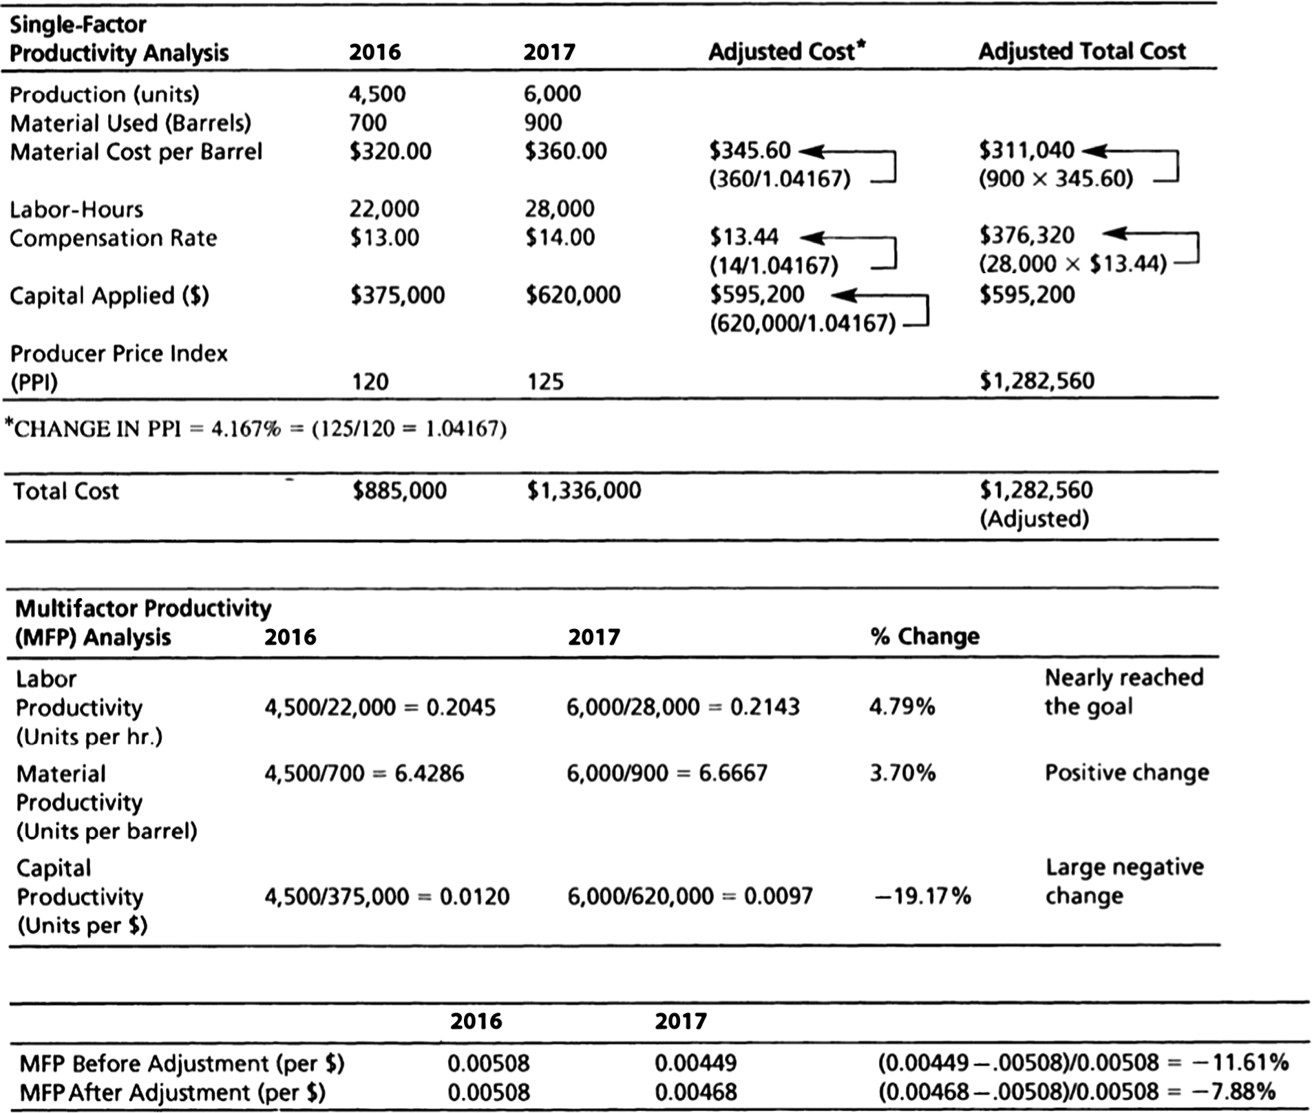

Both labor and material productivity increased, but capital equipment productivity did not. The net result is a large negative change in productivity. If this is a one-time change in the accounting procedures, this negative change should also be a one-time anomaly. The effect of accounting procedures is often beyond the control
of managers. For example, perhaps the capital allocation is based on an accelerated allocation of depreciation of newly installed
technology. This accounting practice will seriously impact near-term productivity and then later years’ productivity figures will benefit from the reduced depreciation flows. This highlights the difficulty in accounting for costs in an effective managerial manner. Decisions and evaluation of operating results should be based on sound managerial accounting practices and not necessarily generally accepted financial accounting principles.
LO 1.4: Compute single-factor productivity
LO 1.5: Compute multifactor productivity
AACSB: Analytical thinking
2. An analysis of adjusted results reduces the negative impact on the capital allocation but there is still a negative growth in multifactor productivity. After adjustment for inflation, the material costs are still higher in 2017. Yet, one must be aware of the extra volatility of the cost of petroleum-based products. Did the manager have control over his price increases? One should look at the changes in a petroleum-based price index, including the cost of oil, over the last two years in order to gain a better understanding of the degree to which the manager had control over these costs. The increase in wages was beyond the manager’s control, and a constant rate should be used for comparing both years’ results. Yet a negative result still remains. Even when material costs in 2017 are converted to the original cost of $320, a negative 5% growth in productivity remains. The increase in the capital base is responsible yet should not persist in future years if the increase was the result of an adoption of new technology.
LO 1.4: Compute single-factor productivity
LO 1.5: Compute multifactor productivity
AACSB: Analytical thinking
3. The manager did not reach the goal. An analysis of the changes in capital costs is warranted. Even after adjusting for
inflation, multifactor productivity was not positive. However, labor and materials productivity was favorable. The capital
investment cost (as figured by the accounting department) was so large as to make his multifactor productivity negative. Multifactor productivity has fallen by 11.61% before adjustment and by 7.87% after the adjustment for inflation.
LO 1.5: Compute multifactor productivity
AACSB: Application of knowledge

