CHAPTER 1 | Economics:
Foundations and Models
Brief Chapter Summary and Learning Objectives
1.1 Three Key Economic Ideas (pages 2–5)
Explain these three key economic ideas: People are rational. People respond to incentives. Optimal decisions are made at the margin.
▪ People must make choices as they try to attain their goals. People make choices because resources are scarce. Most of economics analyzes what happens in markets.
1.2 The Economic Problem All Societies Must Solve (pages 5–9)
Discuss how an economy answers these questions: What goods and services will be produced? How will the goods and services be produced? Who will receive the goods and services produced?
▪ A limited amount of resources can produce a limited amount of goods and services.
▪ The cost of producing more of one good is the value of what must be given up to produce it.
1.3 Economic Models (pages 9–12)
Understand what economic models are and aren’t, and why they are a good idea.
▪ Economists use models—simplified versions of reality—to analyze real-world issues.
▪ Economists accept a model if it leads to hypotheses that are confirmed by statistical analysis.
1.4 Microeconomics and Macroeconomics (page 12)
Distinguish between microeconomics and macroeconomics.
1.5 The Language of Economics (pages 12–14)
Define important economic terms. (It’s not all Greek.)
Appendix A: Using Graphs and Formulas (pages 18–28)
Review the use of graphs and formulas.
Key Terms

Allocative efficiency, p. 8. A state of the economy in which production is in accordance with consumer preferences; in particular, every good or service is produced up to the point where the last unit provides a marginal benefit to society equal to the marginal cost of producing it.
Centrally planned economy, p. 6. An economy in which the government decides how economic resources will be allocated.
Economic model, p. 2. A simplified version of reality used to analyze real-world economic situations.
Economic variable, p. 9. Something measurable that can have different values, such as the price of coffee.
Economics, p. 2. The study of the choices people make to attain their goals, given their scarce resources.
Equity, p. 8. The fair distribution of economic benefits.
Macroeconomics, p. 12. The study of the economy as a whole, including topics such as inflation, unemployment, and economic growth.
Marginal analysis, p. 4. Analysis that involves comparing marginal benefits and marginal costs.
Market, p. 3. A group of buyers and sellers of a good or service and the institutions or arrangements by which they come together to trade.
Market economy, p. 7. An economy in which the decisions of households and firms interacting in markets allocate economic resources.
Microeconomics, p. 12. The study of how households and firms make choices, how they interact in markets, and how the government attempts to influence their choices.
Mixed economy, p. 7. An economy in which most economic decisions result from the interaction of buyers and sellers in markets, but in which the government plays a significant role in the allocation of resources.
Normative analysis, p. 10. Analysis concerned with what ought to be.
Opportunity cost, p. 5. The highest-valued alternative that must be given up to engage in an activity.
Positive analysis, p. 10. Analysis concerned with what is.
Productive efficiency, p. 8. A situation in which a good or service is produced at the lowest possible cost.
Scarcity, p. 2. A situation in which unlimited wants exceed the limited resources available to fulfill those wants.
Trade-off, p. 5. The idea that, because of scarcity, producing more of one good or service means producing less of another good or service.
Voluntary exchange, p. 8. A situation that occurs in markets when both the buyer and seller of a product are made better off by the transaction.

Chapter Outline
You versus Caffeine

If you are like 65 percent of Canadians, you had a cup of coffee this morning—you might even be drinking one now. The simple pleasure of a cup of coffee is brought to you by hundreds of people working in a variety of occupations. Someone planted coffee, someone picked it and someone else took it to a port. A dockworker loaded a ship and a ship’s crew transported the beans to North America. More dock workers, shippers, roasters, packagers, more shippers, retail store workers or baristas and finally you get a cup of coffee. All this happens through the complexities of the markets. Any disturbance in this sequence can change how much you pay. One example is the 6 percent increase in coffee prices prior to Super Typhoon Haiyan in November 2013. Economics helps explain how markets work and what determines prices.
Source: International Coffee Organization http://www.ico.org/prices/pr.htm.
Teaching Tips
There are special features that open and close each chapter of the book:
1. The introduction, or chapter opener, uses a real-world business example to preview the economic issues discussed in the chapter.

2. A boxed feature titled Economics in Your Life complements the business example that opens the chapter. Economics in Your Life poses questions that help students make a personal connection with the chapter theme. At the end of the chapter, the authors use the concepts described in the chapter to answer these questions.
You can use these features—the chapter opener and Economics in Your Life—as the basis for classroom discussion, homework assignments, and examination questions. This Instructor’s Manual includes one extra Economics in Your Life for each chapter so that you can present material in class that is different from the material found in the textbook.
People must make choices as they try to attain their goals. The choices people make represent the trade-offs made necessary by scarcity. Scarcity is a situation in which unlimited wants exceed the limited resources available to fulfill those wants. Economics is the study of the choices people make to attain their goals, given their scarce resources. An economic model is a simplified version of reality used to analyze real-world economic situations.
Teaching Tips
It is important to define economics and explain what scarcity means at the beginning of the course, especially because many students will not have studied economics previously. Some students will better understand what scarcity means if you give them examples of things that are not scarce. You can provide examples of “free resources”—sand on a beach, fresh air—and ask students to contribute their own examples. Your students will quickly learn that the list of free resources is very much shorter than the list of scarce resources.
1.1 | Three Key Economic Ideas (pages 2–5)  Learning Objective: Explain these three key economic ideas: People are rational, people respond to incentives, and optimal decisions are made at the margin.
A market is a group of buyers and sellers of a good or service and the institution or arrangement by which they come together to trade. There are three important ideas students should learn to understand how people make choices and interact in markets: People are rational; people respond to economic incentives; and optimal decisions are made at the margin.
A. People Are Rational
This assumption does not mean that everyone knows everything or always makes the “best” decision. Rational individuals weigh the benefits and costs of each action and choose an action if the benefits outweigh the costs. When deciding, people believe it is their best interest; they may be wrong.
B. People Respond to Economic Incentives
Economists emphasize that consumers and firms consistently respond to economic incentives. When incentives change, people’s actions change accordingly.
C. Optimal Decisions Are Made at the Margin
Economists use the word marginal to mean an extra or additional benefit or cost of a decision. The optimal decision is to continue any activity to the point where the marginal benefit equals the marginal cost. Marginal analysis involves comparing marginal benefits and marginal costs.
Teaching Tips
You don’t need to spend a lot of class time with explanations because subsequent chapters will reinforce students’ understanding of what markets are and the “three key economic ideas.” This section of the chapter includes a Solved Problem that shows the step-by-step process of solving an economic problem related to a chapter learning objective. Solved Problem 1.1 is an example of marginal analysis: whether a student should study an extra hour or watch TV. You can work through the Solved Problem in class and assign the related end-of-chapter problems as homework. This Instructor’s Manual includes some Extra Making the Connection features and Extra Solved Problems that are not in the text so that you have unique problems to present in class or to assign as homework.
1.2 | The Economic Problems All Societies Must Solve (pages 5–9)  Learning Objective: Discuss how a society answers these three economic questions: What goods and services will be produced? How will the goods and services be produced? Who will receive the goods and services produced?
Every society faces the economic problem that it has only a limited amount of economic resources, and so it can produce only a limited amount of goods and services. Society faces trade-offs. A trade-off is the idea that because of scarcity, producing more of one good or service means producing less of another good or service. Every activity has an opportunity cost, which is the highest-valued alternative that must be given up to engage in an activity. Trade-offs force society to answer three fundamental questions:
What goods and services will be produced?
How will the goods and services be produced?
Who will receive the goods and services produced?
A. What Goods and Services Will Be Produced?
The answer to this question is determined by the choices consumers, firms, and the government make. Each choice made comes with an opportunity cost, measured by the value of the best alternative given up.
B. How Will the Goods and Services Be Produced?
Firms choose how to produce the goods and services they sell. For example, firms often face trade-offs between using more workers and using more machines.
C. Who Will Receive the Goods and Services Produced?
In Canada, who receives the goods and services produced depends largely on how income is distributed. An important policy question is whether the government should intervene to make the distribution of income more equal. The debate over how much taxation and government spending is appropriate will continue as long as societies must address the three fundamental questions.
D. Centrally Planned Economies versus Market Economies
Societies organize their economies in two main ways. A centrally planned economy is an economy in which the government decides how economic resources will be allocated. A market economy is an economy in which the decisions of households and firms interacting in markets allocate economic resources. Today, only a few small countries, such as Laos and North Korea, still have completely centrally planned economies. In a market economy, your income is determined by the payments you receive for what you sell. Markets usually reward hard work. Generally, the more extensive the training you have and the more hours you work, the higher your income will be.
E. The Modern “Mixed” Economy
Some government intervention is designed to raise the incomes of the elderly, the sick, and people with limited skills. Some economists argue that government intervention makes it more accurate to refer to the economies of Canada and most other countries as mixed economies rather than market economies. In a mixed economy, most economic decisions result from the interaction of buyers and sellers in markets, but the government plays a significant role in the allocation of resources. Even the United States and China are mixed economies that rely on a combination of both the market and central planning to provide
people with a variety of goods and services. Although China remains a political dictatorship, production of most goods is determined in markets.
F. Efficiency and Equity
Market economies tend to be more efficient than centrally planned economies. There are two types of efficiency. Productive efficiency is a situation in which a good or service is produced at the lowest possible cost. Allocative efficiency is a state of the economy in which production is in accordance with consumer preferences; in particular, every good or service is produced up to the point where the last unit provides a marginal benefit to society equal to the marginal cost of producing it. Voluntary exchange is a situation that occurs in markets when both the buyer and seller of a product are made better off by the transaction.
Markets promote efficiency but don’t guarantee it. Inefficiency arises from various sources. Governments can alter the level of efficiency in a market. Sometimes governments may reduce efficiency by interfering with voluntary exchanges in markets. The production of some goods may damage the environment when firms ignore the costs of environmental damage. In this case, government intervention can increase efficiency.
Society may not find an efficient economic outcome to be desirable. Many people prefer economic outcomes that they consider fair or equitable even if these outcomes are less efficient. Equity is the fair distribution of economic benefits. Equity is harder to define than efficiency. Programs designed to increase equity may reduce efficiency.
Teaching Tips
Ask students for examples of government regulation of private markets in Canada. Responses may include: making the sale of cocaine and narcotics illegal; minimum age requirements for the purchase of alcoholic beverages and cigarettes; or the prohibition of the sale of new drugs before their effectiveness is demonstrated through government supervised tests. Ask students whether one of these examples of government regulation promotes equity or fairness. The difficulty in defining equity will soon become apparent.
To show how students may value equity less than they claim, an economics teacher at a college in Western New York once told her students at the beginning of her course that their grades would be auctioned to the highest bidders. Because grades are typically normally distributed, she offered to sell a few A grades, a few more B grades, and so on. Although the announcement produced shock and grumbling, the auction proceeded, with frenzied bidding for A grades. As prices for A grades rose, bidding switched to B grades. Because few students bothered to bid for C grades, one enterprising student bid on several such grades in the belief that those who lost out on getting an A or B would have to buy their C grades from him—for a higher price than he paid! After about a week, the instructor informed the class the auction was intended only as an economics lesson; they would have to earn their grades the old-fashioned way!
Extra Solved Problem 1.2
Advising New Government Leaders
Suppose that a low-income country experiences a change in government leadership. Prior to this change, the country had a centrally planned economy. The new leaders are willing to try a different system if someone can convince them that it will yield better results. They hire an economist from a country with a market economy to advise them and will order their citizens to follow the economist’s recommendations for change. The economist suggests that a market economy replace central planning to answer the nation’s economic questions (what, how, and who).
What will the economist suggest the leaders order their citizens to do in order to change from a centrally planned economy to a market economy?
Are there reasons why the leaders and citizens of this country might not accept the economist’s suggestions? Briefly explain.
Solving the Problem
Step 1: Review the chapter material.
The problem is about different types of economic systems, so you may want to review the section “Centrally Planned Economies versus Market Economies” on page 6 of the textbook.
Step 2: What will the economist suggest the leaders order their citizens to do?
Market economies allow members of households to select occupations and purchase goods and services based on self-interest and allow privately owned firms to produce goods and services based on their self-interests. Therefore, the economist would advise the leaders of the poor country to not issue any orders. Government officials should have no influence over individual decisions made in markets.
Step 3: Do you believe the leaders and citizens will accept the economist’s suggestions?
Even democratically elected leaders, especially those with significant government involvement in the country’s resource allocation, will find it difficult to accept the new system. They may wonder how self-interested individuals will produce and distribute goods and services so as to promote the welfare of the entire country. This new system requires a significant reduction in government influence in people’s lives, but history has shown that government officials are often reluctant to give up this influence. Acceptance is most likely when the leaders have some knowledge and experience with the successful operation of a market economy in other countries. Ordinary citizens are more likely to accept the economist’s suggestions because they will have more freedom to pursue their own economic goals.
1.3 | Economic Models (pages 9–12)  Learning Objective: Understand what economic models are and aren’t, and why they are a good idea.
Models are simplified versions of reality used to analyze real-world situations. To develop a model, economists generally follow five steps.
1. Decide on the assumptions to use in developing the model.
2. Formulate a testable hypothesis.
3. Use economic data to test the hypothesis.
4. Revise the model if it fails to explain well the economic data.
5. Retain the revised model to help answer similar economic questions in the future.
A. The Role of Assumptions in Economic Models
Models are based on making assumptions because models must be simplified to be useful. For example, when using models, economists make behavioural assumptions about the motives of consumers and firms. Economists assume consumers will buy goods and services that will maximize their satisfaction. Economists assume that firms act to maximize their profits.
B. Forming and Testing Hypotheses in Economic Models
An economic variable is something measurable that can have different values, such as the price of coffee in Canada. A hypothesis in an economic model is a statement that may be correct or incorrect about an economic variable. We must test a hypothesis before we can accept it. To test a hypothesis, we analyze statistics on the relevant economic variables. Economists accept and use an economic model if it leads to hypotheses that are confirmed by statistical analysis.
C. Normative and Positive Analysis
Positive analysis is analysis concerned with what is. Normative analysis is analysis concerned with what ought to be.
D. Economics as a Social Science
Because economics studies the actions of individuals, it is a social science. Economics considers human behaviour in every context, not just in the context of business. Economists have played an important role in formulating government policies in areas such as the environment, health care, and poverty.
Extra Solved Problem 1.3
Sunspot Activity and Economic Growth
Sunspots are sites of strong magnetic fields that appear as dark regions on the surface of the sun. The number of sunspots varies over an 11-year cycle. British economist William Stanley Jevons (1835–1882) advanced a theory, or model, of economic growth based on the occurrence of sunspots. Changes in the number of sunspots cause variations in the earth’s temperature and, according to this theory, changes in agricultural output. Agriculture accounted for a much greater share of total output of the economies of Great Britain and other countries in Jevons’s time than in modern times.
Source: History of Economic Theory and Thought. Jevons Sunspot and Commercial Activity http://www.economictheories.org/2008/08/jevons-sunspots-and-commercial-activity.html.
How can we develop and test a sunspot model of economic growth?
Solving the Problem
Step 1: Review the chapter material.
The problem is about how to use models to analyze economic issues, so you may want to review the section “Economic Models,” which begins on page 9 of the textbook.
Step 2: To develop and test a sunspot model of economic growth, we follow these steps:
1. Decide on the assumptions to use in developing the model. Two assumptions of Jevons’s model are (a) Changes in the Earth’s temperature are related to the amount of sunspot activity, and (b) changes in the Earth’s temperature cause variations in the value of a country’s output of goods and services.
2. Formulate a testable hypothesis. The value of a country’s output of goods and services is greater in years of greater than average sunspot activity than in years of lower than average sunspot activity.
3. Use economic data to test the hypothesis. Compare changes in sunspot activity with changes in a standard measure of the value of a country’s output of goods and services. The most common measure is gross domestic product, or GDP. Because sunspot activity varies in 11-year cycles, data should cover at least one of these cycles. If data for Canada were used, years of greater-than-average sunspot activity should be associated with years of above-average economic growth, while years of lower-than-average sunspot activity should be associated with years of below-average economic growth.
4. Revise the model if it fails to explain well the economic data. The model could fail if factors other than sunspot activity have a significant effect on output of goods and services. These factors include variations in the price of energy, investments in new technologies, changes in tax rates, and other government policies. A revised model would examine the separate influence of sunspots and these other factors.
5. Retain the revised model to help answer similar economic questions in the future. Although the sunspot model is based on a plausible relationship between climate changes and changes in agricultural production, agriculture accounts for a much smaller percentage of the output produced in Canada, the United States, Great Britain, and other Western countries in the twenty-first century than it did in the nineteenth century. Later research has shown other factors to be more important in explaining fluctuations in the total output of goods and services.

1.4 | Microeconomics and Macroeconomics (page 12)  Learning Objective: Distinguish between microeconomics and macroeconomics.
Microeconomics is the study of how households and firms make choices, how they interact in markets, and how the government attempts to influence their choices.
Macroeconomics is the study of the economy as a whole, including topics such as inflation, unemployment, and economic growth.
Extra Solved Problem 1.4
Microeconomic and Macroeconomic Views
Sports fans are used to seeing game action on television from different camera angles. For popular events such as the Olympics, the World Series, and PGA events, network coverage captures action from ground level as well as from higher locations. At some events, there is a camera located in a blimp that circles above the stadium where the event is held. The aerial view of the blimp’s camera is often visually appealing but is never broadcast for very long because the athletes are barely visible. Coverage of the events often includes a view from a mobile or “sideline” camera that can zoom in on individual players or fans sitting in the stands, a degree of detail much greater than that provided by the aerial view. How do the different camera angles help to explain the difference between microeconomics and macroeconomics?
Solving the Problem
Step 1: Review the chapter material.
The problem concerns the differences between microeconomics and macroeconomics, so you may want to review the section “Microeconomics and Macroeconomics,” which appears on page 12 of the textbook.
Step 2: Compare the focus of microeconomics with the television coverage of a sports event.
Microeconomics focuses on how individual households and firms make choices, how they interact in markets, and how the government attempts to influence their choices. This focus is similar to that of a sideline camera at a football game. The camera can focus in on an individual player or fan.
Step 3: Compare the focus of macroeconomics with the television coverage of a sports event.
Macroeconomics is the study of the economy as a whole, including topics such as inflation, unemployment, and economic growth. Macroeconomics does not study the decisions made by individuals but the consequences of the actions of all decision makers in an economy. This is similar to the blimp’s aerial view of the venue where a sports event occurs. One can see the entire venue, but the blimp’s point of view is too far away to see any individual player or fan.

Extra Making  the  Connection | Macroeconomic and Microeconomic Analysis
Economists separate the study of how households and firms make choices and interact in markets (microeconomics) from the study of the economy as a whole (macroeconomics). But some issues can be viewed from both perspectives. Labour productivity is one such issue.
Labour productivity—the quantity of goods and services that can be produced by one worker or by one hour of work—is a microeconomic topic. Labour productivity increases when a firm invests in capital or when a firm's technology improves. Increased labour productivity allows a firm to earn higher profits and to pay its workers higher wages.
Macroeconomists also study labour productivity because it determines the standard of living a country can achieve for its citizens. An increase in productivity is beneficial in the long run, but it can slow the growth of jobs in the short run. During the post-WWII economic expansion from 1950 to 1972, Canada experienced an average growth rate per capita of 2.8 percent. One reason for this was an increase in labour productivity.
Productivity growth in Canada decreased after 1972, and the reasons for this slowdown are not fully understood. Some economists believe that the structural change from the production of goods to the production of services after the mid ‘70s has led to measurement errors. Others suggest that increases in environmental protection and workplace safety cause biased estimations. Still others suggest the rapid increase in oil prices after 1972. These issues are discussed more fully in Chapter 7.

1.5 | The Language of Economics (pages 12–14)  Learning Objective: Define important economic terms.
This section provides a brief definition and preview of terms students will see throughout the book: entrepreneur, innovation, technology, firm (company or business), goods, services, revenue, profit, household, factors of production or economic resources, capital, and human capital.
Extra Economics in Your Life:
Is Cheating an Optimal Decision?
In their best-selling book Freakonomics, Steven D. Levitt and Stephen J. Dubner argue “Who cheats? Well, just about anyone, if the stakes are right . . . . Cheating . . . is a prominent feature in just about every human endeavor.” Evidence that some people cheat surfaced in the summer of 2011 when the board superintendent of the Atlanta school district resigned after a report documented widespread cheating on standardized tests that implicated officials from about 80 percent of Atlanta’s elementary and middle schools. The Georgia Bureau of Investigation found that at least 178 Atlanta teachers and principals cheated to raise student scores on standardized tests. As if the reports of cheating weren’t bad enough, some principals refused to cooperate with the Bureau. One principal even started an ethics investigation against a “whistle-blower” who tried to alert authorities about the scandal. Economic reasoning can explain the incidence of cheating. Steven Levitt and other economists assume that decision-makers—students and non-students alike—are rational. They compare the benefits and costs of their options and make choices for which the expected benefits exceed the expected costs. The benefits of (successful) cheating may be monetary; for example, K–12 teachers in some states are eligible for bonus payments of up to $25,000 if their students perform well on standardized tests. New technology has made it easier for high school and college students to cheat. The widespread use of cell phones and Internet access makes it easier (less costly) to share exam answers and buy term papers.
Sources: Steven D. Levitt and Stephen J. Dubner, Freakonomics New York: HarperCollins 2005, pages 24–25, and Patrik Jonsson, “America’s biggest teacher and principal cheating scandal unfolds in Atlanta,” Christian Science Monitor, July 5, 2011.
Question: For the sake of argument, let’s assume that you would never cheat. Under what circumstances are students in general more or less likely to cheat on an economics examination?
Answer: First of all, understand that your economics instructor will be pleased if you would never cheat under any circumstances. But the benefit of cheating is greater when (a) the positive consequences of receiving a high grade are great (for example, a high grade is necessary to maintain a scholarship, gain admittance to graduate school, or get a good job offer) and/or (b) the probability of getting caught is low (for example, the instructor gives the same multiple-choice exam to all students in a large classroom with no supervision). Reducing the benefit and increasing the cost of getting caught will reduce the incidence of cheating. If appeals to personal integrity are not enough to convince students not to cheat, then a more effective deterrent may be for potential employers to let students know that they don’t hire students with a record of cheating.
Extra AN INSIDE LOOK News Article to Use in Class
Visit www.myeconlab.com for current An Inside Look news articles.
Appendix
Using Graphs and Formulas (pages 18–28)
Learning Objective: Review the use of graphs and formulas.
Graphs simplify economic ideas and help make ideas more concrete. Economists and policymakers can use graphs to help solve real-world problems.
Graphs of One Variable
Figure 1A.1 displays examples of two common types of graphs: bar graphs and pie charts. The height of the bars in the bar graph represents the market shares of automobile firms. The pie chart shows the same information with market shares represented by the size of the pie’s slices. Information on economic variables can also be displayed in time-series graphs. These graphs are displayed on a coordinate grid. The vertical axis (y-axis) of a coordinate grid measures the value of one variable. The point where the vertical axis intersects the horizontal axis is the origin. The horizontal axis of a coordinate grid measures the value of another variable. The points in a coordinate grid represent the values of the two variables. Figure 1A.2 illustrates examples of time-series graphs.
Graphs of Two Variables
Both microeconomics and macroeconomics use two-variable graphs extensively. Figure 1A.3 illustrates the graph of a linear or straight-line demand curve where price is measured along the vertical axis and quantity is measured along the horizontal axis.
A. Slopes of Lines
The slope of a straight line indicates how much the variable measured along the y-axis changes as the variable measured along the x-axis changes. Slope can be measured between any two points on the line because the slope of a straight line has a constant value. The slope can be expressed as the change in the value measured on the vertical axis divided by the change in the value measured on the horizontal axis; slope can also be expressed using the Greek letter delta (Δ) to stand for the change in a variable (slope = Δy /Δx). The slope is also referred to as the rise over the run.
B. Taking into Account More Than Two Variables on a Graph
The demand curve in Figure 1A.4 shows the relationship between the price of pizza and the quantity of pizza sold, but the quantity of any good sold depends on more than just the price of the good. Allowing other variables to change will cause the position of the demand curve in the graph to change. The table in Figure 1A.5 shows the effect of a change in the price of hamburgers on the quantity of pizza demanded. By shifting the demand curve we take into account the effect of changes in a third variable.
C. Positive and Negative Relationships
Sometimes the relationship between two variables is negative, as in the case with the price of pizza and the quantity of pizza demanded. The relationship between two variables can be positive, as in Figure 1A.6 which shows values for income and consumption spending in Canada for the years 2008 to 2011.
D. Determining Cause and Effect
Inferring cause-and-effect relationships by observing graphs can lead to incorrect conclusions. One reason for this is that there may be an omitted variable that is not accounted for in the graph. A related problem in determining cause and effect is reverse causality; this occurs when we conclude that changes in variable X cause changes in variable Y, when changes in variable Y cause changes in variable X.
E. Are Graphs of Economic Relationships Always Straight Lines?
The relationship between two variables is linear when it can be represented by a straight line. Few economic relationships are actually linear. However, it is often useful to approximate a nonlinear relationship with a linear relationship.
F. Slopes of Nonlinear Curves
To measure the slope of a nonlinear curve at a particular point, we must measure the slope of a tangent to the curve at that point. A tangent line touches the curve at only one point. The slope of a tangent is measured in the same way as the slope of any straight line.
Formulas
This section reviews several useful formulas and shows how to use them.
A. Formula for a Percentage Change
The formula for a percentage change between two variables for any two periods is
Percentage change .
B. Formulas for the Areas of a Rectangle and a Triangle
The formula for the area of a rectangle is Base × Height. The formula for the area of a triangle is
½ (Base × Height).
C. Summary of Using Formulas
Follow these steps when using a formula:
1. Make sure you understand the economic concept the formula represents.
2. Make sure you are using the correct formula for the problem you are solving.
3. Make sure the number you calculate using the formula is economically reasonable.
Teaching Tips
You can assign the appendix as “on-your-own” reading. But don’t assume students will understand the formula for computing a slope or a percentage change. Reviewing these formulas in class will be time well spent, either at this point in the course or when these formulas are first applied. Unlike bar charts and pie charts, students will need to use graphs of two variables and percentage changes often throughout the remainder of the text.
SOLUTIONS TO END-OF-CHAPTER EXERCISES

Review Questions
1.1 | Three Key Economic Ideas (pages 2–5)  Learning Objective: Explain these three key economic ideas: People are rational, people respond to incentives, and optimal decisions are made at the margin.
1.1 “People are rational” is the assumption that decision makers explicitly or implicitly weigh the benefits and costs of each action and then choose an action only if the benefits are expected to outweigh the costs. “People respond to incentives” means that consumers and firms consistently respond to economic incentives. “Optimal decisions are made at the margin” means that most decisions are not “all or nothing” but involve doing a little more or a little less of an activity. Therefore, the optimal decision is to continue any activity up to the point where the marginal benefit equals the marginal cost.
1.2 Scarcity is the situation in which unlimited wants exceed the limited resources available to fulfill those wants. Economics is the study of the choices consumers, business managers, and government officials make to attain their goals. Scarcity is central to economics because scarcity requires people to make choices about how to use their resources to best fulfill their wants.

1.2 | The Economic Problems All Societies Must Solve (pages 5–9)  Learning Objective: Discuss how a society answers these three key economic questions: What goods and services will be produced? How will the goods and services be produced? Who will receive the goods and services produced?
2.1 Scarcity implies that every society and every individual faces trade-offs because wants are unlimited, but the ability to satisfy those wants is limited. Societies and individuals cannot have everything they want, so they have to make choices of what to have and what not to have.
2.2 The three economic questions that every society must answer are: 1) What goods and services will be produced? 2) How will the goods and services be produced? 3) Who will receive the goods and services? In a centrally planned economy, the government makes most of these decisions. In a pure market economy, almost all of these decisions are made by the decentralized interaction of households and firms in markets. In a mixed economy, most economic decisions result from the interaction of buyers and sellers in markets, but government plays a significant role in the allocation of resources.

1.3 | Economic Models (pages 9–12)  Learning Objective: Understand the role of models in economic analysis.
3.1 Economists use models for the same reason that any other scientist (and indeed everyone else) does—to make a complicated world simple enough that it can be understood and analyzed, so that questions about it can be usefully answered. Useful models will generate testable predictions. If these predictions are consistent with economic data, then the model isn’t rejected and can be used to understand the economy. Testing models with data can be very difficult, however, because the economy is always changing, and it is difficult to conduct controlled economic experiments.
3.2 In arriving at a useful economic model, these five steps are followed: 1) decide the assumptions to be used; 2) formulate a testable hypothesis; 3) use economic data to test the hypothesis; 4) revise the model if it fails to explain the economic data; and 5) retain the revised model to help answer similar economic questions.
3.3 Positive economic analysis concerns what is; that is, it deals with how the economy actually behaves. Normative economic analysis concerns what ought to be. Economics is mainly concerned with positive analysis—conceptualizing and measuring the costs and benefits of different courses of action. Decision makers (including voters and government officials) can use the trade-offs and costs and benefits identified by positive economic analysis in normatively deciding what course of action should be taken.

1.4 | Microeconomics and Macroeconomics (page 12)  Learning Objective: Distinguish between microeconomics and macroeconomics.
4.1 Microeconomics is the study of how households and firms make choices, how they interact in specific markets, and how the government influences their choices. “Micro” means small, and microeconomics deals with individual decision makers. Macroeconomics is the study of the economy as a whole. “Macro” means large, and macroeconomics deals with economy-wide outcomes, such as the inflation rate, the unemployment rate, and the economic growth rate.

Problems and Applications

1.1 | Three Key Economic Ideas (pages 2–5)  Learning Objective: Explain these three key economic ideas: People are rational, people respond to incentives, and optimal decisions are made at the margin.
1.1 As noted in the chapter, the economic incentive to banks is clear—it is less costly to put up with bank robberies than to take these additional security measures.
1.2 a. Students face scarcity of time, like everyone else, and respond to the incentives of the teacher’s grading system. Students have more incentive to put their efforts into the parts of the course that have the most weight in the grading system.
b. Too little weight on outside readings or the like give students little incentive to read and master the material. Students will put less effort in the parts of the course that have little effect on their grades.
c. Quizzes over assigned readings would give students an incentive to come to class having read the upcoming material. Some teachers give preparation assignments where students have to read and answer questions about the upcoming material, and over the course of the semester students have to successfully complete a certain percentage of the preparation assignments to qualify for an A, or B, or other grade in the course.
1.3 The government makes payments under the UCCB in an effort to offset the costs of childcare, to allow more parents, particularly women, to return to work after having a child. The thinking is that by reducing the cost of childcare, more people will be encouraged to have children. Most people are unlikely to change the number of children they have. $160 a month is not a large enough payment to change the benefits and costs to most people, and therefore not enough to change people’s decisions about having children.
1.4 a. People respond to incentives. Paying first-year university students to go to the gym acts as an additional layer of incentive. The addition of the payment to the health benefits incentivizes students even more. This explains the increased gym attendance
b. Different people respond to different incentives. The payment offered might not be large enough to make some students go to the gym. In order for a program to change people’s behaviour it has to make the benefits larger than the costs.
1.5 Jill is correct. The difference between the additional revenue and the additional cost will be exactly the same as the additional profit.
1.6 Your friend is failing to think at the margin. It doesn’t matter how much time your friend has already spent studying psychology. What matters is the marginal benefit to be received from studying psychology relative to the marginal cost, where cost is measured as the opportunity cost of lower grades in other subjects. If the course is required, that may raise the marginal benefit.

1.2 | The Economic Problem All Societies Must Solve (pages 5–9)  Learning Objective: Discuss how an economy answers these questions: What goods and services will be produced? How will the goods and services be produced? Who will receive the goods and services produced?
2.1 Yes, even Bill Gates faces scarcity because his wants exceed his resources. Gates has established a foundation with billions of dollars to spend on worthy causes like eradicating malaria and reducing homelessness. However, there are an unlimited number of worthy causes that Gates desires to fund, so even he faces scarcity. Secondly, even Gates has only twenty-four hours in a day, so he must make choices about how to spend his scarce time. Everyone faces scarcity, because human desires are virtually unlimited. Because the world’s resources are limited, the only way to not face scarcity would be to reduce your wants to be less than your resources.
2.2 a. It is doubtful that centrally planned economies have been less efficient purely by chance. The underlying reason seems to be that centrally planned economies don’t provide as strong incentives for hard work and innovation as market economies do. In addition, the people running centrally planned economies cannot make the most efficient decisions because they don’t have the information that is in the minds of all the decentralized decision makers in a market economy.
b. You might still prefer having a centrally planned economy if you considered it to be more equitable. (Also, you might prefer a centrally planned economy if you were in charge.)
2.3 A complete explanation for the connection between majoring in economics and success in business would involve many factors. But we can say that economics teaches us how to look at the trade-offs involved in every decision we make. Those who cannot understand the costs of an action and weigh them against its benefits are unlikely to make good decisions. Climbing the corporate or governmental ladder requires making a wider and wider array of such decisions.
2.4 a. The groups that are most likely to get the tickets will be those for whom the expected marginal benefits of going to the radio station on Monday morning are greater than the expected marginal costs. These might include people who have a very low opportunity cost of travelling to the radio station and standing in line, such as people who don’t have a job in the morning and those who live or work very close by. These might also include people who see a large benefit from going to get the tickets, such as die-hard Nicki Minaj fans or professional ticket resellers (“scalpers”).
b. The major opportunity cost of distributing the tickets this way is the cost to the people who attempt to get the tickets—the cost of travel to radio station, the activities that cannot be done (such as earning money at work) while standing in line, and the costs to all those people who try to get tickets but don’t get there soon enough. There’s also the cost of people blocking traffic in and around the radio station.
c. This isn’t an efficient way to distribute the tickets because it wastes so much time. Perhaps the most efficient way to distribute the tickets is to hand them out unannounced to people walking by—this would take only a few minutes. Alternatively, the radio station could sell them back to the concert promoter and have them distribute the tickets. Auctioning off the tickets to the highest bidder would ensure that those who were willing to pay the highest price would obtain the tickets.
d. Equity is hard to define. Some people will see this as equitable, because only the deserving, true fan will put up with the hassle of getting the tickets. Some people might also argue that this system is equitable because the tickets are being distributed for free, making it possible for people with very low incomes to obtain them. Others will disagree, saying that people with a strong desire to obtain the tickets, but who are unable to be at the radio station at the designated time, would have no chance to get the tickets. Other people might argue that the system was not equitable because no money was raised for the concert promoter, who deserves to get some of the benefits of selling the tickets because they took all the risks.

1.3 | Economic Models (pages 9–12)  Learning Objective: Understand the role of models in economic analysis.
3.1 Economists assume that people are rational in the sense that their actions are intended to achieve their goals. This does not mean that economists assume everyone is a genius or always makes the “right” decision in every circumstance. It does mean that economists assume that the actions of consumers and businesses reflect their attempts to achieve their goals.
3.2 The problem with Dr. Strangelove’s theory is that it cannot be tested unless we can devise a way to measure the emission of these subatomic particles, which seems to be impossible because they don’t exist in our universe. Because we cannot test the model’s predictions, it is not very useful to us; even though it might be true, we have no way of knowing.
3.3 The economic data that would be most useful would be to identify those who are unemployed due (largely) to the increase in the minimum wage and to identify those who are able to enjoy the improved income resulting from increased wages. Understanding the number and nature of those who lose and those who gain can help us understand the positive side of the issue. Unfortunately this data will not resolve the normative side of the data debate, as the normative side of the debate requires people to make an assessment over which group is more important.
3.4 a. In the event of a large reduction in the amount of coffee available, Tim Hortons could face an increase in the price of coffee and would likely purchase less coffee from its suppliers. As a result, the price of the coffee Tim Hortons sells to consumers should increase. However, as the strongest player in the Canadian market, Tim Hortons usually books coffee contracts many months in advance. Therefore, if the reduction was just for a few months, the effect might be negligible for Tim Hortons.
b. In a centrally planned economy, the government would decide how to allocate coffee between the different coffee shops and would determine the price. Tim Hortons would have no say and would have to follow the directives of the government.
3.5. a. and c. are positive statements; b. and d. are normative statements.

1.4 | Microeconomics and Macroeconomics (page 12)  Learning Objective: Distinguish between microeconomics and macroeconomics.
4.1 a. and d. are microeconomic questions; b. and c. are macroeconomic questions.
4.2 You should disagree with the assertion. Microeconomics deals with individual decision makers; because the unemployment rate in any one city would be an issue for the economy of the entire city and not an individual, it is a macroeconomic issue rather than a microeconomic issue. Macroeconomics deals with economy-wide outcomes, so the effect of an increase in the tax on alcohol on underage drinking is better thought of as a microeconomic issue.
SOLUTIONS TO CHAPTER 1 APPENDIX
1A.1 a. The relationship is negative because as price decreases, the quantity of pies purchased increases.
b.
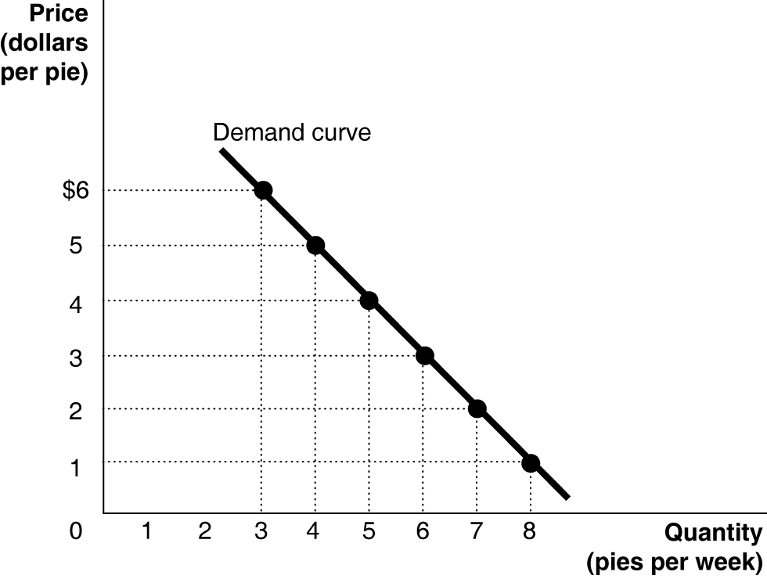
c. The slope = ∆y/∆x = rise/run = −1/1 = –1.

1A. 2
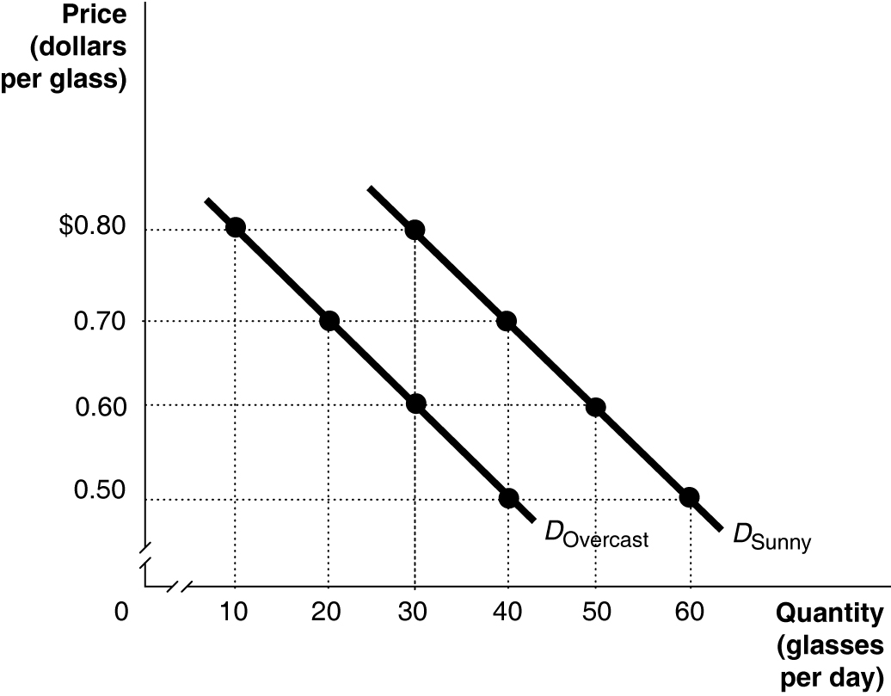
1A.3 Answers will vary somewhat depending on the values determined from the time-series graph. The calculations below use Ford sales rounded to the nearest thousands.
Period Percentage Change
2001 to 2002 [(3.411 − 3.774)/3.774] × 100 = − 9.6%
2002 to 2003 [(3.256 – 3.411)/3.411] × 100 = − 4.5%
2003 to 2004 [(3.112 – 3.256)/3.256] × 100 = − 4.4%
2004 to 2005 [(2.967 − 3.112)/3.112] × 100 = − 4.7%
2005 to 2006 [(2.735 – 2.967)/2.967] × 100 = −7.8%
2006 to 2007 [(2.402 − 2.735)/2.735] × 100 = −12.2%
2007 to 2008 [(1.915 – 2.402)/2.402] × 100 = −20.3%
2008 to 2009 [(1.621 − 1.915)/1.915] × 100 = −15.4%
2009 to 2010 [(1.945 − 1.621)/1.621] × 100 = 20.0%
Sales fell at the fastest rate between 2007 and 2008.

1A.4 ($12,703 − $13,162)/$13,162 = −3.5%
The percentage change in real GDP from one year to the next is the economy’s growth rate.
1A.5
a.
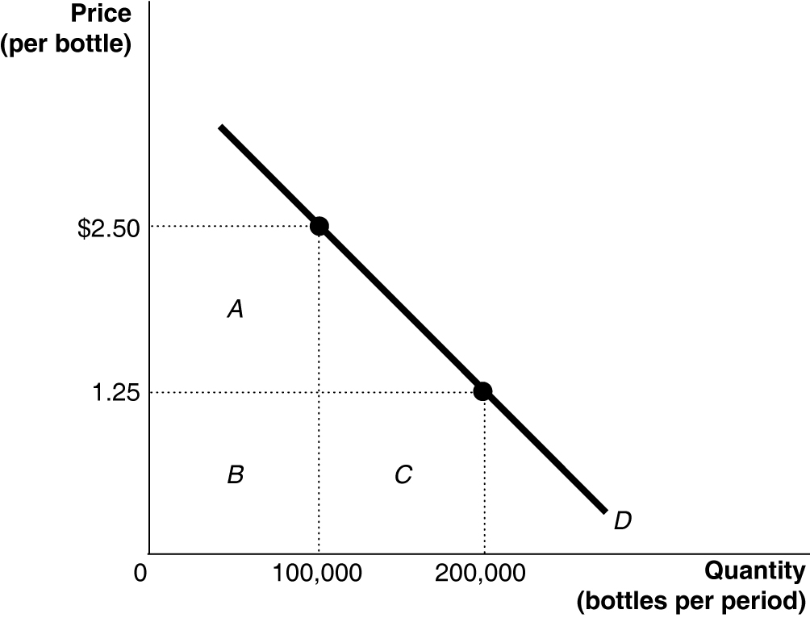
b. At $2.50, the total revenue equals rectangles A + B = $250,000 (because $2.50 × 100,000 = $250,000). At $1.25, the total revenue equals rectangles B + C = $250,000 (because $1.25 × 200,000 = $250,000).
1A.6 The triangle’s area = 0.5 × 60,000 × $0.75 = $22,500.
1A.7 The slope is calculated using the formula:
At point A: rise = 300 − 175 = 125, run = 7 − 5 = 2. Therefore, the slope = 125/2 = 62.5.
At point B: rise = 900 − 700 = 200, run = 14 – 12 = 2. Therefore, the slope = 200/2 = 100.

