Chapter One: Management Science

PROBLEM SUMMARY
1. Total cost, revenue, profit, and
break-even
2. Total cost, revenue, profit, and
break-even
3. Total cost, revenue, profit, and
break-even
4. Break-even volume
5. Graphical analysis (1−2)
6. Graphical analysis (1−4)
7. Break-even sales volume
8. Break-even volume as a percentage
of capacity (1−2)
9. Break-even volume as a percentage
of capacity (1−3)
10. Break-even volume as a percentage
of capacity (1−4)
11. Effect of price change (1−2)
12. Effect of price change (1−4)
13. Effect of variable cost change (1−12)
14. Effect of fixed cost change (1−13)
15. Break-even analysis
16. Effect of fixed cost change (1−7)
17. Effect of variable cost change (1−7)
18. Break-even analysis
19. Break-even analysis
20. Break-even analysis; profit analysis
21. Break-even analysis; indifference (1−20)
22. Break-even analysis
23. Break-even analysis; volume and
price analysis
24. Break-even analysis
25. Break-even analysis
26. Break-even analysis; profit analysis
27. Break-even analysis; price and volume analysis
28. Break-even analysis; profit analysis
29. Break-even analysis; profit analysis
30. Break-even analysis; profit analysis
31. Break-even analysis
32. Multiproduct break-even analysis
33. Decision analysis
34. Expected value
35. Linear programming
36. Linear programming
37. Linear programming
38. Linear programming
39. Forecasting/statistics
40. Linear programming
41. Waiting lines
42. Shortest route
PROBLEM SOLUTIONS
1. a)
b)
2. a)
b)
3. a)
b)
4.
5. 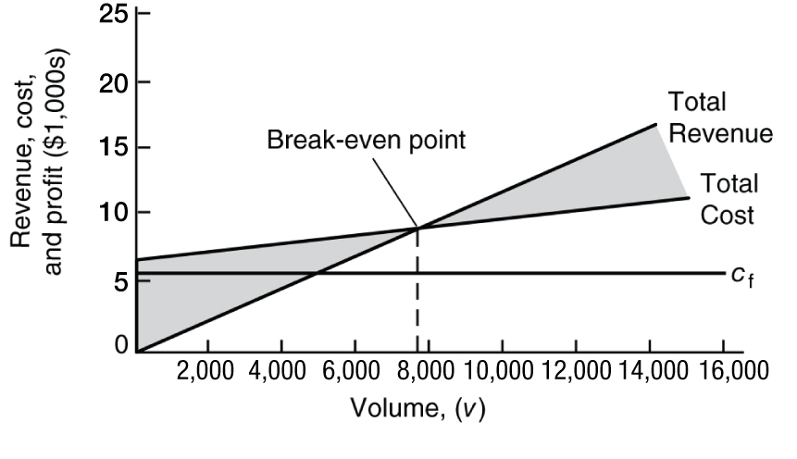
6. 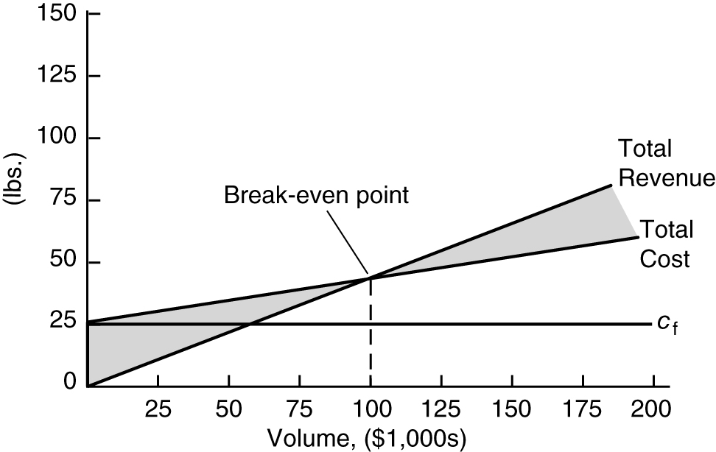
7.
8.
9.
10.
11.
12.
13.
14.
15.
16.
The increase in fixed cost from $25,000 to $35,000 will increase the break-even point from 1,250 to 1,750 or 500 dolls; thus, he should not spend the extra $10,000 for advertising.
17. Original break-even point (from problem 7) = 1,250
New break-even point:
Reduces BE point by 187.5 dolls.
18. a)
b)
c) Revenue for the first 30 days = 30(pv − vc_{v})
= 30[(8.95)(20) − (20)(3.75)]
= $3,120
$27,000 − 3,120 = $23,880, portion of fixed cost not recouped after 30 days.
Total break-even volume = 600 + 5,685.7 = 6,285.7 pizzas
19. a) Cost of Regular plan = $55 + (.33)(260 minutes)
= $140.80
Cost of Executive plan = $100 + (.25)(60 minutes)
= $115
Select Executive plan.
b) 55 + (x − 1,000)(.33) = 100 + (x − 1,200)(.25)
− 275 + .33x = .25x − 200
x = 937.50 minutes per
month or 15.63 hrs.
20. c_{f} = $26,000
c_{v} = $0.67 ($5.36/8 = 0.67)
p = $3.75
= 8,442 slices
Forecasted annual demand = (540)(52) = 28,080
Z = $91,260 – 44,813.6 = 46,446.4
21.
OLD | New
26,000 + (.67)v = 30,000 + (.48)v
.19v = 4,000
v = 21,053 slices
Z = New profit – old profit
Z = $47,781.60 – 46,446.40
= $1,335.20
Purchase equipment
22. a)
p = $0.89 to break even
b) If the team did not perform as well as expected the crowds could be smaller; bad weather could reduce crowds and/or affect what fans eat at the game; the price she charges could affect demand.
c) This will be a subjective answer, but $1.25 seems to be a reasonable price.
Z = vp − c_{f} − vc_{v}
Z = (14,000)(1.25) − 7,500 − (14,000)(0.35)
= 17,500 − 12,400
= $5,100
23. a) c_{f} = $1,700
c_{v} = $12 per pupil
p = $75
= 26.98 or 27 pupils
b) Z = vp − c_{f} − vc_{v}
$5,000 = v(75) − $1,700 − v(12)
63v = 6,700
v = 106.3 pupils
c) Z = vp − c_{f} − vc_{v}
$5,000 = 60p − $1,700 − 60(12)
60p = 7,420
p = $123.67
24. a) c_{f} = $350,000
c_{v} = $12,000
p = $18,000
= 58.33 or 59 students
b) Z = (75)(18,000) − 350,000 − (75)(12,000)
= $100,000
c) Z = (35)(25,000) − 350,000 − (35)(12,000)
= 105,000
This is approximately the same as the profit for 75 students and a lower tuition in part (b).
25. p = $400
c_{f} = $8,000
c_{v} = $75
Z = $60,000
v = 209.23 teams
26. Fixed cost (c_{f}) = 875,000
Variable cost (c_{v}) = $200
Price (p) = (225)(12) = $2,700
v = c_{f}/(p – c_{v}) = 875,000/(2,700 – 200)
= 350
With volume doubled to 700:
Profit (Z) = (2,700)(700) – 875,000 – (700)(200)
= $875,000
27. Fixed cost (c_{f}) = 100,000
Variable cost (c_{v}) = $(.50)(.35) + (.35)(.50) + (.15)(2.30)
= $0.695
Price (p) = $6
Profit (Z) = (6)(45,000) – 100,000 – (45,000)(0.695)
= $138,725
This is not the financial profit goal of $150,000.
The price to achieve the goal of $150,000 is,
p = (Z + c_{f} + vc_{v})/v
= (150,000 + 100,000 + (45,000)(.695))/45,000
= $6.25
The volume to achieve the goal of $150,000 is,
v = (Z + c_{f})/(p − c_{v})
= (150,000 + 100,000)/(6 − .695)
= 47,125
28. a) Monthly fixed cost (c_{f}) = cost of van/60 months
+ labor (driver)/month
= (21,500/60) + (30.42 days/month)($8/hr)
(5 hr/day)
= 358.33 + 1,216.80
= $1,575.13
Variable cost (c_{v}) = $1.35 + 15.00
= $16.35
Price (p) = $34
v = c_{f}/(p − v_{c})
= (1,575.13)/(34 − 16.35)
v = 89.24 orders/month
b) 89.24/30.42 = 2.93 orders/day − Monday through Thursday
Double for weekend = 5.86 orders/day − Friday through Sunday
Orders per month = approximately (18 days)
(2.93 orders) + (12.4 days)(5.86 orders)
= 125.4 delivery orders per month
Profit = total revenue − total cost
= vp – (c_{f} + vc_{v})
= (125.4)(34) − 1,575.13 – (125.4)(16.35)
= 638.18
29. a)
v = 31.25 jobs
b) (8 weeks)(6 days/week)(3 lawns/day) = 144 lawns
Z = (144)(30) − 500 − (144)(14)
Z = $1,804
c) (8 weeks)(6 days/week)(4 lawns/day) = 192 lawns
Z = (192)(25) − 500 − (192)(14)
Z = $1,612
No, she would make less money than (b)
30. a)
v = 21.88 jobs
b) (6 snows)(2 days/snow)(10 jobs/day) = 120 jobs
Z = (120)(35) − 700 − (120)(3)
Z = $3,140
c) (6 snows)(2 days/snow)(4 jobs/day) = 48 jobs
Z = (48)(150) − 1800 − (48)(28)
Z = $4,056
Yes, better than (b)
d) Z = (120)(35) − 700 − (120)(18)
Z = $1,340
Yes, still a profit with one more person
31. c_{f} = $7,500
Monthly c_{f} = ($2,300)(12)
= $27,600
Total c_{f} = $35,100
c_{v} = 0
p = $0.24

v = 12,188 hits per month
$45,000 = v(.24) – (12)(3,500) – (0)v
.24v = 87,000
v = 362,500
v = 30,208 hits per month
32. This is a “multiproduct” break-even problem. The formula for the break-even volume is,
v = 8,089.89 units
cupcakes = (8,089.89)(.70)
= 5,622.92
cookies = (8,089.89)(.30)
= 2,426.97
BE sales $ = (5,662.92)(3.20) + (2,426.97)(2.50)
= $24,188.76
33. This is a decision analysis problem – the subject of Chapter 12. The payoff table is:
 | Weather Conditions
Decision Alternatives | Good | Bad
$3.25 | $12,800 | $8,450
$4.00 | $14,400 | $5,275
The student’s decision depends on the degree of risk they are willing to assume.
Chapter 12 includes decision criteria for this problem.
34. This problem uses expected value for the decision alternatives in problem 30.
Expected value ($3.25) = ($12,800)(0.60) + ($8,450)(0.40) = $11,060

Expected value ($4.00) = ($14,400)(0.60) + ($5,275)(0.40) = $10,750
Although the decision to sell hotdogs for $3.25 results in the greatest expected value, the results are so close, Annie would likely be indifferent.
35. There are two possible answers, or solution points:
x = 25, y = 0 or x = 0, y = 50
Substituting these values in the objective function:
Z = 15(25) + 10(0) = 375
Z = 15(0) + 10(50) = 500
Thus, the solution is x = 0 and y = 50
This is a simple linear programming model, the subject of the next several chapters. The student should recognize that there are only two possible solutions, which are the corner points of the feasible solution space, only one of which is optimal.
36. The solution is computed by solving simultaneous equations,
x = 30, y = 10, Z = $1,400
It is the only, i.e., “optimal” solution because there is only one set of values for x and y that satisfy both constraints simultaneously.

37.
 |  | Labor usage | Clay usage | Profit | Possible
# bowls | # mugs | 12x + 15y < = 60 | 9x+5y < = 30 | 300x + 250y | solution?
0 | 1 | 15 | 5 | 250 | yes
1 | 0 | 12 | 9 | 300 | yes
1 | 1 | 27 | 14 | 550 | yes
0 | 2 | 30 | 10 | 500 | yes
2 | 0 | 24 | 18 | 600 | yes
1 | 2 | 42 | 19 | 800 | yes
2 | 1 | 39 | 23 | 850 | yes
2 | 2 | 54 | 28 | 1100 | yes, best solution
0 | 3 | 45 | 15 | 750 | yes
3 | 0 | 36 | 27 | 900 | yes
1 | 3 | 57 | 24 | 1050 | yes
3 | 1 | 51 | 32 | 1150 | no
2 | 3 | 69 | 33 | 1350 | no
3 | 2 | 66 | 37 | 1400 | no
3 | 3 | 81 | 42 | 1650 | no
4 | 0 | 48 | 36 | 1200 | no
0 | 4 | 60 | 20 | 1000 | yes
1 | 4 | 72 | 29 | 1300 | no
4 | 1 | 63 | 41 | 1450 | no
2 | 4 | 84 | 38 | 1600 | no
4 | 2 | 78 | 46 | 1700 | no

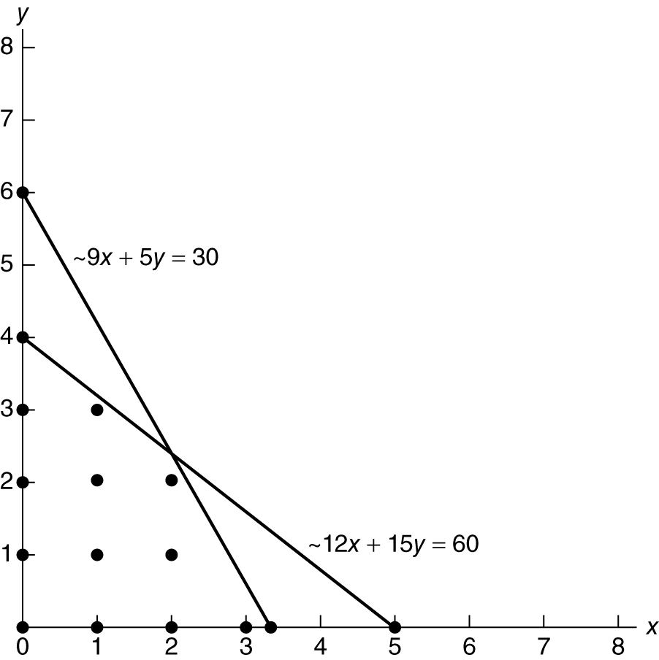
38. Maximize Z = $30x_{AN} + 70x_{AJ} + 40x_{BN} + 60x_{BJ}
subject to
x_{AN} + x_{AJ} = 400
x_{BN} + x_{BJ} = 400
x_{AN} + x_{BN} = 500
x_{AJ} + x_{BJ} = 300
The solution is x_{AN} = 400, x_{BN} = 100, x_{BJ} = 300, and
Z = 34,000
This problem can be solved by allocating as much as possible to the lowest cost variable, x_{AN} = 400, then repeating this step until all the demand has been met. This is a similar logic to the minimum cell cost method.
39. This is virtually a straight linear relationship between time and site visits; thus, a simple linear graph would result in a forecast of approximately 34,500 site visits.
40. Determine logical solutions:
 | Cakes | Bread | Total Sales
1. | 0 | 2 | $12
2. | 1 | 2 | $22
3. | 3 | 1 | $36
4. | 4 | 0 | $40
Each solution must be checked to see if it violates the constraints for baking time and flour. Some possible solutions can be logically discarded because they are obviously inferior. For example, 0 cakes and 1 loaf of bread is clearly inferior to 0 cakes and 2 loaves of bread. 0 cakes and 3 loaves of bread is not possible because there is not enough flour for 3 loaves of bread.
Using this logic, there are four possible solutions as shown. The best one, 4 cakes and 0 loaves of bread, results in the highest total sales of $40.
41. This problem demonstrates the cost trade-off inherent in queuing analysis, the topic of Chapter 13. In this problem the cost of service, i.e., the cost of staffing registers, is added to the cost of customers waiting, i.e., the cost of lost sales and ill will, as shown in the following table.

Registers staffed | 1 | 2 | 3 | 4 | 5 | 6 | 7 | 8
Waiting time (mins) | 20 | 14 | 9 | 4 | 1.7 | 1 | 0.5 | 0.1
Cost of service ($) | 60 | 120 | 180 | 240 | 300 | 360 | 420 | 480
Cost of waiting ($) | 850 | 550 | 300 | 50 | 0 | 0 | 0 | 0
Total cost ($) | 910 | 670 | 480 | 290 | 300 | 360 | 420 | 480
The total minimum cost of $290 occurs with 4 registers staffed

42. The shortest route problem is one of the topics of Chapter 7. At this point, the most logical “trial and error” way that most students will probably approach this problem is to identify all the feasible routes and compute the total distance for each, as follows:
1-2-6-9 = 228
1-2-5-9 = 213
1-3-5-9 = 211
1-3-8-9 = 276
1-4-7-8-9 = 275
Obviously inferior routes like 1-3-4-7-8-9 and
1-2-5-8-9 that include additional segments to the routes listed above can be logically eliminated
from consideration. As a result, the route 1-3-5-9 is the shortest.
An additional aspect to this problem could be to have the students look at these routes on a real map and indicate which they think might “practically” be the best route. In this case,
1-2-5-9 would likely be a better route, because even though it’s two miles farther it is Interstate highway the whole way, whereas 1-3-5-9 encompasses U.S. 4-lane highways and state roads.
CASE SOLUTION: CLEAN CLOTHES CORNER LAUNDRY
a)
b) Solution depends on number of months; 36 used here. $16,200 ÷ 36 = $450 per month, thus monthly fixed cost is $2,150
529.4 additional items per month
c) Z = vp − c_{f} − vc_{v}
= 4,300(1.10) − 2,150 − 4,300(.25)
= $1,505 per month
After 3 years, Z = $1,955 per month
d)

e) With both options:
Z = vp − c_{f} − vc_{v}
= 4,700(.99) − 2,150 − 4,700(.25)
= $1,328
She should purchase the new equipment but not decrease prices.
CASE SOLUTION: OCOBEE RIVER RAFTING COMPANY
If demand is less than 375 rafts, the students should not start the business.
If demand is less than 833 rafts, alternative 2 should not be selected, and alternative 1 should be used if demand is expected to be between 375 and 833.33 rafts.
If demand is greater than 833.33 rafts, which alternative is best? To determine the answer, equate the two cost functions.
3,000 + 12v = 10,000 + 8v
4v = 7,000
v = 1,750
This is referred to as the point of indifference between
the two alternatives. In general, for demand lower than this point (1,750) the alternative should be selected with the lowest fixed cost; for demand greater than this
point the alternative with the lowest variable cost should be selected. (This general relationship can be observed by graphing the two cost equations and seeing where they intersect.)
Thus, for the Ocobee River Rafting Company, the following guidelines should be used:
demand < 375, do not start business; 375 < demand
< 1,750, select alternative 1; demand > 1,750, select alternative 2
Since Penny estimates demand will be approximately 1,000 rafts, alternative 1 should be selected.
Z = v_{p} − c_{f} − vc_{v}
= (1,000)(20) − 3,000 − (1,000)(12)
Z = $5,000
CASE SOLUTION: CONSTRUCTING
A DOWNTOWN PARKING LOT
IN DRAPER
a) The annual capital recovery payment for a capital expenditure of $4.5 million over 30 years at
8% is,
(4,500,000)[0.08(1 + .08)³⁰] / (1 + .08)³⁰ − 1
= $399,723.45
This is part of the annual fixed cost. The other part of the fixed cost is the employee annual salaries of $140,000. Thus, total fixed costs are,
$399,723.45 + 140,000 = $539,723.45
b) If 365 days per year are used, then the daily
usage is,
This seems like a reachable goal given the size of the town and the student population.
CASE SOLUTION: A BUS SERVICE
FOR DRAPER
Fixed cost (3 buses) = 1,200,000
Total Variable Cost = 591,300
Annual Revenue = 648,240

Passengers/bus/trip = 37
Passenger fare = 4
Trips/bus/day = 4
Number of buses = 3
Days/year = 365
Total annual revenue = 648,240 = (37)(4)(4)(3)(365)

Bus operating hrs/day = 18
Operating cost/hr = 90
Days/year = 365
Total annual variable cost = 591,300 = (18)(90)(365)

- First year loss = (1,143,060.00)
- Years to break even:
Loss in year 1 = –1,143,060.0
Not possible to break even
- 45 passengers per trip:
Annual Revenue = 788,400
First year loss = (1,002,900)
Not possible to break even
50 passengers per trip:
Annual revenue = 876,000
First year loss = (915,300)
Break even year: (3.215) years
- Decrease in trips:
Annual revenue = 657,000
Total variable cost = 443,475
First year loss = (986,475)
Break even year: (5.62) years
Bus operating hrs/day = 13.5
Operating cost/hr. = 90
Days/year = 365
Total annual variable cost = 443,475
- $1,200,000 Grant:
Fixed Cost = 0
First Year Revenue = 56,940

