Solutions to Chapter 3 Exercises
SOLVED EXERCISES
S1. (a) There is one initial node (I) for Hansel making the first move; three decision nodes (D) including the initial node, which represent the points where either Hansel or Gretel make a decision; and six terminal nodes (T):

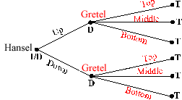

(b) There is one initial node (I) for Hansel making the first move; four decision nodes (D) including the initial node, which represent the nodes where Hansel or Gretel make a decision; and nine terminal nodes (T):
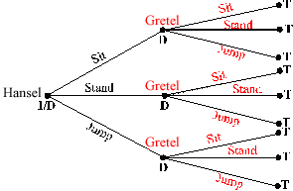

(c) There is one initial node (I) for Hansel making the first move; five decision nodes (D) including the initial node, which represent the nodes where Hansel or Gretel make a decision; and eight terminal nodes (T):
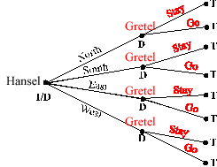

S2. For this question, remember that actions with the same label, if taken at different nodes, are different components of a strategy. To clarify the answers, the nodes on the trees are labeled 1, 2, and so forth (in addition to showing the name of the player acting there). Actions in a strategy are designated as N1 (meaning N at node 1), and so forth. The trees are below in the solutions to Exercise S3. Numbering of nodes begins at the far left and proceeds to the right, with nodes equidistant to the right of the initial node and numbered from top to bottom.
(a) Scarecrow has two strategies: (1) N or (2) S. Tinman has two strategies: (1) t if Scarecrow plays N, or (2) b if Scarecrow plays N.
(b) Scarecrow has two actions at three different nodes, so Scarecrow has eight strategies: 2 • 2 • 2 = 8. To describe the strategies accurately, we must specify a player’s action at each decision node. Scarecrow decides at nodes 1, 3, and 5, so we will label a strategy by listing the action and the node number. For example, to describe Scarecrow choosing N at each node, we write (N1, N3, N5). Accordingly, the eight strategies for Scarecrow are (N1, N3, N5), (N1, N3, S5), (N1, S3, N5), (S1, N3, N5), (N1, S3, S5), (S1, N3, S5), (S1, S3, N5), and (S1, S3, S5).
Tinman has two actions at three different nodes, so Tinman also has eight strategies: 2 • 2 • 2 = 8. Tinman’s strategies are (n2, n4, n6), (n2, n4, s6), (n2, s4, n6), (s2, n4, n6), (n2, s4, s6), (s2, n4, s6), (s2, s4, n6), and (s2, s4, s6).
(c) Scarecrow has two actions at three decision nodes, so Scarecrow has eight strategies: 2 • 2 • 2 = 8. Scarecrow’s strategies are (N1, N4, N5), (N1, N4, S5), (N1, S4, N5), (S1, N4, N5), (N1, S4, S5), (S1, N4, S5), (S1, S4, N5), and (S1, S4, S5). Tinman has two strategies: (t2) and (b2). Lion has two strategies: (u2) and (d2).

S3. (a) Beginning with Tinman, we see that Tinman prefers a payoff of 2 over 1, so Tinman chooses t. With Tinman choosing t, Scarecrow receives a payoff of 0 for N and 1 for S, so Scarecrow chooses S. Thus, the rollback equilibrium is Scarecrow’s choosing S and Tinman’s choosing t (even though he won’t have a chance to play it). Tinman’s action does not affect the rollback equilibrium, because Scarecrow expects Tinman to choose t, so Scarecrow best responds by choosing S:
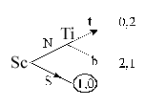
(b) The graph below indicates which action Scarecrow and Tinman choose at each node. Scarecrow’s equilibrium strategy is S1, S3, N5, and Tinman’s is n2, n4, s6, yielding the equilibrium payoff (4, 5):
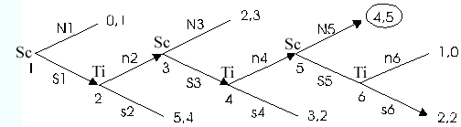

(c) The graph below indicates which action Scarecrow, Tinman, and Lion choose at each node. Scarecrow’s equilibrium strategy is N1, N4, N5; Tinman’s is b; and Lion’s is d, yielding the payoff (2, 3, 2):
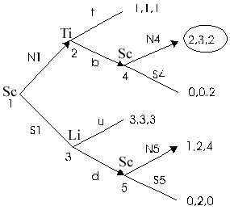

S4. The game tree is shown below:

Boeing prefers $300 million to losing $100 million, so Boeing will peacefully accommodate Airbus’s entry into the market. Airbus expects Boeing to accommodate its entry peacefully, so it can make $300 million by entering, or nothing by not entering, so Airbus will enter the market. Thus, the rollback equilibrium is Airbus’s entering the market and Boeing’s peacefully accommodating, with a payoff to each firm of $300 million in profit.

S5. (a) For Barney to win the game, he must remove the last matchstick, which means that if he leaves Fred 1 to 4 matches, Fred can remove all of them and Barney would lose, so Barney must leave more than 4 matchsticks. Because there are 6 matchsticks and Barney must take at least 1, Barney should remove only 1 matchstick, which will leave Fred with 5 matchsticks. No matter what Fred does, Barney, on his next turn, will be able to remove all the remaining matchsticks to win the game. More precisely, Barney should take 1 matchstick on his first turn. If Fred takes f matchsticks, Barney should take (5 – f) matchsticks.
(b) From part (a), we know that whomever is left with 5 matchsticks will lose the game, so Barney should remove enough matchsticks to leave Fred only 5. If Barney leaves Fred 6 to 9 matches, then Fred will leave Barney with 5, and Barney will lose, so Barney must leave Fred with more than 9 matches. Also, if Barney leaves 11 matches, Fred can ensure he is left with 6 to 9 matches by choosing only 1 match, leaving Barney with 10 matches and no way to keep Fred from having 6 to 9 matches. Thus, Barney must take 2 matches, leaving Fred with 10, and must choose (5 – f) matches on each subsequent turn.
Another way to view this problem is that a player will lose if his turn begins with 5 matches. Thus, each player always wants to remove matchsticks to leave his opponent with 5. Since we know what happens when 5 matchsticks remain, we can divide the number of remaining matchsticks into units of 5. For example, 12 matchsticks can be divided into two units of 5 with 2 extra. Barney wants to force Fred to have some multiple of 5, so Barney removes 2 matches at first, and then (5 – f) matches in each of his subsequent turns.
(c) The full game has 21 matchsticks, and Fred begins. As described in part (b), Fred wants to leave Barney with some multiple of 5, and 21 is 4 units of 5 with 1 extra. So Fred should remove 1 matchstick on his first turn, and then (5 – b) matchsticks on his subsequent turns, where b is the number of sticks that Barney has just removed. With optimal play, Fred will win every time.
(d) Each player wants to leave the other player a multiple of 5 matchsticks. So on each turn, the player should divide the remaining matchsticks by 5 and remove the remainder. If the remainder is 0 and more than 4 matchsticks remain, then the player is stuck with a multiple of 5. That player should randomly choose 1 to 4 matchsticks, hoping that the opponent will make a mistake on a subsequent turn. If 4 or fewer matchsticks remain, then the player should remove all of them to win the game.

S6. (a) The game tree is shown below:
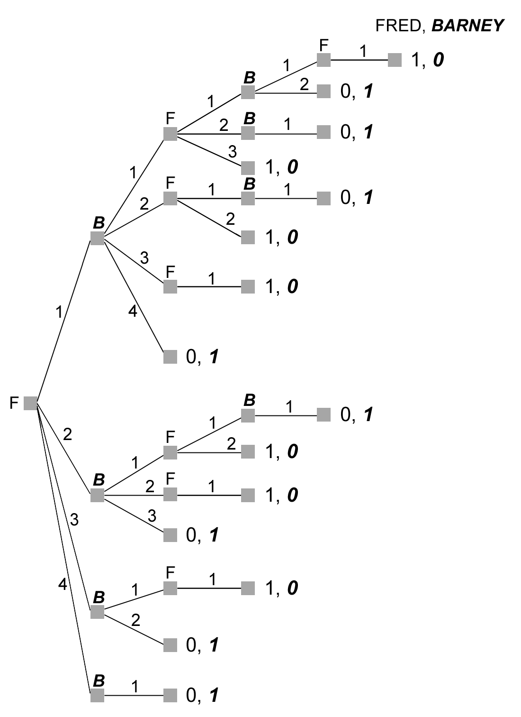
(b) The graph in part (a) indicates the four rollback equilibria, which can be described as Fred’s taking 1 to 4 matchsticks, and then Barney’s removing all remaining matchsticks. Letting the first number represent the number of matchsticks removed by Fred and the second by Barney, the four rollback equilibria may be described as (1, 4), (2, 3), (3, 2), and (4, 1).
(c) With 5 matchsticks at the beginning of the game, there is a second-mover advantage, because no matter what quantity the first mover removes, the second mover can remove all remaining matchsticks to win the game.
(d) There is more than one rollback equilibrium because, so long as Barney plays optimally, any of Fred’s four actions at the initial node leads to the same payoff. Thus, in equilibrium, he is indifferent among those four actions at that node.

S7. (a) Elroy will win if the running total is at least 91 on his turn, because he can bring the total to exactly 100 from any number between 91 and 99. However, if the running total is 90, then Elroy cannot win because he cannot get the total to 100 and after his turn the total will be at least 91. So, any player faced with a total of 90 on his turn will lose the game. This also means that Elroy will win if the running total is at least 81 (and no higher than 89) on his turn, because he can bring the total to 90 and force Judy to put the total at 91 or higher. Continue this process all the way back to the start of the game. Elroy will win if the running total is at least 1 (and no higher than 9) on his turn. This is guaranteed to happen if he goes second so the game has a second-mover advantage. The second player can take the running total to a multiple of 10 on each turn and is guaranteed to be able to win.
(b) The player who goes first cannot win, so all choices between 1 and 9 are equally good (or bad). From the second move onward, the best strategy is to choose a number that takes the current total to a multiple of 10. If that is impossible, choose any number as all are equally good (or bad).

S8. (a) The game tree is shown below:
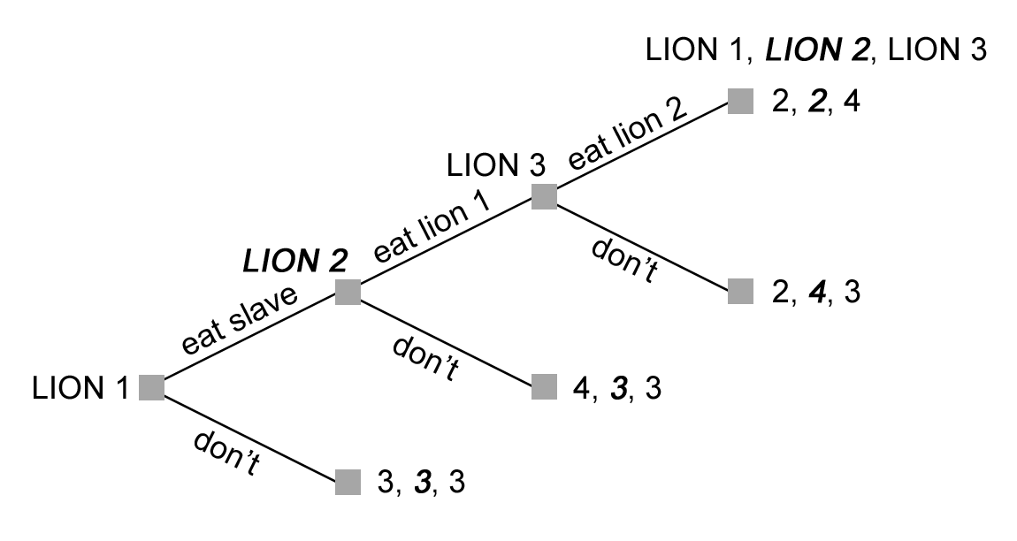
(b) The rollback equilibrium is Lion 1 eats the slave, Lion 2 does not eat Lion 1, and Lion 3 would eat Lion 2 if given the opportunity (but he is not given that opportunity in equilibrium play).
(c) There is a first-mover advantage because Lion 3 will always eat Lion 2 if able, so Lion 2 has an incentive not to eat Lion 1 in order to protect himself from Lion 3.
(d) Each lion has 2 actions at a single node (eat, don’t eat), so each has 2 complete strategies.

S9. (a) The game tree is shown below:
(b) Rollback pruning is illustrated by arrows on branches of the tree. The equilibrium entails Frieda’s choosing Rural; Big Giant’s always choosing Urban (UU, or U if U and U if R); and Titan’s choosing Urban unless both Frieda’s and Big Giant have chosen Rural (UUUR). The equilibrium payoffs are (2, 5, 5) to the stores in order of their moves.

S10. (a) The game tree is shown below:
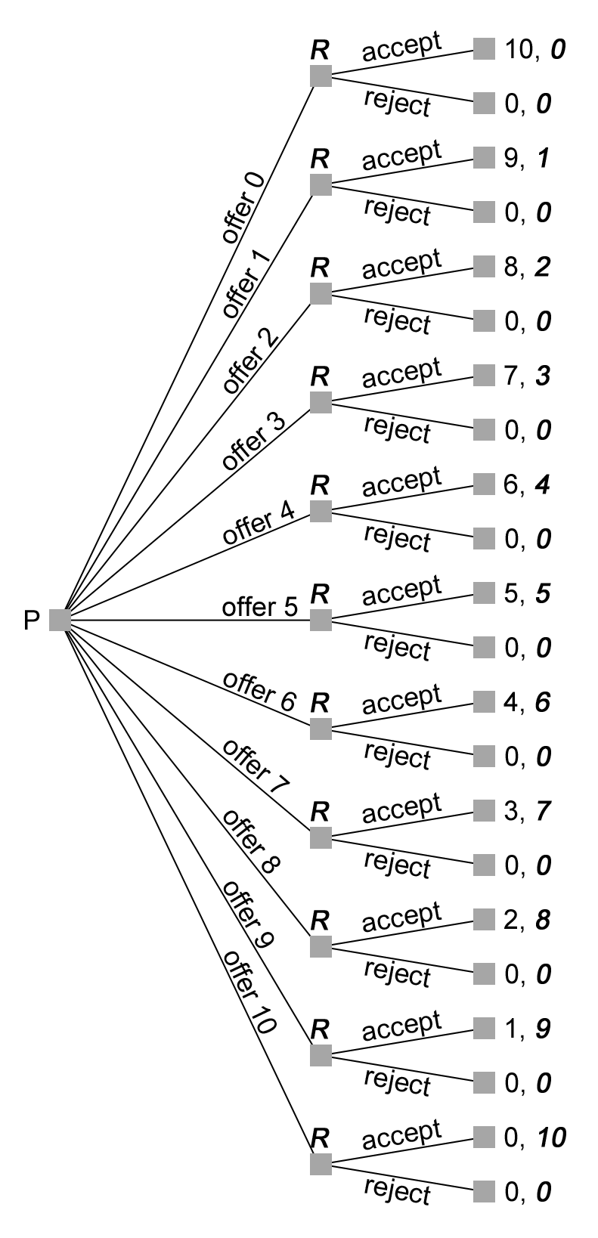
(b) The Proposer has one node with 11 actions; thus the Proposer has 11 complete strategies. We can list these as the split proposed, with the first number indicating the portion for the Proposer and the second for the Responder. The 11 complete strategies are 0/10, 1/9, 2/8, 3/7, 4/6, 5/5, 6/4, 7/3, 8/2, 9/1, and 10/0.
The Responder has 11 nodes with actions accept or reject at each node; thus the Responder has 2¹¹, or 2,048 complete strategies. Some examples of possible strategies include accepting only 5/5, accepting only 10, accepting only odd numbers, and rejecting all offers.
(c) Assuming that the players care only about their cash payoffs means that the Responder will definitely accept any positive offer and will be indifferent between accepting and rejecting when offered nothing. If the Proposer assumes that the Responder will accept an offer of $0 when indifferent, then the rollback equilibrium is to offer $0 and for it to be accepted. However, although the Proposer may be unsure of the Responder’s action in the face of indifference, he can expect the Responder to accept an offer of $1. If there is uncertainty about the Responder’s action when she’s indifferent, the rollback equilibrium occurs where the Proposer offers $1 and that offer is accepted.
(d) Because Pete knows Rachel will accept any offer of $3 or more, Pete can maximize his payoff by offering only $3.
(e) There are many possible utilities that may represent Rachel’s utility. One common utility is fairness, in which Rachel receives a utility equal to the dollar amount if the offer is within 40% to 60% of the total amount and a utility of zero otherwise. This is because if the offer is below 40%, she feels that the Proposer is being unfair, and she will punish him. If the offer is above 60%, she feels guilty for accepting. In this game, this means that Rachel will accept an offer between and including $4 to $6 and will reject all other offers.
(f) One possible explanation is that the average Responder values not only the money, but also the fairness of the offer. So if the offer is too low—that is, unequal in its split—then the Responder emphasizes the unfairness over the value of the money and rejects the offer.

