Kimberly-Clark Corporation (KMB)
Solution to Continuing Case, Chapter 1

Welcome to the solutions to Kimberly-Clark Continuing Case.

Your task in this first chapter is one of familiarizing yourself with the Kimberly-Clark, its products, and its business model. You are also introduced to the summary measures that analysts refer to when evaluating a company. As this is an exercise in discovery, we leave it to you to go to the sources mentioned in the Case and educated yourself about the firm. Remember, one does not buy a stock, one buys a business and when you buy a business you should know the business. So you will find your understanding of KMB’s business here to be important to you as you analyze the firms and value its shares in later chapters.

Here is a guide to answering the questions posed in the case.

Note: Web sites change, so links here and elsewhere may not be correct at the time you go to them. But you will find your way via Google or a similar search engine.

- To understand KMB’s core business, go first to the business statement in the 2010 10-K, the firm’s web site, and make a Google or Yahoo search. Also go to finance web portals such as Yahoo! Finance.

- Go to the same sources. Also go the investor relations page at

http://www.kimberly-clark.com/investors.aspx

Click of the Fact Sheet to see details of the current global business plan and the strategic objectives of the firm:

COMPANY strategies

• Manage portfolio to balance growth, profitability and
cash flow
• Invest in brands, innovation and growth initiatives
• Deliver sustainable cost reduction
• Disciplined capital management to improve ROIC and
return cash to shareholders

- Go to the same sources, particularly the business statement in the 10-K. See the goal set in the Global Business Plan on the Fact Sheet on the investor web page above. Kimberly-Clark has a fairly stable business model and its strategy is doing much of the same, but doing it better. Expanding into global markets is a focus. Brand building and maintenance through advertising and promotion is important, along with innovative R&D to enhance the product line. Reducing production and distribution costs is also important.
- Competition is fierce. Proctor & Gamble (PG) and Energizer Holdings (ENR) are considered the main competitors, but there are many firms in the Household Products sector. You’ll find descriptions of these firms in the solution to Chapter 3 of the Continuing Case.
- The main risk comes from price competition and product innovation by competing firms that would crowd out KMB’s products. Loosing a big customer, like Wal-Mart, would also be serious. Product liability is always a concern, along with bad reputation that might develop if quality control fails. And then there is accounting risk that can hit a company badly. See the Risk Factors section in the 10-K.

- Here is the price chart for KMB for the five years up to May 2012 (from Yahoo! Finance):

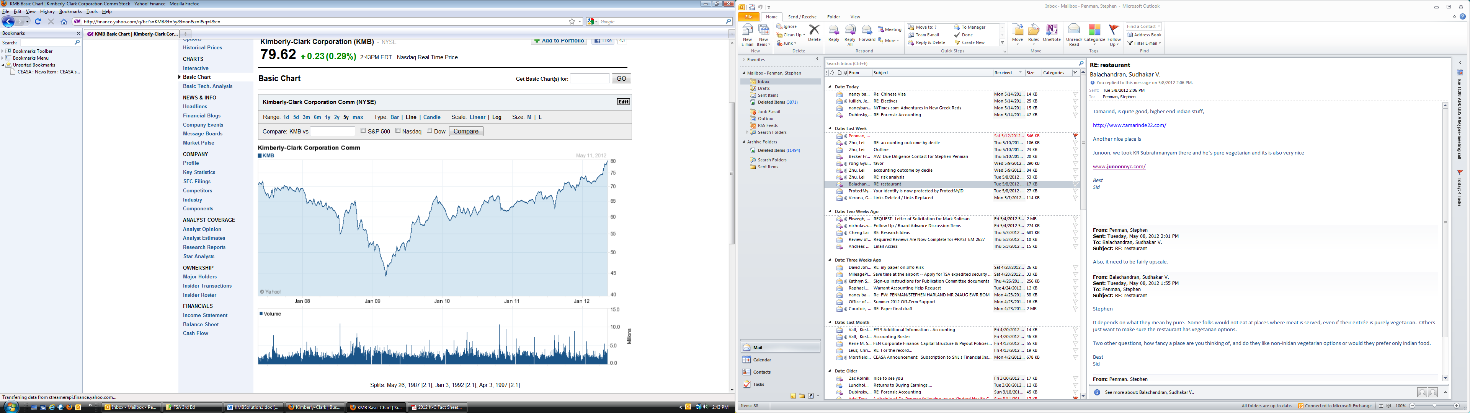

Over 2010, KMB’s stock price increased from $62.71 to $63.04. The firm paid a dividend of $2.64 per share, so the return for 2010 was:

Stock Rate of Return = $\frac{\$\text{63}\text{.}\text{04}−\$\text{62}\text{.}\text{71}+\$2\text{.}\text{64}}{\$\text{62}\text{.}\text{71}}$= 4.74%

- The features that are most important to us (and which we will be referring to later) are:

  - The current price of $65.24
  - The P/E ratio (14.67 on a trailing 12 months of earnings)
  - Market capitalization of $26.38 billion
  - Indicated dividend for 2011 of $2.80 (this is a yield of 4.30% on the current stock price. (An indicated dividend is the forecast of the dividend for the coming year.)
  - The mean analysts’ buy/hold/sell recommendation on a scale of 1 to 5 (KMB had a mean recommendation of 2.6, effectively a “hold”)
  - The mean price target for one year ahead of $68.79. This says that analysts
are expecting the price to be $68.79 twelve months from now. With an
indicated dividend of 2.80, this implies a rate of return for the next year of
9.73%.
  - Earnings estimates. These come in two slices:
(1) point eps forecasts for the forward year (2011: $4.98) and the
following year (2012: $5.35)
(2) an estimate of the eps growth rate (9.10%) for the next five years. The average estimate over all analysts is sometimes referred to as the
consensus estimate. The variation among analysts (High vs Low) gives
some idea of the uncertainty about future earnings.
  - Revenue forecasts for 2011 and 2012. The 2012 number is a 3.32% increase over the forecasted 2011 number.
  - The forward P/E ratio which is price/eps estimate for 2011
= $65.24/$4.98
= 13.10
  - PEG ratio. This is the forward P/E ratio of 13.10 dividend by the forecast of eps percentage growth rate for the next five years of 9.1%: For KMB,

Forward P/E = Price/Eps estimate for 2005 = $64.81/$3.81 = 17.0

PEG = 13.10/9.1 = 1.44

We will explain what the PEG ratio means in Chapter 6, but roughly it indicates how the market is pricing growth relative to growth expectations: If the P/E is high but the growth forecast is low, you get a high PEG ratio that indicates that the market is overpricing growth. But it is more subtle than that, as we will see in Chapter 6.

- With an average recommendation of 2.6 (on a scale of 1 to 5), analysts see KMB as reasonable priced: 2.6 is a “hold” recommendation. A forward P/E of 13.10 is a little below the average P/E for stocks in history (about 14).
- Mr. Buthman is comparing the cost of borrowing with the dividend yield, and thinks that if he borrows at less than 4.30% and buys stock that is yielding 4.30%, he is making money on the trade. But he is wrong. The dividend yield has nothing to do with the expected return on the stock (it’s just the dividend component of the return). He could make borrowing look cheaper by increasing the dividend, but that is absurd. But, in any case, the issue is whether this transaction adds value for shareholders. (As we will see later in Chapter 3), share repurchases cannot add value for shareholders in the shares a bought as fair market value. He is seeing the situation purely as a matter of cash savings: he saves on paying the dividend and pays out less cash on the borrowing to do so. This is not thinking about value for shareholders.

- In mid-May 2012, the price stood at $79.60, quite a bit higher than in March 2011. Check for the current price at the point you are reading this.

Earnings per share for 2011 was $4.02 (in the 2011 10-K), so the analysts’ consensus forecast of $4.98 turned out to be over-optimistic. Note that sell-side analysts have a tendency to be optimistic in their forecasting. Their five-year growth forecasts are particularly suspect.

