CHAPTER 1 | Economics:
Foundations and Models

Thinking Critically
- Students will not have covered concepts such as demand and supply or the labour market, but they should be able to intuitively think about the concepts introduced in this chapter to explore this question. Students should be able to apply the concept of opportunity cost and the production possibility frontier model to this problem. In particular, students should think about the assumptions that underpin the production possibility frontier model, i.e. a fixed point in time, a fixed quantity and quality of factors of production and a fixed state of technology. Offshoring will lead to an increase in the demand for scarce factors of production. So, the availability of scarce factors of production will act as a constraint to the number of high-skilled jobs that can be transferred from developed to developing countries.

- Offshoring can increase inequalities in both developed and developing countries. In developed countries offshoring can lead to structural unemployment and the loss of middle income, middle class jobs. People who lose their jobs in developed countries either never work again or take lower paid less skilled jobs. So, income inequalities increase due to an increase in the number of low-paid jobs. In developing countries offshoring creates a relatively small number of high-paid jobs. The creation of a high-income elite further increases income inequalities.

1.1 | Three Key Economic Ideas  Learning Objective: Explain these three important economic ideas: people are rational; people respond to incentives; optimal decisions are made at the margin.
Review Questions
1.1. Briefly discuss each of the following economic ideas: people are rational; people respond to incentives; optimal decisions are made at the margin.
‘People are rational’ is the assumption that decision makers explicitly or implicitly weigh the benefits and costs of each action and then choose an action only if the benefits are expected to outweigh the costs. ‘People respond to incentives’ means that consumers and firms consistently respond to economic incentives. ‘Optimal decisions are made at the margin’ means that most decisions are not ‘all or nothing’ but involve doing a little more or a little less of an activity. Therefore, the optimal decision is to continue any activity up to the point where the marginal benefit equals the marginal cost.
1.2. What is scarcity? Why is scarcity central to the study of economics?
Scarcity is the situation in which unlimited wants exceed the limited resources available to fulfil those wants. Economics is the study of the choices consumers, business managers and government officials make to attain their goals. Scarcity is central to economics because scarcity requires people to make choices about how to use their resources to best fulfil their wants.
Problems and Applications
1.3. In interviews with Australian university economics graduates, students spoke of how the study of economics provided a solid grounding that was helpful in their subsequent careers, which included working in government departments, private banks, other financial institutions and large private companies such as Shell. The students commented that studying economics enabled them to:
- Think logically and critically.
- Develop a way of problem solving that they could apply to most decision making.
- Consider alternative policy solutions and their consequences.
Why might studying economics be particularly good preparation for being a top manager of a corporation, running your own business, working in international public organisations or having a leading role in government?
Economics teaches us how to look at the trade-offs involved in every decision. Those who cannot conceptualise the costs of an action and weigh them against its benefits are unlikely to make good decisions. Top managers, business owners, workers in international public organisations and leaders in government must all be aware of the opportunity cost of all decisions and policies, and the trade-offs involved, to arrive at the best decisions regarding the use of scarce resources.
1.4. Do you agree or disagree with the following assertion: ‘The problem with economics is that it assumes consumers and firms always make the correct decision. But we know everyone’s human, and we all make mistakes.’
Economists assume that people are rational in the sense that their actions are intended to achieve their goals. This does not mean that economists assume everyone is a genius or always makes the ‘right’ decision in every circumstance. It does mean that economists assume that the actions of consumers and businesses reflect their attempts to achieve their goals.
1.5. [Related to Solved problem 1.1] Suppose Dell is currently selling 250 000 Inspiron laptops per month. A manager at Dell argues: ‘The last 10 000 laptops we produced increased our revenue by $8.5 million and our costs by $8.9 million. However, because we are making a substantial total profit of $25 million from producing 250 000 laptops, I think we are producing the optimal number of laptops.’ Briefly explain whether you agree with the manager’s reasoning.
The manager is failing to think at the margin. Dell has lost $400 000 on the last 10 000 laptops, so its profits would have been higher if the company had not produced them.
1.6. [Related to Solved problem 1.1] From 2009 onwards movie studios began to release a number of films in 3D format. To show films in this format cinemas have to purchase 3D equipment that costs around $75 000 for each projector. Usually, cinema owners charge about $4 more for a ticket to a 3D movie than for a movie in the conventional 2D format. If you owned a cinema discuss how you would go about deciding whether to invest in 3D equipment.
If you can charge $4 more per ticket for a 3D movie, then you must sell 18 750 tickets to 3D movies to cover the additional $75 000 equipment cost ($4 x 18 750 tickets = $75 000). If you believe you will be able to sell at least 18 750 tickets for 3D movies, then you will be able to cover your additional equipment costs and the investment will be a good idea. For any tickets sold beyond the first 18 750, the marginal benefit will be greater than the marginal cost and your profits will increase.
1.7. [Related to Solved problem 1.1] Two students are discussing Solved problem 1.1.
Joe: ‘I think the key additional information you need to know in deciding whether to produce one million more iPhones is the amount of profit you are currently making while producing 10 million. Then you can compare the profit earned from selling 11 million iPhones with the profit earned from selling 10 million. This information is more important than the additional revenue and additional cost of the last one million iPhones produced.’
Jill: ‘Actually, Joe, knowing how much profits change when you sell one million more iPhones is exactly the same as knowing the additional revenue and the additional cost.’
Briefly evaluate their arguments.
Jill is correct because profit equals revenue minus cost, so the additional revenue minus the additional cost will equal the additional profit.
1.8. Late in the semester a friend tells you, ‘I was going to drop my psychology unit so that I could concentrate on my other units, but I had already put so much time into the unit that I decided not to drop it.’ What do you think of your friend’s reasoning and what economic concepts are involved in your friend’s reasoning? Would it make a difference to your answer if your friend has to pass the psychology unit at some point to graduate? Briefly explain.
Your friend is failing to think at the margin. It doesn’t matter how much time your friend has already spent studying psychology. What matters is the marginal benefit to be received from studying psychology relative to the marginal cost, where cost is measured as the opportunity cost of lower grades in other subjects. If the course is required, that may raise the marginal benefit.

1.2 | Scarcity, Trade-offs and the Economic Problem that Every Society Must Solve  Learning Objective: Understand the issues of scarcity and trade-offs, and how the market makes decisions on these issues.
Review Questions
2.1. Explain how the concept of opportunity cost arises from the central economic problem of scarce resources and unlimited wants.
Scarcity implies that every society and every individual faces trade-offs because wants are unlimited, but the ability to satisfy those wants is limited. Societies and individuals cannot have everything they want, so they have to make choices of what to have and what not to have.
2.2. What are the three economic questions that every society must answer? Briefly discuss the differences in how centrally planned, market and mixed economies answer these questions.
The three economic questions that every society must answer are: 1) What goods and services will be produced? 2) How will the goods and services be produced? 3) Who will receive the goods and services? In a centrally planned economy, the government makes most of these decisions. In a pure market economy, almost all of these decisions are made by the decentralised interaction of households and firms in markets. In a mixed economy, most economic decisions result from the interaction of buyers and sellers in markets, but government plays a significant role in the allocation of resources.
2.3. What is the difference between productive, allocative and dynamic efficiency?
Productive efficiency occurs when a good or service is produced at the lowest possible cost. Allocative efficiency means that what is produced reflects consumer preferences—every good or service is produced up to the point at which the last unit provides a marginal benefit to consumers equal to the marginal cost of producing it. Dynamic efficiency occurs when new technologies and innovation are adopted over time.
2.4. What is the difference between efficiency and equity? Why do government policy-makers often face a trade-off between efficiency and equity?
Efficiency is concerned with producing the goods and services that people want at the lowest cost. Equity is ‘fairness’, a concept that can differ dramatically from person to person. Government policy-makers often want to make economic outcomes ‘fairer’, but this usually involves redistributing income from one group to another. Redistributing income usually (but not always) hampers efficiency because it reduces incentives to produce and drives up production costs.
Problems and Applications
2.5. Does Bill Gates, one of the richest people in the world, face scarcity? Does everyone? Are there any exceptions?
Yes, even Bill Gates faces scarcity because his wants exceed his resources. Gates has established a foundation with billions of dollars to spend on worthy causes like eradicating malaria and reducing homelessness. However, there are an unlimited number of worthy causes that Gates desires to fund, so even he faces scarcity. Secondly, even Gates has only 24 hours in a day, so he must make choices about how to spend his scarce time. Everyone faces scarcity, because human desires are virtually unlimited. Because the world’s resources are limited, the only way to not face scarcity would be to reduce your wants to be less than your resources.
2.6. In a market economy, why does a firm have a strong incentive to be productively, allocatively and dynamically efficient? What does the firm earn if it is efficient, and what happens if it is not?
The incentive for a firm in a market economy to be allocatively efficient—producing goods and services that consumers demand—and productively efficient—producing those goods and services at the lowest cost—is profit. If a firm is not allocatively efficient and productively efficient, then it will eventually suffer losses and go out of business. The profit motive and need to compete also means firms must be dynamically efficient to survive, constantly looking for new ways of doing things, reducing costs by improving production techniques and developing new products and services.
2.7. Would you expect new and better machinery and equipment to be adopted more rapidly in a market economy or in a centrally planned economy? Briefly explain.
Managers in a market system generally have an economic incentive to adopt better machinery and equipment whenever the benefits to their firms exceed the costs. Managers in centrally planned economies are rarely as directly rewarded for such decisions, and they are rarely given the authority to carefully weigh costs versus benefits in making decisions.
2.8. Centrally planned economies have been less efficient than market economies.
a. Has this happened by chance or is there some underlying reason?
b. If market economies are more economically efficient than centrally planned economies, would there ever be a reason to prefer having a centrally planned economy rather than a market economy?
a. It is doubtful that centrally planned economies have been less efficient purely by chance. The underlying reason seems to be that centrally planned economies don’t provide as strong incentives for hard work and innovation as market economies do. In addition, the people running centrally planned economies cannot make the most efficient decisions because they don’t have the information that is in the minds of all the decentralised decision makers in a market economy.
b. You might still prefer having a centrally planned economy if you considered it to be more equitable. (Also, you might prefer a centrally planned economy if you were in charge.)
2.9. When it comes to health care we usually want everything medical technology can offer. Why then do governments limit services such as health care and, furthermore, why don’t governments make health care free for everyone?
If all of an economic system’s resources were devoted to health care provision, then there would be other important goods and services, such as food, housing, clothing and education that would not be provided. An economic system that provided its citizens state-of-the-art health care but so little food that most were on the verge of starvation, and no housing so that many were sleeping in streets and fields, and no schooling so most were illiterate, would generally be regarded as inefficient and treating the population unfairly be depriving them of such important goods and services. A market economy restricts access to health care, just as it restricts access to all goods and services, by charging a price at which less than an unlimited quantity of health care is demanded.
2.10. Assume that the state and territory governments throughout Australia increase the price of water in an attempt to reduce consumption for domestic use. What are the equity considerations with this policy?
As water is a necessity, domestic consumption cannot be avoided so all people would pay the higher price. This would affect lower income earners more than higher income earners. Lower income earners would have to forego other goods and services to be able to afford the water, and they may also reduce their consumption of water where possible. Higher income earners may be able to afford to pay the higher water price, not have to forego other goods and services to the same extent, and not reduce consumption. Therefore the policy may be inequitable.
2.11. Suppose that your local police recover 100 tickets to a big football match in a drug raid. It decides to distribute these to residents and announces that tickets will be given away at 10 a.m. on Monday at the Town Hall.
a. What groups of people will be most likely to try to get the tickets? Think of specific examples and then generalise.
b. What is the opportunity cost of distributing the tickets this way?
c. Productive efficiency occurs when a good or service (such as the distribution of tickets) is produced at the lowest possible cost. Is this an efficient way to distribute the tickets? If possible, think of a more efficient method of distributing the tickets.
d. Is this an equitable way to distribute the tickets? Explain.
a. The groups that are most likely to get the tickets will be those for whom the expected marginal benefit of going to the Town Hall on Monday morning is greater than the expected marginal costs. These might include people who have a very low opportunity cost of travelling to the Town Hall and standing in line, such as people who don’t have a job in the morning and those who live or work very close by. These might also include people who see a large benefit from going to get the tickets, such as die-hard football fans or professional ticket scalpers.
b. The major opportunity cost of distributing the tickets this way is the cost to the people who attempt to get the tickets—the cost of travel to the Town Hall, the activities that cannot be done (such as earning money at work) when one is standing in line, and the costs to all those people who try to get tickets but don’t get there soon enough. (There may also be the cost of people blocking traffic in and around the Town Hall.)
c. This isn’t an efficient way to distribute the tickets, since it wastes time and resources. Perhaps the most efficient way to distribute the tickets is to hand them out unannounced to people walking by—this would take only a few minutes. Alternatively, the police could sell them back to the original ticket vendor and have them redistribute the tickets, or they could be sold on eBay.
d. Equity is hard to define. Some people will see this as equitable, since only the deserving, true fan will put up with the hassle of getting the tickets. Others will disagree, saying that no money was raised for the taxpayers, who deserve to get the benefits of selling the tickets since they fund the police department.

1.3 | Economic Models  Learning Objective: Understand the role of models in economic analysis.
Review Questions
3.1. Why do economists use models? How are economic data used to test models?
Economists use models for the same reason that any other scientist (and indeed anyone else) does—to make a complicated world simple enough that it can be understood and analysed, so that questions about it can be usefully answered. Useful models will generate testable predictions. If these predictions are consistent with economic data, then the model isn’t rejected and can be used to understand the economy. Testing models with data can be very difficult, however, because the economy is always changing, and it is difficult to conduct controlled economic experiments.
3.2. Describe the five steps by which economists arrive at a useful economic model.
In arriving at a useful economic model, these five steps are followed: 1) decide the assumptions to be used; 2) formulate a testable hypothesis; 3) use economic data to test the hypothesis; 4) revise the model if it fails to explain the economic data; and 5) retain the revised model to help answer similar economic questions.
3.3. What is the difference between normative analysis and positive analysis? Is economics concerned mainly with normative analysis or mainly with positive analysis? Briefly explain.
Positive economic analysis concerns what is; that is, it deals with how the economy actually behaves. Normative economic analysis concerns what ought to be. Economics is mainly concerned with positive analysis—conceptualising and measuring the costs and benefits of different courses of action. Decision makers (including voters and government officials) can use the trade-offs and costs and benefits identified by positive economic analysis in normatively deciding what course of action should be taken.
Problems and Applications
3.4. Suppose an economist develops an economic model and finds that ‘it works well in theory, but it fails in practice’. What should the economist do next?
The model should be revised in light of its failure to explain or predict real world events.
3.5. Dr Strangelove’s theory is that the price of mushrooms is determined by the activity of subatomic particles that exist in another universe parallel to ours. When the subatomic particles are emitted in profusion, the price of mushrooms is also high. When subatomic particle emissions are low, the price of mushrooms is also low. How would you go about testing Dr Strangelove’s theory? Discuss whether or not this theory is useful.
The problem with Dr Strangelove’s theory is that it cannot be tested unless we can devise a way to measure the emission of these subatomic particles, which seems to be impossible because they don’t exist in our universe. Because we cannot test the model’s predictions, it is not very useful to us; even though it might be true, we have no way of knowing.
3.6 [Related to the opening case] Some firms have begun offshoring work to the Philippines.
a. Why have firms done this?
b. Is offshoring work to lower paid workers in the Philippines a risk-free proposition for firms?
a. Firms have offshored work primarily to reduce costs.
b. No, as shown after the consumer backlash against companies found to be involved in offshoring work to Bangladesh after the 2013 Rana Plaza factory fire. Risks can also arise around quality control.
3.7. [Related to Don’t let this happen to you] Explain which of the following statements represent positive analysis and which represent normative analysis.
a. A $2 per-packet tax on cigarettes will reduce smoking by teenagers by 12 per cent.
b. The federal government should spend more on cancer research.
c. Rising paper prices will increase textbook prices.
d. The price of coffee at a café is too high.
a. Positive economic statement
b. Normative economic statement
c. Positive economic statement
d. Normative economic statement

3.8. [Related to Making the connection 1.1] The Making the connection explains that the debate over immigration has both positive and normative elements. What economic statistics would be most useful in evaluating the positive elements in this debate? Assuming that these statistics are available or could be gathered, are they likely to resolve the normative issues in this debate?
In terms of positive economics, it would be helpful to know the impact immigration has on domestic wages of skilled, semi-skilled and unskilled labour. It would also be useful to have data on the shortages of skilled labour in the economy, and the impact these labour shortages have on firms’ costs and the constraints on economic growth. As a large number of migrants are international students, data on the effect of the reduction in immigration on university enrolments would be valuable. Further, many temporary visa holders (up to four years) in Australia are on working holidays, and supply casual labour to industries such as horticulture (fruit picking) and some service industries that have difficulty finding sufficient labour, in part due to the location of these industries, the hours of work or the type of work. Data on casual labour shortages in these areas would be useful to the debate on immigration. However, even if these data are available (and much of the data are available), it probably would not address normative issues such as people disagreeing with immigration for political or cultural reasons, or disagreeing with government intervention in the market for philosophical reasons. Further, when normative issues arise, the best positive data and information available may not be sufficient to change long-held views.
3.9. If you want to buy or sell a home, land or investment property you will have to sign a sale contract. The legal work involved in preparing the sale contract, mortgage and other related documents is called conveyancing. Until fairly recently in New South Wales (NSW) this work had to be carried out by a solicitor. The NSW government abolished this restriction and allowed licensed conveyancers, who were not qualified lawyers, to do conveyancing.
a. How might the old system have protected consumers?
b. Why did critics of the old system argue that it protected lawyers more than it did consumers?
c. Briefly discuss whether you think changing the law was a good idea.
a. The old system helped protect consumers by providing high-quality advice from lawyers.
b. This system allowed lawyers in a specialty to limit the number of lawyers in that specialty and increase fees for consumers. By allowing less qualified, but perfectly able, conveyancers to do conveyancing work fees would be reduced.
c. Occupational licensing is a major topic in economics. While the licensing requirements—in this case the control of conveyancing—help ensure high-quality work from lawyers, they also are in the self interest of lawyers because the requirements help maintain lawyers’ salaries. Given this trade-off, whether the system is a good one is a normative question.

1.4 | Microeconomics and Macroeconomics  Learning Objective: Distinguish between microeconomics and macroeconomics.
Review Question
4.1. Briefly discuss the difference between microeconomics and macroeconomics.
Microeconomics is the study of how households and firms make choices, how they interact in specific markets and how the government influences their choices. ‘Micro’ means small, and microeconomics deals with individual decision makers. Macroeconomics is the study of the economy as a whole. ‘Macro’ means large, and macroeconomics deals with economy-wide outcomes, such as the inflation rate, the unemployment rate, and the economic growth rate.
Problems and Applications
4.2. Briefly explain whether each of the following is primarily a microeconomic issue or a macroeconomic issue.
a. The effect of higher cigarette taxes on the quantity of cigarettes sold.
b. The effect of higher income taxes on the total amount of consumer spending.
c. The reasons for the economies of East Asian countries growing faster than the economies of sub-Saharan African countries.
d. The reasons for low rates of profit in the airline industry.
a. and d. are microeconomic questions.
b. and c. are macroeconomic questions.
4.3. Briefly explain whether you agree with the following assertion:
Microeconomics is concerned with things that happen in one particular place, such as the unemployment rate in one city. In contrast, macroeconomics is concerned with things that affect the country as a whole, such as how the rate of teenage smoking in Australia would be affected by an increase in the tax on cigarettes.
You should disagree with the assertion. Microeconomics deals with individual decision makers; because the unemployment rate in any one city would be an issue for the economy of the entire city and not an individual, it is a macroeconomic issue rather than a microeconomic issue. Macroeconomics deals with economy-wide outcomes, so the effect on teen smoking of an increase in the tax on cigarettes is better thought of as a microeconomic issue.

1.A | Appendix: Using Graphs and Formulae  Learning Objective: Review the use of graphs and formulae.
Problems and Applications
1A.1. The following table gives the relationship between the price of pies and the number of pies Bruce buys per week.

QUANTITY  PRICE OF PIES | WEEK
$3.00 6 | 2 July
2.00 7 | 9 July
5.00 4 | 16 July
6.00 3 | 23 July
1.00 8 | 30 July
4.00 5 | 6 August
a. Is the relationship between the price of pies and the number of pies Bruce buys a positive relationship or a negative relationship?
b. Plot the data from the table on a graph similar to the one in Figure 1A.3. Draw a straight line that best fits the points.
c. Calculate the slope of the line.
a. Negative.
b.
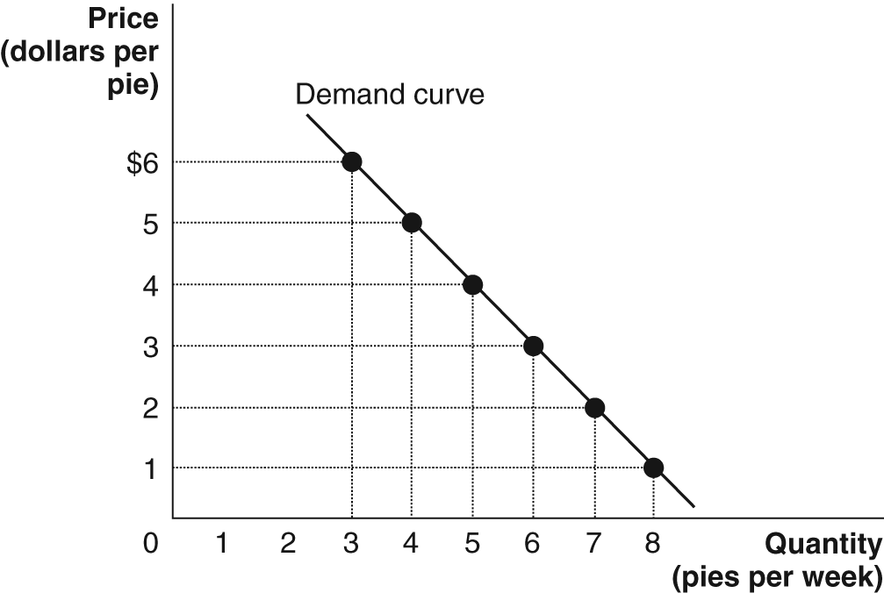
c. The slope = –1.
1A.2. The following table gives information on the quantity of glasses of lemonade demanded on sunny and overcast days. Plot the data from the table on a graph similar to Figure 1A.5. Draw two straight lines representing the two demand curves—one for sunny days, the other for overcast days.

PRICE (DOLLARS PER GLASS) | QUANTITY (GLASSES OF LEMONADE PER DAY) | WEATHER
$0.80 | 30 | Sunny
0.80 | 10 | Overcast
0.70 | 40 | Sunny
0.70 | 20 | Overcast
0.60 | 50 | Sunny
0.60 | 30 | Overcast
0.50 | 60 | Sunny
0.50 | 40 | Overcast
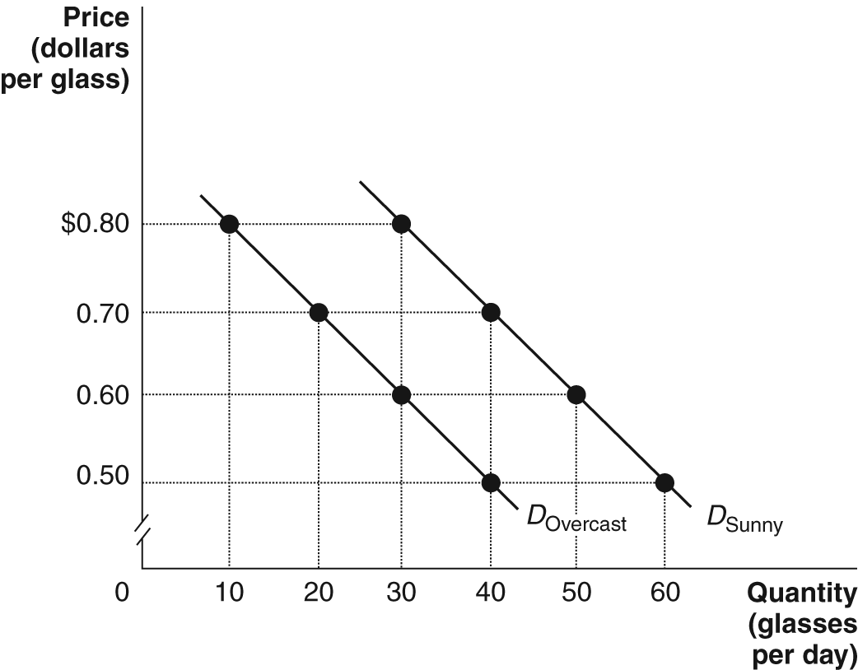
1A.3. Real GDP in Australia in 2002 was $1 073 336 million and in 2012 real GDP was $1 451 110 million. What was the percentage change in real GDP from 2002 to 2012? What do economists call the percentage change in real GDP from one year to the next?
The total percentage change for the decade was 35.20%, while the annual average percentage change was 3.52%. The percentage change in real GDP from one year to the next is the economy’s growth rate.
Percentage change
1A.4. Assume the demand curve for Pepsi passes through the following two points:

PRICE PER BOTTLE OF PEPSI | NUMBER OF BOTTLES OF PEPSI SOLD
$2.50 | 100 000
1.25 | 200 000
a. Draw a graph with a linear demand curve that passes through these two points.
b. Show on the graph the areas representing total revenue at each price. Give the value for total revenue at each price.
a.
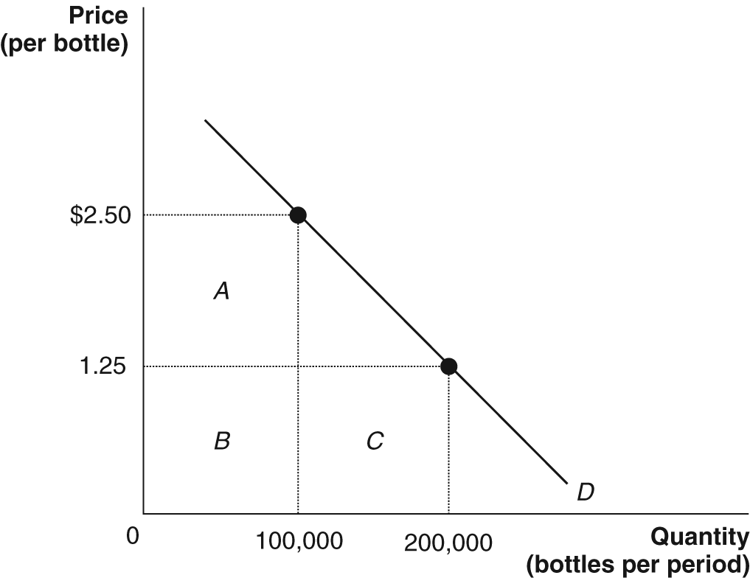
b. At a price of $2.50, the total revenue equals rectangles A + B = $2.50 x 100 000 = $250 000. At a price of $1.25, the total revenue equals rectangles B + C = $1.25 x 200 000 = $250 000.
1A.5 What is the area of the blue triangle shown in the following figure?
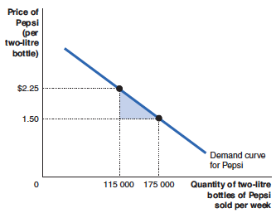
The triangle’s area = 0.5 x 60 000 x $0.75 = $22 500.

1A.7. Calculate the slope of the total cost curve at point A and at point B in the following figure.
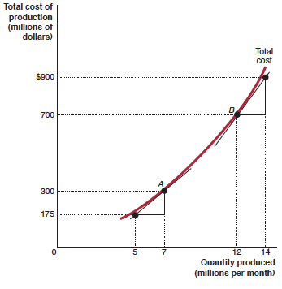
The slope is calculated using the following formula:
At point A:
At point B:

ENDNOTES ? Alumni Profiles, School of Economics, University of Queensland, at <http://www.uq.edu.au/economics/bachelor-of-economicsgraduates>, viewed 5 October 2014.
Australian Bureau of Statistics (2013), Australian National Accounts: National Income, Expenditure and Product, Cat. No. 5206.0, Time Series Workbook, at <www.abs.gov.au>.

