PART 1 OVERVIEW

CHAPTER 1 INTRODUCTION TO CORPORATE FINANCE

Chapter Outline [PowerPoint slide 1–1]

1.1 What is Corporate Finance?
1.2 Corporate Securities as Contingent Claims on Total Firm Value
1.3 The Corporate Firm
1.4 Goals of the Corporate Firm
1.5 Financial Institutions, Financial Markets, and the Corporation
1.6 Trends in Financial Markets and Management
1.7 Outline of the Text
In the first class session you should hand out the course syllabus and describe the content of the course. If you plan to use a financial calculator, your students should acquire and learn to use the calculator as soon as possible.
The topics addressed in this chapter include:
- The forms of business organization.
- The objective of the firm and the financial manager.
- Control of the modern corporation.
- The Financial Markets
- An outline of the course.
Note: If Financial Accounting serves as a prerequisite for your Financial Management course (and your university has a policy of honoring prerequisites), Chapter 2 serves as a review chapter rather than new material. In that situation, you may wish to cover Chapter 2 before Chapters 7 and 8, or skip it entirely.
What is Corporate Finance? [PowerPoint slide 1–2]

PowerPoint slide 1–2 makes a good question on test one; for some reason it really separates the “A” students from everyone else. The balance sheet model of the firm (Figure 1–1) is replicated and animated in PowerPoint slides 1–3, 1–4, 1–5, and 1–6. Going through these slides effectively introduces the course content as the three major questions of corporate finance: the capital structure question, the capital budgeting question, and net working capital investment decision (or if you prefer, short–term financial planning).
Going through the cells in the organizational chart in Figure 1.3 of the text (reprinted an animated in PowerPoint slide 1–8) is a convenient way to give students a brief overview of the course content. It also provides the instructor with an opportunity to describe a number of career paths for finance students.
Cash Flows between the Firm and the Financial Markets [PowerPoint slide 1–10]

The cash flow relationships illustrated in Figure 1.4 of the text (reprinted an animated in PowerPoint slide 1–10) describe the value of real assets and financial assets. It also highlights how value is created and is a good place to introduce the valuation principles.
Debt and Equity as Contingent Claims [PowerPoint slides 1–12 & 1–13]

We use text Figure 1.5 (repeated below) to describe debt and equity claims as contingent claims on the total firm value. The most important concept stems from the following characteristics of equity and debt claims:
- The promised payoff to debtholders is fixed, but depends on firm value in financial exigency.
- Debtholders get paid before stockholders.
- Due to limited liability, stockholders are not required to “guarantee” that debtholders receive their full promised amount, F.
Therefore, payoffs to stockholders are contingent upon the value of the firm (X). If the value of the firm is less than the promised payoff to debtholders (X < F), stockholders receive nothing.
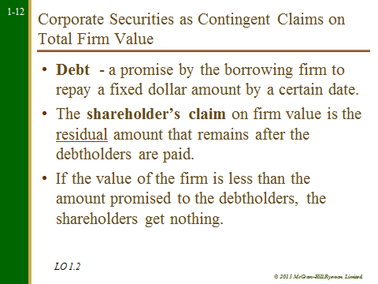

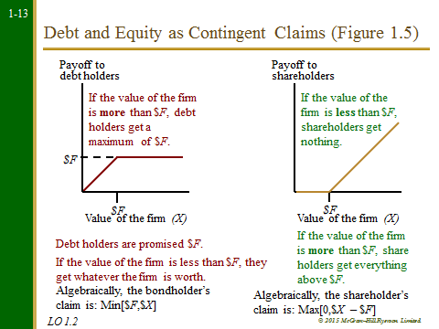
The Form of Business Organization [PowerPoint slide 1–16]

All students have been introduced to the forms of business organization in some pre–requisite course. Here you may wish to focus the discussion on issues concerning liability, control and taxation for the four forms of business organization: sole proprietorships, partnerships, corporation and income trusts.
Sole Proprietorship

Ask students to imagine going into business tutoring one of the prerequisite courses. This may be a good time to smoke out students inappropriately enrolled in your course if they haven’t met the prerequisites.
- Owned by one person
- Inexpensive to form
- Income taxed as personal income
- Unlimited liability for business debts
- Limited life
- Equity limited to owner's personal wealth

Partnership

In a General Partnership, all partners have unlimited liability. In a Limited Partnership, at least one partner is a general partner with unlimited liability. Limited partners generally do not participate in management.
- Inexpensive to form
- Income taxed as personal income
- General partners have unlimited liability
- Limited life
- Management control resides with general partners
- Difficult to transfer ownership
We cover the substantial restrictions on transferability of partnership shares by pointing out that being partners with someone is not unlike being married to them—with the exception that if you want a divorce you have the additional burden of finding a suitable replacement spouse for your former partner. Usually gets a huge laugh.
- Difficult to raise large amounts of capital

Corporation

- Separate legal entity
- Limited owner liability
- Ownership is easily transferred
- Unlimited life
- Taxed at the corporate rate
- Greater access to the financial markets
Income Trusts

- Separate legal entity
- Limited owner liability – although has yet to be tested in the courts. Some provinces are further ahead in this decision than others. This issue has also caused many institutional investors from investing in trusts.
- Ownership is easily transferred
- Limited life – trusts are set up with a limited life.
- All distributions to unitholders are tax deductible so that the trust can have no taxable income. The income flows through to the unitholders and is taxed at the appropriate rates, depending on the nature of the income (business, interest, or capital gains).
- Greater access to the financial markets
- Unitholders expect that all available cash flows will be distributed out.

The Goal of the Corporate Firm [PowerPoint Slide 1–19]

The goal of the corporate firm is the central theme that links all the topics of this course. This is also a good time to get participation from students by asking them to suggest what these goals might be. Some typical responses are:
- Maximize profits
- Minimize costs
- Maximize sales or market share
- Maintain steady earnings growth
- Survive in business
- Social responsibility
- Be the best on some other measure (quality of product, whatever)

Usually the students’ consensus is that from a business perspective, maximizing profit should be the goal, if for no other reason than it is a necessary condition to achieve other goals. This is a good time to ask students to define profit:

- Accounting profit or after–tax cash flow
- Short–term or long–term profit
- How much risk is acceptable to achieve the desired profit level

In concluding the discussion, emphasize that important elements of the corporate goal are the size, timing, and riskiness of expected future after–tax cash flows. The principles of valuation suggest that these three elements are summarized in the stock price of the firm. Therefore, Modern Finance Theory usually assumes that the objective of the firm is to maximize the wealth of the stockholders. Other commonly mentioned objectives include: (1) profit maximization, (2) market share, (3) employee welfare, and (4) social responsibility. These other objectives are not mutually exclusive and if the primary goal (i.e. maximizing stockholder wealth) is defined correctly, all these objectives can be accomplished.
The Corporation: Separation of Ownership and Control [PowerPoint slide 1–22]

The figure below [animated in PowerPoint slide 1–22] shows the various participants in the firm. Use it as a guide to discuss issues relating to the control of the modern corporation.
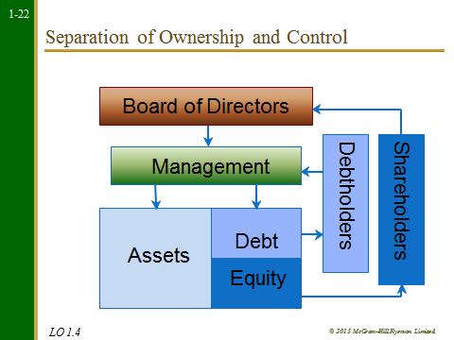
Separation of ownership and control is a characteristic of most large corporations where management is responsible for the day–to–day operations of the firm while owners (shareholders) have limited input. Conflicts arise when the goals of management differ from the goals of shareholders. Of course, there are always exceptions to the rule.
Two studies of the ways in which shareholder and manager goals can diverge are:

1. Oliver Williamson ("Managerial Discretion and Business Behavior," American Economic Review 1963) suggests that managers have expense preference because perquisites such as company cars and office furniture have more value to managers than to shareholders.
2. Gordon Donaldson (Managing Corporate Wealth: The Operations of a Comprehensive Financial Goals System, Praeger Publishers, 1984) suggests three motives underlie managers' actions: a) survival, b) independence, and c) self–sufficiency. Donaldson concludes that these motives lead managers to maximize corporate wealth – the wealth over which they have control.
Do Shareholders Control Managerial Behavior? [PowerPoint Slide 1–24]

This section discusses how shareholders can/may control management. This is a good opportunity to introduce recent developments in corporate control, such as institutional shareholders and the trend towards indirect stock ownership through pension and mutual funds. These topics often generate lively discussions, especially if you can use a M&A example from a local company. Following are the typical ways through which shareholders align their goals with those of management:

- Managerial incentives:
- Incentives such as performance plans linked to accounting income (or, even better, EVA) or equity participation through stock options help to bring the objectives of management more into line with those of the shareholders.
- Takeovers:
- Takeovers can be a shareholder's best friend if they (or the threat of their existence) force management to work in the shareholders' interests.
- The voting mechanism and corporate governance:
- The corporate charter often determines how difficult it is to replace the management team through the board of directors (this is addressed in depth in the chapter on Mergers and Acquisitions).
- The labor market for managers:
- Managers have a strong incentive to work in the shareholders' interests if they can be easily replaced.

Agency Costs

Agency costs refer to the costs of resolving the conflicts of interest between managers and shareholders. Agency problems are “costly” because shareholders have to expense resources (either in the form of direct monitoring, or providing incentives such as stock options) to motivate management to act in shareholders’ best interests. At the heart of agency problems is the separation of equity ownership from managerial control.

The Set–of–Contracts Perspective

From the Set–of–Contracts Perspective, the corporation is defined as a legal framework of contracts. The three most important contracts are:
- The debt's–claim on the firm's assets and cash flow.
- The equity's claim on the firm's residual assets and cash flow.
- The shareholders' contract with the management team to run the company on their behalf.

Conflicts of interest, especially in times of financial distress, are present between shareholders, debtholders, management, and other stakeholders in the firm (including employees, suppliers, customers, and creditors). Conflicts of interest can also arise within each of these groups. For example, some shareholders may believe that the firm should invest only in ecologically responsible projects while others care only about increasing their wealth. Conflicts between classes of debt such as subordinated debt and unsubordinated debt are especially prevalent in times of financial distress.
Financial Markets and Institutions [PowerPoint slides 1–26 to 1–32]

Depending on the focus of the course, this section can either be skimmed over or extensively reviewed. Our experience is that students are always keenly interested in financial markets and institutions and are happy to spend time on this material, especially if they have not yet had an investments course.

Financial Institutions
Intermediaries – Financial institutions make funds available to firms from the funds placed in their trust by investors. Examples of financial institutions or intermediaries include: chartered banks, trust companies, investment dealers, insurance companies, and mutual funds.
Indirect finance – Funds are supplied to demanders through a financial intermediary. One example is a bank loan
Direct finance – Funds are supplied to demanders directly from suppliers – with no financial intermediary. One example is a bond issue directly to the end bondholder.

Money Versus Capital Markets
Money markets – The market in which short–term (1 year or less) securities are bought and sold. It is a dealer market, i.e., dealers buy and sell from their inventories.
Capital market – The market for long–term debt and equity shares. It is primarily a brokered market, i.e., brokers match up buyers and sellers.
Primary Versus Secondary Markets
Primary market – Refers to the original sale of securities. Public offer, OSC registration, underwriters are part of this market.
Secondary market – Refers t the resale of securities. Stock exchanges (Toronto Stock Exchange, Montreal Exchange..) and the over–the–counter (OTC) are parts of this market.
Listing – Stocks that trade on an exchange are said to be listed.

Trends in Financial Markets and Management [PowerPoint slides 1–32 & 1-33]

Prior to concluding the lecture, some instructors enjoy discussing new trends in financial management. We have listed a couple of areas of interest.

- Integration and Globalization
- Increased Volatility
- Financial engineering – the creation of new securities or financial processes which help to reduce risk, lower financing costs and/or minimize taxes.
- Advances in Computer Technology have created e–business bringing new challenges for the financial Manager. They have also created opportunities to combine different types of financial institutions to take advantage of economies of scale and scope.
- Regulatory Dialectic

An Outline of the Text [PowerPoint slide 1–32]

Ask the students to imagine they are the CFO of a company with $2 billion in excess cash: “What can the firm do with this excess cash?” The list that results provides a survey of corporate finance topics.
- Invest in a new project or upgrade existing facilities
- Find an acquisition candidate
- Invest in financial assets
- Repay debt
- Repurchase shares of stock
- Pay a dividend

We try to relate these options to the three big questions in corporate finance:
- The capital budgeting question;
- The capital structure question; and
- Financial planning / short–term finance.

Which wraps up the lecture right where we started.

