CHAPTER 1
INTRODUCTION TO BUSINESS FORECASTING

CHAPTER OVERVIEW

This chapter presents a broad overview of business forecasting.

LEARNING OBJECTIVES

- Introduce Business Forecasting
- Introduce the role of forecasting in supply chain management
- Introduce the importance of collaborative forecasting
- Review subjective forecasting methods
- Introduce concepts related to new product forecasting
- Introduce two simple "Naive" forecasting models
- Develop criteria for evaluating forecast accuracy
- Introduce making forecasts with FORECASTXTM

NOTES TO TEACHERS

1. A large part of Chapter One is designed to motivate students for the task ahead, especially since many students will find the applied quantitative analysis of data initially threatening. I have found that the following points are worth making to students. First, clearly establish that quantitative forecasting is necessary for business success because it helps reduce uncertainty surrounding business decisions; hence knowledge of forecasting is necessary for one's career. The numerous examples in this chapter provide plenty of real-world evidence of the need for business forecasting skills. Second, point out some of the real-world entities that employ FORECASTXTM. A partial list may be found at: http://www.johngalt.com/clients.shtml.

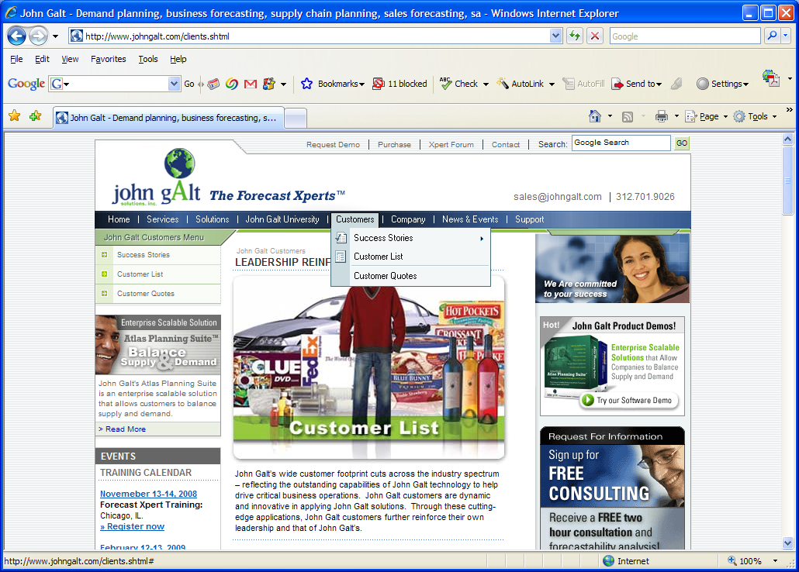
On this screen select “Success Stories.”

Finally, you might suggest that students should put mastery of FORECASTXTM on their resume, since forecasting skills can sometimes take them a long way in a short while. The message is simple: Forecasting skills are in demand!

2. While FORECASTXTM is a powerful tool, its use is only mastered after some investment in basic statistics. Accordingly, students should understand that forecasting depends on knowledge and application of some basic statistical concepts such as hypothesis testing and regression modeling. The payoff is that the student will be able to generate and interpret quantitative forecasts using state-of-the-art-forecasting tools.

3. The recognition that improving functions throughout the supply chain can be aided by appropriate use of forecasting tools has led to increased cooperation among supply chain partners. This cooperative effort has become known as CPFR (Collaborative Planning Forecasting and Replenishment). CPFR involves coordination, communication, and cooperation among participants in the supply chain.

Some benefits of collaborative forecasting include:

1. Lower inventory and capacity buffers.
2. Fewer unplanned shipments/production runs.
3. Reduced stock-outs.
4. Increased customer satisfaction and repeat business.
5. Better preparation for sales promotions.
6. Better preparation for new product introductions.
7. Dynamically respond to market changes.

Some companies that have successfully implemented collaborative forecasting partnerships. Examples include Wal-Mart, Target, K-Mart, Sears, EMD Chemicals, Whirlpool, Fuji Photo Film, and Goodyear.

4. Students may at first prefer subjective methods since they generally do not require any statistical background. However, it should be pointed out that subjective methods, in some way, depend upon someone's opinion. This leads to the problem of bias, and politicization of the forecast process.

5. This chapter presents two simple forecasting models termed “naive” methods by the authors. While there is a temptation to view these models as purely pedagogical, in some cases, they are quite useful. Specifically, the first-naive model, in which the forecast is last period’s actual value, is useful in forecasting time series that follow a so-called “random walk” behavior such as many stock prices.

In the second-naive-forecasting model, the direction from which the latest observation was obtained is combined with last period's actual value in an adaptive adjustment model. This model is designed for data with a growth factor or trend. Finally, this is a good time to introduce the concept of a weighting factor and it’s role in the forecast process. Accordingly, students should learn to select a value of the dynamic adjustment weighting factor that maximizes forecast accuracy.

6. Perhaps the most important material of the chapter, is the section introducing various methods of evaluating the “goodness of fit” of forecasting models. Since there are always various competing models that can be used to generate forecasts, some criteria is needed to select which model performs the best. Seven commonly used measures of forecast accuracy are presented on pages 34 – 35. Perhaps the two most common of these is root-mean-squared error (RMSE), which is similar to the basic statistical notion of a standard deviation, and the mean absolute percentage error (MAPE).

Students should note that the simple average of forecast errors is an inappropriate measure of forecast accuracy since the average can be zero and yet the model performs very poorly as measured by the error variance. Accordingly, “goodness-of-fit” measures involve either taking the absolute value of forecast errors or squaring forecast errors. This implies different behavior for the two classes of measures with regard to outliers. Specifically, measures involving a quadratic loss function penalize larger forecast errors more on the margin, whereas the marginal penalty is constant using absolute measures. The result is that the two types of measures may give conflicting information about relative model adequacy. However, most of the time they are likely to give similar results.

Finally, students should note which measures are appropriate for model selection among different-sized variables and which are designed for a single series.

7. It never makes sense to give a single number as a forecast. In the real world, practitioners generate several forecasts including point and interval estimates, and often conduct sensitivity analysis. The goal is to maximize the information provided by the forecast process.

8. We present a running example of forecasting total houses sold using the various techniques introduced in each successive chapter. Accordingly, students should view the set of examples of forecasting total houses sold as an example of the forecast model selection process for a very important industry.

Students should be asked why the simple naive model is amended to use a twelve-month lag to forecast sales rather than the usual one-period lag. The reason is clear from Figure 1.7 (page 38); total houses sold are highly seasonal. Most students who have been employed in retail sales will have a clear understanding of this concept.

9. This is one course you do not need to supplement with outside examples, data, cases, etc. We have tried to provide many examples and to describe complicated statistical techniques in a manner that is accessible to students. In addition, the text and this Manual are designed so students can actively participate in text examples as well as easily generate forecasts of their own. Accordingly, by following the text sequence of applications using FORECASTXTM, the students will find themselves doing things they had no dream they would capable of mastering just weeks ago.

ANSWERS TO END-OF-CHAPTER EXERCISES

1. Advantages in using subjective forecasting methods include ability to generate forecasts when there is a shortage of historical data and/or when quantitative expertise is not available. Also, use of salespersons and consumer surveys can provide valuable information for forecasting new product sales. On the other hand, since subjective methods essentially use somebody’s opinion, they are always subject to bias. In addition, they are subject to manipulation and therefore tend to be inconsistent over time.

Quantitative forecasting is generally more accurate and can be adjusted to improve fit by applying specialized methods such as one that accounts for seasonality. Also it is easier to use more than one forecasting method, thus increasing the overall informational content of the forecast. Quantitative forecasting methods, however, may be more costly and the collection of data can be time consuming.

2. See Excel file c1p2Solution.

3. See Excel file c1p3Solution.

- See Excel file c1p4Solution.

- See Excel file c1p5Solution.

6. As an illustrative example IBM annual reports were used in obtaining the following total revenue data, as well as forecasts based on the first-naïve model. Student results will vary.

Year | IBM Revenue (millions) | Naïve Revenue Forecast
1983 | 40180 | MISSING
1984 | 45937 | 40180
1985 | 50056 | 45937
1986 | 51250 | 50056
1987 | 54217 | 51250
1988 | MISSING | 54217

A plot of IBM's revenue and forecasts using the first-naive model is presented below.

Note that the forecasting model systematically under predicts actual revenue. This is because the forecasts are based solely of what was observed last period and suggests that the first-naïve model does poorly on data with a significant trend.

- See Excel file c1p7Solution.

- See Excel file c1p8Solution.

