Chapter 1
Graphs, Equations, and Inequalities

Chapter 1 Mixed Review Worksheets
1.
The solution set is .
2.
The solution set is
3.
The solution set is .
4.
Since does not cause a denominator to equal zero, the solution set is .
5.
The solution set is .
6.
The solution set is .
7.
The solution set is .
8.
The solution set is .

9.
10.
The solution set is .
11.
The solution set is .
12.
The solution set is .
13.
The solution set is .
14.
The solution set is .
15.
This is impossible since the principal square root always yields a non-negative number. Therefore, there is no real solution.
16.
The solution set is .
17.
The solution set is .
18.
The solution set is .
19.
The solution set is .
20.
Since 8 does not make any denominator equal to 0, the solution set is .
21.
or
The solution set is .
22.
23.
Use the Zero option from the CALC menu.
The solution set is .
24.
Use the Intersect option on the CALC menu.
The solution set is .
25.
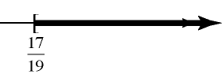
26.
27.
28.
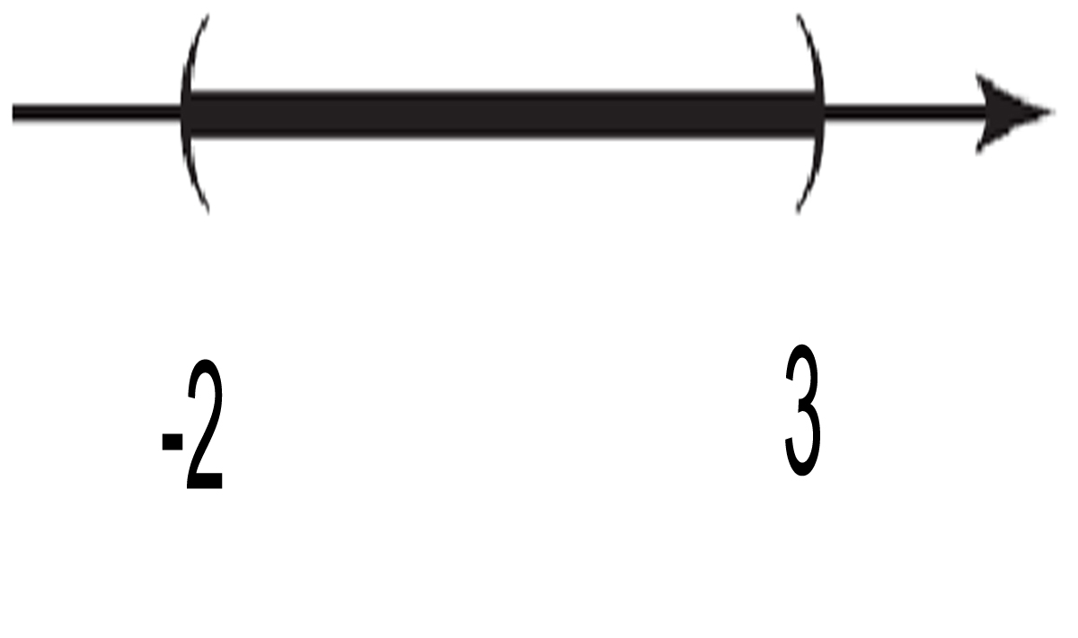
29.
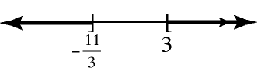
30.
31.
32.
33.
34.
35.
36.
37.
The solution set is .
38.
The solution set is .
39.
The solution set is .
40.
The solution set is .
41.
a.
b.
42.
a.
b.
43.
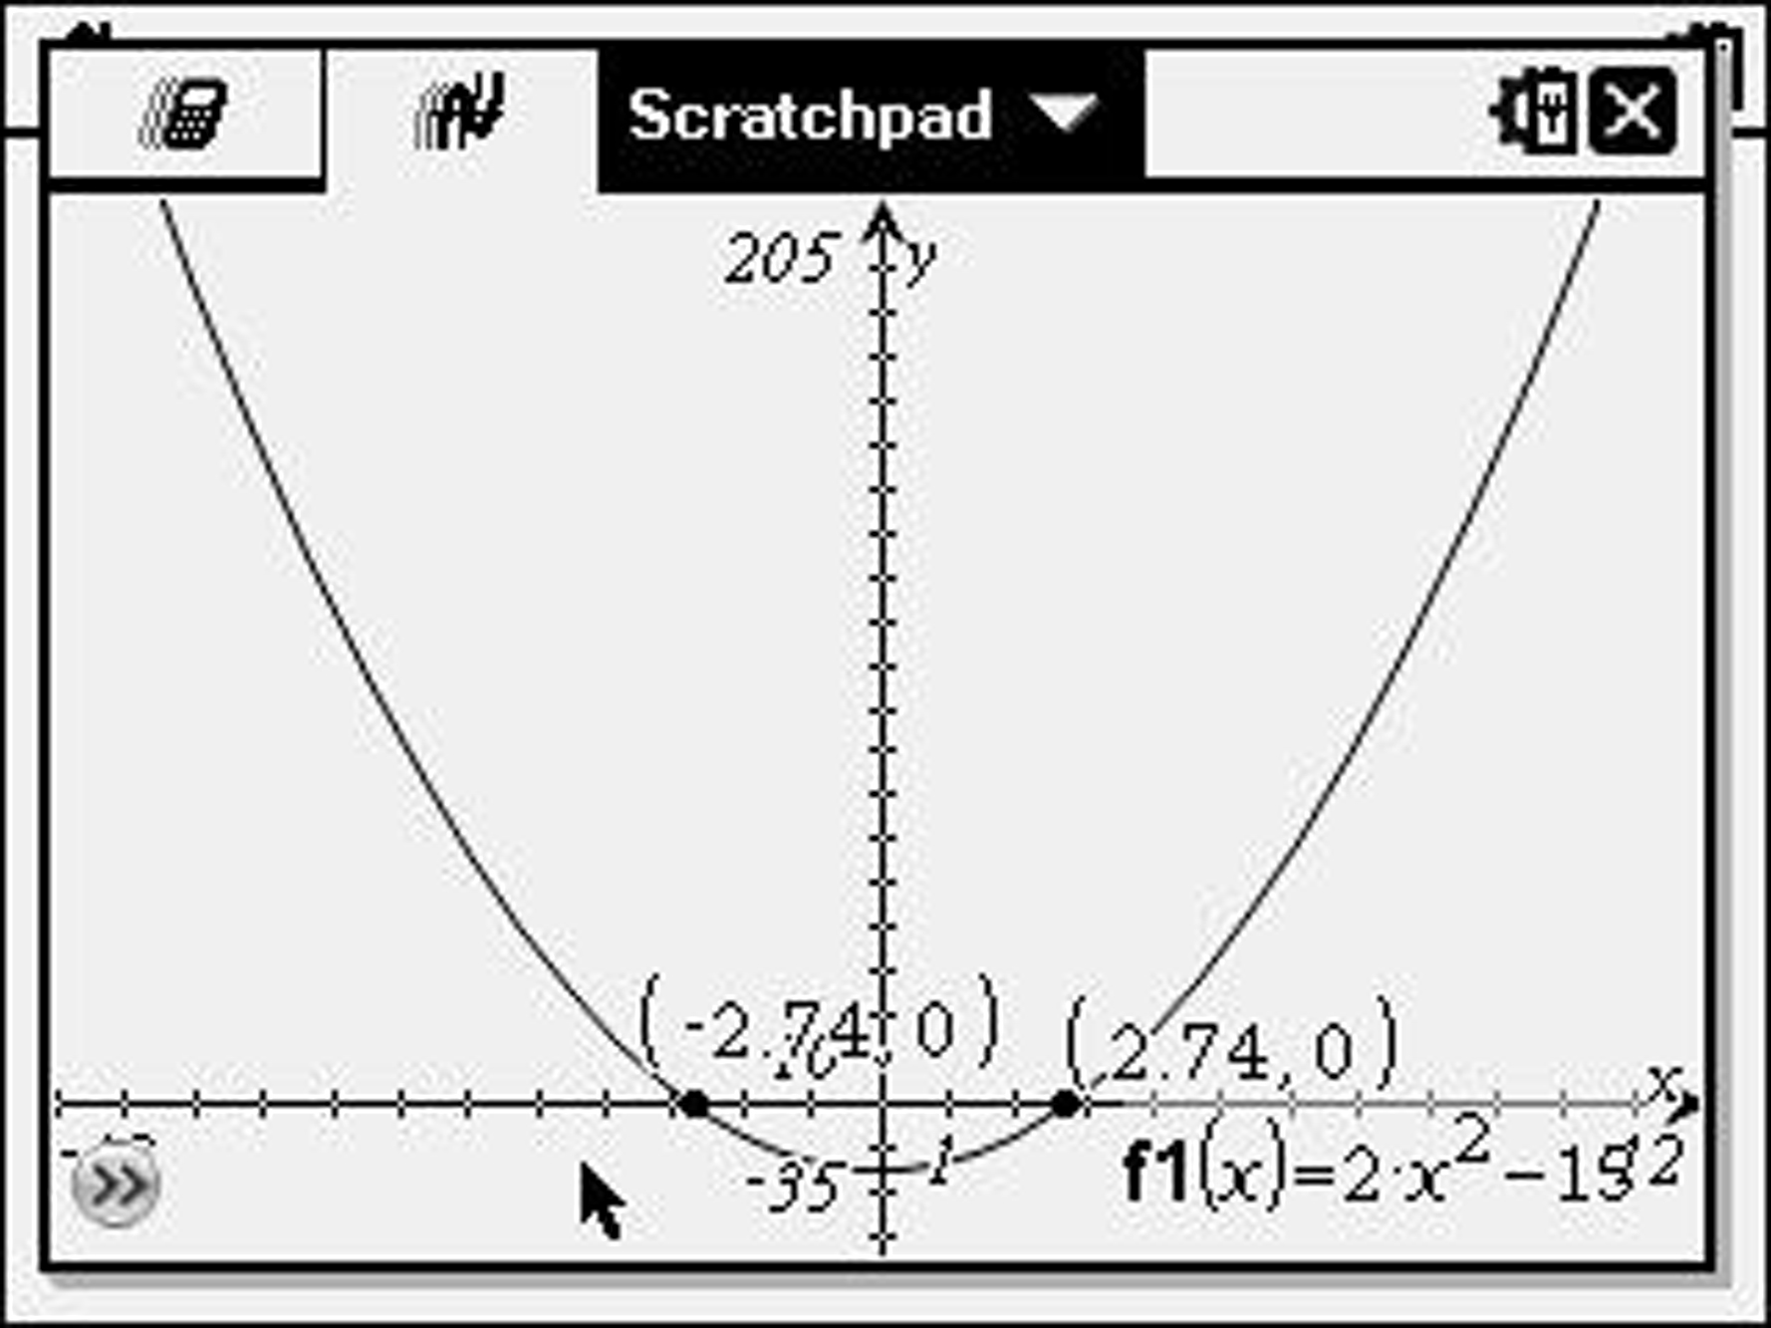
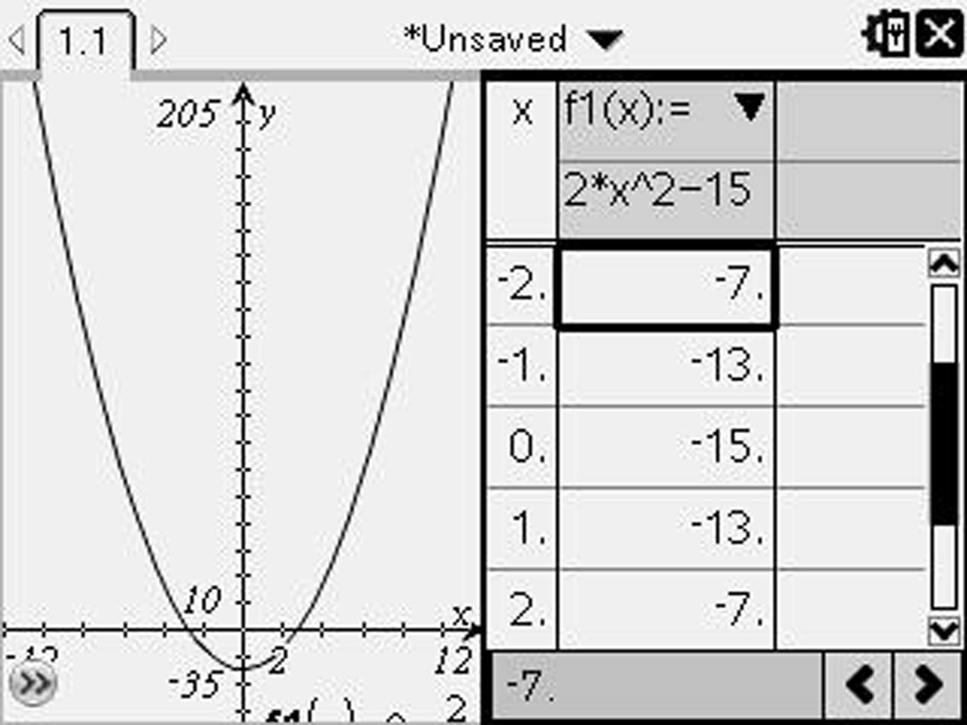
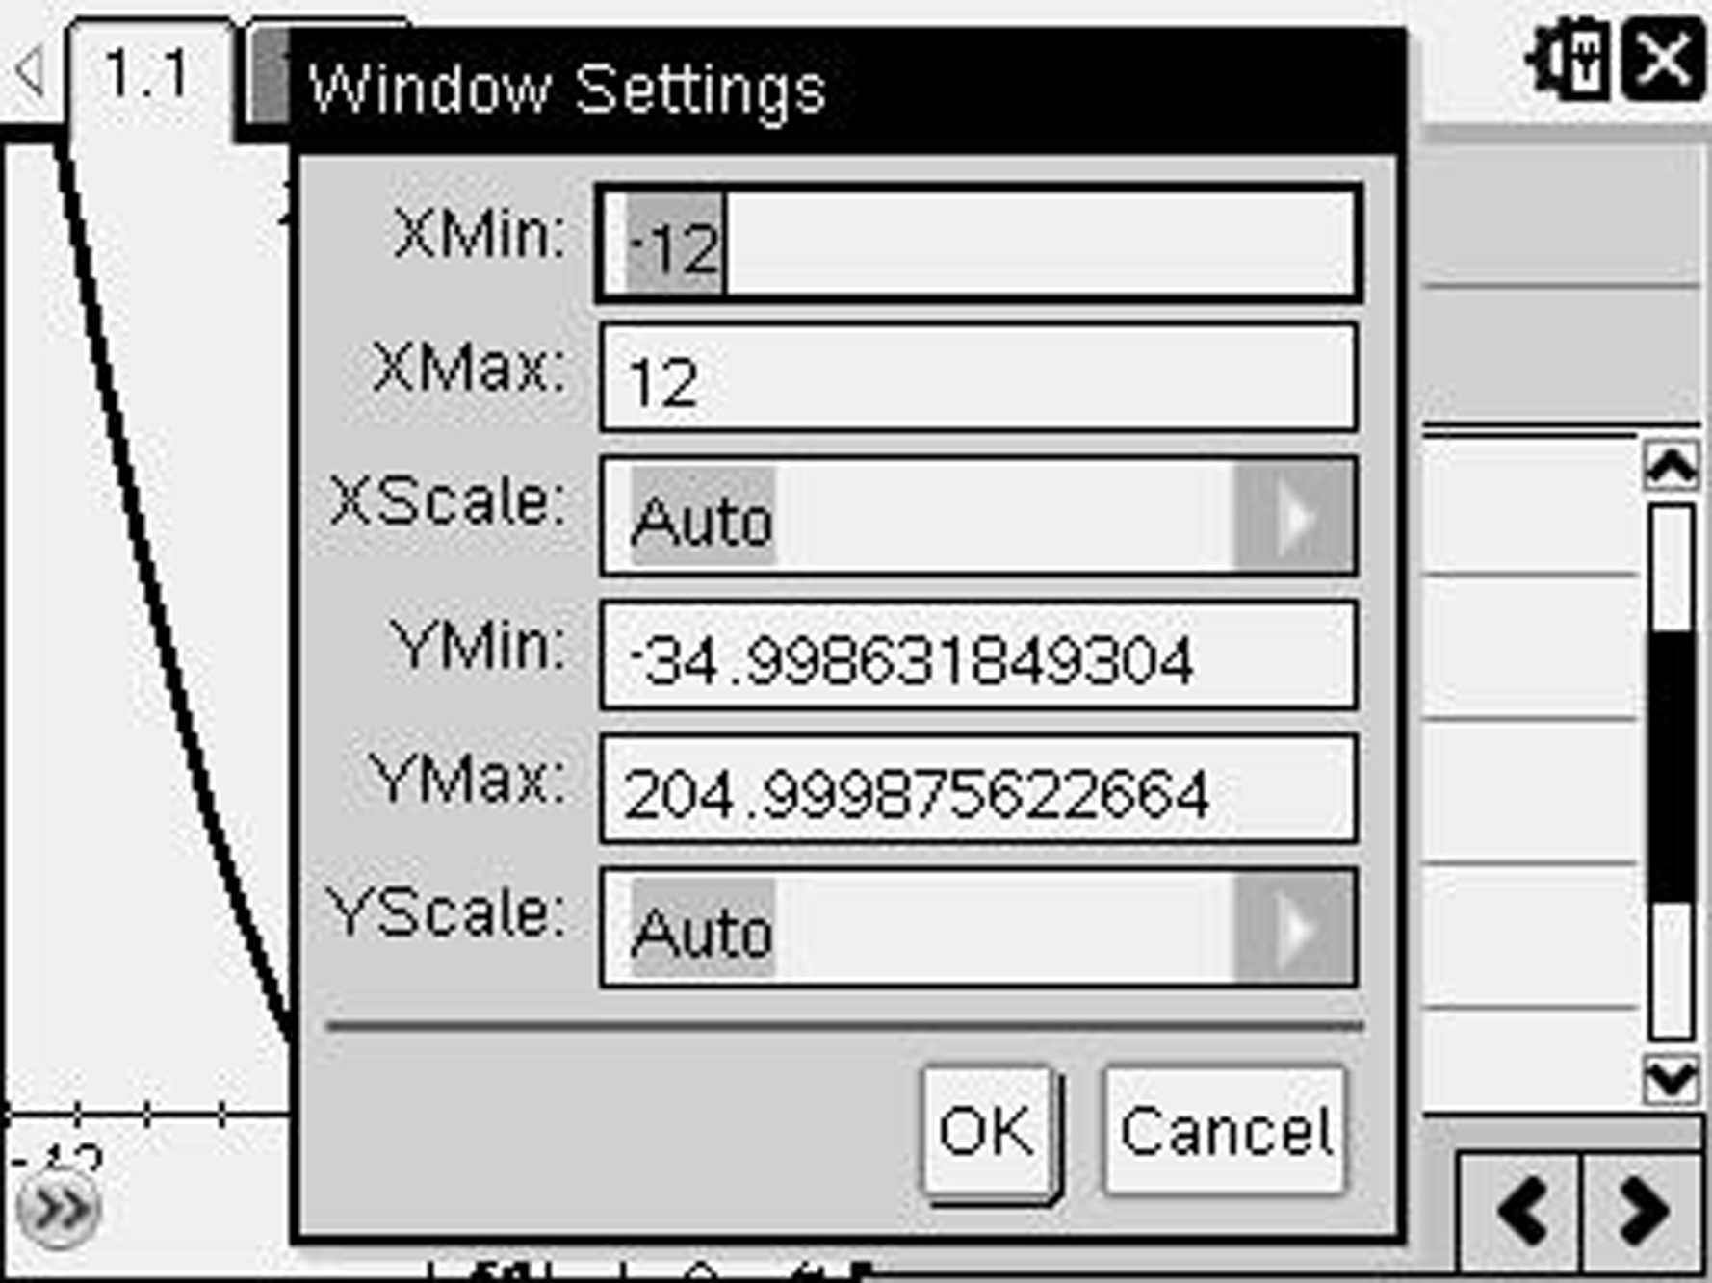

44. ,
x-intercepts:
y-intercept:
45.
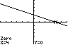 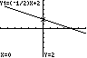
46.
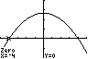 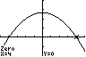
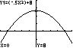
47. Given the points .
Find the distance between each pair of points.
The Pythagorean theorem is satisfied, so this is a right triangle.
48.
49. Let represent the distance the plane can travel.
Since the total time is at most 7 hours, we have:
The plane can travel at most 1724.8 miles or 862.4 miles one way. This is 246.4 miles farther than in Problem 114.
50. Let r represent the rate of the Metra train in miles per hour.
The Amtrak Train has traveled 10 fewer miles than the Metra Train.
The Metra Train is traveling 30 mph, and the Amtrak Train is traveling mph.
51. Let represent the time it takes the smaller pump to empty the tank.
Since the two pumps empty one tank, we have:
We can solve this equation for t by using the quadratic formula:
It takes the small pump approximately 12.385 hours (12 hr 23 min) to empty the tank.
52. Let x represent the amount of the 15% solution added.
90 cubic centimeters of the 15% solution must be added, producing 150 cubic centimeters of the 25% solution.
53. Consider the diagram
By the Pythagorean Theorem we have
The width is 6 inches and the length is 6 + 2 = 8 inches.

